How to Add a Freeze Frame to the Pharmacy MIS Tool
For this example we will be adding a freeze frame to the “MIS – Pharmacy” sheet.
Step 1: Use the toolbox buttons to navigate to either “MIS – Pharmacy”, “MIS-Appliance”, “MIS-Abated” or “MIS-Cross Boundary”.
Step 2: When the Pharmacy MIS sheet opens check you are at the far left column and top row of the sheet.
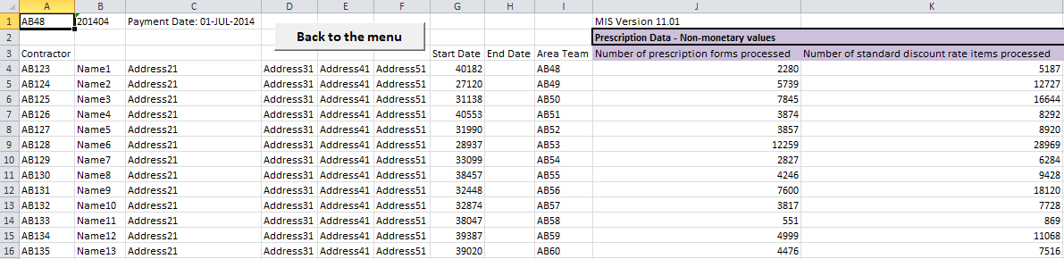
Step 3: Select the cell that will form the fix point for the sheet. In this example cell B4 is the fix point. This means column A, and all rows above 4 will remain fixed. Columns B onwards and rows 4 down will move.
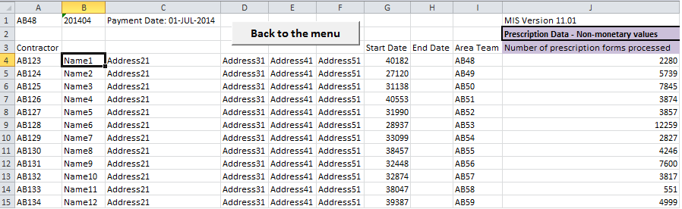

Step 4: Once your fix point is selected use the menu at the top to select
View -> Freeze Panes -> Freeze Panes
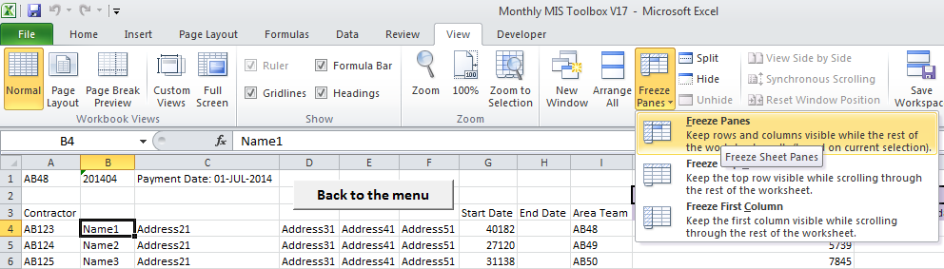
The result is that you now have a freeze pane on screen where Column A is always on screen as is rows 1,2 and 3.
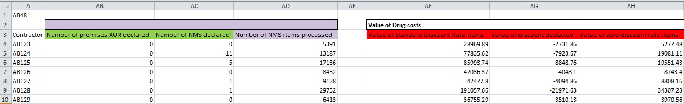

Step 5: To remove a Freeze Pane simply left click on View -> Freeze Pane -> Unfreeze Panes.
