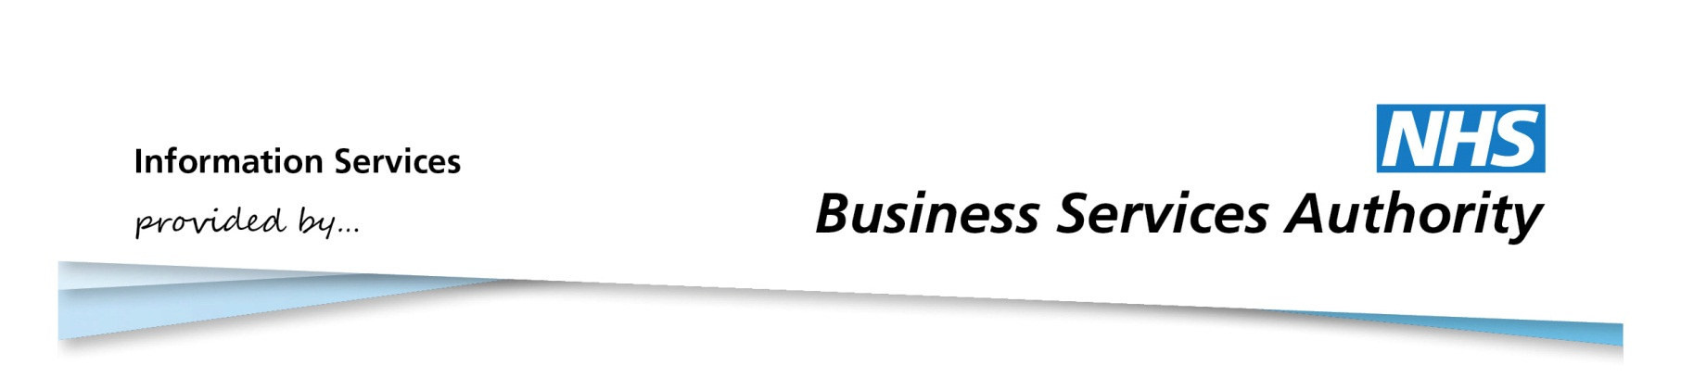

Information Services Portal
Changing Active/Default Profiles

Home Page
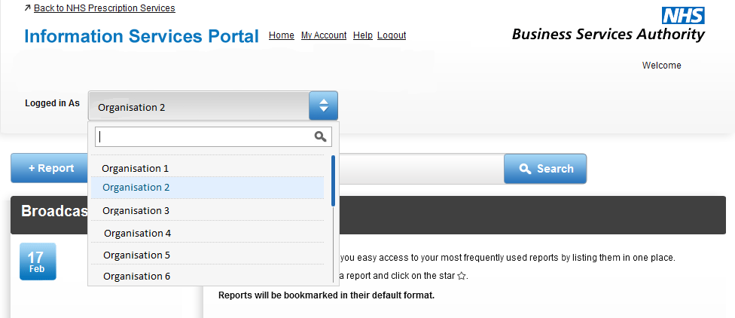
1a
1a
If you have access to multiple organisations there will be a drop down menu displaying your default active profile. If you wish to change your active profile, choose the organisation you require from the drop down list.
1b
1b
When the active profile has been changed, a message will appear. The next time you login, the system will have reverted back to the default profile

Home Page

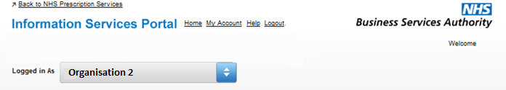
2a

2a click Edit Personal a
To change the default profile, from the home page click into My Account

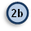click Edit Personal Details

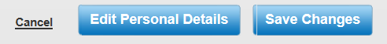

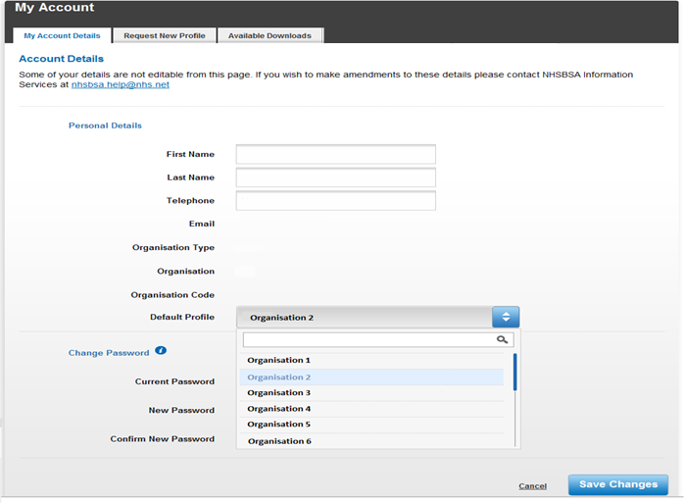
2d
2c

Click onto the default profile drop down menu and choose the organisation you want as your default profile.
When you have made your choice, click Save Changes.
2d

2e2d

2ed
After saving your changes you will be sent to the home page and a message will be shown. The next time you login to the system, it will display your new default profile.

