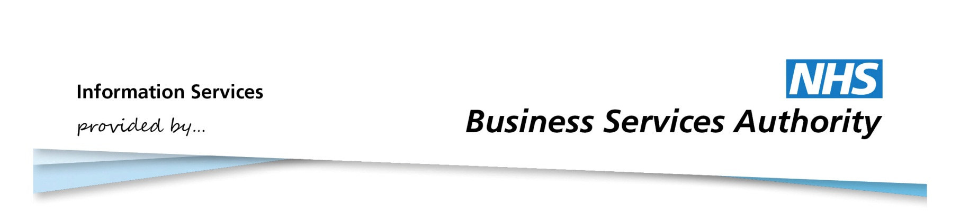

Information Services Portal
My Account

Home Page
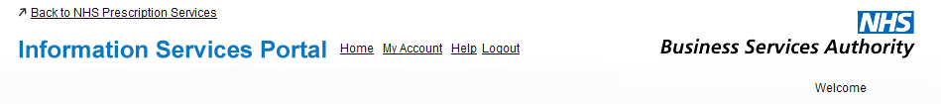
1a
1a
From the home page, click My Account to access your account details.

2c
2a
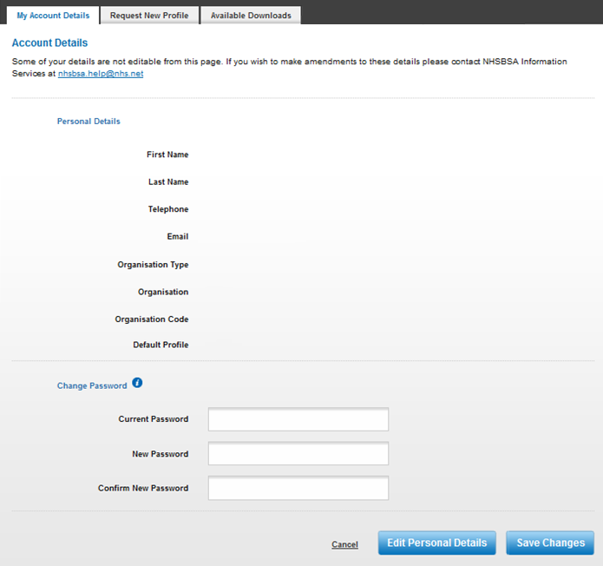
2f
2e
2d
2b

2a
This section will display your personal details, as well as the details of your organisation. If you have access to multiple organisations then your default organisation will be shown.
2b
If you wish to amend your personal details, click Edit Personal Details. This will allow you to change your first name, last name, and telephone number. Click Save Changes when you have finished.
2c
If you wish to change other details, such as your organisation, please contact NHSBSA Information Services team via the email address given.
2d
If you want to change your password, enter the relevant details here.
2e
To view information on how to choose a new password, click on this symbol.
2f
For information about the Request New Profile tab please see the Requesting a New Profile User Guide. For information about the Available Downloads tab, please see the Data Download User Guide.

