MIS Toolbox Categorisation Explained in Detail
Quartiles: The quartiles of a ranked set of data values, are the three points that divide the data set into four equal groups, each group comprising a quarter of the data.
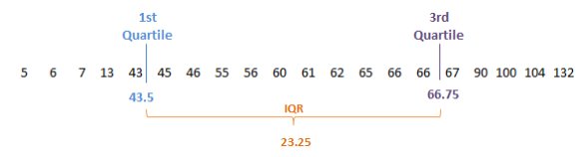
Inter Quartile Range (IQR): The difference between the 1st and 3rd Quartile of the data.
John Tukey’s Method of outlier activity
The positive of using this approach is that the method is not dependant on distributional assumptions. The method takes the IQR and calculates above the 3rd quartile and below the 1st quartile.
Lower Outlier = (Quartile 1) – (1.5 x IQR)
Upper Outlier = (Quartile 3) + (1.5 x IQR)

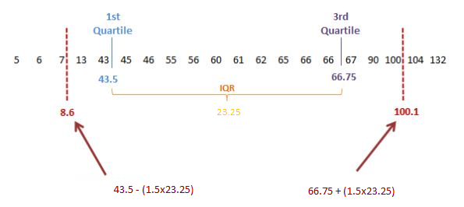

Monthly MIS Explanation
Upper Outlier: Any contractors where there values are above the calculated Tukey Upper Outlier.
Above Average: Any contractors where there value is less than or equal to the Tukey Upper Outlier value and above the 3rd quartile.
Upper Quartile: Any contractors where there value is less than or equal to the 3rd Quartile and above the median.
Lower Quartile: Any contractors where there value is less than or equal to the Median and above the 1st Quartile.
Below Average: Any contractors where there value is less than or equal to the 1st quartile and above the Tukey Lower Outlier.
Lower Outlier: Any contractors where there values are below or equal to the calculated Tukey Lower Outlier.

The contractors are then assigned a category based on the average across that area team.
Cumulative MIS Explanation
The categories for the outlier activity is calculated per month across the area team, including the abated data. The average of the months loaded is calculated and the category for the cumulative assigned to the contractors, except in upper outlier which is shown below.
Example 1: Contractor is cumulatively classed as Upper Outlier
In this example the contractor is continually conducting a high number of MUR’s and thus is always in the Upper Outlier category. Thus there final category is Upper Outlier.
Monthly | 1 | 2 | 3 | 4 | 5 | 6 | 7 | 8 | 9 | 10 | 11 | 12
No. MUR's Conducted | 100 | 100 | 100 | 100 | 100 | 100 | 100 | 100 | 100 | 100 | 100 | 100
Category | Upper Outlier | Upper Outlier | Upper Outlier | Upper Outlier | Upper Outlier | Upper Outlier | Upper Outlier | Upper Outlier | Upper Outlier | Upper Outlier | Upper Outlier | Upper Outlier

Example 2: Contractor is cumulatively classed as Upper Outlier
In this example the contractor has conducted the total 400 MURs in the first 2 months of the financial year. For the other 10 months they have conducted no MUR’s. The average of category would have been Lower Outlier; however that would mask the fact that they have conducted unusually high behaviour in the first 2 months. Thus in this case they are assigned to the Upper Outlier category.
In summary if a contractor is assigned to the ‘Upper Outlier’ group in any month that has been loaded into the cumulative toolbox, there cumulative group will be ‘Upper Outlier’ irrespective of the other groups. This is to ensure abnormal frequencies are not missed.
Monthly | 1 | 2 | 3 | 4 | 5 | 6 | 7 | 8 | 9 | 10 | 11 | 12
No. MUR's Conducted | 200 | 200 | 0 | 0 | 0 | 0 | 0 | 0 | 0 | 0 | 0 | 0
Category | Upper Outlier | Upper Outlier | Lower Outlier | Lower Outlier | Lower Outlier | Lower Outlier | Lower Outlier | Lower Outlier | Lower Outlier | Lower Outlier | Lower Outlier | Lower Outlier

