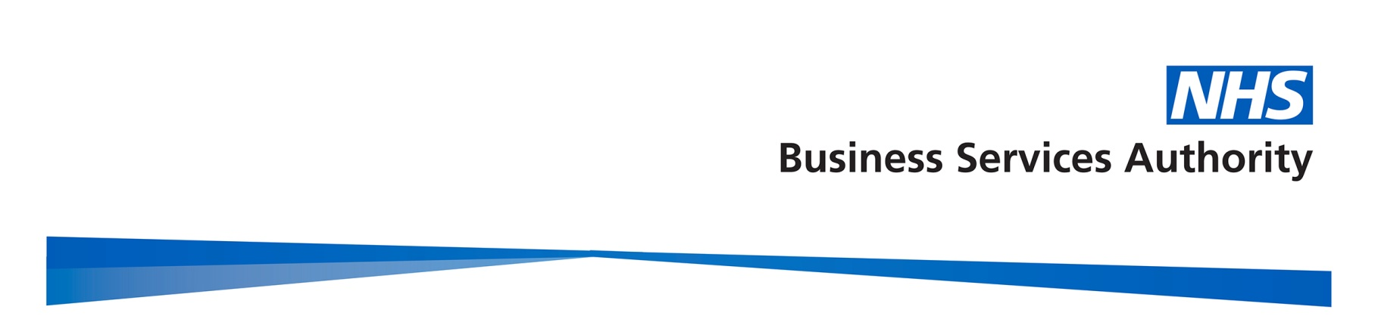
NHS Business Services Authority
Summary of Minutes of the NHSBSA Board Meeting
held at 10.30am on 14 September 2017

Present:

Mark Ellerby Non-Executive Director and Acting Chair
Alistair McDonald Chief Executive
Debra Bailey Non-Executive Director
Andrew Flanagan Non-Executive Director
Tim Nolan Non-Executive Director
Mark Dibble Director of Corporate Services and Corporate Secretary (from item 2)
Patrick McGahon Director of Finance and Commercial (from item 2)

In Attendance:

Nigel Zaman Department of Health
Neale Blevins Safety, Health and Environment Manager (item 5 only)
David Jukes Head of Governance and Secretary to the Board

Apologies:

Silla Maizey Chair
Ben Masterson DH

- Executive Director Proposals

The Board APPROVED and agreed to APPOINT the new officer members of the Board – Mark Dibble, Executive Director of Corporate Services and Corporate Secretary; and, in principle - the Executive Director of Strategy, Business Development and Growth. This would be approved in due course when an individual was nominated for appointment.

The Board APPROVED the resignation of Steven Pink, Director of Change and Commercial Delivery, and as officer member of the Board on 30 August 2017. This role was not included in the new directorate structure.

The Board thanked Mr Pink for his hard work and dedication to the NHSBSA, and wished him well in his future role.

- Chief Executive’s Report

Mr McDonald introduced the report, which included details on:

- Work being undertaken by NHS Digital on understanding the enhancements needed in the Electronic Prescription Service (EPS);
- NHS England Consultation on Guidance for CCGs: Items which should not be routinely prescribed in primary care;
- NHS Improvement – Securing a sustainable NHS workforce for the future;
- The Brexit Health Alliance;
- DH Procurement Transformation Programme;
- NHSBSA Directorate Structure update, and
- New Appointments of SIRO and Caldicott Guardian.

Outcome: The Board NOTED the Chief Executive’s report.

- Business Performance Report

Mr McDonald introduced the report, which included:

- Electronic Prescription Service (EPS) uptake progress;
- Pacific Programme progress, and progress against the £1bn savings NHSBSA goal;
- Supplier Management performance and KPIs;
- HR Shared Services performance;
- Creation of the new Special Health Authority - NHS Counter Fraud Authority;
- Pensions Programme status;
- DH Procurement Transformation Programme status;
- Service digitization update, and
- ITIS programme status.

Mr Dibble gave an update on:

- HR and OD services, and
- Governance – Health and Safety, Internal Governance, Environment and Resource Efficiency and Corporate Risks and Issues.

Outcome: The Board NOTED the report.

- Financial Report

Mr McGahon gave an overview of the financial position, including funding allocations for revenue DEL, external development projects and allocation for capital programme.

Outcome: The Board NOTED the report.

- Corporate Responsibility Annual Report 2016/17 and Strategy for 2017/18.

Prior to this item, the Board received health and safety training delivered by Ward Hadaway law firm. This covered the Board’s legal responsibilities in relation to health and safety regulations.

Mr Dibble introduced the Corporate Responsibility (CR) Annual Report 2016/17, and Corporate Responsibility (CR) Strategy 2017/18, supported by Neale Blevins (NHSBSA SHE Manager) and David Jukes.

Outcome: The Board ENDORSED the report

- Any Other Business

The Board NOTED confirmed minutes from the Audit Committee held on 4 May 2017.

The Board received and NOTED an update from the Remuneration and Nominations Committee held on 24 August 2017.
The Board NOTED confirmed minutes from the Remuneration and Nominations Committee held on 27 April and 23 May 2017.

Mr McGahon made a declaration of interest, being appointed as Chair of Carlisle College. This would be added to the Board’s register.

- Date and Venue of the next Meeting

The next Board meeting was planned for 11 and 12 October 2017 in Stella House, Newcastle upon Tyne.

