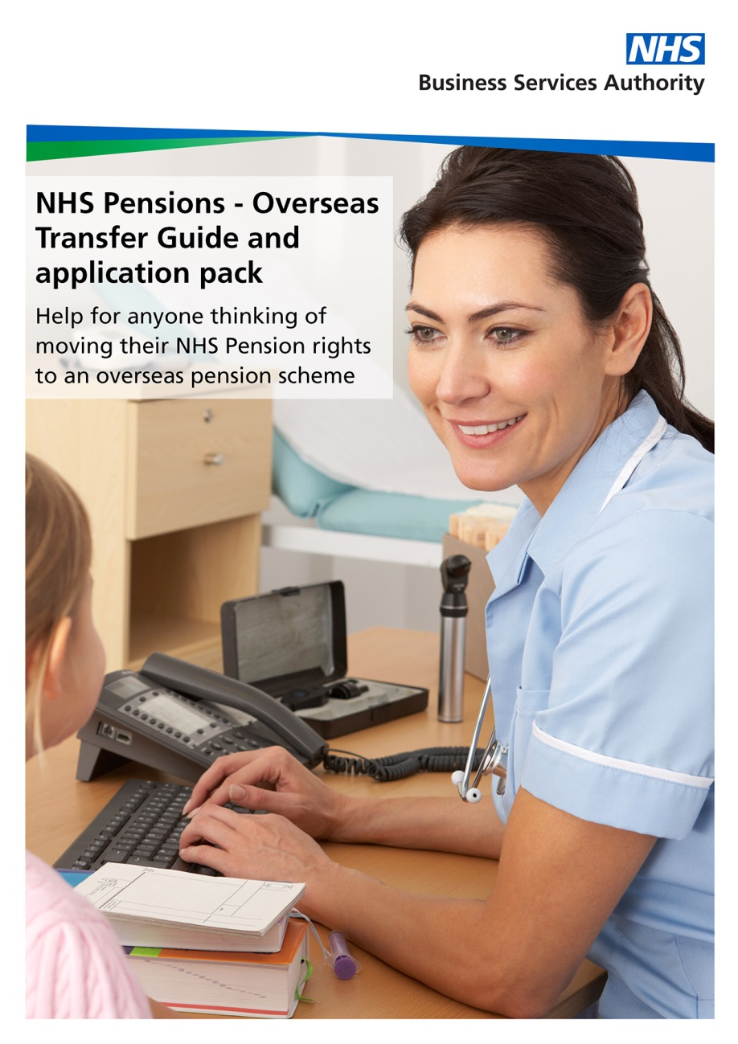
Request for a transfer value to an overseas pension scheme

Where can I transfer to?

You will only be able to transfer pension benefits overseas if:

- the receiving scheme is registered with HM Revenue and Customs (HMRC) as a Qualifying Recognised Overseas Pension Scheme (QROPS).
- if you have two years or more qualifying membership the receiving QROPS is an occupational scheme that provides defined benefits (see Pensions Act 2015 below)
- if you have less than two years’ qualifying membership, the receiving QROPS is an occupational scheme that provides defined benefits, or a QROPS that provides ‘flexible benefits’

If you are considering a transfer please read the following guidance carefully.
Please also read the ‘Leaving early and transferring out guide’ available on our website: www.nhsbsa.nhs.uk/nhs-pensions.
If the transfer value is required for divorce/civil partnership dissolution purposes, please do not continue with this form. Instead, please visit our website for the relevant forms and guidance at: www.nhsbsa.nhs.uk/nhs-pensions

If the transfer request is to a UK scheme please do not use this pack, instead download the Transfer Out guide and application pack available on our website at: www.nhsbsa.nhs.uk/nhs-pensions.

If you have not yet left NHS pensionable employment a transfer is not possible. We can provide an estimated transfer value of your NHS Pension Scheme benefits; however, this is not a guaranteed statement of the amount available for transfer. We can’t provide a guaranteed statement of entitlement until you have left the NHS Pension Scheme and we have been provided with details of your new scheme.

The Pensions Act 2015

From 6 April 2015, where a member has more than two years membership in the NHS Pension Scheme, transfers to schemes that provide ‘flexible benefits’ are not permitted.

This means that a transfer will not be possible if the overseas scheme provides benefits that meet the definition of ‘flexible benefit’ found at section 74 of the Pensions Schemes Act 2015:

74 Meaning of “flexible benefit”
(a) a money purchase benefit,
(b) a cash balance benefit, or
(c) a benefit, other than a money purchase benefit or cash balance benefit, calculated by reference to an amount available for the provision of benefits to or in respect of the member (whether the amount so available is calculated by reference to payments made by the member or any other person in respect of the member or any other factor).

NHS pension benefits

You will find information about the NHS Pension Scheme on our website: www.nhsbsa.nhs.uk/nhs-pensions.

What is a transfer value?

A transfer value is the capitalised value of the benefits you have built up and any associated rights at the calculation (or guarantee) date.

Are there any time/age limits?

A transfer to a QROPS is only possible if you left the NHS Pension Scheme on 1 January 1986 or later.

If you have less than two years qualifying membership (and not had a transfer in from a personal pension plan) a transfer to a QROPS is only possible if:

- you join your new scheme within 12 months of leaving pensionable NHS employment, and
- apply for a transfer within 12 months joining your new scheme, and
- complete the transfer before you reach normal pension age.

Amount available for transfer

To calculate your transfer value we will assume that the receiving scheme is able to accept liability for any contracted out rights (the Guaranteed Minimum Pension (GMP) and/or Section 9(2B) rights) if you have these, unless we are told differently. If this is not the case, the final amounts available for transfer will depend on the status of the receiving scheme, because some may not be able to accept the transfer value or may only be able to accept part of it.

Statement of entitlement

A statement of entitlement is the guaranteed transfer value of your NHS Pension Scheme benefits. If you have left NHS pensionable employment, and the receiving scheme is known, we will normally issue a statement of entitlement within three months of an application and guarantee the amount for three months in accordance with the Pension Schemes Act 1993.

The transfer payment

If the correct, fully completed TV18 option forms are returned within the three month period and before your normal pension age, payment of the guaranteed amount can be made.

Payment of the transfer value discharges the NHS Pension Scheme of all liability in respect of your rights under the Scheme.
A transfer payment must be made before you reach your normal pension age. If you are approaching normal pension age please keep this in mind and allow sufficient time for the transfer process to be completed. Otherwise the transfer cannot go ahead.

A transfer payment will only be made if the following requirements are met:

- Where the member has more than 2 years qualifying membership the receiving scheme is a Defined Benefit Scheme
- The receiving scheme satisfies HMRC requirements to be a QROPS.
- The name of the receiving overseas scheme must exactly match the QROPS name on the HMRC QROPS list at the time of payment.
- The payee matches the QROPS name. If the payee does not exactly match the QROPS name a letter must be received from the scheme explaining the reasons for this.
- The receiving scheme passes the due diligence test NHS Pensions is required to complete before payment can be made.

Before completing our option forms sent with the statement of entitlement, the receiving scheme should ensure that the name of the overseas scheme confirmed on the QROPS certificate matches the one on the HMRC QROPS list by referring to the HMRC website: www.hmrc.gov.uk (entering QROPS list in the search engine). They should contact HMRC direct if they have any questions about the information HMRC hold.

Penalties for making an unauthorised payment

A transfer to an overseas scheme that is not a QROPS or Registered Pension Scheme will make the transfer value an unauthorised payment. This means you will have a personal tax liability of 55% of the payment. In addition, NHS Pensions will also have tax liabilities.

Therefore, NHS Pensions reserves the right to contact HMRC and the receiving scheme regarding the QROPS status of any overseas scheme before making any payment.

Overseas transfer charge by HMRC

From 9 March 2017 certain transfers to and from a QROPS will be liable to a 25% tax charge called the overseas transfer charge.

A charge is not payable where one of the following applies:

- The member is resident in the same country in which the QROPS receiving the transfer is established
- The member is resident in a country within the European Economic Area (EEA) and the QROPS is established in a country within the EEA
- The QROPS is set up by an international organisation
- The QROPS is an overseas public service pension scheme and the member is an employee of an employer that participates in the scheme
- The QROPS is an occupational pension scheme and the member is an employee of a sponsoring employee under the Scheme.

More guidance can be found on HMRCs website.

Charging for a transfer value

You are entitled to one free transfer value in any 12 month period. Any further request will be charged for. Details about the information we can provide free of charge, together with our Schedule of Charges can be found on our website at: www.nhsbsa.nhs.uk/nhs-pensions.

If you have left the NHS Pension Scheme and the receiving scheme is either not known or we need to confirm the registration status of the scheme with HMRC, an estimated transfer value will be provided. We will not charge for a statement of entitlement once the receiving scheme is known, or our checks with HMRC are complete. However, there will be a charge for the provision of any subsequent statement of entitlement within the 12 month period.

Date of residency

NHS Pensions can provide a transfer value at the date of residency. This will be chargeable.

Financial advice

The transfer is at your own risk and it is in your own interests to make sure you know what pension benefits your new scheme or plan is offering you before you make your decision. NHS Pensions recommends that you consider taking financial advice before deciding to transfer.

In order to proceed with a transfer to a QROPS when your transfer value is over £30,000, The Pensions Regulator requires that you must provide a signed confirmation from your independent financial advisor of the appropriate financial advice you have received. The signed confirmation must include the following statements:
- That the advisor has the required authorisations under the relevant legislation to provide advice on the transfer of safeguarded benefits.
- The advice provided is specific to the type of transaction proposed by the member.
- The name of the member that was given the advice and the scheme in which they hold safeguarded benefits to which the advice applies.
- The reference number of the company or business in which the advisor works.

Pensions Liberation Fraud

If you are thinking of transferring your NHS pension rights you should carefully compare the pension benefits you are giving up with what your new pension scheme is offering you. You should also read the Pension Regulator guidance for Scheme members on Pension Liberation Fraud which is available for download from our website at: www.nhsbsa.nhs.uk/nhs-pensions, and can be found at www.thepensionsregulator.gov.uk

Further information

Contracted out rights

If you were a non practitioner member of the NHS Pension Scheme between 6 March 1978 and 5 April 2016 you will have been contracted out of the State Additional Pension before contracting out ceased on 6 April 2016.

Transferring contracted out membership is at your own risk. When you retire, it is possible that the pension benefits you receive from your new scheme may be less than the benefits you would have received in the NHS Pension Scheme, or the State Additional Pension. Neither you or your spouse or civil partner, would have a claim against the NHS Pension Scheme or the State Additional Pension scheme for any shortfall in the benefits paid by your new scheme.

When signing the transfer option forms, you will be declaring that you understand this and that the scheme that you are transferring to may not be regulated in any way by the law of the UK. As a consequence, there may be no obligation under that law on the receiving scheme to provide any particular value or benefit in return for the transfer payment.

Public Sector Transfer Arrangements (the ‘Club’)

The ‘Inner’ and the ‘Outer’ Club

Within the public sector transfer arrangements there are ‘Inner’ and ‘Outer’ Club schemes. The NHS Pension Scheme is a member of the ‘Inner Club’. However, the method of calculating the transfer value will depend on the classification of the receiving Club scheme.
Inner Club refers to transfers of Career Average Revalued Earnings (CARE) scheme benefits between schemes made under the Public Service Pensions Act 2013 and such other public service schemes whose rules are similar to those of any of the schemes made under the 2013 Act.
Outer Club refers to transfers of final salary benefits between Club schemes that operate on a final salary basis, or that are able to accept final salary benefits.

Club calculation time limits

If the receiving scheme is a member of the Public Sector Transfer Club a transfer on Club terms can only be made if the length of the break between leaving the NHS Pension Scheme and joining the new scheme is no more than five years.

In addition, your signed election to proceed with the transfer must be received by NHS Pensions within 12 months of becoming eligible to transfer for Club transfer arrangements to apply. A request for an estimate is not classed as an election to proceed; this time limit refers to the request for payment of the transfer value.

If the conditions for the Club transfer are not met you may still be able to transfer on non Club terms.

You can find more information about the Club on the Civil Service website at: www.civilservice.gov.uk/pensions/transfer-club

If you have more than two years’ qualifying membership and want to transfer to a QROPS that is a member of the Public Sector Transfer Arrangements, please write to us first for us to determine if a transfer to that scheme is possible.

Annual Allowance

When transferring from the NHS Pension Scheme to another Club scheme, any excess growth in the receiving scheme’s benefits (e.g. resulting from an increase in pensionable pay, or in scheme revaluation) will be taken into account when calculating the pension input amount for Annual Allowance purposes.

More information about the Annual Allowance is available on our website at: www.nhsbsa.nhs.uk/nhs-pensions

Lifetime Allowance

Pension funds must be tested against the standard Lifetime Allowance at the time of the transfer payment. When we send your statement of entitlement, we will include a request for additional information to establish your Lifetime Allowance. We will then advise you at the time of making the transfer payment what percentage of standard Lifetime Allowance has been used by the transfer value.

NHS Money Purchase Additional Voluntary Contributions (MPAVCs)

Please contact your MPAVC provider direct if you also want to transfer your MPAVC fund.

How we use your information

The NHS Business Services Authority – NHS Pensions will use the information provided for administering your NHS Pension Scheme membership and processing payment of your NHS pension benefits. We may share your information to administer and pay your NHS pension, enable us to prevent and detect fraud and mistakes, for debt collection purposes, or as required by law. For more information about who we share your information with and how long we keep your personal data and your rights, please visit our website at www.nhsbsa.nhs.uk/yourinformation

More information

More information about the NHS Pension Scheme can be found on our website at: www.nhsbsa.nhs.uk/nhs-pensions. Our online knowledge base, ‘Ask Us’, can answer your questions 24 hours a day, 7 days a week.

The Pensions Regulator has guidance for members, pension scheme administrators, pension
providers and Independent Financial Advisors on pension scams.

Please read the Pension Scam Awareness Booklet for members, which is available on the Pensions Advisory Service website:

www.thepensionsregulator.gov.uk

The following organisations provide information about transfers that may assist members when
deciding whether to transfer. They are:

The Financial Conduct Authority
Financial Conduct Authority, 25 North Colonnade, Canary Wharf, London, E14 5HS
Website: www.fca.org.uk

The Pensions Regulator
Pensions Regulator, Napier House, Trafalgar Place, Brighton, BN1 4DW
Website: www.thepensionsregulator.gov.uk

The Pensions Advisory Service
11 Belgrave Road, London, SW1V 1RB
Website: www.pensionsadvisoryservice.org

Next steps

Please complete the overseas transfer request form at the back of this guide and send it to:

NHS Pensions
PO Box 2269
Bolton
BL6 9JS

Please note we will not action the transfer value request until we receive the fully completed transfer request form enclosed.

We may need to contact HMRC to confirm the registration status of the receiving scheme before we make a transfer value payment.

We will send the transfer value to you. Please forward it to your new pension provider or Independent Financial Advisor (IFA).

Transfer overseas request form
Please note: We cannot provide a transfer value if Parts A and Part B of this form are not fully completed as required

If the receiving scheme does not have HM Revenue and Customs (HMRC) approval, a transfer is not possible. You should only continue if the receiving scheme does have HMRC approval.

Part A should be completed by you and Part B is for completion by your new pension provider or Independent Financial Advisor.

Part A - About you

Surname
Other names
NI number

Address:
Telephone number:
Email address:
Date joined/will join new pension scheme
I am still an active member of the NHS Pension Scheme |  |  |  |  |  |  | Yes No
Date applied for transfer
Marital status – Please tick the relevant box and provide the date where applicable.
Single
Married |  |  |  | Date of marriage
Spouse’s Gender |  |  |  | Male |  | Female
Formed Civil Partnership |  |  |  | Date of Civil Partnership
Divorced/Civil Partnership Dissolution |  |  |  | Date of Decree Absolute/Civil Partnership Dissolved
Widowed/surviving partner |  |  |  | Date of spouse’s/civil partner’s death

Please read and sign the following declaration:

I declare that:
- I have read and understood the ‘Leaving early and transferring out guide’ given to me by my employer when I left the NHS Pension Scheme (the guide is also available on the NHS Pension Scheme website at www.nhsbsa.nhs.uk/nhs-pensions)
- I have read the Pension Scams awareness leaflet for members, which is available on the Pensions Advisory Service website
- I understand that in order to facilitate the transfer all the transfer details and any request for supplementary information regarding the transfer will be released to the person or organisation named in Part B
- I have read and understood the charging process outlined in the transfer out guidance notes.
- The information I have given is correct and complete to the best of my knowledge and belief.

Member’s signature: |  | Date:

If you are an active member, or the receiving scheme is not yet known, or is not a Qualifying Recognised Overseas Pension Scheme, please tick here
The form should now be forwarded to NHS Pensions and we will provide an estimated transfer value. The final amount available for transfer will depend on the status of the receiving scheme and a guaranteed statement of entitlement and option forms will not be issued until we receive Parts A and B fully completed.

If the receiving scheme is known, please tick here
The pension provider or Independent Financial Advisor must now complete Part B in full. Otherwise the form will be returned.

Part B - About the receiving scheme

If the receiving scheme is an Overseas Qualifying Recognised Overseas Pension Scheme (QROPS), please tick here

If the receiving scheme is a defined benefit scheme, please tick here
(Please provide evidence of this in the form of your scheme rules)
The pension provider or Independent Financial Advisor must confirm the scheme meets the following criteria or the transfer cannot go ahead.
We understand that in order for NHS Pensions to make a transfer payment:
- the name of the overseas scheme must appear on the HMRC QROPS list at the time of payment
- the name of the receiving overseas scheme must exactly match the QROPS name on the HMRC QROPS list
- the payee must match the QROPS name (if the names do not match exactly, a letter must be enclosed to explain the reasons for this)
- we have attached a copy of our QROPS Certificate.

Name of the receiving scheme:
Please attach a copy of the HMRC QROPS Registration Notification (please note a screen print is not acceptable).

Date joined/will join new pension scheme
Signature on behalf of receiving scheme/IFA
Position |  |  |  | Date
Company stamp

NHS Pensions may need some additional information about the receiving scheme to determine if it is a scheme we are permitted to make a transfer to.

Note: The transfer value will be sent to the member to pass on to their new pension provider or IFA.

