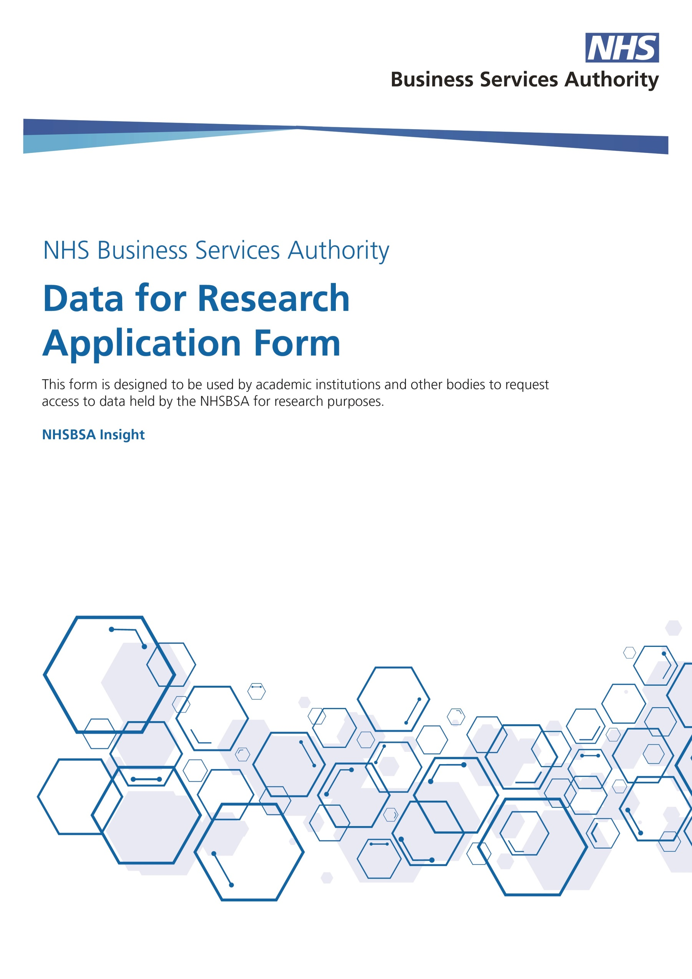

NHSBSA Data for Research Application Form

Prior to making a request, please ensure you have checked our online publications and those held by other public sector bodies such as NHS Digital or the Office of National Statistics to ensure the data you require is not already available.

A non-refundable assessment fee will apply for each submitted research data application. We aim to respond to each assessment within 6 to 8 weeks.

Please read through this document thoroughly and ensure you have completed all fields as required before submitting this application for assessment. Failure to do so could create a delay in the assessment process or result in your application being rejected.

Please complete the white boxes and mark NA where not applicable.

Please see the Appendices for an application process map and a checklist which may help you during the process.

If at any time you need to check specific details with the NHSBSA, please do not hesitate to contact us for an informal discussion on your application.

Once completed please return this form to:
nhsbsa.researchinsight@nhs.net

NHS Business Services Financial Information
With your application you must include details to allow the NHSBSA to raise an invoice for the payment of the initial assessment fee.
Initial assessment fee | £898.00
If you are an NHS Organisation applying for this data then VAT may not apply. If not, then you must add VAT to the initial assessment fee.
Purchase Order No.
Invoice Contact Name
Invoice Contact Telephone Number
Invoice Contact Email Address
Invoicing Address
Company Name
Address Line 1
Address Line 2
Address Line 3
Address Line 4
Postcode

To ensure the swift review of your application, ensure you provide remittance advice to:
nhsbsa.researchinsight@nhs.net
nhsbsa.accountsreceivable@nhs.net

If you have any queries about the status of your payment, please let us know at:
nhsbsa.researchinsight@nhs.net
nhsbsa.accountsreceivable@nhs.net

Once completed please return this form to:
nhsbsa.researchinsight@nhs.net

Your application will be reviewed by the NHSBSA Research Committee and you should receive a response within 6-8 weeks of payment of the application fee. Incomplete forms will be returned to sender and will delay the application process.

Please complete the below in full
Data request title or reference  Please contact nhsbsa.researchinsight@nhs.net  for a research reference number and enter it here. | Click here to enter text.
Request date | Click here to enter a date.

Your details (who is completing this form)
Full name | Click here to enter text.
Address | Click here to enter text.
 | Click here to enter text.
 | Click here to enter text.
 | Click here to enter text.
Postcode | Click here to enter text.
Email address | Click here to enter text.
Telephone number | Click here to enter text.
Your Academic Institution
Academic institution name | Click here to enter text.
Academic institution address | Click here to enter text.
 | Click here to enter text.
 | Click here to enter text.
 | Click here to enter text.
Postcode | Click here to enter text.

The applicant (if different from Page 3) & requesting organisation
Applicants title |  | Click here to enter text.
Applicants full name |  | Click here to enter text.
Job title |  | Click here to enter text.
Applicants organisation name |  | Click here to enter text.
Address Line 1 |  | Click here to enter text.
Address Line 2 |  | Click here to enter text.
Address Line 3 |  | Click here to enter text.
Address Line 4 |  | Click here to enter text.
Postcode |  | Click here to enter text.
Applicants telephone number(s) |  | Click here to enter text.
Applicants email address |  | Click here to enter text.
Requesting organisation  Is the address which the organisation is registered at in the UK, the same as the work address provided for the applicant? |  | ☐ Yes  ☐ No
If NO, provide the main office address in the UK:
Organisation name | Click here to enter text.
Address Line 1 | Click here to enter text.
Address Line 2 | Click here to enter text.
Address Line 3 | Click here to enter text.
Address Line 4 | Click here to enter text.
Postcode | Click here to enter text.
Organisation type | ☐ NHS or CQC-registered health and/or social care provider  ☐ Local authority  ☐ Other health and/or social care system public body  ☐ Government agency/department outside of health and social care  ☐ Academic institution  ☐ Research service provider  ☐ Research funder  ☐ Individual Citizen(s)  ☐ Other, please specify below:
 | Click here to enter text.
Organisation website URL
Click here to enter text.
Funding organisation name if applicable
Provide the full name of the organisation that will be providing financial sponsorship
Click here to enter text.
Funding organisation type | ☐ NHS or CQC-registered health and/or social care provider  ☐ Local authority  ☐ Other health and/or social care system public body  ☐ Government agency/department outside of health and social care  ☐ Academic institution  ☐ Research service provider  ☐ Research funder  ☐ Charity or organisation from tertiary/voluntary sector  ☐ Individual Citizen(s)  ☐ Commercial / industry, e.g. pharmaceutical  ☐ Other, please specify below:
 | Click here to enter text.
Website URL
Click here to enter text.
Funding programme details
Outline the funding programme under which the financial sponsorship will be provided
Click here to enter text.
Year of submission / award
Click here to enter text.
Funding applicant or partner
Click here to enter text.
Financial sponsorship
Click here to enter text.

Study/Data information

Title of the study
Provide the title of the study / research for which the data is requested below:
Detail of the study
Please provide a summary of the purpose of the study and how the study will be undertaken and what the desired outcomes include.

Benefits overview
Please write in the space below. Be as specific and detailed as possible.
Click here to enter text.

Commercial and funding
Is the application in any way commercial? If so, then clearly demonstrate how this benefits the health and social care system. If external funding is provided, this application must show whether the funding organisations receive any outputs and if any of those outputs will be used commercially. Please enter below.
Click here to enter text.

Conflict of interest statement
Please upload a copy of the conflict of interest (CoI) statement that you intend to include in any publication which might result from this work.

Click here to enter text.

Protocol for the study
Please upload the protocol information for the study.
Click here to enter text.
Data required  Describe the cohort of data required and if applicable, the data sets from which the data will be derived. | ☐ Dental Data Set  ☐ Prescription Data Set  ☐ Other
Patient or GP/Dentist contact  Does this study require any contact with patients, general practitioners or dentists? | ☐ Yes  ☐ No

If YES, outline the required contact and interactions (e.g. a survey) and if applicable, what other data will be collected below.

Click here to enter text.

Upload a copy of any communication material you will be using for contact purposes.

Click here to enter text.
Date this data is required by:
Click here to enter a date.
List of fields required:
(Data dictionaries are available by request for prescription and dental data)

Patient identifiable data (PID)
We expect that requests for patient identifiable data should come with approval from the relevant Research Ethics Committee and this approval must be included with your application. Anonymised data at individual level is classed as patient identifiable even if the individual cannot be re-identified and will require one of the below legal basis categories.

Legal basis  Present your legal basis for requesting patient identifiable data. Check all that apply. |  |  | ☐ Legal powers  ☐ Section 251  ☐ Patient consent  ☐ Care Act 2014 requirement section 122  ☐ Other, please specify below:
 |  |  | Click here to enter text.

Upload the evidence/documents that back up your legal bases. These must include a copy of the research project DPIA and system security.

Where requesting under patient consent please provide a copy of any patient information provided to inform consent.

Click here to enter text.
Frequency  Indicate how often this data will be required. |  |  | ☐ One-off  ☐ Periodic – monthly  ☐ Periodic – quarterly  ☐ Periodic – annually  ☐ Ad hoc – irregular dissemination  ☐ Continuous  ☐ Other, please specify below:
Linked data requirement  Does this study include links with other data sets? |  |  | ☐ Yes  ☐ No
If YES, outline the purpose of the required data link(s) below:
If YES, provide further details including a description of the data sets, any patient identifiable data, the sources and/or methods of data collection and how they are used with the requested data below:
Dataset | Classification of data | Data set period |  | Data minimisation efforts | Legal basis for dissemination

Usage specification
Confirm the end use of this data
 | Click here to enter text.
Format requirements
All data issued will be encrypted.
☐ Supply an electronic extract in the following format: | ☐ Excel  ☐ CSV  ☐ ASCII  ☐ Other, please specify below:
 | Click here to enter text.
☐ Send to applicant’s email an electronic extract in the following format: | ☐ Excel  ☐ CSV  ☐ ASCII  ☐ Other, please specify below:
 | Click here to enter text.
☐ Send via SFTP to an agreed location | Include full details including locations and encryption requirements.
☐ Commission the appropriate data custodian to extract the relevant data and to perform the analyses
☐ Other | Please specify.

Planned data retention period
Click here to enter text.
Reasoning for retention period
Click here to enter text.
Processing locations
☐ England  ☐ UK  ☐ EEA  ☐ Other | Organisation Name
 | Address
 | Country
☐ England  ☐ UK  ☐ EEA  ☐ Other | Organisation Name
 | Address
 | Country
☐ England  ☐ UK  ☐ EEA  ☐ Other | Organisation Name
 | Address
 | Country
Storage locations (including backups)
☐ England  ☐ UK  ☐ EEA  ☐ Other | Organisation Name
 | Address
 | Country
☐ England  ☐ UK  ☐ EEA  ☐ Other | Organisation Name
 | Address
 | Country
☐ England  ☐ UK  ☐ EEA  ☐ Other | Organisation Name
 | Address
 | Country

Locations of data use
☐ England  ☐ UK  ☐ EEA  ☐ Other | Organisation Name
 | Address
 | Country
☐ England  ☐ UK  ☐ EEA  ☐ Other | Organisation Name
 | Address
 | Country
☐ England  ☐ UK  ☐ EEA  ☐ Other | Organisation Name
 | Address
 | Country
Processing activities
State how you will be working with the required data, for example, what are you going to be doing to the data when turning it from the supplied data to the output(s)?
If data will be stored, processed or in any other way accessible by a third party organisation or across multiple locations within the same organisation, provide details and explain why this is necessary.

Click here to enter text.

Click below to attach a data flow diagram setting out how the data will be transferred between each organisation. Include the changes each organisation will make to the data where possible.

Governance
Protocol review  Has this protocol / study been peer reviewed by another Committee? (e.g. grant award or ethics committee.) | ☐ Yes  ☐ No
If YES, please provide:
The reviewing committee name(s)
Click here to enter text.
A brief outline of the review process(es)
Click here to enter text.
The outcome/findings
Click here to enter text.
Security arrangement
Confirm for each organisation involved, the arrangements that are in place to assure the data will be managed securely.
Organisation name
Click here to enter text. | ☐ Data Security & Protection Toolkit  ☐ ISO 27001  ☐ Other, please specify below:
 | Click here to enter text.
Click here to enter text. | ☐ Data Security & Protection Toolkit  ☐ ISO 27001  ☐ Other, please specify below:
 | Click here to enter text.
Click here to enter text. | ☐ Data Security & Protection Toolkit  ☐ ISO 27001  ☐ Other, please specify below:
 | Click here to enter text.
Upload any proof / evidence of the above arrangements where available.
Click here to enter text.

Data Protection Act (DPA)
For each organisation named in this document please complete the below:
DPA Organisation name | DPA Registration No. | Expiry Date
 | Click here to enter text. | Click here to enter a date.
Click here to enter text. | Click here to enter text. | Click here to enter a date.
Click here to enter text. | Click here to enter text. | Click here to enter a date.

Appendix 1
Process Map

Appendix 2
Checklist
☐ | Reference Number Requested & Provided
☐ | Discuss with NHSBSA to identify any areas of uncertainty and confirm
☐ | Ethics committee approval attached if required
☐ | Additional legal basis evidential documentation attached
☐ | DPIA and System Security police attached
☐ | Proof of Security Arrangements attached
☐ | Purchase Order Raised
☐ | Data flow diagram attached
☐ | Application form completed in full
☐ | Submit application form

