Health and safety
Strategy and action plan 2021/22

‘Safety first’

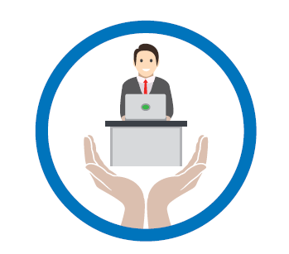

1. Introduction and links to our broader strategy

This strategy is a public commitment of how the NHS Business Services Authority (NHSBSA) plans to continue achieving high standards of health and safety through the provision of healthy working environments, safe working practices and safe people working therein. During 2021/22, the business’s key area of focus will continue to be ensuring the health, safety and welfare of its people in response to the COVID-19 pandemic. We will continue to operate our strategic governance approach to leading and managing our response, using multi-disciplinary teams at appropriate organisational levels to assess ongoing developments, plan our approach and ensure we deliver what is required to keep our people safe.

This is in addition to ensuring delivery of the duties placed upon us by health and safety law and any central government mandates. This Strategy also sets out how the NHSBSA will continue to add broader value to society through its activities, including utilising our expertise and capabilities to support the government’s COVID-19 response.

Our Health and Safety Strategy and Action Plan is part of the NHSBSA’s broader approach to corporate responsibility, outlined in the NHSBSA Business Strategy 2021-24.

Our health and safety objectives, targets and actions (see appendix) are created through extensive consultation, as well as consideration of our legal and mandated requirements. The following are our key sources of consultation and information informing this strategy:

- National Joint Safety, Health and Environment (SHE) Committee (national consultative committee attended by representatives from across the business, chaired by Executive Director of People and Corporate Services, occurring at least three times per year)

- Local Safety, Health and Environment (SHE) Groups (site / business area specific groups, focusing on local SHE issues)

- Health and Safety Management System – including risk and legal requirement reviews (at least annual), and quarterly team performance reviews – managed by the Safety, Health and Environment (SHE) Manager

The NHSBSA Strategy explains the vision of the NHSBSA, including our strategic goals. The Health and Safety strategy and action plan embodies all of our values and contributes to the delivery of many of our strategic goals. The Action Plan in the appendix clearly states which strategic goals the actions in each objective area contribute to.

2. Our vision

Full details of our health and safety commitments are documented in our Health and Safety Policy, which is available on our intranet, internet and by request.

In summary, we are committed to achieving high standards of health and safety through the provision of healthy working environments, safe working practices and safe people working therein.

We will achieve this by providing:

- a safe working environment including safe entry and exit to all workplaces

- safe systems of work

- consistent policies for significant health and safety risks

- consultation with all staff on health and safety matters

- training, information, instruction and supervision for all employees as required

- emergency preparedness, including the management of accidents, first aid and ill-health issues

- systems to monitor health and safety performance.

Ultimately, our strategy should help to ensure everyone thinks…

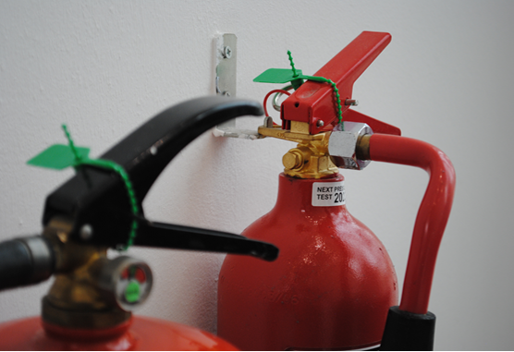
‘Safety first’

3. Meeting our duties and delivering improvements

As a starting point, the NHSBSA must comply with a range of health and safety laws related to our operational activities. We manage this through the operation of our Health and Safety Management System.

However, compliance is only a starting point for us, and we recognise that a proactive approach to the health and safety delivers a broad range of benefits.
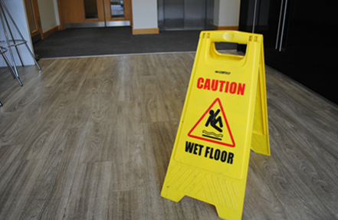
Why health and safety is important to us

A sensible and well organised health and safety culture should not be seen as a regulatory burden - it offers significant opportunities and benefits for both employees and employers, which can include:

- a healthier, happier, engaged workforce with increased motivation and morale

- increased employee retention and reduced sickness absence and associated costs

- improved organisational reputation, with both potential employees and service users

- improved accessibility to work for those with health issues

- legal compliance and delivery of government policies

- reduced pressure on the health and care system

Added value

We also recognise that our activities, products and services, and the way we choose to deliver them, can create added value for the broader environment, society and the economy. This impact is often far greater than our immediate operational areas of focus. We aim to maximise this value, for example by assessing projects and procurement activity to enhance our added value.

Delivering our objectives

Our health and safety action plan (see appendix) gives details of:

- actions we will take (including action owner, outcome and target deadline)
- the health and safety objective it supports
- associated target if applicable

Each objective also contributes to the delivery of one or more of the NHSBSA’s strategic goals and these are also highlighted.

Responsibilities and governance
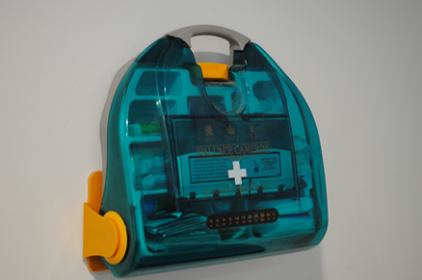
Our Chief Executive is ultimately responsible for the delivery of this strategy. This is delegated to the Executive Director of People and Corporate Services as Leadership Team representative.

Mark Ellerby is our non-executive director champion, ensuring appropriate oversight of the executive directors’ performance.

Our National Joint Safety, Health and Environment (SHE) Committee drives the agenda from a strategic level and ensures appropriate consultation takes place. This is chaired by our Executive Director of People and Corporate Services, and is made up of representatives from across the business (terms of reference are available on request). The committee meets at least three times per year.

Our local SHE Groups provide the link to our people and local health and safety management, and ensures engagement and consultation happens across the business (terms of reference are available on request). These groups meet throughout the year and staff representatives ensure the agenda is delivered locally.

Reporting and monitoring our progress internally

Progress against our objectives, targets and actions is monitored by the SHE Manager, collating data from relevant functions as required.

Reporting is undertaken as follows:

- Board – Board papers and Annual Report

- Leadership Team – Performance report at each monthly meeting, six monthly overview report and Annual Report

- Staff – Quarterly update report, newsletters and My Hub (Intranet) articles and Annual Report.

Reporting progress to our external stakeholders

We publish specific details on our health and safety performance in the NHSBSA Annual Report and Accounts, and also a specific Safety, Health & Environment Annual Report. This contains detailed data related to our performance and progress, with commentary.

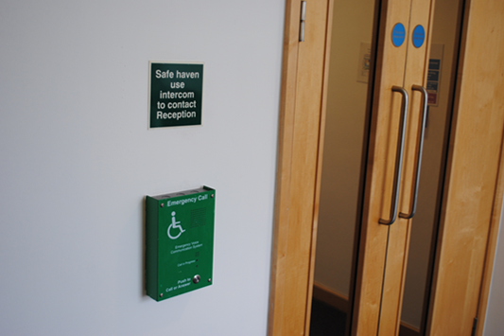

Appendix – Health and Safety Action Plan for 2021/22

This action plan sets out our health and safety objectives to ensure we continue to improve our performance, and meet our legal and mandated duties.

Objectives are grouped into the following key areas; 1) Maintaining an appropriate governance framework, which ensures continual improvement and a commitment to fulfil our compliance obligations, 2) Healthy working environments, 3) Safe working practices, 4) Safe people, 5) Creating wider environmental, social and economic value, through our activities and supply chain. Objectives in each area contribute to delivery of one or more NHSBSA strategic goals, and these are included in each section.

How our objectives have been set:
The key below indicates which objectives have been set as a result of either; being a legal requirement, being mandated by central government, identified via our health and safety management system (HSMS), or were highlighted as a priority during the consultation and engagement we have carried out with our committees (including stakeholder input) or staff groups.

Each objective in the plan is marked with the relevant symbol(s), under the column headed ‘Benefits / rationale’:

L – Legal requirement Gov – Government Mandate HSMS – Health and Safety Management System
E – Employee consultation (including local SHE Groups) M – Management consultation (including National Joint SHE Committee)

Summary of targets:

The following is a summary of our corporate targets:

Operational performance indicators:
- To perform better than the best performers in our business sector (less than 7 RIDDORs in 2021/22¹).

(¹ based on Health and Safety Executive 2019/20 RIDDOR accident rate data for Public Administration)

Management performance indicators:
- Maintain Health and Safety Management System
- Deliver Annual SHE Audit Plan

These are highlighted below where linked to a specific action.

Objective Area 1: Maintaining an appropriate governance framework, which ensures continual improvement and a commitment to fulfil our compliance obligations

NHSBSA strategic goals supported:
- Customer, Our People, Social Impact, Value, Ambition, Pandemic Support

Action |  | Benefits / rationale | Lead(s) / Resources | Time-scale | Measure of success | Corporate target
a | Include health and safety commentary in NHSBSA Annual Report and Accounts 2020/21, and more detailed SHE Annual Report | Information included in Annual Report(s), ensuring transparency and sharing approach with stakeholders  (L, Gov, HSMS)  Added value: Sharing of approach with other organisations, encouraging responsible business practice | Head of Governance | 31/12/21 | Mandated and stakeholder interest information included in Annual Report(s), made publicly available | Management system
b | Update Health and Safety Strategy and Action Plan for 2021/22, reviewed and approved by National Joint SHE Committee and NHSBSA Leadership Team | Agreed plan and monitoring arrangements in place  (L, HSMS)  Added value: Sharing of approach with other organisations, encouraging responsible business practice | Head of Governance | 31/08/21 | Agreed Strategy and Action Plan in place | Management system
c | Provide updates to staff on health and safety performance | Awareness maintained in workforce of progress against targets  (L, HSMS) | SHE Manager | 31/03/22 | Quarterly updates published and promoted | Management system
d | Non- exec and exec Champions to continue in their roles | Health and safety issues are championed at Board and Leadership Team levels  (L, HSMS, E, M) | Non-exec champion  Exec-champion | 31/03/22 | Exec and non-exec champions in place, who champion health and safety issues at Board and LT level | Management system

e | National Joint SHE Committee to monitor performance against health and safety strategy | Staff consultation and oversight of the delivery of the health and safety strategy  (L, HSMS, E, M) | National Joint SHE Committee  SHE Manager | 31/03/22 | National Joint SHE Committee meetings take place and monitor progress | Management system  Audit Plan
f | Local SHE staff groups to represent business areas and provide input and support | Staff consultation and support provided on local actions  (L, HSMS, E, M) | Local staff SHE groups | 31/03/22 | Local staff SHE group meetings take place and provide support and input | Management system  Audit Plan
g | Maintain membership of/ communications with stakeholder groups, including e.g. HSE, NHS Employers, IOSH, CIPD etc., informing policy / practice in year | Ensures alignment with mandated requirements, and sharing of best practice, legislation changes etc.  (HSMS, M)  Added value: Sharing of approach with other organisations, encouraging responsible business practice | SHE Manager, SHE Advisors | 31/03/22 | Memberships maintained and events / training etc. attended | Management system

Objective Area 2: Healthy working environments

NHSBSA strategic goals supported:
- Our People, Social Impact, Value

Action |  | Benefits / rationale | Lead(s) / Resources | Time-scale | Measure of success | Corporate target
a | Maintain Property and Facilities Management Health and Safety meetings, ensuring cross-working on management of buildings / services | Safe working conditions maintained across estate  (L, HSMS, M) | SHE Manager | 31/03/22 | Meetings attended and actions completed throughout year | Accident / Incident  Management system
b | Include SHE on agenda of hard/ soft FM review meetings with suppliers, ensuring input from SHE Team, and monitoring contract requirements | Safe working conditions maintained across estate  (L, HSMS, M) | Estates Management | 31/03/22 | Meetings attended and actions completed throughout year | Accident  Management system
c | Support the continuation of the roll-out of smart and agile working practices, including further flexible working, hot desking and working from home, reviewing and implementing health and safety arrangements as required | Safe working practices maintained in agile working practices  (L, HSMS, M)  Added value: Availability of flexible working helps people manage work-life balance, e.g. caring responsibilities etc. | SHE Manager | 31/03/22 | Agile working practices are delivered, in safe manner | Accident/ Incident  Management system
d | Maintain and deliver rolling programme of building maintenance/ improvements/ refurbishment | Premises maintained and improved, ensuring healthy working environment for our people  (L, M) | Estates Management | 31/03/22 | Completion of programme | Accident/ Incident

Objective Area 3: Safe working practices

NHSBSA strategic goals supported:
- Our People, Social Impact, Value

Action |  | Benefits / rationale | Lead(s) / Resources | Time-scale | Measure of success | Corporate target
a | Continue to embed business SHE requirements into new service areas and infrastructure | Working practices reviewed against current policy and best practice. Improvements made where required  (L, HSMS, E, M)  Added value: Injuries etc. treated, reducing pressure on health and care system | SHE Manager | 31/03/22 | Embed SHE requirements | Accident / Incident  Management system
b | Maintain COVID-19 secure buildings requirements and work with Estates Team to enable a COVID-19 Secure estate | Working practices reviewed against current policy and best practice. Improvements made where required  (L, HSMS, E, M)  Added value: Injuries or infection etc. treated, reducing pressure on health and care system | SHE Manager  Estates Management | 31/03/22 | Embedded COVID Secure measures and COVID Secure Certification across the whole NHSBSA Estate, COVID-19 infections minimised within the business | Accident / Incident  Management system
c | Provide systems to track and assess DSE requirements and home working requirements | Working practices reviewed against current policy and best practice. Improvements made where required  (L, HSMS, E, M)  Added value: Injuries or infection etc. treated, reducing pressure on health and care system | SHE Manager | 01/07/21 | Tracking of home workers and their equipment during COVID-19 restrictions | Accident / Incident  Management system

Objective Area 4: Safe people

NHSBSA strategic goals supported:
- Our People, Social Impact, Value, Ambition

Action |  | Benefits / rationale | Lead(s) / Resources | Time-scale | Measure of success | Corporate target
a | Monitor and enhance policy, procedures and guidance around assessing and reducing COVID-19 infections within the business | Awareness maintained in workforce, infection rate within the business minimised  (HSMS, E, M)  Added value: Improvement in public health, reducing pressure on health and care system | SHE Manager | 31/03/22 | Policy and procedure development and implemented, COVID-19 infections minimised within the business | Accident / Incident  Management system
b | Manage a system for staff to return to work where required during COVID-19 restrictions | Awareness maintained in workforce, infection rate within the business minimised  (HSMS, E, M)  Added value: Improvement in public health, reducing pressure on health and care system | SHE Manager | 31/03/22 | Screening and managed return to work process in place that takes into account a reduced Estates maximum headcount, COVID-19 infections minimised within the business | Accident / Incident  Management system
c | Continue rolling SHE Audit Schedule, coaching staff and tracking implementation of actions | Health and safety arrangements and practices checked, and improvements made  (L, HSMS, M) | SHE Manager | 31/03/22 | Audit plan completed | Accident / Incident  Management system  Audit Plan

Objective Area 5: Creating wider environmental, social and economic value through our activities and supply chain

NHSBSA strategic goals supported:
- Our People, Social Impact, Value

Action |  | Benefits / rationale | Lead(s) / Resources | Time-scale | Measure of success | Corporate target
a | Maintain a supplier engagement process with those suppliers in areas of high priority | Key risks / opportunities addressed through supplier engagement  (L, Gov, HSMS, M)  Added value: Broader health and safety benefits gained through contract management, down supply chains etc | Commercial Sustainable Procurement Lead  SHE Manager | 31/03/22 | Supplier engagement process established and embedded | Accident / management system
b | Support and assist in the re-shaping of how the NHSBSA works as a business during and after COVID-19 restrictions, including how the estate is operated going forwards | Key risks / opportunities addressed  (L, Gov, HSMS, M)  Added value: Broader health and safety benefits gained through changes to working practices and operation of the estate etc | Corporate Services  SHE Manager | 31/03/22 | Smarter working practices, efficient operation of the estate, COVID-19 infections minimised within the business | Accident / Incident  Management system

