ePACT2 user guide
CCG – Accessing and Using Financial Reports

Interactive Contents
Use this interactive contents list to jump straight to the content you want to see. Just click the titles below to go directly to that section:
Contents
Accessing the Financial Reports 1
Accessing and Using the IPP (Itemised Prescribing Payment) Report 2
Accessing the Remuneration Values Report 9
Using the Remuneration Values Report 10
Accessing and Using the PMD (Prescribing Monitoring Document) Report 14
Accessing and Using the Invoice Reconciliation Report 18
Getting more help 20

Accessing the Financial Reports
There are several financial reports available to CCG users to monitor the various aspects of reimbursement costs for individual Commissioner/Providers.
Access to an individual organisation's financial report data is only available to authorised users approved to view the financial data by the named organisation.
The financial reports available to CCG users are:
- IPP (Itemised Prescribing Payment) report
- Remuneration Values report
- Prescribing Monitoring Document report
- Invoice Reconciliation report

To access any of these financial reports, select the Financial Reports tab when you have logged in to the system:
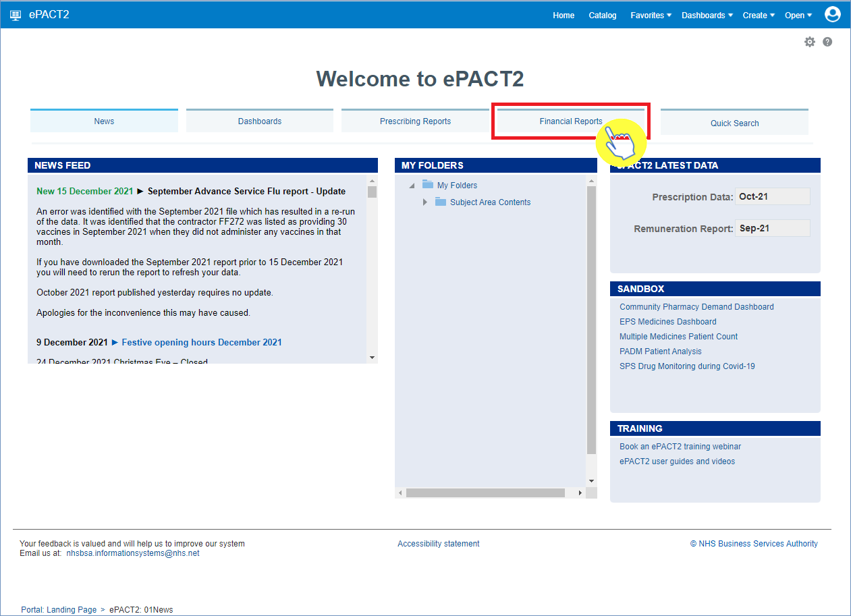

Once selected, you will then be presented with the financial reports available for you to use:
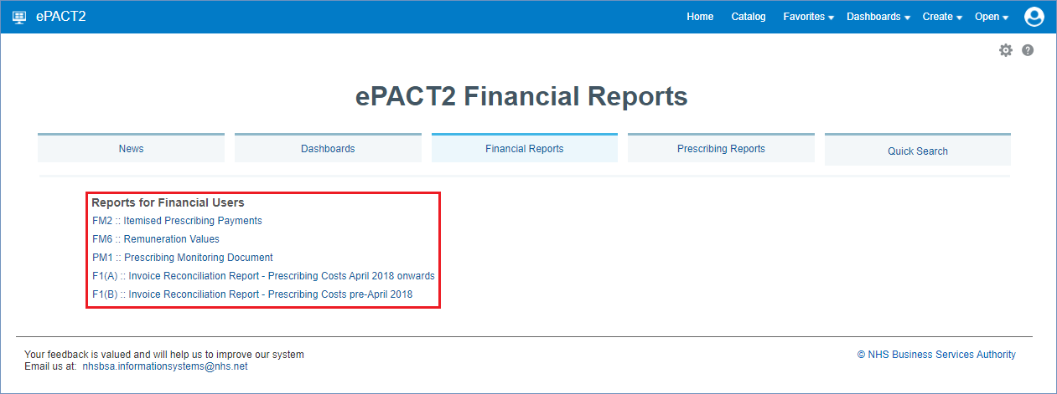

Accessing and Using the IPP (Itemised Prescribing Payments) Report
Firstly, select the IPP report by clicking on the link once:
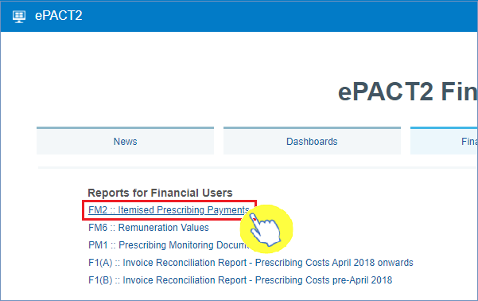
Once the link has been selected, the IPP report will open up and default to the ‘Commissioner/Provider Overview’ page.

Commissioner/Provider Overview page
The Commissioner/Provider Overview page shows the detailed breakdown of reimbursement costs for individual Commissioner/Providers, including CCG’s, but will only show data for those organisations that you have been approved access for to view their financial data:
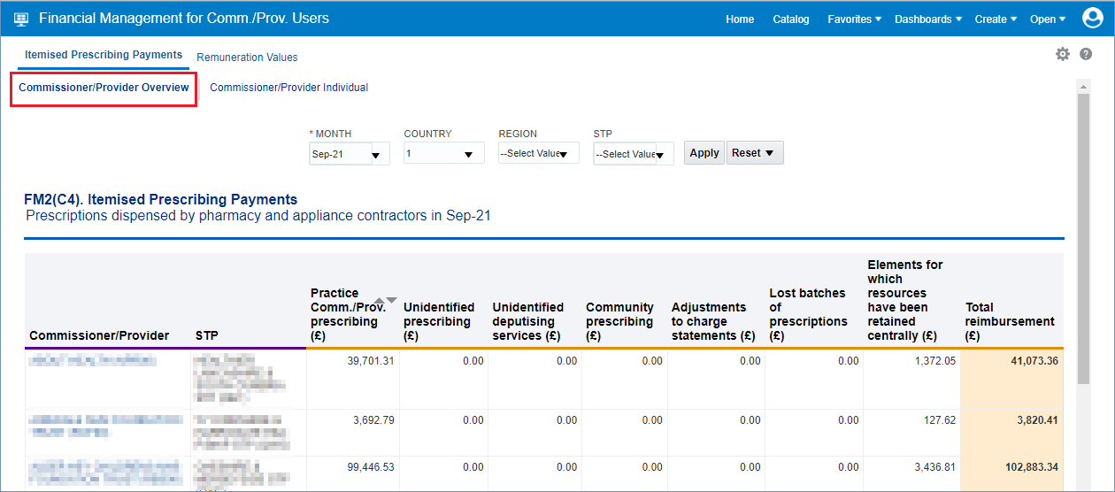

- Once accessed, users then have the options to select the criteria they want (shown below), to display the financial data for the organisations they have access to. This will allow the user to select all the different individual months of financial data held for those organisations.

- Be sure once you’ve made a selection in any of the drop-down menu’s that you click the ‘Apply’ button to initiate these changes:

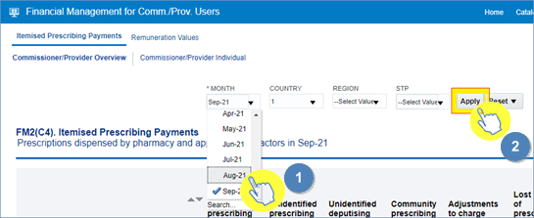

Once you have specified the month and applied that change, the IPP ‘Commissioner/Provider Overview’ page will display the report for all of the organisations you have been granted access to view their financial data.

Each of the columns in the table of data refer to specific charges relating to the CCG(s) you have access for, and are explained below:

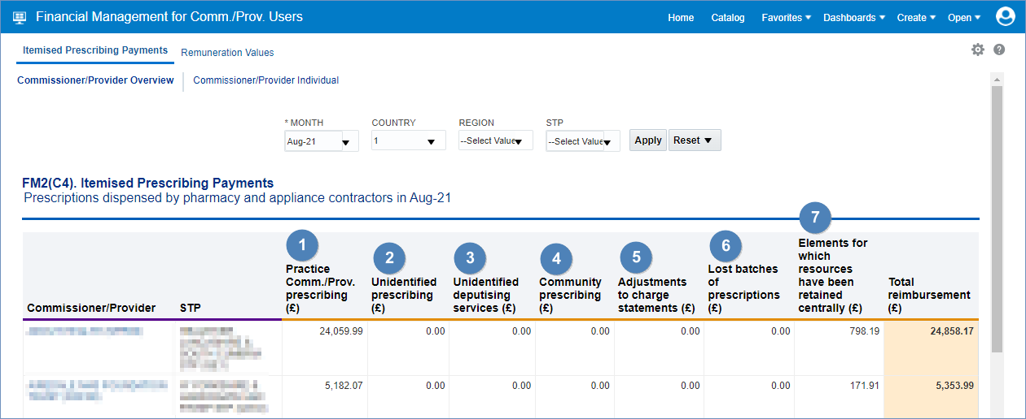

Column 1 - Practice / Comm. / Prov. prescribing where the correct practice, cost centre or hospital unit could be identified

The actual cost of prescribing in the named commissioner / provider by identified practice prescribers, commissioner / provider employed prescribers or hospital units i.e. GP, nurse, supplementary prescribers or hospital units, for the named dispensing month, which have been dispensed in primary care

Column 2 - Unidentified prescribing where only the commissioner / provider could be identified

Contains all commissioner / provider prescribing which has been dispensed in primary care that cannot be linked to a specific prescriber or hospital unit but can be linked to the named commissioner / provider

Column 3 - Unidentified deputising services where only the commissioner / provider could be identified

Contains all deputising service prescribing which has been dispensed in primary care that can be linked to the named commissioner / provider

Column 4 - Community Prescribing

Contains all prescribing issued under a community Nurse Prescribing Contract. Community Nurse Prescribing contracts were discontinued in April 2013 as part of NHS reforms

Column 5 - Adjustments to Charge Statements (this line is currently not used)

The actual cost of adjustments caused by, for example, late notification of GP movements, computer-produced prescriptions for a GP still being generated for a previous practice, and pricing errors
Column 6 - Lost batch prescriptions (this line is currently not used)

The actual cost of lost batches as authorised by the commissioner / provider. From April 2013, commissioner / provider no longer authorise lost batches as this is now done by Area Teams

Column 7 - Elements for which resources have been retained centrally

This is the proportional share per commissioner / provider of other costs based on prescribing which cannot be directly attributed to practices

These costs include:

- VAT
- nationally unidentified prescribing
- broken bulk
- schedule adjustments
- net cross-boundary costs
- out of pocket expenses and payments for containers for national unidentified prescribing
- Urgent Medicine Supply (wef December 2016)

The amount of resources retained centrally invoiced or charged to an organisation is a proportion based on actual cost for that month.

If the total actual cost for England in that month is £1000 and your organisation accounted for £100 of that, your organisation would be charged 10% of the centrally retained items value.

All organisations set up on NHSBSA systems to provide prescriptions are charged a proportion of the costs in centrally retained items whether they be CCGs, hospital trusts, local authorities or independent sector healthcare providers (ISHPs).

Commissioner/Provider Individual page
The Commissioner/Provider Individual page in the IPP report will allow a user to view an individual commissioner/provider and the financial data held for that organisation. This will be the same financial data as displayed in the ‘Commissioner/Provider Overview’ page.
If the user has access to multiple organisations’ financial data, there is a prompt where you can select each individual organisation to view:
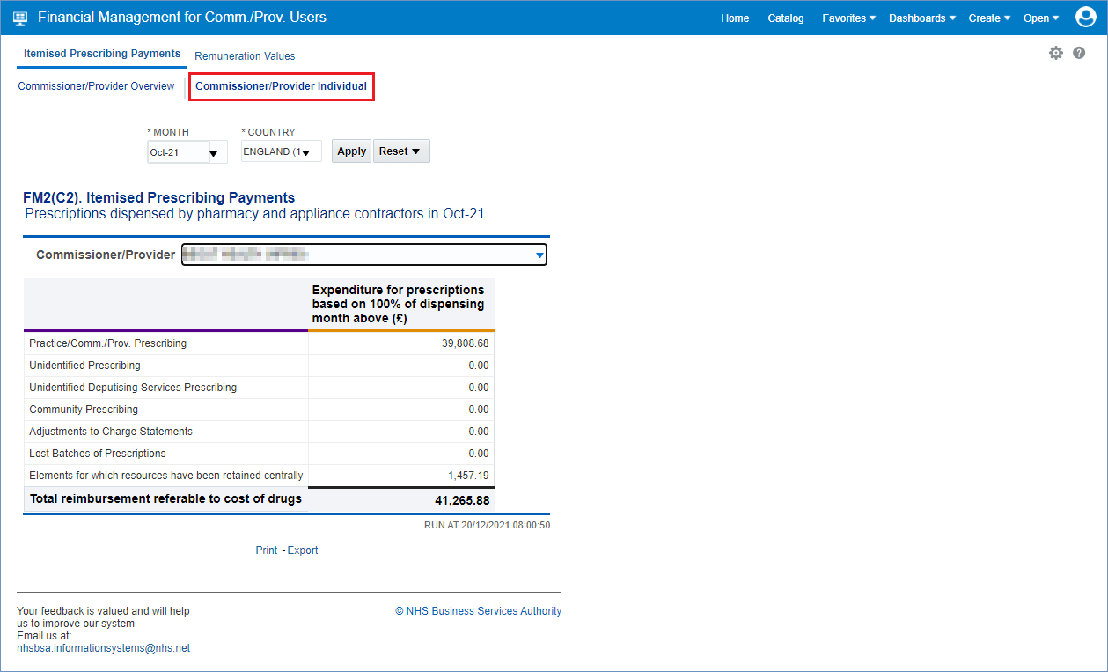

- Once accessed, users then have the options to select the criteria they want (shown below), to display the financial data for the organisations they have access to. This will allow the user to select all the different individual months of financial data held for those organisations

- Be sure once you’ve made a selection in any of the drop-down menu’s that you click the ‘Apply’ button to initiate these changes:

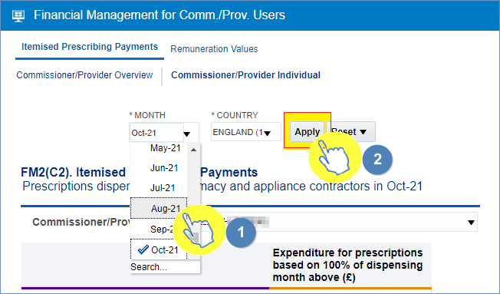
Once you have specified the month and applied that change, the IPP ‘Commissioner/Provider Individual’ page will display the report for a single organisation that you have been granted access to view their financial data.

If you have access to more than one organisation’s financial data, you can view each of these organisations individually by selecting the organisation you want to see data for using the ‘Commissioner/Provider’ prompt (highlighted red):

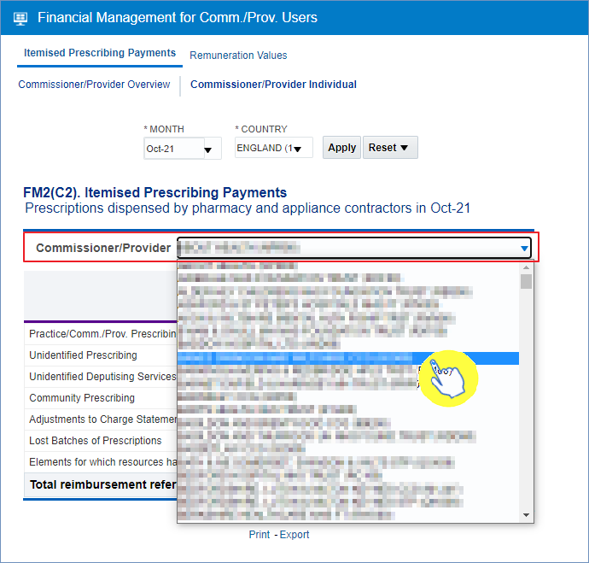

The report will then display the individual organisations financial data, the lines of the report (highlighted red below) display the same information as the ‘Commissioner/Provider Overview’ page:

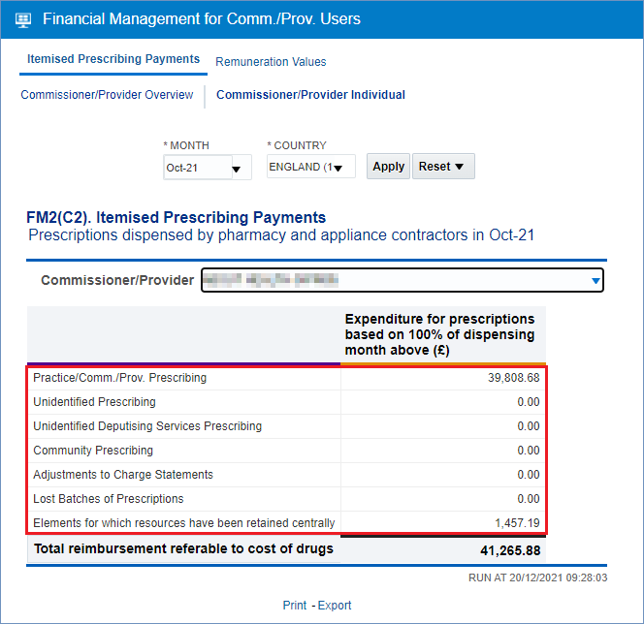

Accessing the Remuneration Values Report
Firstly, select the Remuneration Values report by clicking on the link once:
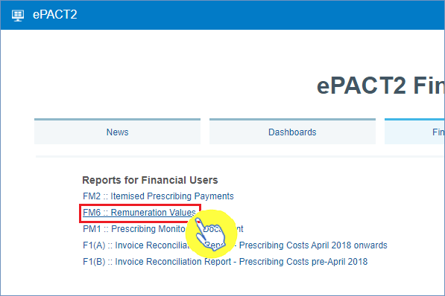

Once accessed, the Remuneration Values report will:
- provide information to support the monitoring and management of remuneration payments for pharmaceutical services supplied by pharmacy and appliance contractors

- only shows payments which relate to remuneration and include payments previously sourced from funding held centrally by the Department of Health and Social Care, known as the global sum

This report is split for CCG users into 2 views:
- The first view being a summary report for the remuneration values of commissioner/providers that make up a particular STP

- The second view is an itemised report breaking down those remuneration values into their different areas for a specified commissioner/provider

All remuneration costs are invoiced to the appropriate organisation with the exception of those relating to Clinical Commissioning Groups, which are recharged to NHS England.
Where a particular fee or an allowance cannot be directly attributable to a specific commissioner / provider, the activity and associated amount recharged is shared across all commissioner / providers.
The basis for the sharing is in accordance with specified formulae, which are listed in the remuneration report glossary (Excel: 164KB).
The fees column shows the number of identifiable fees which can be directly attributed to a commissioner / provider, cost centre or hospital unit.
Fees are identified from the prescriber number or the commissioner / provider information included on the prescription form.
Fees which cannot be attributed to a particular commissioner / provider are shared and shown under 'national unidentified prescribers'.
Unidentified prescriber shows the fees / allowances attributed to unidentified prescribers where a prescription form (FP10, FP10HP) does not contain enough detail to identify the prescriber, but the commissioner / provider can be identified.

Using the Remuneration Values Report
Once this report has been accessed you will first be able to choose the month’s financial data you want to view.
- Select the appropriate month you wish to view

- Initiate these changes by clicking the ‘Apply’ once you’ve selected a month to view

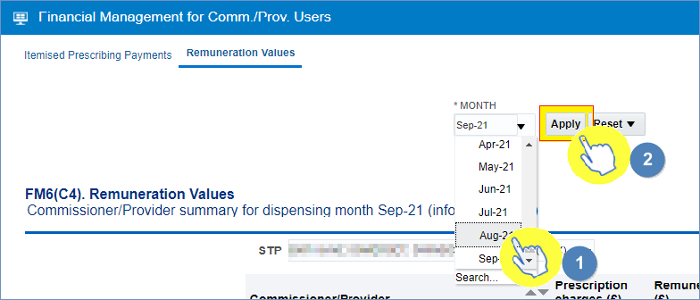

Once a month has been selected, the first view in the report will show a summarised view of remuneration values attributed to all the commissioner/providers of a particular STP. Remember - users will only have access to view data for organisations they have been approved by.

You can use the STP drop-down list (highlighted red) to select different STP’s in which you can view this summarised remuneration data for the CCG(s) you have the permission to view their data:

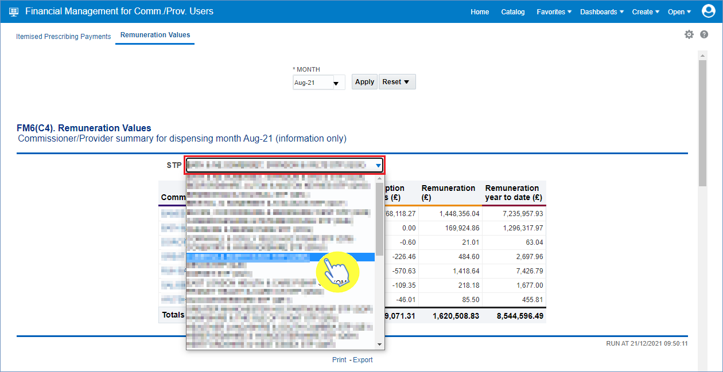

You will then be able to see this summarised view of the remuneration values financial data for the organisation you’ve selected, this view will show all the commissioner/providers that make up the STP selected, including CCGs:

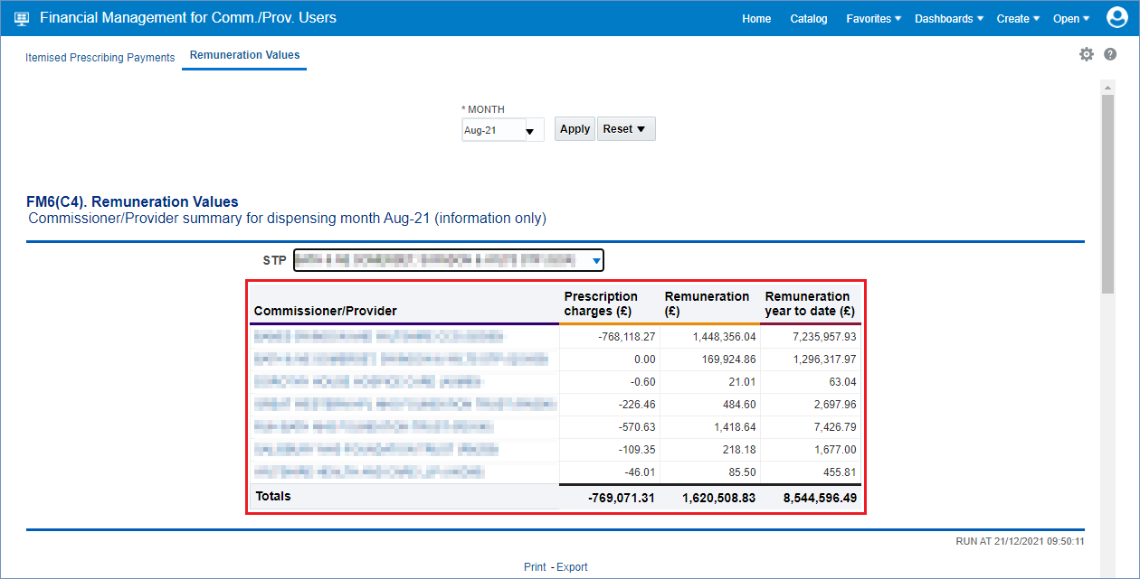
The second view in the Remuneration Values report will then allow a user to view an itemised breakdown of a specific commissioner/provider’s remuneration values.

Firstly, select the STP in which the CCG you want to view the data for resides using the STP drop-down list:

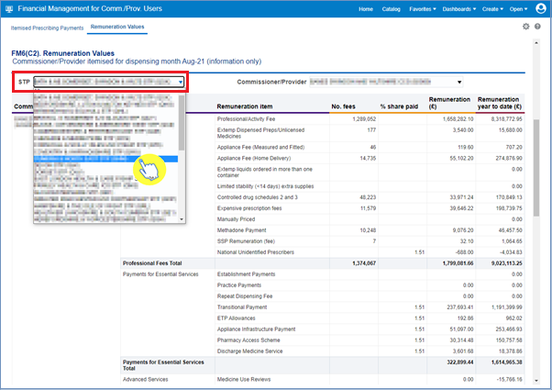

Then, use the ‘Commissioner/Provider’ prompt to select the CCG you wish to view:
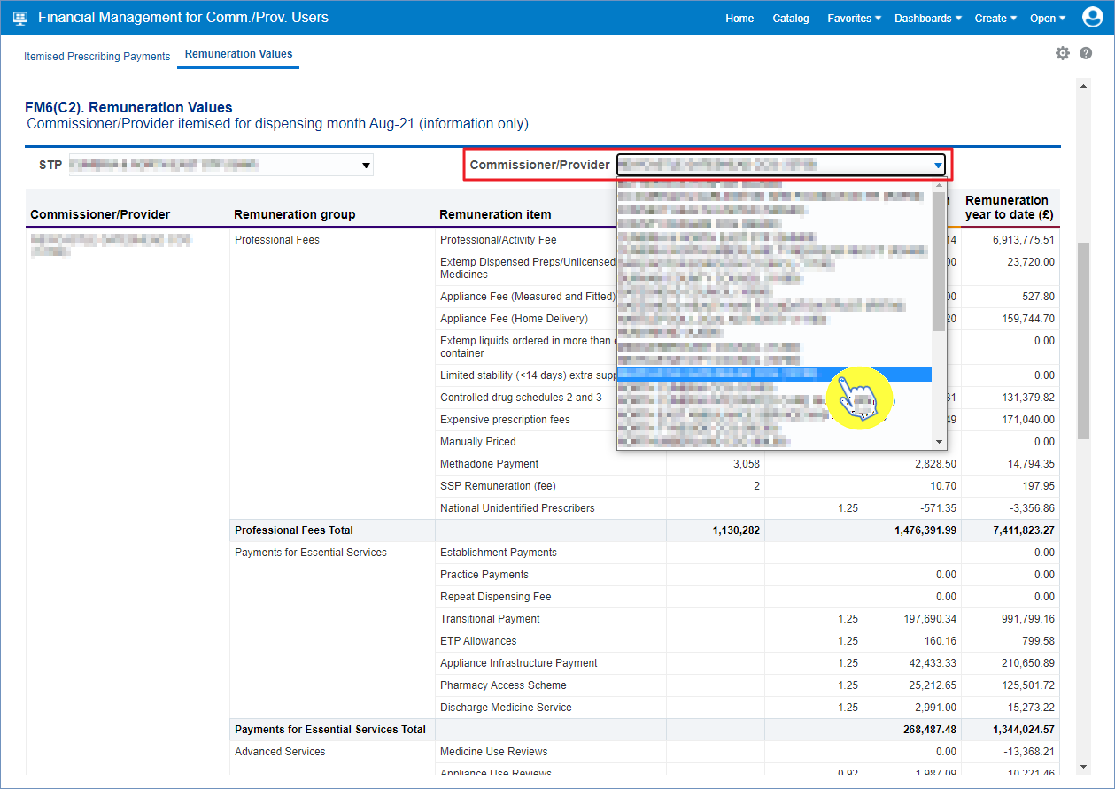
You will now have an itemised breakdown of the remuneration values for the CCG you have specified:
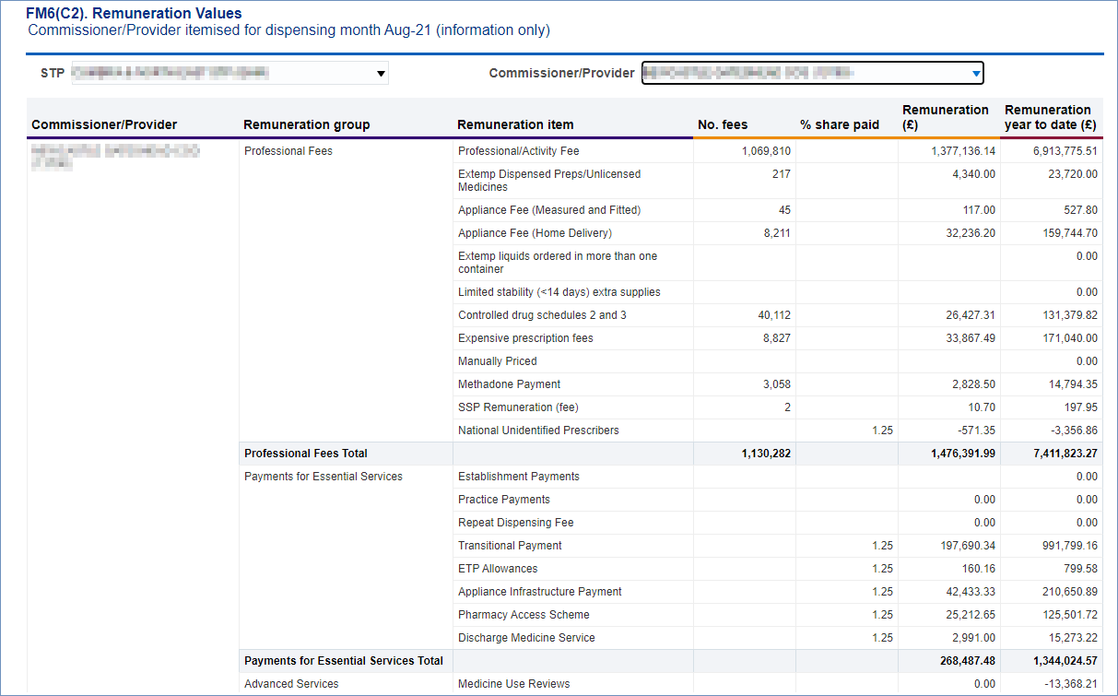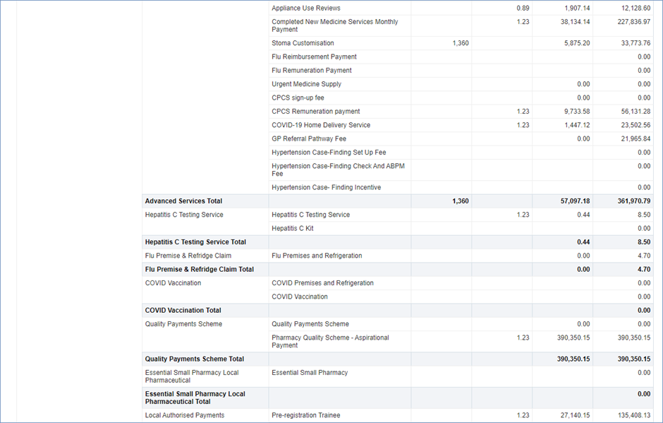
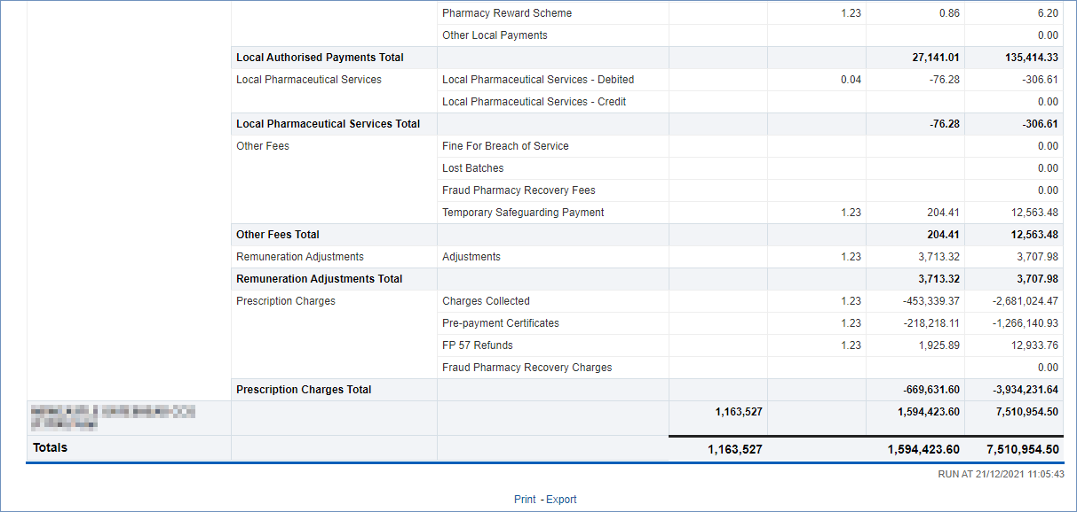

Accessing and Using the PMD (Prescribing Monitoring Document) Report
The PMD (Prescribing Monitoring Document) report provides monthly financial information about prescribing costs against budgets, to enable management of the drugs element of unified budgets.
The figures shown on this report are for monitoring purposes only and do not reflect the actual charge.
Data within the PMD report is updated on a monthly basis.
Statements are issued every month and show:
- the indicative prescribing budget for the current financial year (not shown in April or May)
- total monthly expenditure
- cumulative expenditure (April to current month)
- forecast out-turn (based on information provided by the Department of Health and Social Care, which is based on a spending pattern, calculated using previous year’s spending data). The accuracy is determined by local factors at a local level (not shown in April or May)
- the number of dispensing days in the month and year to date
The annual statement produced for March shows the actual expenditure for the financial year.

To access the PMD report select the link within the Financial Reports page:
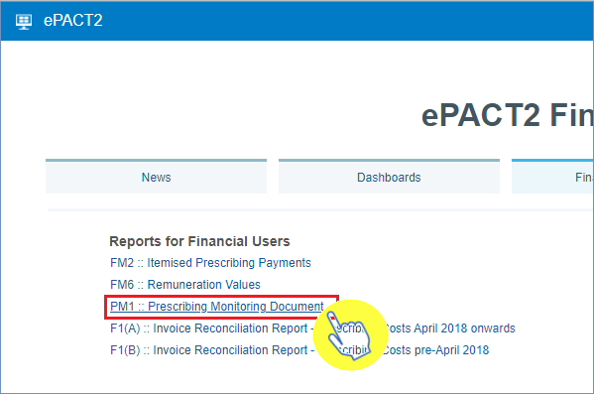

Once selected, this will open up the Prescribing Monitoring Document report. The report will default to the ‘National Statement’ page in the report. To view specific CCG data in the PMD report, a user should then select the ‘STP & Comm./Prov. Statement’ page:
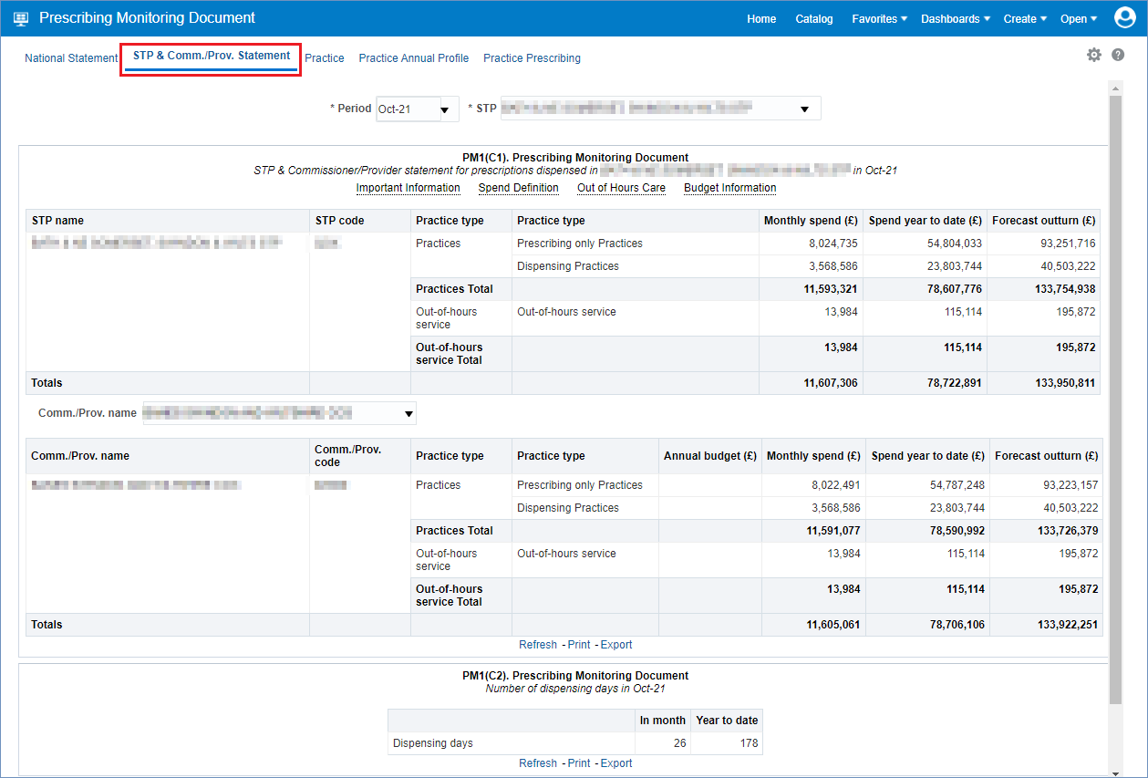
Once the ‘STP & Comm./Prov. Statement’ page has been selected, you can then change the month you want to view, and the STP the report relates to.
To change the criteria to the month for the PMD report you wish to view, and the STP that the CCG you are looking to return data for resides in, use the prompt drop-down lists (shown below):
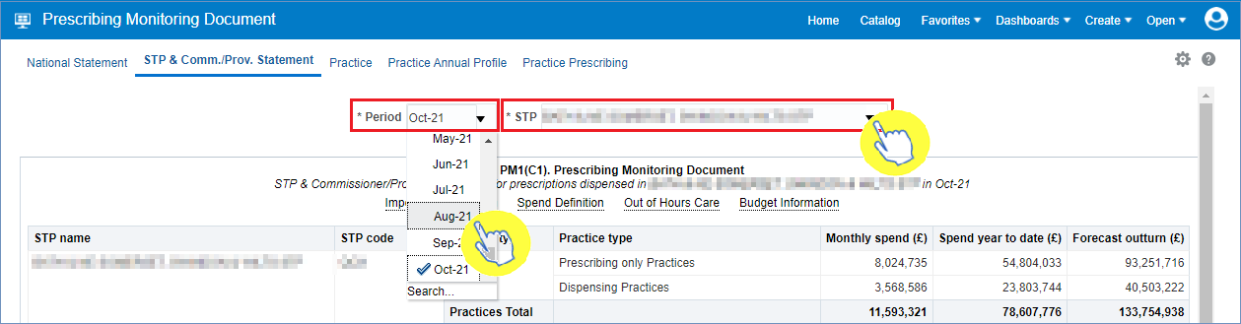

Once a month and STP has been specified in the criteria selection, users can then use the ‘Comm./Prov.’ prompt drop-down list (highlighted red below) to display data for a specific CCG within the STP chosen in the criteria selection (if an organisation is not specified ALL commissioner/providers within that STP will be displayed):
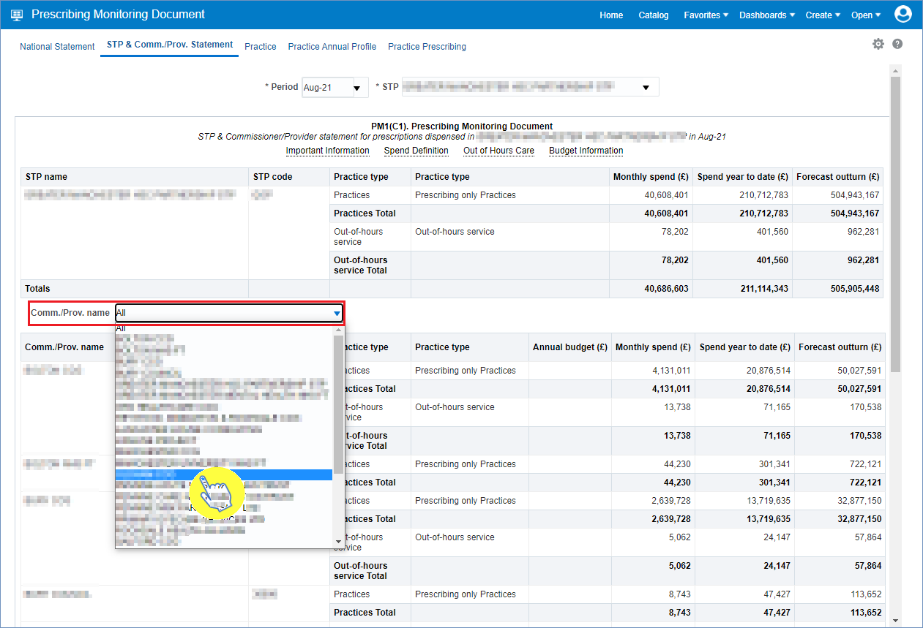

Once an individual CCG has been selected, the PMD report will display data for the STP, the CCG you have specified (highlighted red) and the number of dispensing days in the month specified:
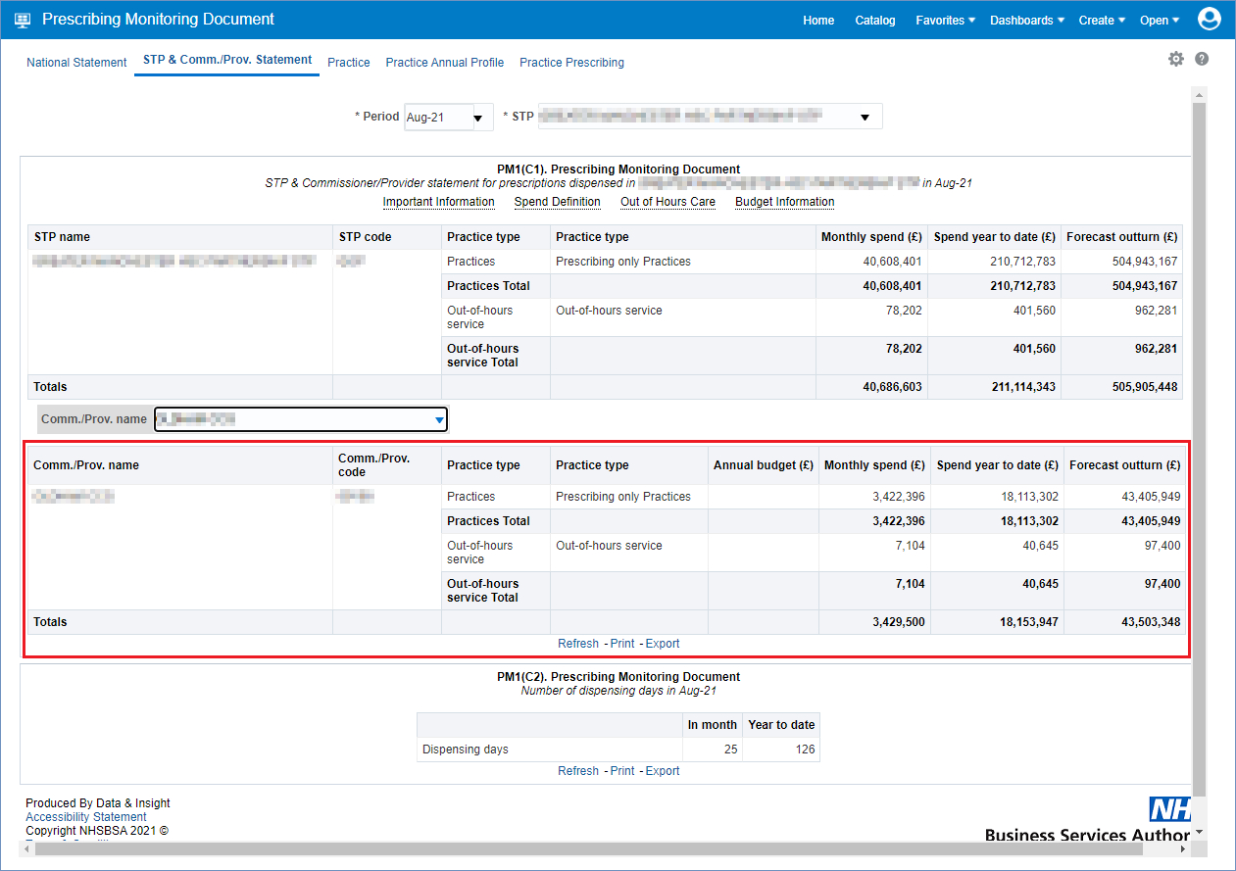

Accessing and Using the Invoice Reconciliation Report
To access the Invoice Reconciliation report select the link within the Financial Reports page:
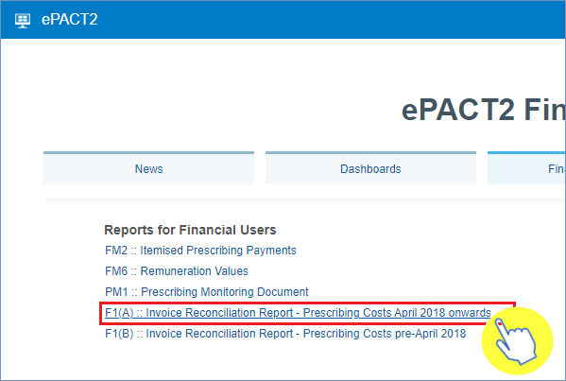
Please note: if you’re using the Invoice Reconciliation report but require data for an organisation prior to April 2018, then please use the F1(B):: Invoice Reconciliation Report – Prescribing Costs pre-April 2018

Once accessed, the Invoice Reconciliation report will give you the options to specify a month, and an organisation in which to run the report for using the ‘Month’ and ‘Commissioner/Provider plus Code’ prompts.
- Select a month and a commissioner/provider using the drop-down list prompts provided (highlighted red below)

- Be sure to click ‘OK’ to then enact your selections and run the Invoice Reconciliation report

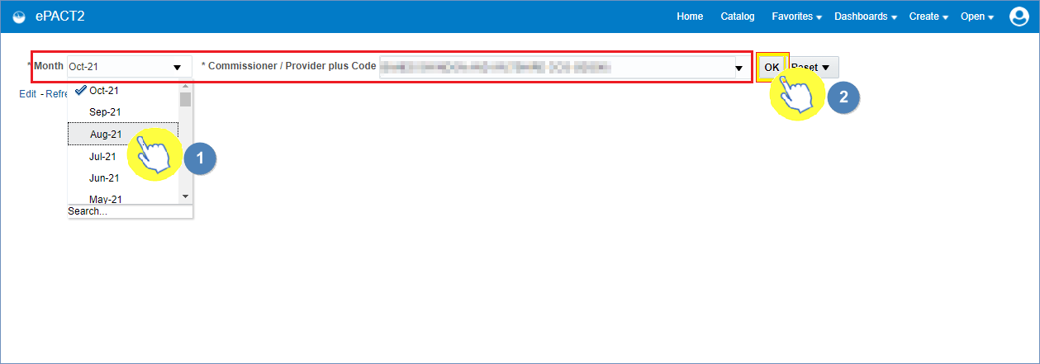
The report will then return data for the month and organisation selected:

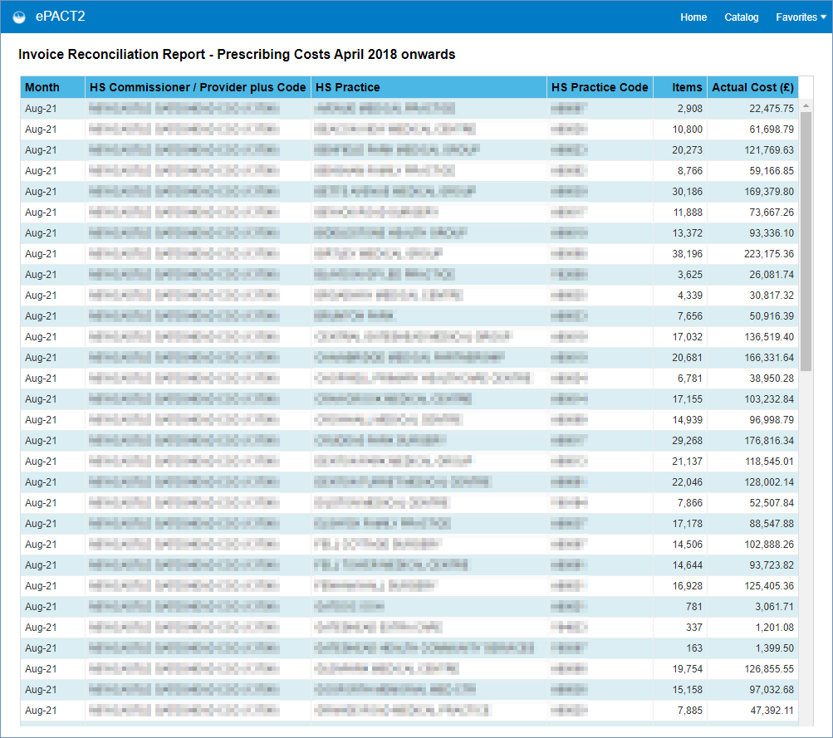

Getting more help

Additional training material and user guides
The ePACT2 training team has developed several how to guides to help you get the best out of ePACT2. These can be found on our ePACT2 user guides page
Webinar sessions
We offer a free, personalised webinar training service to all our users and you can book as many as you need.
You can let us know if you have any specific topics or reports you’d like to cover or if you would prefer an introductory tour. You can take part wherever you are as long as you can get online.
You can find our more and book you webinar by going to our ePACT2 training page
Use the following icons
Numbers
Pointing hand
Double headed arrow
Four-way arrow
Round - Arrow
Magnifying glass

