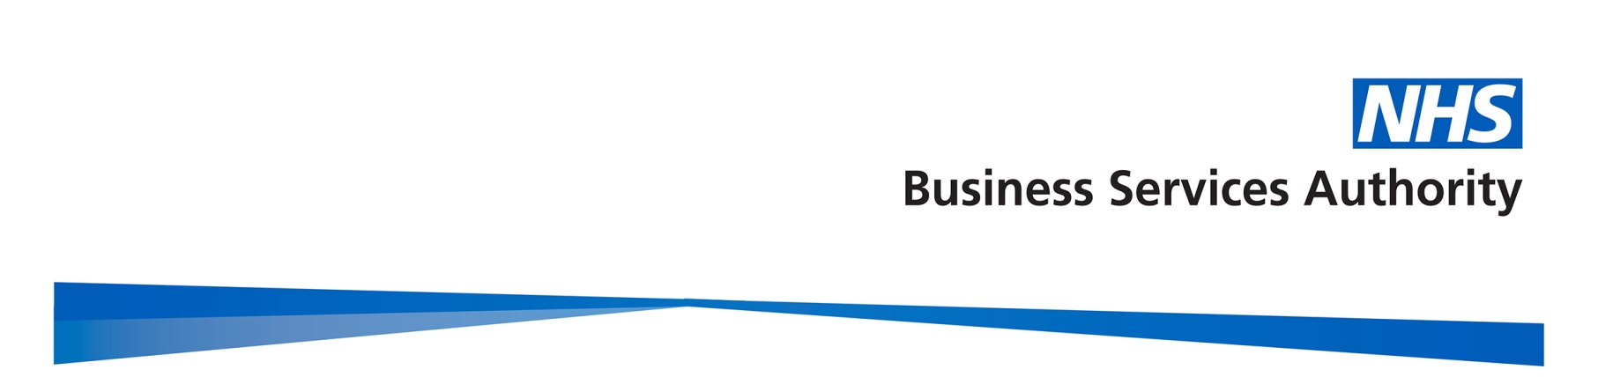

Gender Pay Gap Report

2020/21

March 2022

Contents
Contents 2
Introduction 3
Gender summary of workforce 4
Proportion of males and females in each pay band 4
Hourly Rate by gender for each band.………………………………………………………...6
Mean and Median pay gap per band…………………………………………………….……7
Proportion of males and females in each pay quartile 9
Gender pay gap in hourly pay 10
Mean gender pay gap in hourly pay 10
Median gender pay gap in hourly pay 11
Bonus gender pay gap 11
Proportion of males and females receiving a bonus payment 11
Mean and median bonus gender pay gap 12
Summary 12
Actions to remove the gender pay gap 13

Introduction

Under the Equality Act 2010 (Specific Duties and Public Authorities) Regulations 2017, the NHS Business Services Authority (NHSBSA), along with all public bodies with more than 250 employees, is required to publish gender pay gap information by 30th March each year. This includes information on the mean and median gender gaps in hourly pay, the mean and median gender gaps in bonus pay, the proportion of men and women who received bonuses, and the proportions of male and female employees in each pay quartile.

The gender pay gap shows the difference in the average pay between all men and women in an organisation. It is different to equal pay, which examines the pay differences between men and women who carry out the same or similar jobs or work of equal value. It is unlawful to pay people unequally because they are a man or a woman.

At the NHSBSA, our people are at the centre of our business strategy and we aspire to be an employer of choice who provides a great, inclusive place to work and can recruit and retain the right, diverse talent with the wide range of knowledge, skills and capabilities we need. We’re committed to a diverse and inclusive culture which supports the fair treatment and reward of all colleagues, irrespective of gender, and our pay framework is based on the principles of fairness, transparency, and consistency.

This report fulfils our reporting requirements and more importantly sets out what we are doing to address the gender pay gap in our organisation. The data is based on a snapshot of all employees as of 31 March 2021, as this is the date which all public authorities must use each year. The calculations used are those set out in the relevant legislation to ensure the data is calculated consistently across organisations.

Gender profile

Gender summary of workforce

On the 31 March 2021, the NHSBSA employed 3,292 colleagues, an increase in headcount of 150 from the previous year when it was 3,142. The chart below demonstrates the gender profile of the workforce, which shows that we continue to employ more women (58.8%, and 1936 headcount) than men (41.2% and 1356 headcount). This has remained static from the previous year when it was also 58.8% women to 41.2% men.
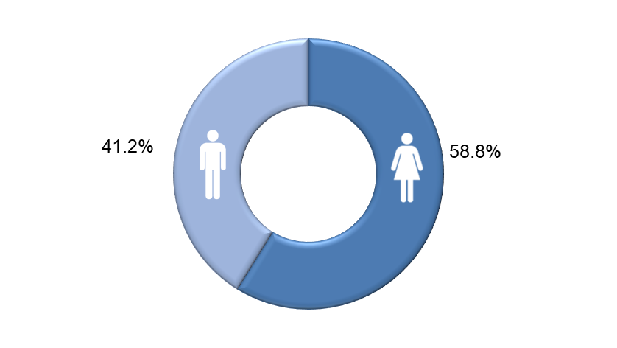

Proportion of males and females in each pay band

The NHSBSA uses NHS Agenda for Change payscales for the vast majority of colleagues. Pay bands vary by levels of responsibility and each band has a set pay range with increments. Colleagues move up the increments in their band on a length of service basis so that generally those who have spent longer in the same grade would be expected to earn more, regardless of gender. In addition, we have a small group of colleagues who are on pay scales other than Agenda for Change. These include colleagues on Civil Service grades who have transferred into the NHSBSA, a small number on NHS Medical and Dental salary scales, and our most senior employees who receive NHS Executive and Very Senior Manager salaries.

The two charts on the following page reveal the total headcount of colleagues within each pay band by gender, and the percentages of men and women within each pay band. The salary scales other than Agenda for Change as described above are shown as ‘Non-AfC’ on the charts.

Headcount by Pay Band, by Gender
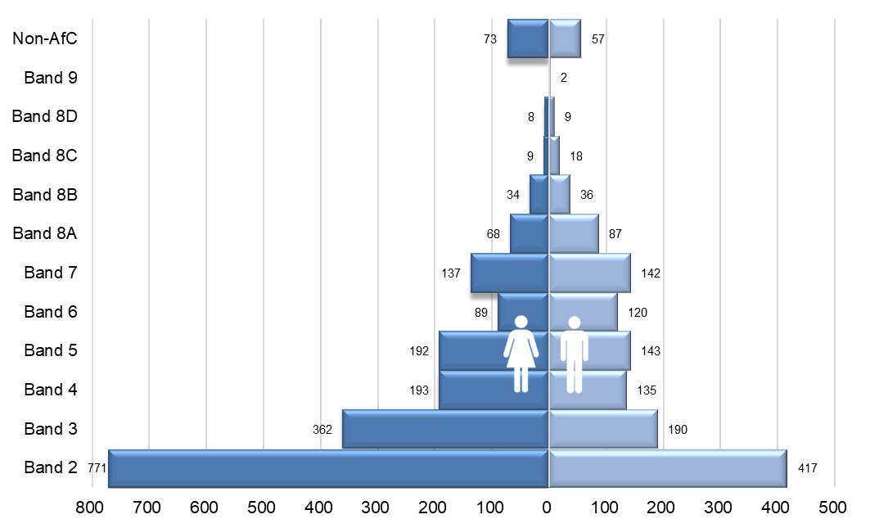

Percentage of men and women in each Pay Band
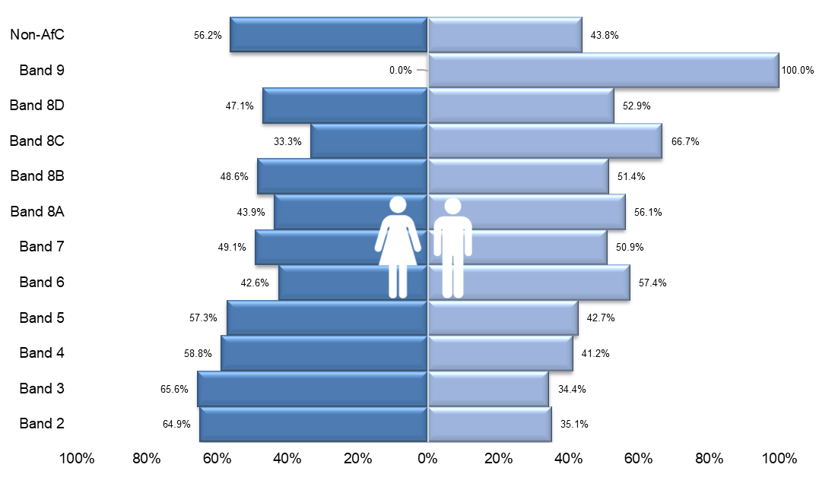

The charts above show that most of our colleagues are concentrated in the lower pay bands (2-5). In addition, these pay bands have significantly higher percentages of female colleagues, compared to male colleagues. This gender split changes to more male colleagues in some of the higher pay bands, however bands 7, 8B and 8D are nearly equally balanced.

Hourly Rate by gender for each grade

The following graphs show the breakdown by mean and median hourly rates for each grade, by gender.

Mean Hourly rate for each grade

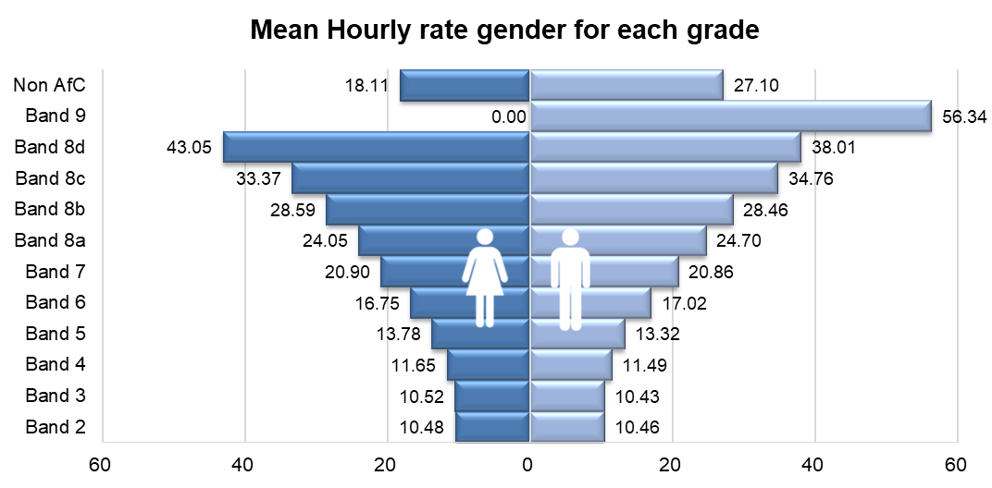

Median Hourly rate for each grade

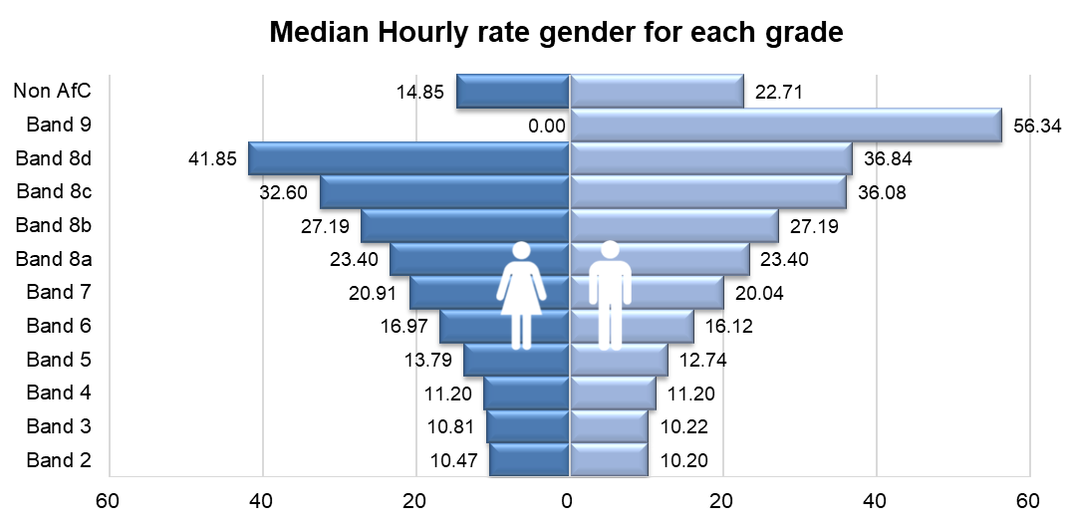

Mean and Median Pay Gap per Band

The charts below demonstrate the mean and median pay gap between men and women at each pay band. These show that some of the larger pay gaps are at the bands where there is a small head count and these individuals are all or mostly of one gender, for example there are less than 5 colleagues within Band 9 and they are all men, so the mean and median pay gaps for Band 9 are both 100%.

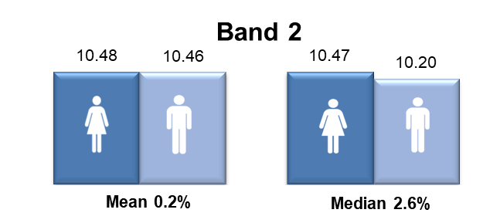
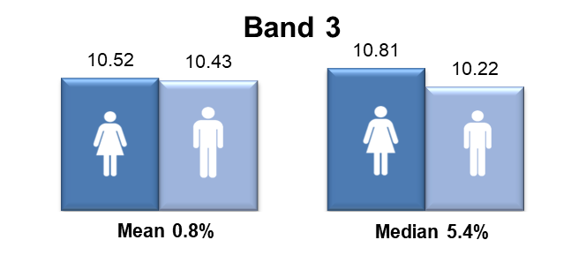
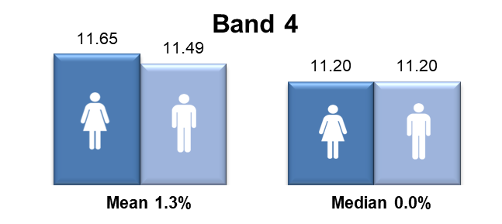
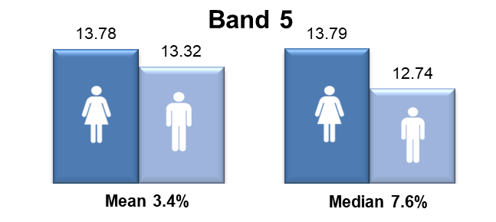
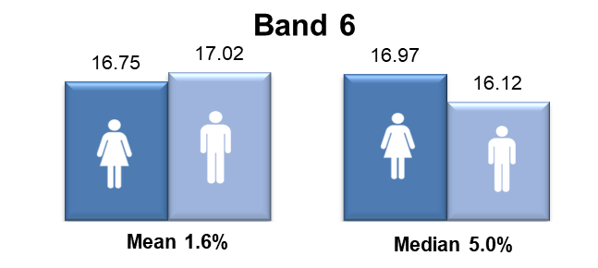

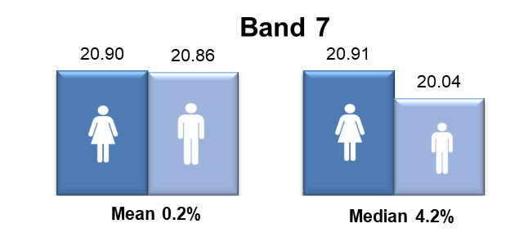
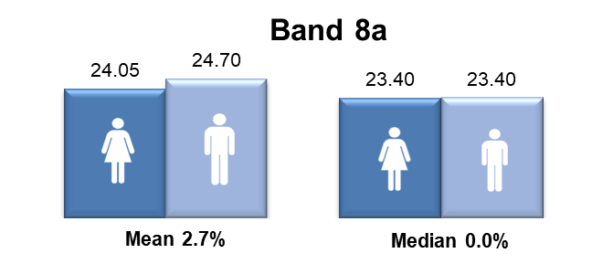
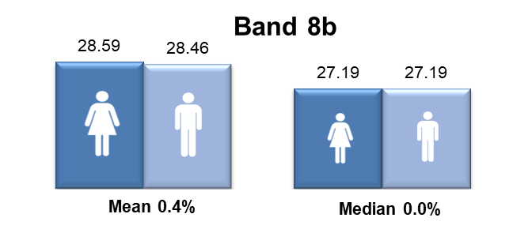
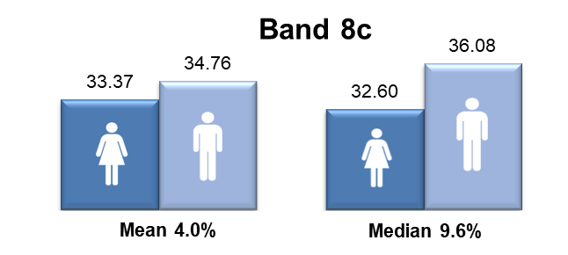
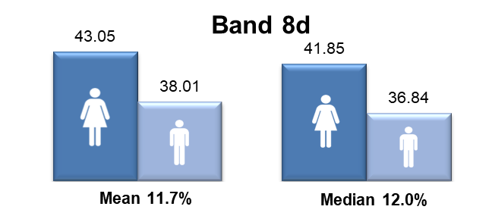
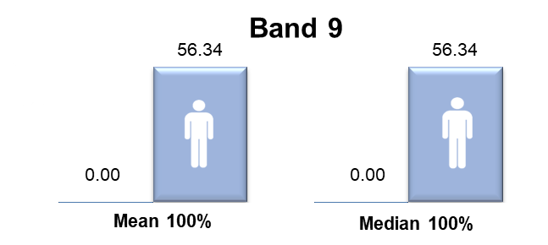
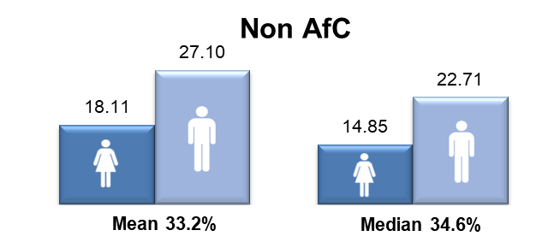

Proportion of males and females in each pay quartile

The graph below illustrates the gender distribution of the workforce across four equally sized quartiles. The proportion of males and females in each quartile, from the lowest to the highest paid, is calculated by dividing the workforce into four equal parts. The first three quartiles contain a higher percentage of women than men, but this is reversed in the highest quartile. This reflects the analysis by pay band.

2020-21 quartiles

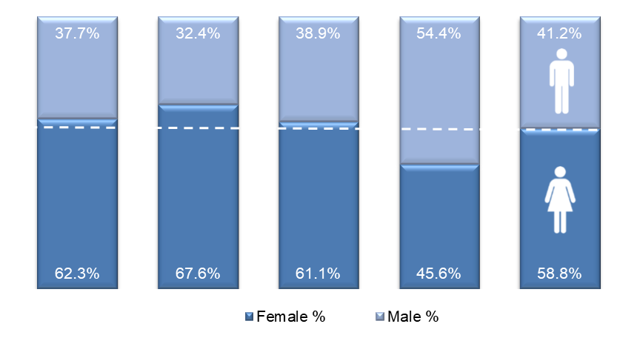
Lowest ← Pay → Highest

For comparison purposes, the pay quartiles from the previous year have been included overleaf. This reveals that the percentage of female colleagues in the first (lower) quartile has increased by 2.1%, 3.1% in the second quartile, 0.9% in the third quartile, and has reduced by 4.5% in the fourth (highest) quartile.

2019-20 quartiles

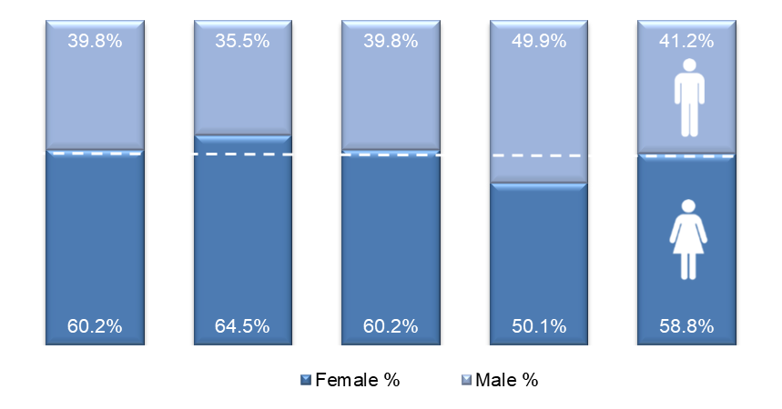
Lowest ← Pay → Highest

Gender pay gap in hourly pay

Mean gender pay gap in hourly pay

The mean, commonly known as the average, is calculated by adding up the wages of all colleagues and dividing the figure by the total number of colleagues. The mean gender pay gap is the difference between mean male pay and mean female pay. The mean gender pay gap for hourly pay within the NHSBSA in 2020-21 is 12.6%. This difference in hourly pay is influenced by the greater proportion of female colleagues in the lower pay bands and male colleagues in some of the higher pay bands. This figure has increased by 1.3% from 2019-20, which is a reversal in trend from the previous four years which have seen a continual gradual decrease.
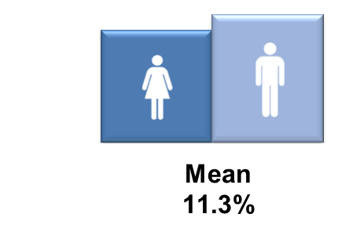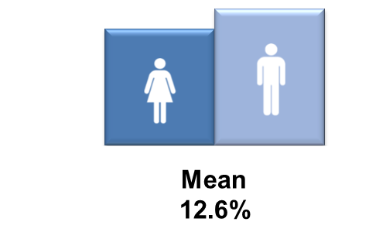
2019-20 2020-21

Median gender pay gap in hourly pay

The median is the figure that falls in the middle of a range when the wages of all colleagues are lined up from the lowest to the highest salary. The median gap is the
difference between the colleague in the middle of the range of male wages and the middle employee in the range of female wages. The median is regarded as typically a more representative figure than the mean, which can be distorted by a handful of highly paid employees. In 2020-21 there is a 2.3% median gender pay gap between men and women in the NHSBSA, which is an increase of 1.7% from the previous year.

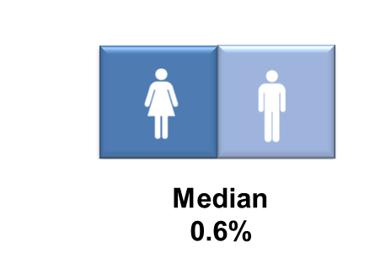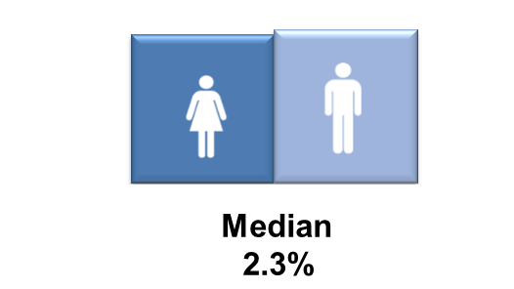
2019-20 2020-21

Bonus gender pay gap

The NHSBSA has a performance related bonus paid in only one area of the organisation (NHS Prescription Services), where the bonus is paid for high volume data entry depending on output and accuracy, regardless of gender. The roles that qualify for the bonus are in Agenda for Change pay band 2 only, the lowest band of the pay scale. The bonus scheme was phased out in September 2021, meaning that there will be no more bonus payments after that date within the NHSBSA.

Proportion of males and females receiving a bonus payment

More female colleagues than men received a bonus in 2020-21, with 20.3% of total female colleagues, compared to 14.9% of all male colleagues receiving a bonus in the same period. This was influenced by the greater proportion of female colleagues in the roles which qualify for the bonus. It is interesting to note that the overall number colleagues receiving a bonus has reduced from the previous year. This is due to a reduction in prescriptions work and colleagues being redeployed into roles that do not attract a bonus.
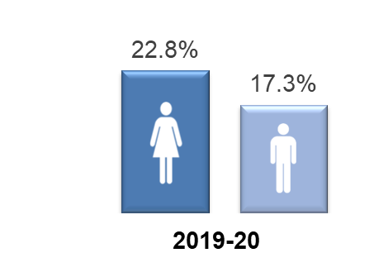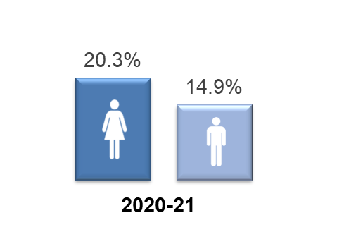

Mean and median bonus gender pay gap

The chart below reveals that there is a 16.3% pay gap between the mean bonus pay of the male and female colleagues who received the above bonus in the year 2020-21, and a 12.4% bonus pay gap using the median calculation. This shows that men received a higher bonus amount, despite more women than men receiving a bonus, which would be linked to men achieving higher rates of output and accuracy, the two factors measured for the bonus. It is noted that the mean bonus pay gap has increased by 2.9% from 2019-20 and the median bonus pay gap has reduced by 0.1% from 2019-20.
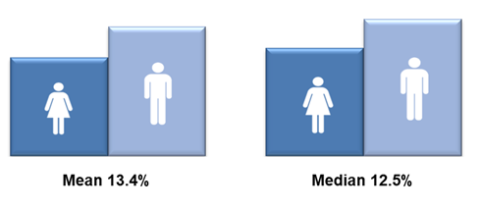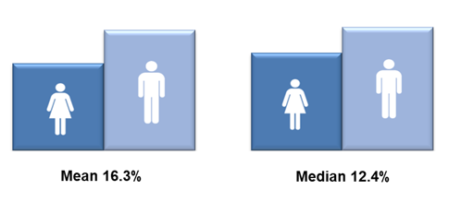

2019-20 2020-21

Summary

The table overleaf summarises the various gender pay gap calculations for 2020-21 and includes those from the previous year for comparison purposes. The mean gender pay gap for hourly pay within the NHSBSA in 2020-21 is 12.6%. This difference in hourly pay is influenced by the greater proportion of male colleagues occupying more roles in the higher pay bands (and upper pay quartile). It is noted that this has increased from 2019-20 by 1.3% which has reversed a trend of gradual reductions since 2017.

The median is regarded as typically a more representative figure than the mean, which can be distorted by a handful of highly paid employees. In 2020-21 there is a 2.3% median gender pay gap between men and women in the NHSBSA, which has increased by 1.7% from the previous year. Historically the median gap has fluctuated between 0% and 3.1% since 2016. This increase is related to the increase in female colleagues in the lower pay quartiles and a decrease in the upper pay quartile of 4.5% from 2019-20, meaning an 8% proportional difference between men and women where this was equal in 2019-20.

It also noted that the mean bonus gender pay gap has increased by 2.9% but the median bonus gender pay gap has decreased by 0.1%

 |  |  | % 2019-20 | % 2020-21 | % change
Median gender pay gap |  |  | 0.6% | 2.3% | +1.7%
Mean gender pay gap |  |  | 11.3% | 12.6% | +1.3%
Median bonus gender pay gap |  |  | 12.5% | 12.4% | -0.1%
Mean bonus gender pay gap |  |  | 13.4% | 16.3% | +2.9%
Proportion of male and female employees paid a bonus: |  | Male | 17.3% | 14.9% | -2.4%
 |  | Female | 22.8% | 20.3% | -2.5%
Proportion of male and female employees in each quartile:
 | 2019-20 |  |  | 2020-21
Quartile | Female % |  | Male % | Female % | Male %
First (lower) quartile | 60% |  | 40% | 62% | 38%
Second (lower middle) quartile | 65% |  | 35% | 68% | 32%
Third (upper middle) quartile | 60% |  | 40% | 61% | 39%
Fourth (upper) quartile | 50% |  | 50% | 46% | 54%

Actions to remove the gender pay gap

The NHSBSA is committed to addressing our gender pay gap and is undertaking a wide range of actions to continue to reduce this. During the last year, significant progress has been made in the following areas:

- Creation of our new Shadow Board as part of our leadership development offer, with ring-fenced seats for colleagues from the equality groups we are under-represented by at senior levels within the NHSBSA, including women. Each Shadow Board member is also sponsored by a member of our Leadership Team for further development. The Shadow Board meet the day before each main Board to debate, provide constructive challenge and feedback on Board agenda items. This initiative helps us to develop our aspiring future leaders and provides an opportunity to proactively address this under-representation within our leadership community.

- Development of our Women’s Colleague Network, aimed at increasing the voice of female colleagues. Focussing on issues specific to women, it feeds into the wider Diversity and Inclusion Network and links to the above Shadow Board. Through their lived experience, network members act as a ‘critical friend’ to the NHSBSA to help identify any issues or barriers in relation to practices and policies to ensure they are as inclusive as possible. Membership of the network is open to all female colleagues, regardless of role or pay band, and also provides learning and development opportunities as well as networking and support.

- Progression of a corporate women’s development programme aimed specifically at female colleagues to help develop capability and confidence to progress. Members of the Learning and Organisation Development team have been accredited by Springboard through completion of their ‘Train the Trainer’ programme. A pilot was originally planned for the spring of 2020, however this was delayed due to the Covid-19 pandemic and the pause of face-to-face delivery. The programme was adapted to be delivered remotely, offering ‘bite-sized’ sessions. A pilot was run in January 2021 and was well received. Evaluation data from this pilot is currently being reviewed in order to make future sessions as effective as possible. The programme is open to all women and supports them to build a personal development plan, focussed on their strengths, values and personal aspirations. It aims to act as a springboard to increase confidence and capability, encouraging women to maximise their potential and explore career opportunities.

- We developed new guidance for managers on supporting colleagues with menopause in the workplace as this can have a hugely detrimental impact on the career development of women. We also trained ‘Menopause Champions’ who can provide support to colleagues. These new champions have formed a Menopause Champions group within our wider Wellbeing Network and as well as providing support, they raise awareness amongst colleagues and managers through delivery of ‘Menopause cafes’ which are safe spaces for colleagues to share their experiences and provide support to each other.

- Other awareness and communications campaigns have been delivered to colleagues and externally, such as those for International Women’s Day, which raise awareness of female role models working at a senior level within the NHSBSA or in a traditionally male-dominated occupation, and we have promoted learning and development opportunities such as external Women in Leadership events.

Going forward, we will continue to build on this progress by focussing on:

- Implementing an organisation-wide approach to gender diversification of recruitment panels, following the evaluation of a trial ending in June 2021, and ensuring all who recruit within the NHSBSA complete the new recruitment training, to ensure we take all possible steps to remove any gender bias, including unconscious bias, in the selection methods we use.

- Designing, developing and delivering a new in-house Reciprocal Mentoring for Inclusion Programme. This programme is intended to bring about organisational change around diversity and inclusion issues, including those relating to women’s equality, whilst also supporting individual learning and development for under-represented colleagues, and building leadership capability around these issues.

- Supporting female colleagues to maximise their potential through the wider launch of the in-house development programme for women, following the review of the pilot, which has been adapted for virtual delivery during the Covid-19 pandemic.

- Maximising development opportunities for female colleagues with potential to increase the representation of women at senior levels, including continuing to support the new Shadow Board and ensuring that all members have sponsorship from a Leadership Team member to support their career development and aspirations.

- Developing and retaining our people with potential and attracting external talent as part of our talent management strategy, linked to our appraisal and PDP process, and working collaboratively with the NHS Leadership Academy and others to offer opportunities to participate in external talent programmes.

- Assessing our menopause support by participating in the ‘Menopause Friendly Workplace’ accreditation scheme, which will help us identify any further support we need to put in place for colleagues

- Supporting our Women’s Colleague Network, empowering them to work on areas and issues they identify for action in collaboration with the Wellbeing and Inclusion Team and other colleague networks, and ensuring their voice is maximised.

- Updating our family-friendly HR policies to ensure they are as accessible, inclusive and engaging as possible and developing supporting guidance for colleagues and managers and increasing awareness of these through promotional campaigns.

- Actively seeking feedback from our female colleagues about their work/life balance needs as we consider our future ways of working as we come out of the Covid-19 pandemic.

