# NHS Jobs current service account review

The current version of NHS Jobs is due to close. You will be able to access the service or any of your data held within the current version of NHS Jobs until the service’s contract expires in early 2023.

The latest closing date an advert can contain is **31 October 2022**. An error message will appear to advise recruiters, ‘This service will be replaced with the new NHS Jobs service. To ensure this transition can happen on time, closing dates later than 31 October 2022 are not permitted’.

It will not be possible to publish adverts after **24 October 2022**. Other workflows from ‘Draft’, ‘Pending approval’, etc. will not allow publication and will display a validation error message to explain to recruiters, ‘This service will be replaced with the new NHS Jobs service, and it is no longer possible to create new adverts.

Contents

NHS Jobs current service account review 1

Reviewing your NHS Jobs account 3

Switch off automatic emails 4

Archiving your vacancies 5

Run reports to extract data 7

Disable user accounts 8

## Reviewing your NHS Jobs account

You should review your NHS Jobs account in line with your internal procedures.

In preparation for this, we recommend that you:

* switch off automatic emails
* archive your vacancies
* run reports to extract any data that you might need in the future
* disable user accounts.

The benefits of following these steps are:

* you will be left with a clear dashboard where all applicants have been processed
* your data will have been downloaded for future use once access to the service is no longer available

## Switch off automatic emails

This page gives you instructions for how to switch off automatic emails.

**Important:** If the application workflow ‘Send rejection emails automatically’ is enabled, you’ll need to disable it to prevent applicants from receiving notifications for job listings they have applied for previously.

To switch off automatic emails, complete the following steps:

1. Select the ‘Admin’ section.
2. Select the ‘Configuration options’ section.
3. Untick the ‘Send rejection emails automatically’ box.

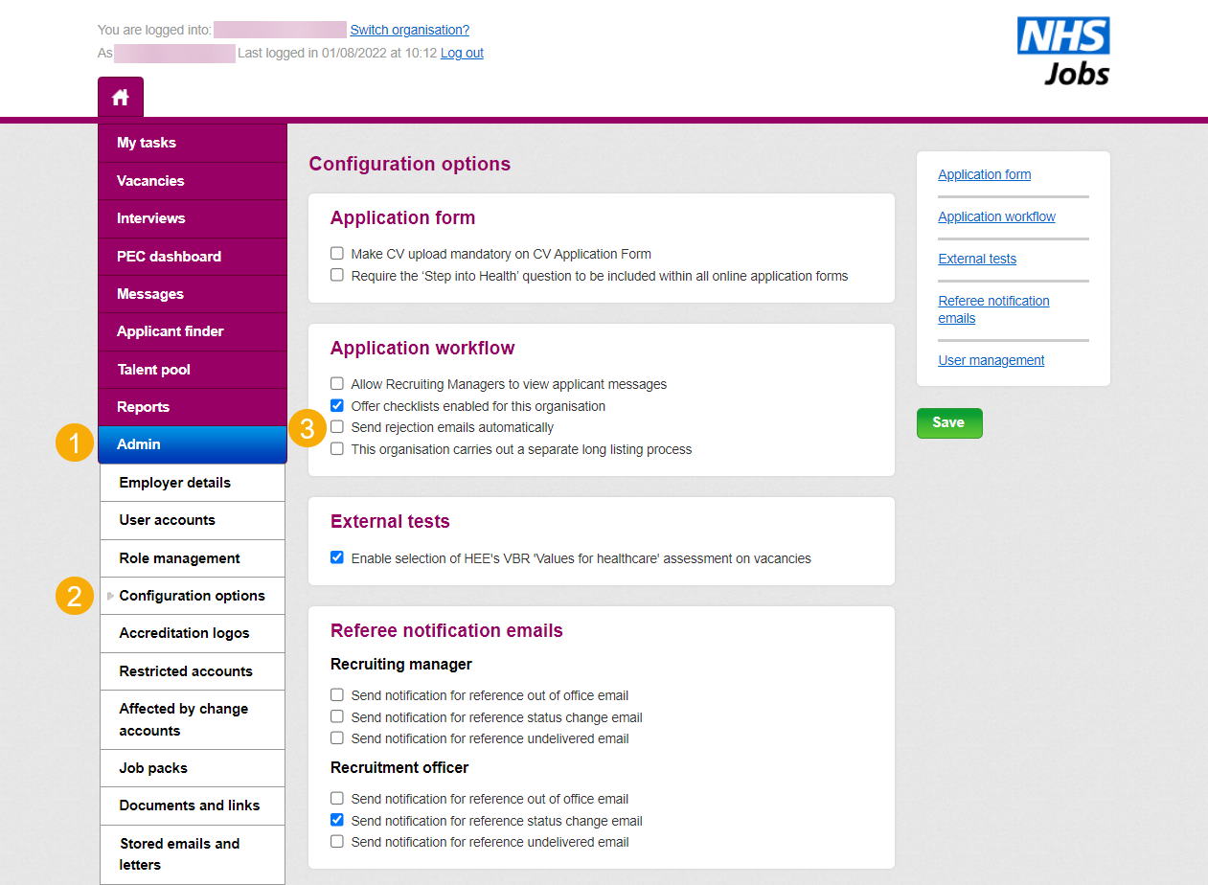

Go to the next page

## Archiving your vacancies

This page gives you instructions for how to archive your vacancies.

**Important:** If you’re still using the current NHS Jobs service to advertise your vacancies, you can enable the ‘Send rejection emails automatically’ option.

To begin archiving your vacancies, complete the following steps:

1. Select the ‘Vacancies’ section.
2. Select the ‘Actions’ button.

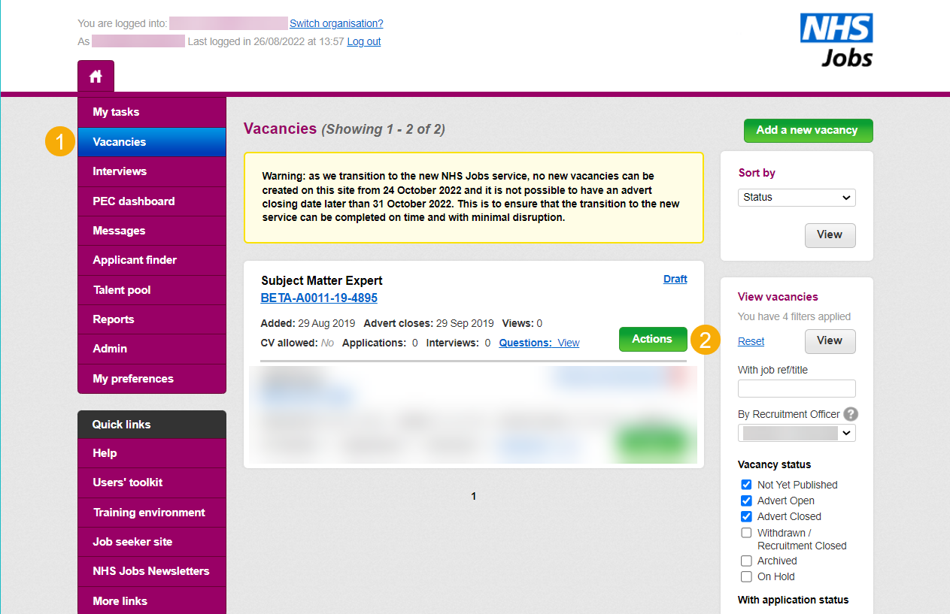

1. Select the ‘Close recruitment’ option.

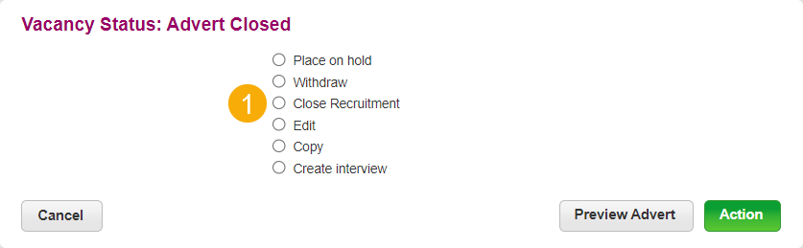

Go to the next page

1. Select the ‘Archive’ option.

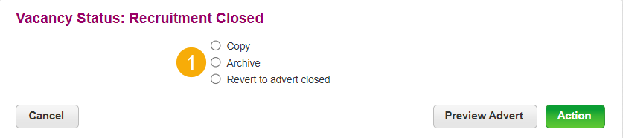

Go to the next page

## Run reports to extract data

This page gives you instructions for how to run reports to extract data.

You should consider running these reports:

1. Master Report (and/or Downloadable CSV Master Report).
2. Equal Opportunities Progress Report. This will enable your organisation to meet the public sector responsibility under the Equality Act 2010 if applicable.

There are several other reports under Flexible Reporting and Standard Reporting. User guides on reporting can be found within the current NHS Jobs under **System Administrator Training Materials.**

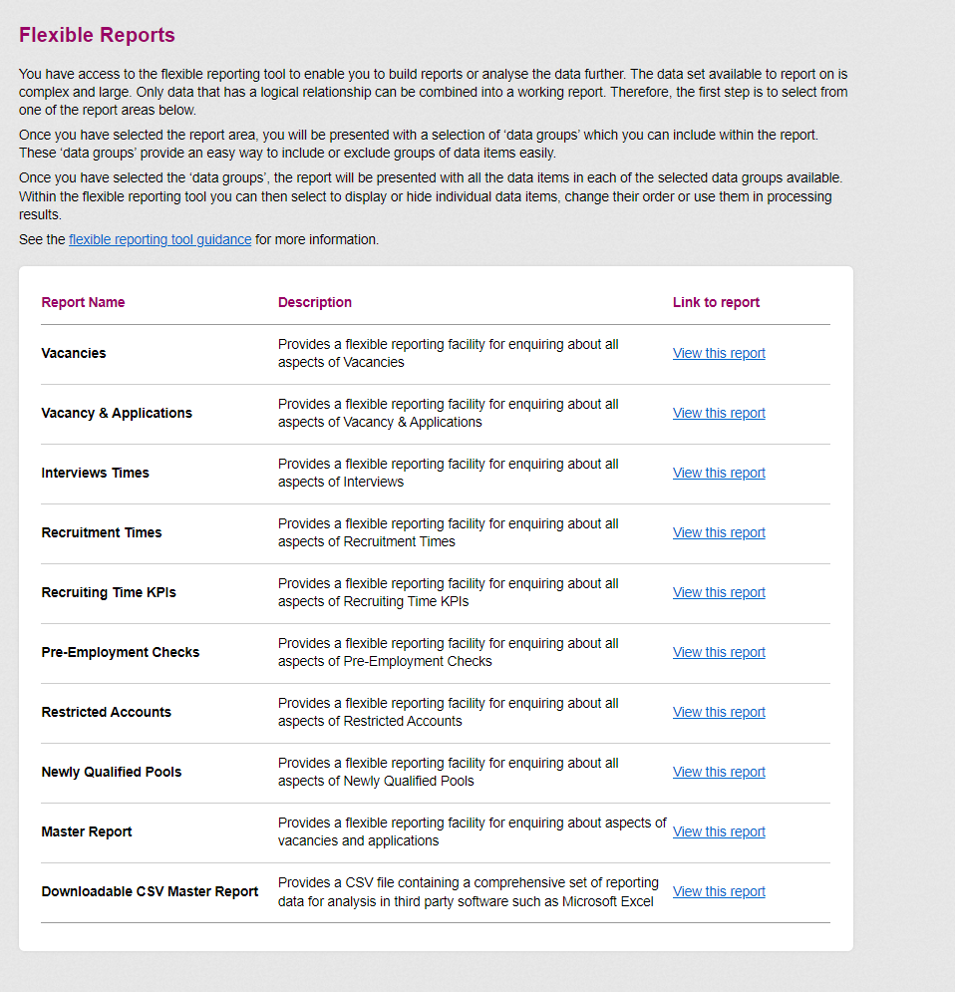

Go to the next page

## Disable user accounts

To ensure that no further action is taken in this NHS Jobs account, all user accounts should be disabled in line with terms and conditions of the service.

If you have any questions or need any support with the above instructions, please contact the Optimisation Support Team on [nhsbsa.nhsjobs@nhs.net](mailto:nhsbsa.nhsjobs@nhs.net)