eOPS v3 dashboard guidance

Interactive Contents
Use the interactive contents list to jump straight to the content you want to see.
Just click the titles below to go directly to that section:
eOPS3 – NHS Sight Tests
NHS Sight Test Summary, Contractor Sight Tests and Performer Sight Tests
Referral Summary, Contractor Referrals and Performer Referrals
Early Retest Summary, Contractor Early Retests and Performer Early Retests
GOS6 Domiciliary Visits Summary, Contractor GOS6% of Sight Tests and Performer GOS6% of Sight Tests
GOS3 Voucher Summary, Contractor GOS3% of Sight Tests and Performer GOS3% of Sight Tests
Contractor Supplements % of GOS3 Vouchers and Performer Supplements % of GOS3 Vouchers
GOS4 Claims Summary, Contractor GOS4 Claims Summary and Performer GOS4 Claims Summary
Glossary
Getting more help

eOPS3 – NHS Sight Tests

Dashboard name
NHS England Ophthalmic Dashboard v3
This is also referred to as eOPSv3.
This guide is designed to complement the NHSBSA eOPS v3 Dashboard to provide context on the different types of analyses & information presented.
- eOPS3 uses a claim level patient dataset from PCSE.
- All reports are currently based on 7 NHS regions & 42 Sustainability and Transformation Partnerships (STPs)
- All references to Year refer to Calendar Year and NOT Financial Year.
- Do make use of the hover text inside of graphs and other analysis. These can be useful to identify exactly each data point and other related information.
- This guidance does not display every graphic or analysis available within eOPS, for instance GOS 4 Repairs have been described but additional graphs & tables for GOS 4 Replacements and GOS 4 Small Glasses have been omitted. The logic applied to one can apply to all similar graphs.
For further help and guidance, you can contact the NHSBSA Ophthalmic Insight team at: eopssupport@nhsbsa.nhs.uk

NHS Sight Test Summary, Contractor Sight Tests and Performer Sight Tests
Analysis Name | Analysis Description | Image
NHS Sight Tests | The total count of NHS Sight Tests | 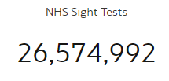
GOS1 Sight Tests | The total count of all NHS GOS 1 Sight Tests where NHS Sight Test count > 0 | 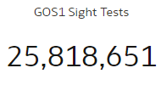
GOS6 Domiciliary Visits | The total count of all NHS GOS6 – Domiciliary Visits | 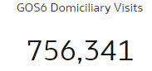
GOS6% of NHS Sight Tests | The % of NHS Sight Tests that had GOS6 Domiciliary Visits | 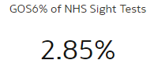
GOS6 Full Fee Visits | The total count of all NHS GOS6 Full Fee Visits | 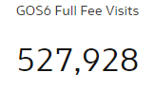
GOS6 Part Fee Visits | The total count of all NHS GOS6 Part Fee Visits | 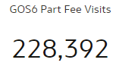
Early Retests | The total count of all NHS Early Retests | 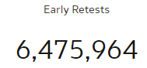
Referrals | The total count of all NHS Referrals | 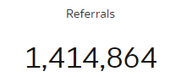
NHS Sight Tests by Region | Map showing the total number of NHS Sight Tests by Region | 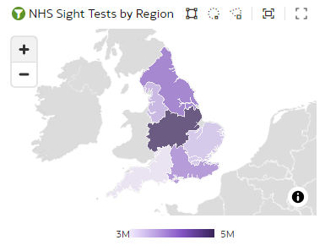
GOS1s vs GOS6s by ICB | Chart showing number of GOS1s vs number of GOS6s by ICB | 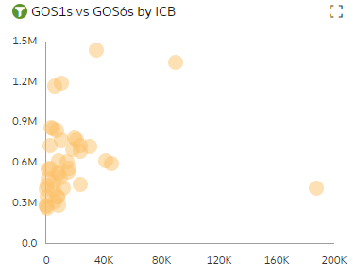
NHS Sight Test Trend | Chart showing the trend over time of all NHS Sight Tests | 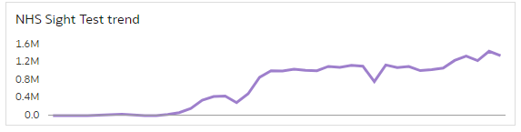
Sight Test Total by GOS Claim type | Chart showing the total count of NHS Sight Tests split between GOS1 NHS Eye Tests & GOS6 Domiciliary Visits | 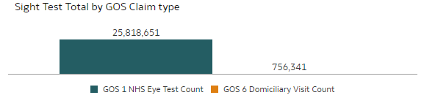
NHS Sight Test trend by Age Band | Chart showing a trend over time for NHS Sight Tests by Age Band | 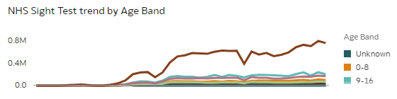
NHS Sight Test Total by Age band | Chart showing the total count of NHS Sight Tests by Age Band | 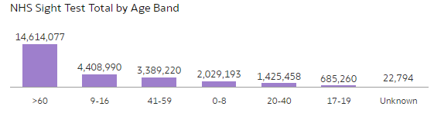
Sight Test Summary by NHS Region & ICB | Table showing the total count of NHS Sight Tests by NHS Region & ICB | 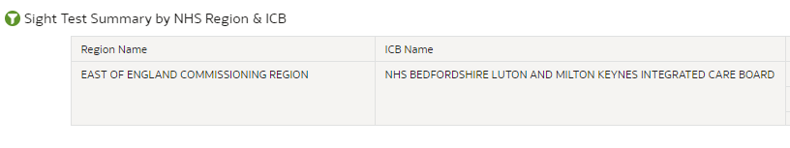
Contractors | The total count of all NHS Contractors | 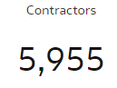
Contract Avg. Claims | The average number of claims per NHS Contract | 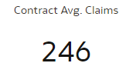
GOS1s vs GOS6s by Contractor | Chart showing number of GOS1s vs number of GOS6s by Contractor | 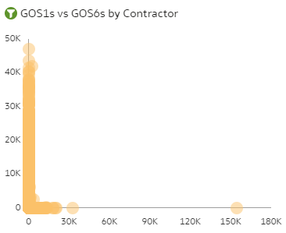
Sight Test Summary by Contractor | Table showing the total count of NHS Sight Tests by Contractor | 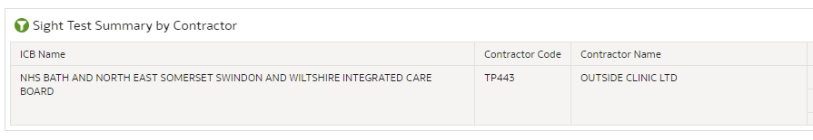
Performers | The total count of all NHS Performers | 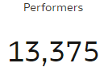
Performer Avg. Claims | The average number of claims per NHS Performer | 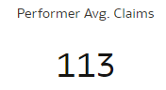
NHS Sight Tests by Contractor | Map showing the total number of NHS Sight Tests by Contractor | 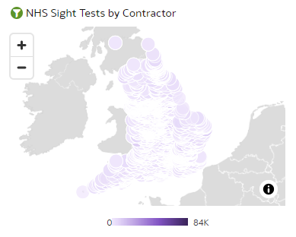
GOS1s vs GOS6s by Performer | Chart showing number of GOS1s vs number of GOS6s by Performer | 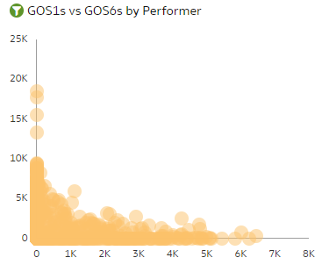
Sight Test Summary by Contractor | Table showing the total count of NHS Sight Tests by Contractor and Performer | 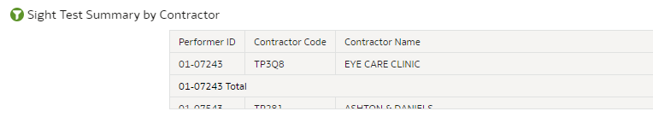

Referral Summary, Contractor Referrals and Performer Referrals
Analysis Name | Analysis Description | Image
Total NHS Sight Tests | The total count of NHS Sight Tests
Patient Referrals | The total count of all Patient Referrals | 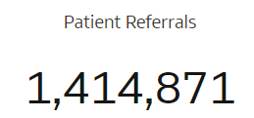
Referral % of NHS Sight Tests | The total % of referrals from NHS Sight Tests | 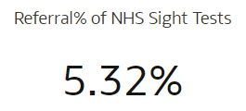
Contract Avg. Referral Count | The average number of referrals per contract | 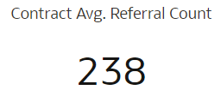
Performer avg. Referral Count | The average number of referrals per performer | 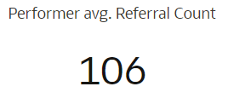
Referral % by region | Map showing the % of referrals by region | 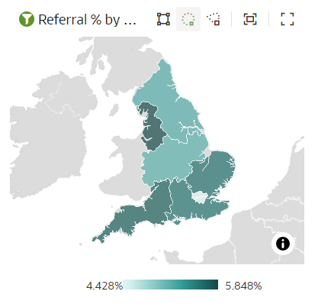
Referral % from Sight Tests trend | Chart showing the % of referrals from total sight tests | 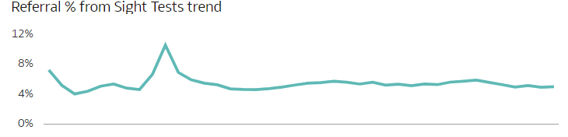
Referral % vs NHS Sight Tests by ICB | Chart showing the % of referrals vs NHS Sight Tests by ICB | 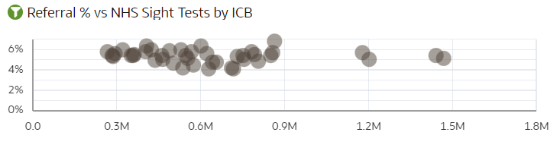
Referral % of Sight Tests trend by Age Band | Chart showing a trend for the % of referrals from total sight tests by age band | 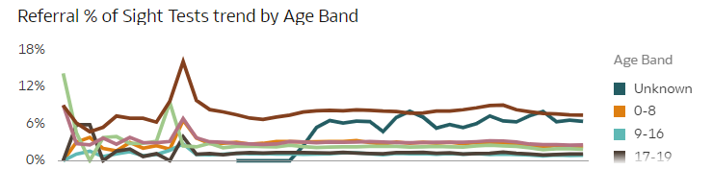
Referral % of Sight Tests total by Age Band | Chart showing % of referrals from total sight tests by age band | 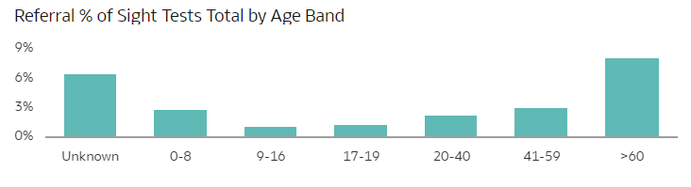
Referral Summary by Region & ICB | Table showing total referrals by Region & ICB | 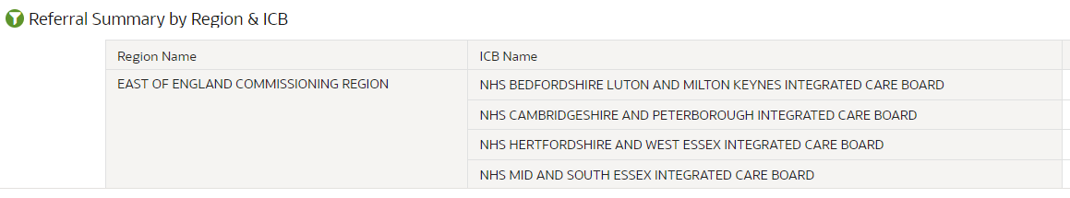
Referral % by ICB | Map showing the % of referrals by ICB | 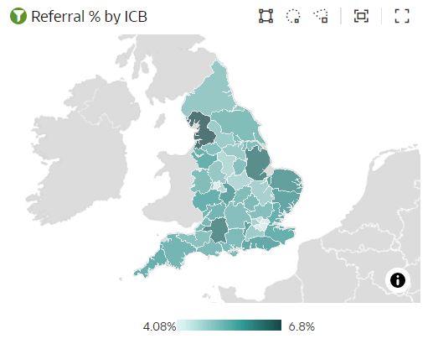
Referral % vs NHS Sight Tests by Contractor | Chart showing the % of referrals vs NHS Sight Tests by Contractor | 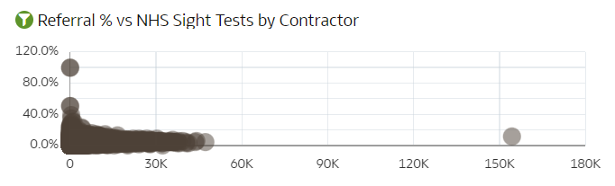
Referrals from Sight Tests Summary by Contractor | Table showing total referrals by Contractor | 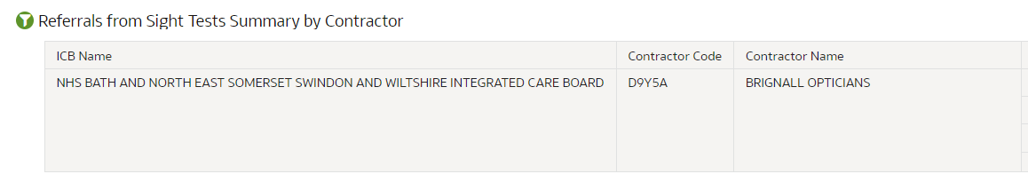
Performer Count | Count of all performers | 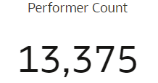
Performer avg. Referrals | The average number of referrals for performers | 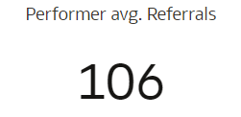
Referral % by Contractor | Map showing the % of referrals by Contractor | 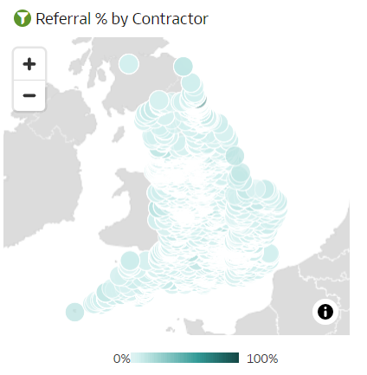
Referral % vs Total Sight Tests by Performer | Chart showing the % of referrals vs NHS Sight Tests by performer | 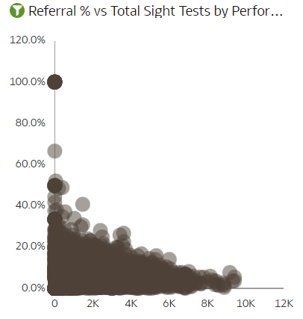
Referral Total by Claim Type | Chart showing the total number of referrals by claim type | 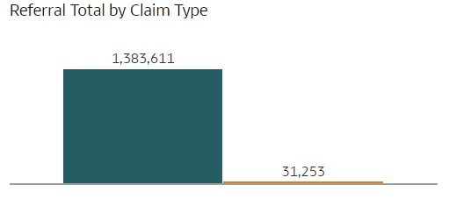
Referral % Total by Age Band | Chart showing the total % of referrals by age band | 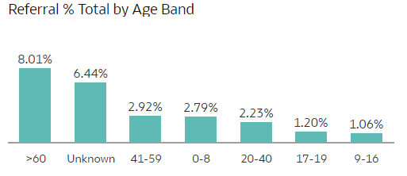
Referrals from NHS Sight Tests by Performer & Contractor Summary | Table showing total number of referrals by performer & contractor | 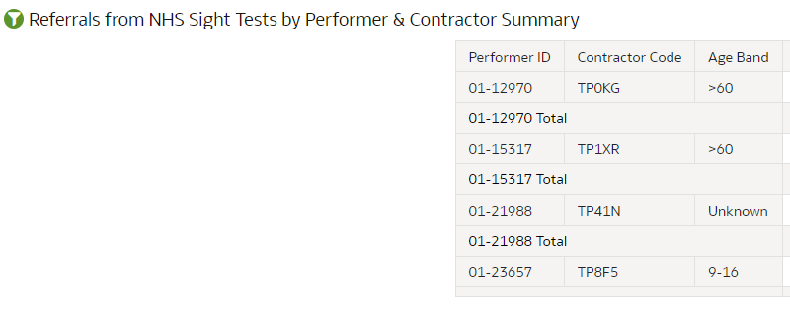

Early Retest Summary, Contractor Early Retests and Performer Early Retests
Analysis Name | Analysis Description | Image
Total Early Retests | The total number of early retests | 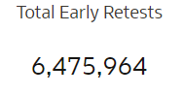
GOS1 Early Retests | The total number of GOS1 early retests | 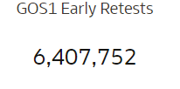
GOS6 Early Retests | The total number of GOS6 early retests | 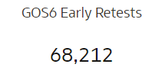
Early Retests by Region | Map showing the total number of early retests by region | 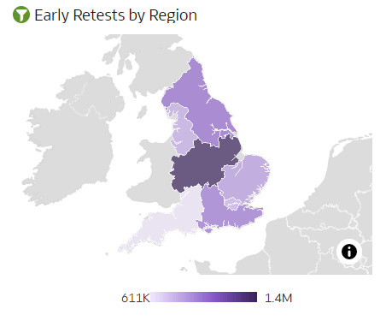
Early Retest Trend by Age Band | Chart showing a trend of the total number of early retests by age band | 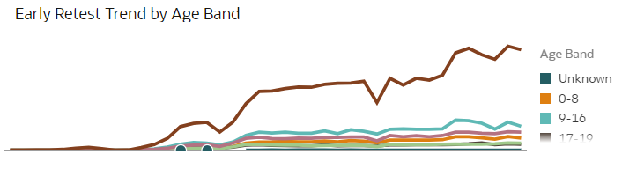
Total Early Retests by Age Band | Chart showing the total number of early retests by age band | 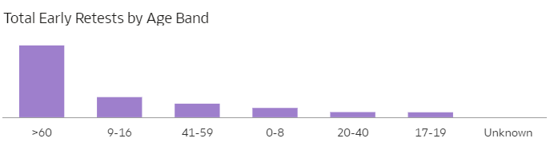
Early Retest Trend by Reset Reason | Chart showing a trend of the total number of early retests by retest reason | 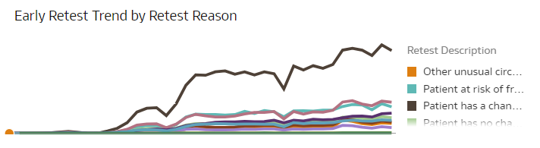
Total Early Retests by Reason | Chart showing the total number of early retests by retest reason | 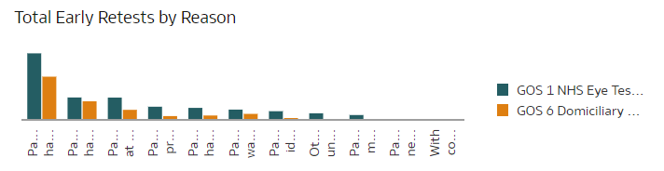
Early Retest Summary by Region & ICB | Table showing the total number of early retests by Region & ICB | 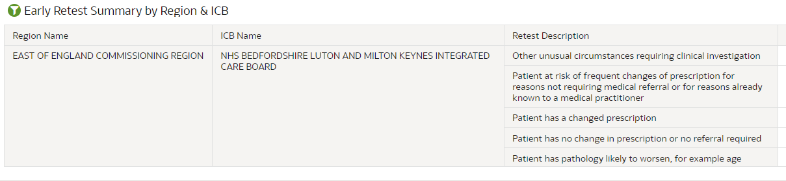
Contractor Early Retests | Map showing the total number of early retests by contractor | 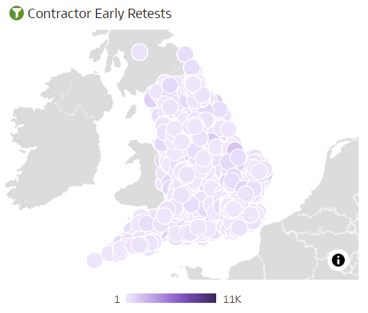
Early Retest Reasons by GOS Type | Chart showing the total number of early retests by GOS type | 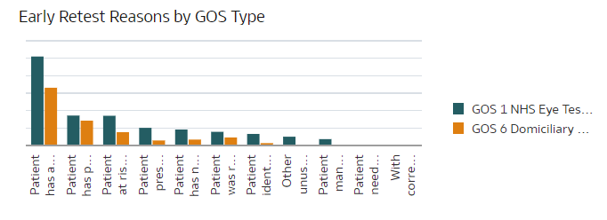
Early Retests by Contractor, Reason & Age Band | Table showing the total number of early retests by Contractor, Reason & Age Band | 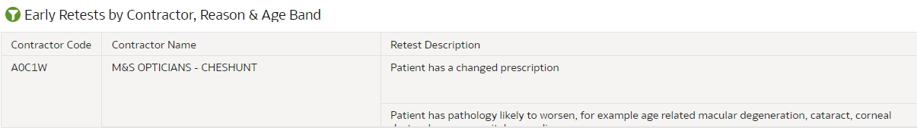
Early Retest Trend by GOS Claim Type | Chart showing a trend of the total number of early retests by GOS claim type | 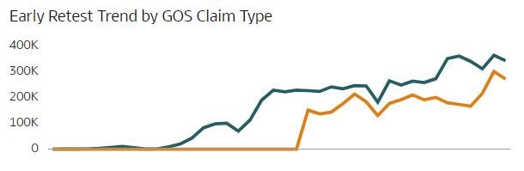

GOS6 Domiciliary Visits Summary, Contractor GOS6% of Sight Tests and Performer GOS6% of Sight Tests
Analysis Name | Analysis Description | Image
GOS6 Visits Total by Region | Map showing the total number of GOS6 visits by region | 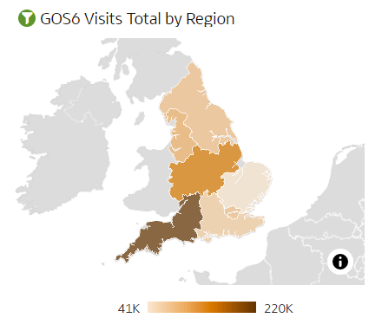
GOS6 Visit % of Tests vs Total Sight Tests by ICB | Chart showing the % of GOS6 visits vs total sight tests by ICB | 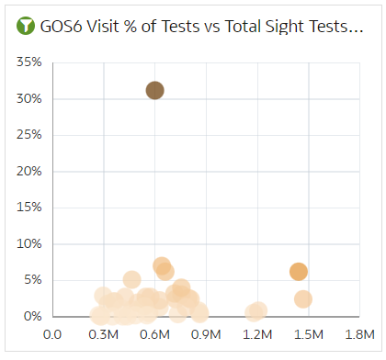
GOS6 Visit Total trend by Fee Type | Chart showing a trend of the total number of GOS6 visits by fee type | 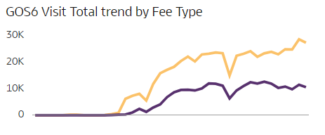
GOS6 Visit Total trend by Age Band | Chart showing a trend of the total number of GOS6 visits by age band | 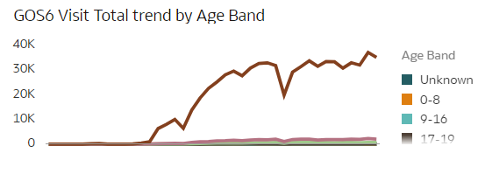
GOS6 Visit Total by Age Band | Chart showing the total number of GOS6 visits by age band | 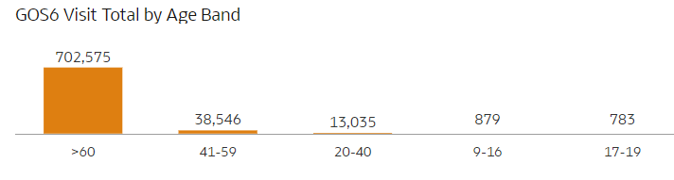
Region & ICB GOS6 Domiciliary Visit Summary | Table showing the total number of GOS6 domiciliary visits by Region & ICB | 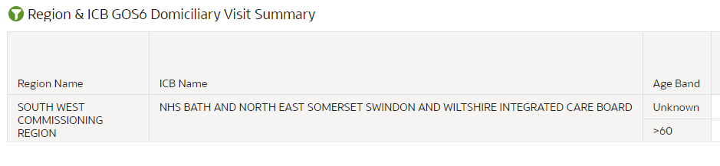
Contractor avg. GOS6 Count | The average of contractor GOS6 domiciliary visits | 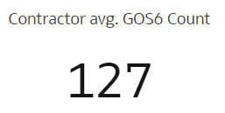
GOS6 % of NHS Sight Tests by ICB | Map showing the GOS6% of all NHS sight tests by ICB | 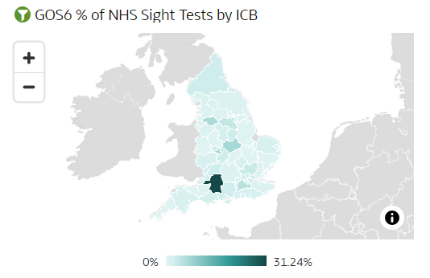
GOS6 % vs Sight Tests by Contractor | Chart showing the GOS6 % vs sight tests by contractor | 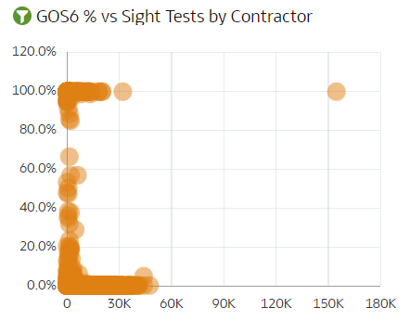
GOS6 % of Sight Tests trend | Chart showing a % trend of GOS6 sight tests | 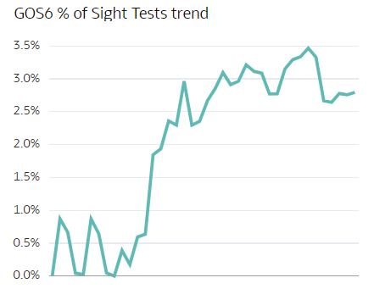
GOS6 % by Age Band | A chart showing the % of GOS6 visits by age band | 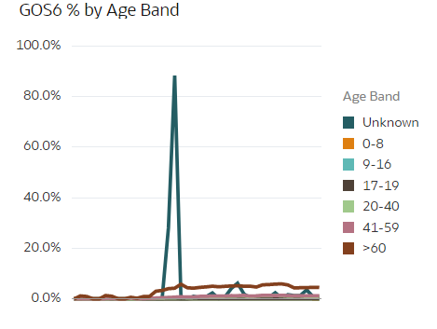
Contractor GOS6% of Sight Tests Summary | Table showing the % of GOS6 visits by contractor | 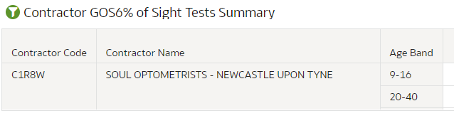
% of GOS6 performers | Total % of GOS6 performers | 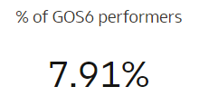
Performer avg. GOS6 Count | The average number of performer GOS6 visits | 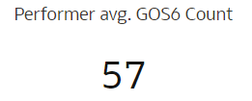
GOS6 % by Month | Map showing the % Of GOS6 visits by month | 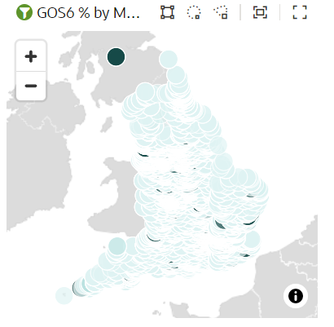
GOS6 % against Total Sight Tests by Performer | Chart showing the GOS6 % against sight tests by performer | 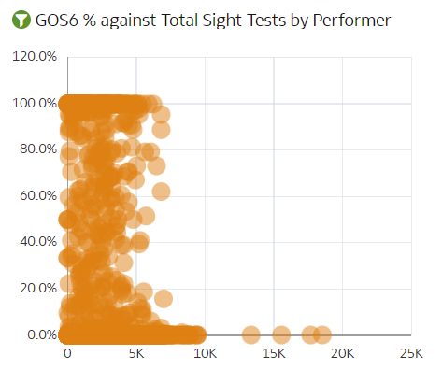
Performer by Contractor & Age Band Summary | Table showing the total number of GOS6 domiciliary visits by contractor % age band | 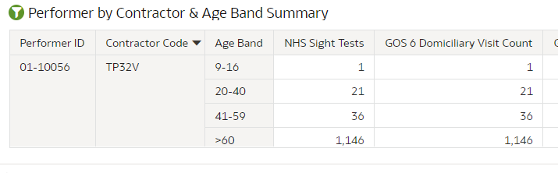

GOS3 Voucher Summary, Contractor GOS3% of Sight Tests and Performer GOS3% of Sight Tests
Analysis Name | Analysis Description | Image
GOS3 Optical Vouchers | Total number of GOS3 optical vouchers | 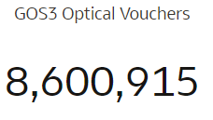
GOS3 Voucher % | Total % of GOS3 vouchers | 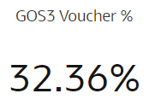
Total Supplements | Total number of supplements | 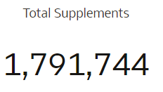
Supp’s % of Vouchers | Total % of vouchers with supplements | 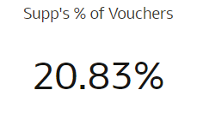
GOS3 First Vouchers | Total number of GOS3 vouchers that were first vouchers | 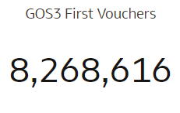
GOS3 Second Vouchers | Total number of GOS3 vouchers that were second vouchers | 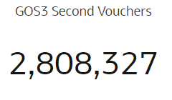
GOS3 Voucher Total by Region | Map showing the total number of GOS3 vouchers by region | 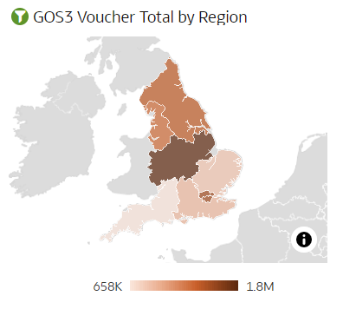
Voucher % vs Total GOS3 by ICB | Chart showing the % of vouchers vs total GOS3 by ICB | 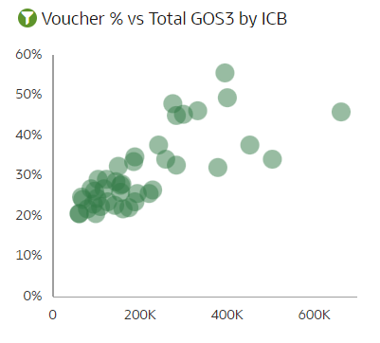
GOS3 Voucher Total trend | Chart showing a trend of the total number of GOS3 vouchers | 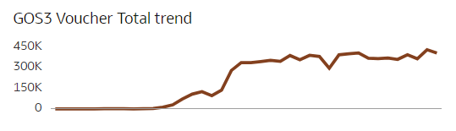
GOS3 Voucher Total by Voucher Type | Chart showing the total number of GOS3 vouchers by voucher type | 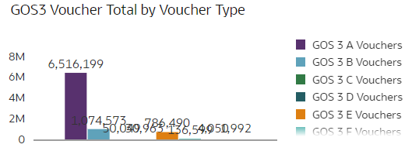
GOS3 Voucher Total Trend by Age Band | Chart showing a trend of the total number of GOS3 vouchers by age band | 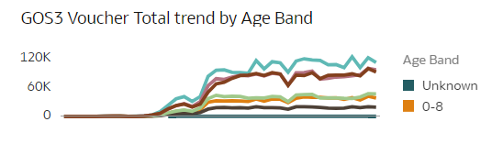
GOS3 Voucher Total by Age Band | Chart showing the total number of GOS3 vouchers by age band | 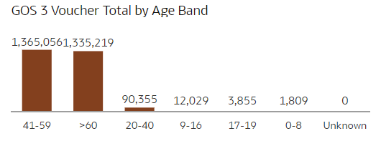
Region & ICB GOS3 Voucher Summary | Table showing the total number of GOS3 vouchers by Region & ICB | 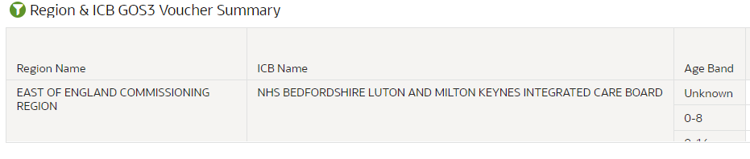
Contract avg. Vouchers | The average of contractor vouchers | 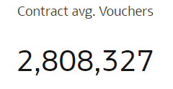
GOS3 % of Sight Tests by ICB | Map showing the GOS3% of all sight tests by ICB | 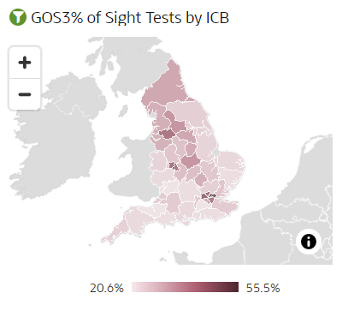
GOS3 % vs Sight Tests by Contractor | Chart showing the GOS3 % vs sight tests by contractor | 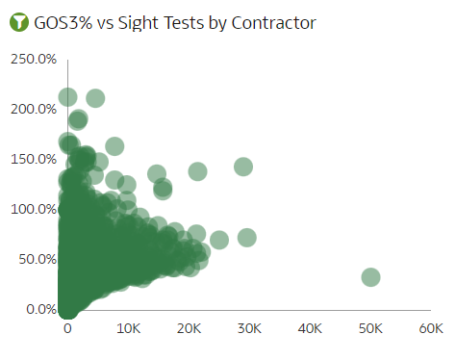
GOS3% of Sight Tests trend | A chart showing a trend of the % of GOS3 sight tests | Insert new screenshot when fixed
GOS3 Voucher total by Voucher Type | A chart showing the total number of GOS3 vouchers by voucher type | 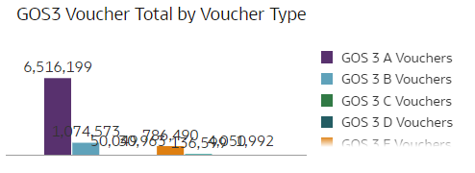
GOS3% of Sight Tests trend by Age Band | A chart showing a trend of the % of GOS3 sight tests by age band | 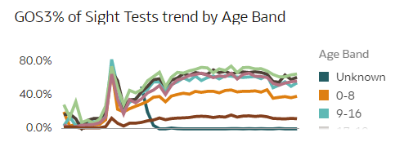
GOS3% of Sight Tests by Age Band | A chart showing the % of GOS3 sight tests by age band | 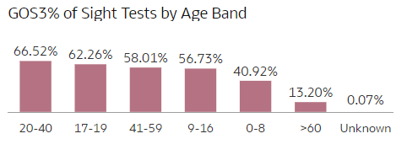
ICB & Contractor GOS3 Voucher Summary | Table showing the total number of GOS3 vouchers by ICB & Contractor | 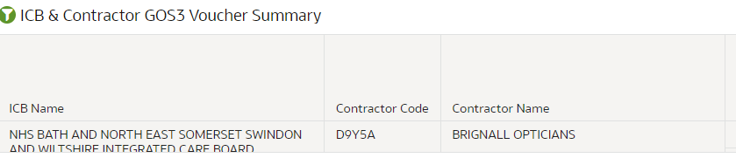
Performer avg. Vouchers | The average of performer vouchers | 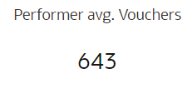
GOS3 % of Sight Tests by Contractor | Map showing the GOS3% of all sight tests by contractor | 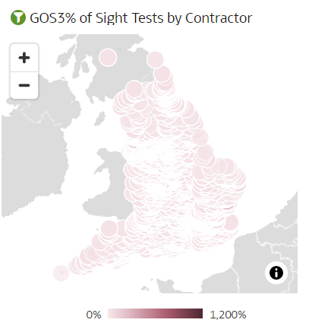
GOS3 % vs Sight Tests by Performer | Chart showing the GOS3 % vs sight tests by performer | 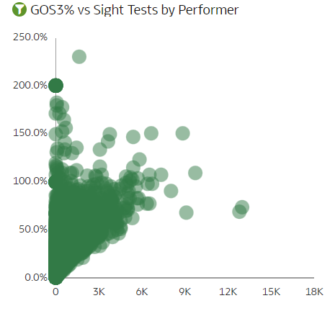
Performer & Contractor GOS3 Voucher Summary | Table showing the total number of GOS3 vouchers by performer & contractor | 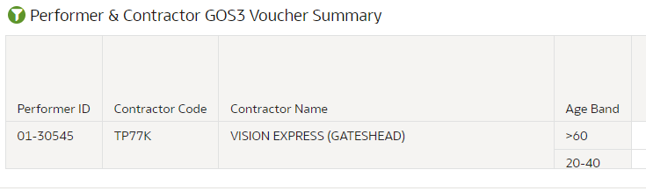

Contractor Supplements % of GOS3 Vouchers and Performer Supplements % of GOS3 Vouchers
Analysis Name | Analysis Description | Image
Tints | The total number of tint supplements | 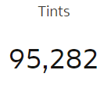
Prisms | The total number of prism supplements | 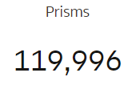
Small Glasses | The total number of small glasses supplements | 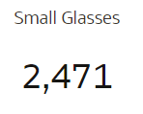
Second Pairs | The total number of second pairs supplements | 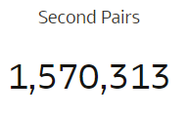
Special Facial Char. | The total number of special facial characteristics supplements | 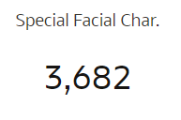
Supp’s % of Vouchers by ICB | Map showing the supp’s % of vouchers by ICB | 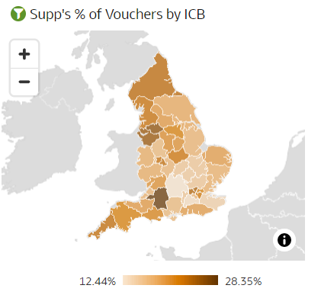
Supp’s % vs Vouchers by Contractor | Chart showing the supp’s % vs vouchers by contractor | 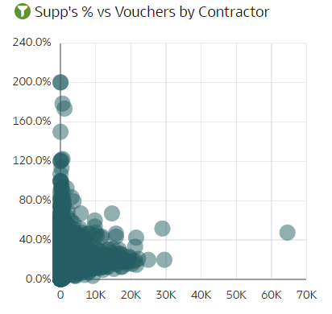
GOS3 Supplement Total trend | Chart showing a trend of the total number of GOS3 supplements | 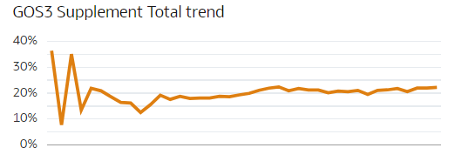
Supp % of Vouchers by Supplement | Chart showing the supplement % of vouchers by supplement | 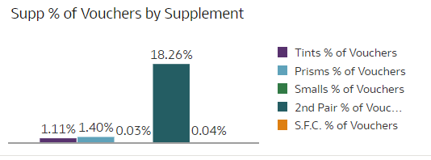
GOS3 Supplement Total by Age Band | Chart showing the total number of GOS3 supplements by age band | 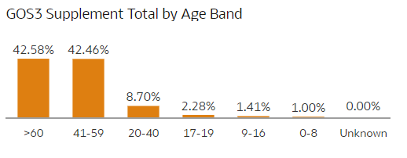
Contractor Supplement Summary | Table showing the total number of supplements by contractor | 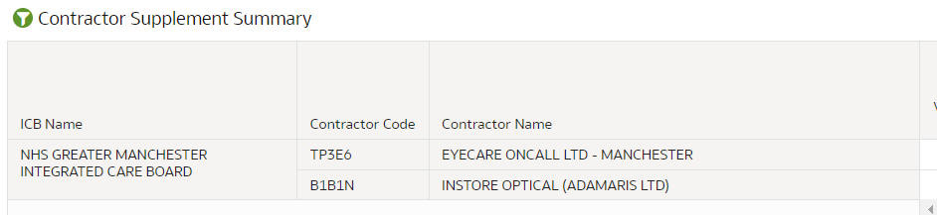
Supp’s % of Vouchers by Contractor | Map showing the supp’s % of vouchers by contractor | 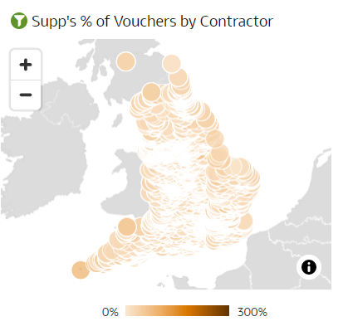
Supp’s % vs Vouchers by Performer | Chart showing the supp’s % vs vouchers by performer | 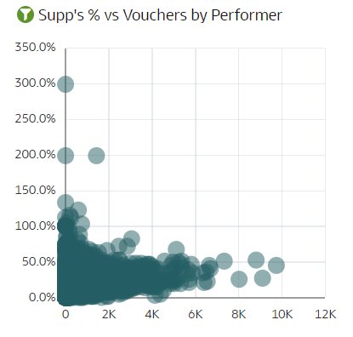
Supp % of Total Vouchers trend | Chart showing a trend of the total % of supplements | 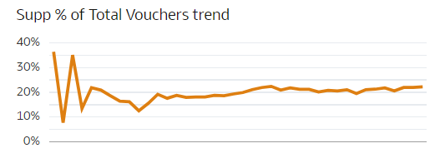
Supp % of Vouchers by Age Band | Chart showing the supplement % of vouchers by age band | 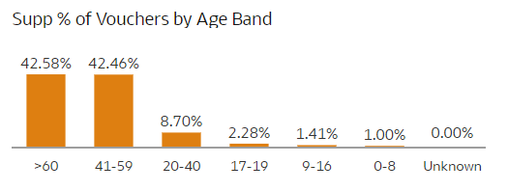
Contractor Supplement Summary | A table showing the total number of supplements by contractor | 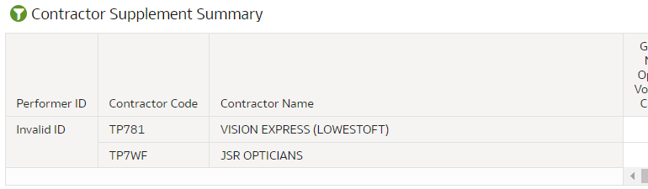

GOS4 Claims Summary, Contractor GOS4 Claims Summary and Performer GOS4 Claims Summary
Analysis Name | Analysis Description | Image
GOS4 Claim Total | Total number of GOS4 claims | 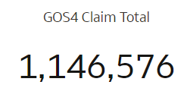
GOS4 Under 16 | Total % of GOS4 claims for under 16’s | 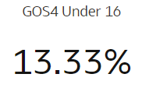
GOS4 Repairs | Total number of GOS4 repairs | 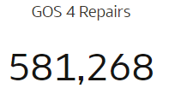
GOS4 Replacements | Total number of GOS4 replacements | 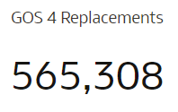
GOS4 Small Glasses | The total number of GOS4 small glasses | 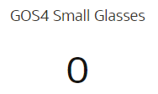
GOS4 Special Facial Characteristics | The total number of GOS4 special facial characteristics | 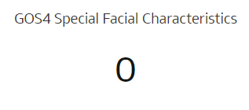
Repairs and Replacements by Region | Map showing the total number of repairs and replacements by region | 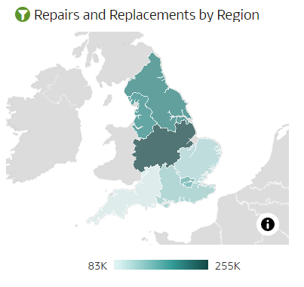
GOS4% vs GOS4 Total by ICB | Chart showing the % of GOS4 vs total GOS4 by ICB | 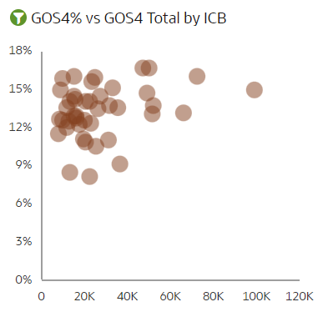
GOS4 Claim Total by Type Trend | Chart showing a trend of the total number of GOS4 claims by type | 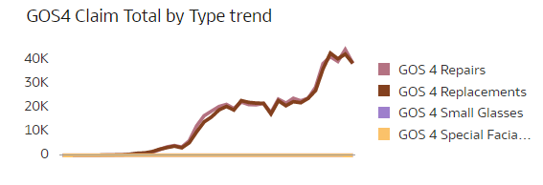
GOS4 Total by Type | Chart showing the total number of GOS4 claims by type | 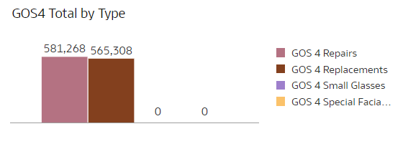
GOS4 Claim Total by Age Band Trend | Chart showing a trend of the total number of GOS4 claims by age band | Insert screenshot when fixed
GOS4 Claim Total by Age Band | Chart showing the total number of GOS4 claims by age band | 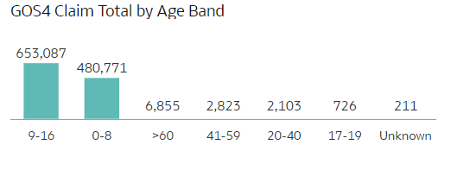
GOS4 Summary by Region & ICB | Table showing the total number of GOS4 claims by Region & ICB | 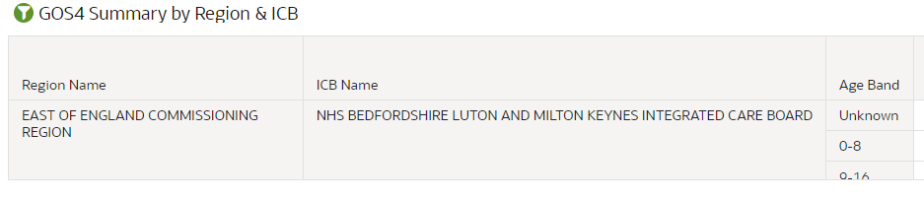
GOS4% of GOS3 Vouchers | The % of GOS3 Vouchers that are GOS4 | 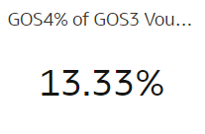
Distinct Contractors | Total number of distinct contractors | 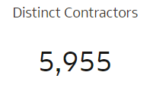
Contractor avg. GOS4 Claims | The average of GOS4 claims per contractor | 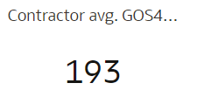
GOS4 Claim Total by ICB | Map showing the total number of GOS4 claims by ICB | 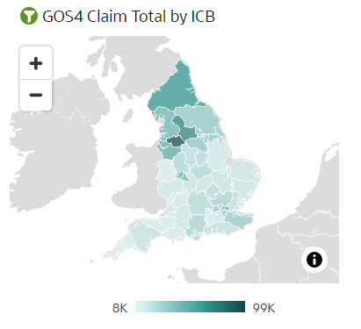
GOS4% vs GOS4 Total by Contract | Chart showing the % of GOS4 vs total GOS4 by contractor | 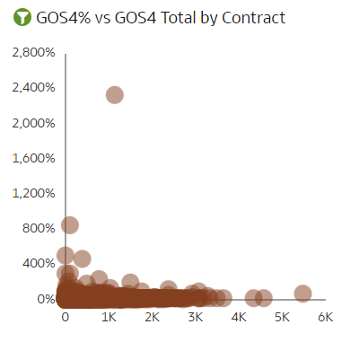
GOS4 Summary by Contractor | A table showing the total number of GOS4 claims by contractor | 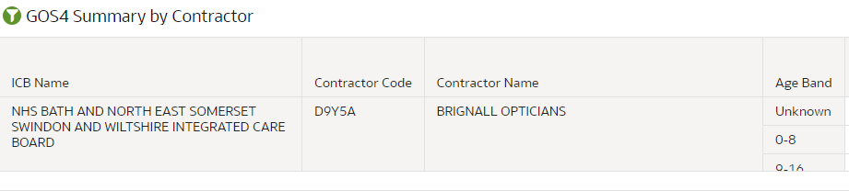
Performer avg. GOS4 Claims | The average of GOS4 claims per performer | 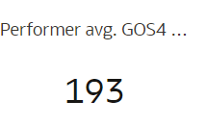
GOS4% vs GOS4 Total by Performer | Chart showing the % of GOS4 vs total GOS4 by performer | 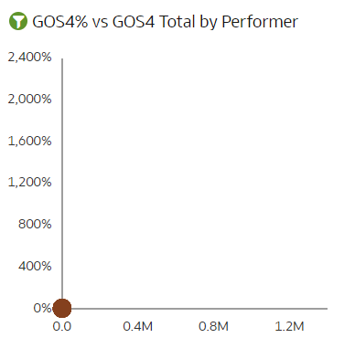
GOS4 Summary by Performer & Contractor | Table showing the total number of GOS4 claims by performer & contractor | 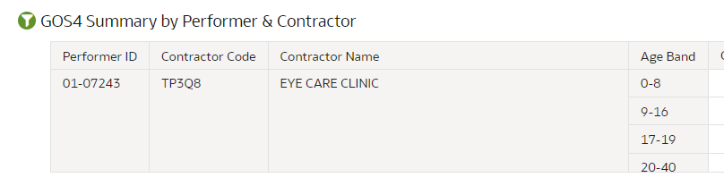

Glossary
Additional Services Contract | For domiciliary services, also referred to as mobile services & operate outside of fixed premises, normally at a patient’s place of residence.
Axis | If used in reference to a graph, this means the lines upon which the scale of the graph is drawn against. Used for plotting the coordinates or data points on a graph. There’s generally an X-axis or horizontal line & Y-axis or vertical line.
CCG | CCGs are groups of GPs that are responsible for designing & maintaining local health services in England through commissioning or buying health & care services. All GP practices have to belong to a CCG. These came into effect as of 01 April 2013 & were designed using the 2011 LSOAs to replace the even older PCT organisations. There were 212 at one point.
Complex Bifocal | A highly specialised lens that has two distinct parts, with each part having a different focal length – would be used for near vision & the other would be used for distance.
Contract | Any individual or otherwise, wishing to provide NHS services under GOS terms, must hold one of these with the Area Team responsible for the area that they wish to operate - See also; Mandatory Contract, Additional Services Contract or Enhanced Services Contract.
Data Point | A discrete unit of information or value.
Dioptre | A unit of measurement for the refractive power of a lens or curved mirror.
Domiciliary Visit | Domiciliary eye care is for patients who are unable to visit a high street practice unaccompanied due to a mental, physical, or learning disability.
Enhanced Services Contract | Entitles holders to perform additional, commissioned services from the NHS, such as Minor Eye Conditions Services (MECS), referral refinements or Intraocular Pressure (IOP) services.
FY | An acronym for Financial Year. This relates to the 365-day period (366 on a leap year) from 1st April XX to 31st March XX +1.
GOS | An acronym for General Ophthalmic Services. This was developed in response to Part 6 of the NHS Act 2006, requiring anyone who wished to provide NHS Sight Tests to enter into contracted terms with the now superseded PCTs. See also; PCTs.
GOS1 | This is the application for an NHS funded Sight Test.
GOS2 | A Patient’s Prescription. One of these may not be generated after a sight test – this is up to the provider of the service.
GOS3 | This is the voucher issued due a detected degradation in visual health; the GOS3 shows the clinical reasoning why the voucher was issued.
GOS4 | This is an application for Repairs, Replacements or for Small Glasses adjustments to existing visual aids, when it is determined that a new prescription is not necessary.
GOS5 | Help with Private eyesight test & is beyond the scope of eOPS.
GOS6 | This is the application for a Domiciliary Visit.
GOS Forms | There are six altogether numbered 1 – 6 inclusive. Only four are used in eOPS - GOS 1, 3, 4 & 6. These are used for capturing patient; performer & supplier level activity data necessary for the commissioning of GOS services, patient entitlement checks & to performance manage individual GOS Contracts.
Hover Text | A computer programming feature that allows small boxes to appear on screen, displaying any further information available when the mouse icon hovers over particular parts of a graph.
LSOA | An acronym for Lower Super Output Layer is a standardized geographical area, designed to improve the reporting of small area statistics in England & Wales.
Mandatory Contract | Any provider of NHS commissioned Sight Test services to the general public must obtain & be legally entitled to one of these.
PCT | Primary Care Trust. These were NHS Commissioning bodies before they were replaced with CCGs, which they themselves are now defunct & replaced with STPs. There were 151 PCTs.
Prism | Used on visual aids to help correct double vision.
Sight Test | A method to determine the level of degradation in the recipients’ visual health.
Single Complex | A spectacle lens with a power of +/- 10 or more dioptres in any one meridian.
STP | An acronym for Sustainability & Transformation Partnership. These are five-year plans covering all aspects of NHS spending in England. Forty-four areas have been identified as the geographical ‘footprints’ on which the plans are based, with an average population size of 1.2 million people (the smallest covers a population of 300,000 & the largest 2.8 million). A named individual has led the development of each STP. Most STP leaders come from clinical commissioning groups (CCGs) & NHS trusts or foundation trusts, but a small number come from local government. These replaced most of the CCGs.
Supplement | These are additional items that can be claimed for to help restore vision – See also; Tint, Prism, Second Pair, Single Complex, Complex Bifocal.
Tint | A thin coating applied to one or both lenses on a patient’s visual aid, to reduce & filter out specific light wavelengths that are a cause of, or contribute towards, degraded visual health. Sunglasses are a good example of a visual aid with a tint, but these are not considered as a supplement – A tint should only be prescribed (& claimed for!) when a clinical need presents itself, e.g., a patient suffers with light sensitivity problems.
Voucher | There are currently 10 voucher types in total, from Voucher A to J, though eOPS currently handles Vouchers A to H only. These are only issued out depending on the complexity of the lens required to help restore a Patient’s vision. It entitles the holder to help with the cost of spectacles or other items that help to restore a patient’s vision & each has a different financial value. Vouchers can be used for full or part payment towards the cost of the visual aid.
YTD | An acronym for Year to Date. Within eOPS, this is used to mean Financial Year to Date, or the period from 01/04/XX to the latest period.

Getting more help

Additional training material and user guides
The eOPS training team has developed several how to guides to help you get the best out of eOPS. These can be found on our eOPS user guides page
Webinar sessions
We offer a free, personalised webinar training service to all our users and you can book as many as you need.
Our webinar sessions are booked as 30 mins slots and are delivered just to you or your invited colleagues. Our experienced trainers deliver these sessions using MS Teams.
You can let us know if you have any specific topics or reports you would like to cover or if you would prefer an introductory tour. You can take part wherever you are as long as you can get online.
You can find our more and book your webinar by going to our eOPS training page

