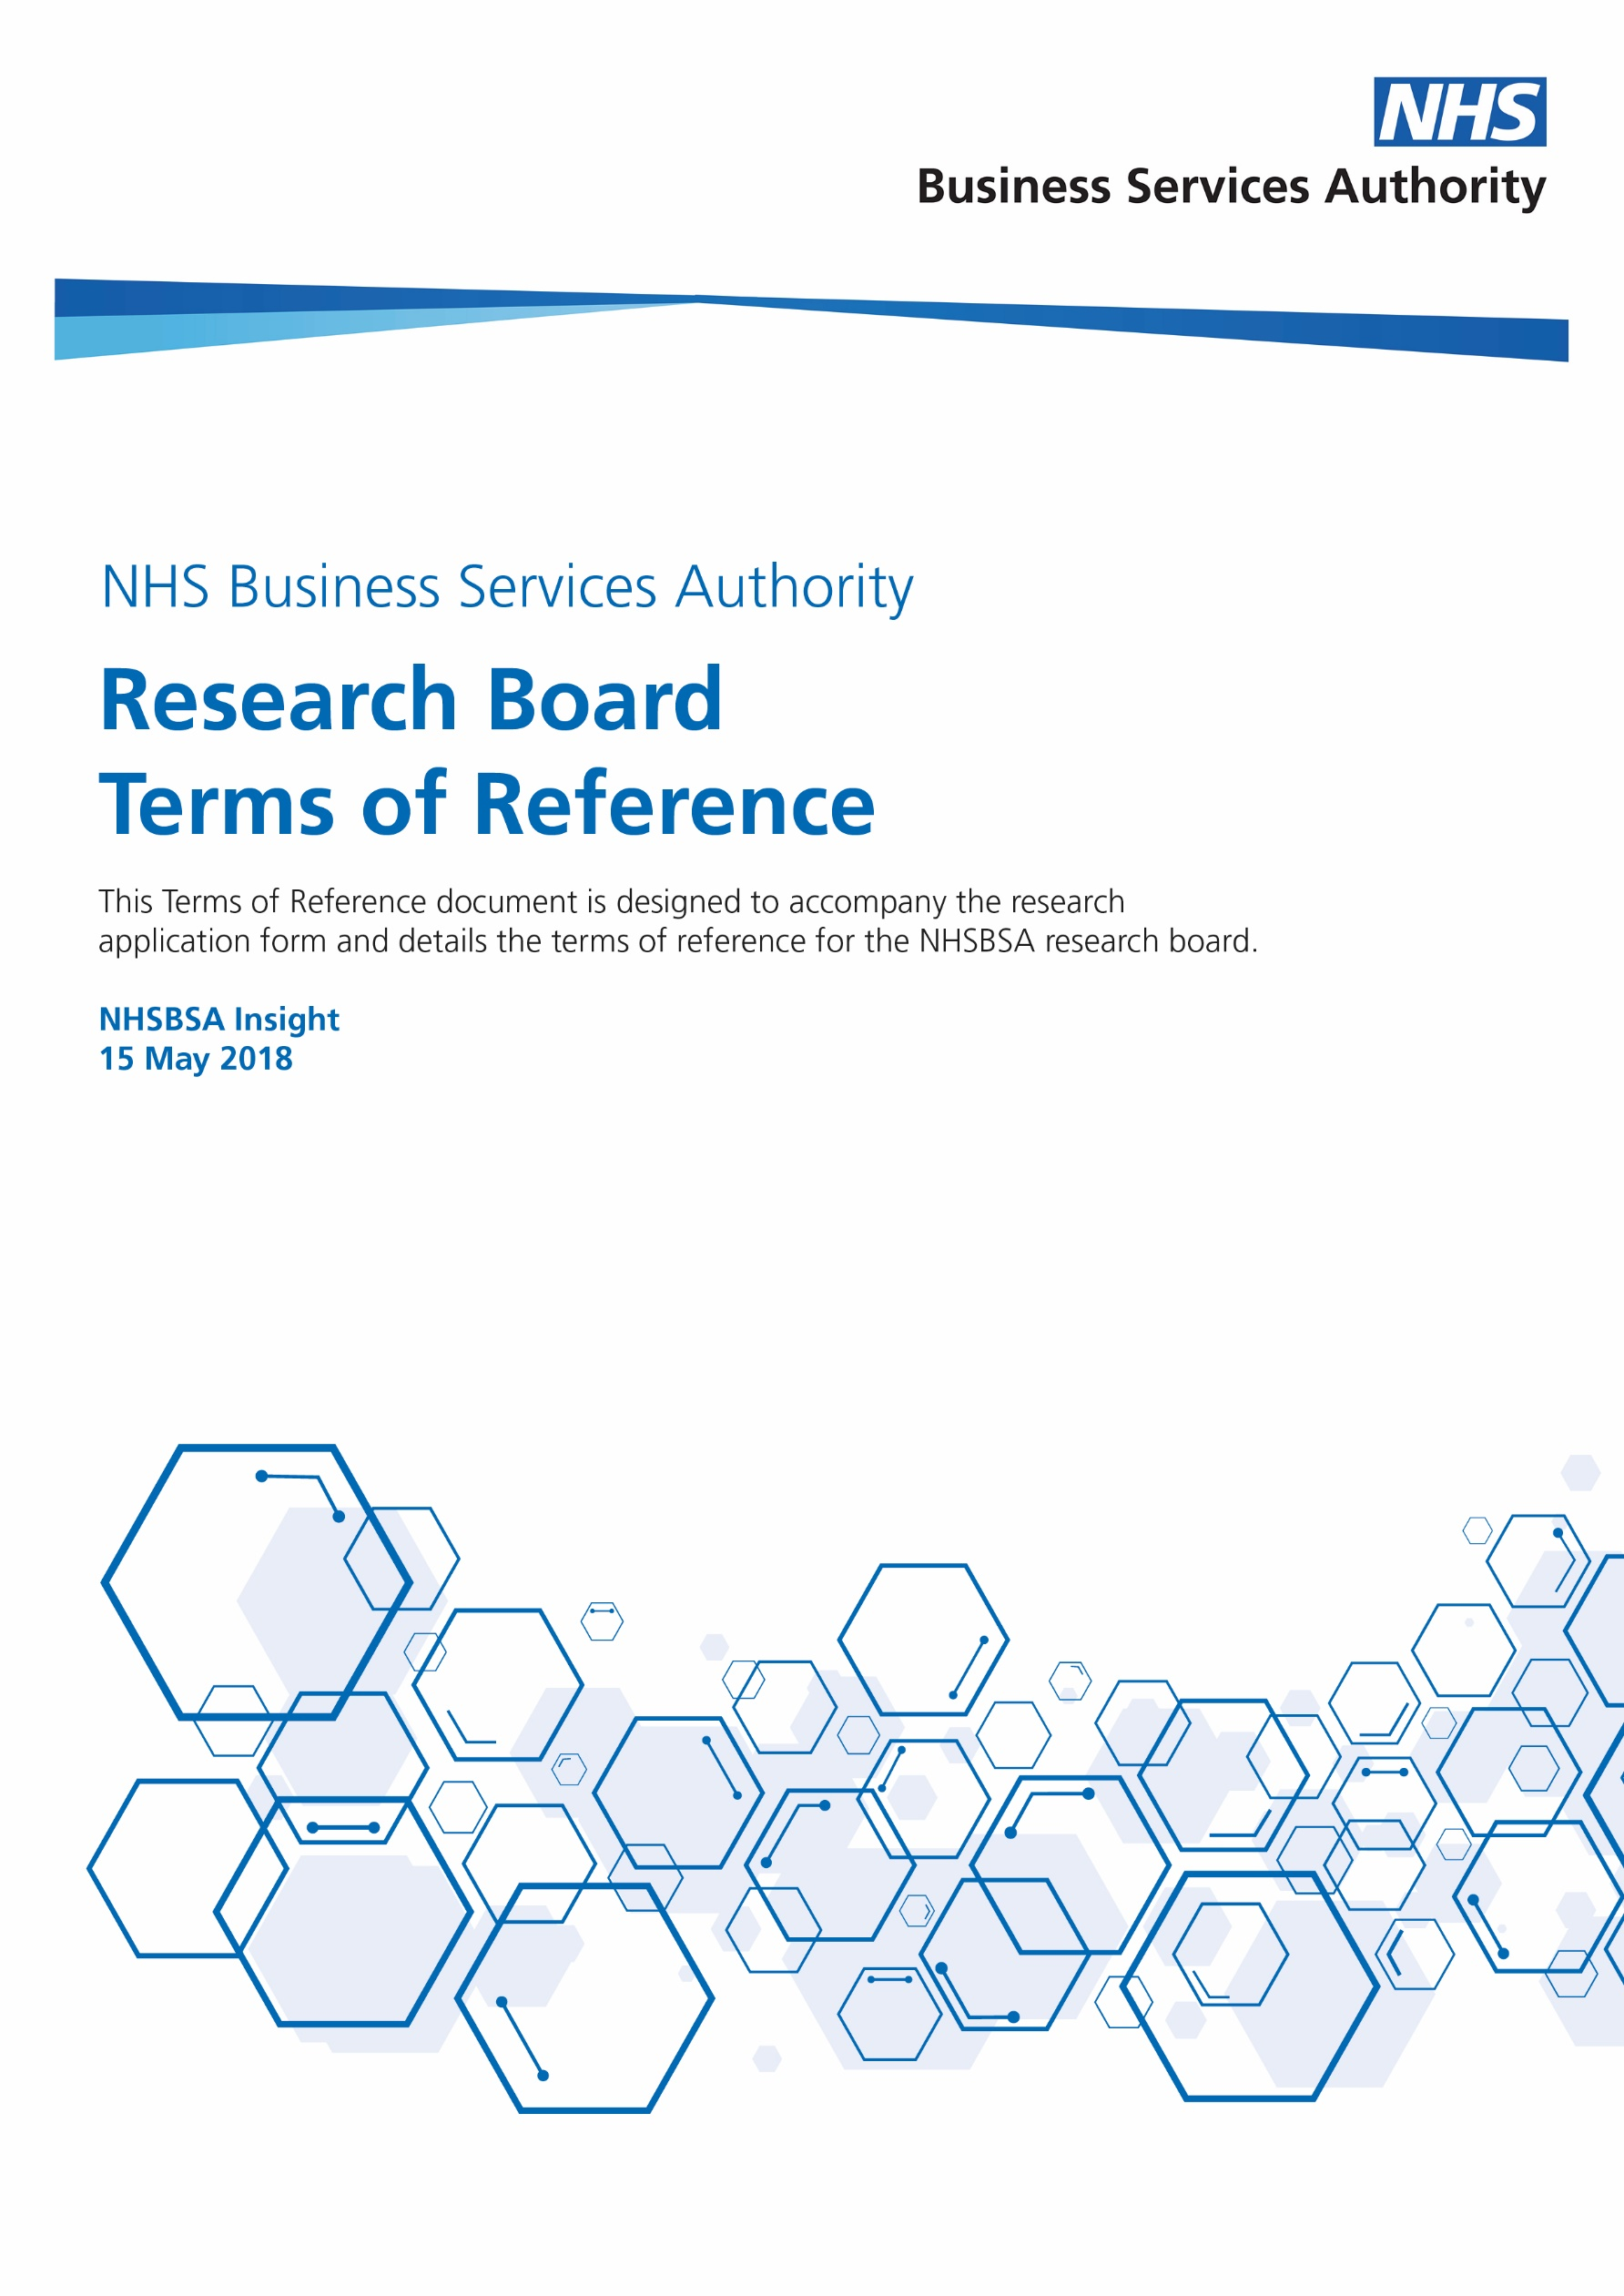

Supporting research

This document has been produced for organisations who would like to use the data held by the NHSBSA for research purposes.
The support that we can offer includes:
- Survey design and implementation
- Contacting NHS professionals on your behalf to invite them to participate in your research
- Analytical support using NHSBSA data
- Access to data extracts

Our selection processes

The NHSBSA Research Board has been established to facilitate and support research. The Research Board is comprised of senior stakeholders from the NHSBSA and its sponsoring organisations. The Research Board has been established to consider the various requests that we receive from researchers to support their research projects. Due to the volume and complexity of requests the NHSBSA receives it is not able to support all of them and therefore we apply selection criteria to prioritise and chose which projects to support.
All requests for research related to NHSBSA will be reviewed by the Research Board members who will come to a consensus on each application.
Researchers will receive a response to their request as soon as is possible, and typically between six to eight weeks from submission.

Reviewing applications

All applications will be judged on the following criteria:
- The research is being delivered by an unbiased, experienced, and credible team with academic backing
- Research governance is in place
- Compliance with NHS Information Governance and the Data Protection Act
- Sponsorship or collaboration with another NHS organisation
- Project outcomes that support policy or national frameworks to deliver best practice
- Whether the data and/or analysis requirements can be supported practically
- Clarity around what support will be required by NHSBSA
- Your ability to cover NHSBSA costs
- Whether the burdens placed on the NHSBSA is reasonable in the balance with the likely outcomes of the study
- Data or analysis requested is not already available in the public domain or planned to be in the public domain
- Whether the project can be accommodated within required timescales given other operational activities

Approval

If your research is approved, you will be expected to comply with any data sharing agreements and memorandums of understanding.

Completing the application

To discuss your application with the relevant NHSBSA team please email:
dataservicessupport@nhsbsa.nhs.uk
Once you are ready, please submit the application form hosted on the NHSBSA website to the same address.

Appendix A – Process Map

