eRD patient list data email
How to access the information

The following reports are offered monthly to practices.

- NHS Number Report - This report provides the NHS numbers for patients who may be suitable for eRD prescribing that have received the same medicines, dispensed for 10 or more months in the last 12 months.

- eRD Patient Review Report – This is a practice level data file and provides the NHS numbers for patients who will require a prescribing review as they have two remaining issues of their current batch issue, whether that’s 6, 8 or 12 issues.

- eRD Practice Report – This is a monthly report which shows your eRD activity and % change from the previous month for items and unique patients. This report may have previously been referred to as the ‘eRD burst report’

To sign up for these reports, email epssupport@nhsbsa.nhs.uk with the subject heading ‘3x eRD Reports’ and include in the body of the email:

- the practice ODS Code,
- practice name,
- the practice managers name, and
- the practice’s NHS.net generic email address that you would like the reports to be sent to.

The three reports are currently sent out separately each month, (between the 6th and 20th day). The NHS Number and eRD Patient Review reports are sent as Excel spreadsheets which are password protected.

We can only send these reports automatically to a generic practice email address to comply with GDPR requirements. Once the practice receives the reports, they are then in control of the data can forward it to an individual’s email account following their own GDPR rules.

At the first time of requesting the NHS Numbers Report a practice should receive this within 48 hours. Two separate emails will be delivered to the practice’s generic nhs.net email address supplied. Firstly, an email containing the password to access the data and then after a small-time delay, an email containing an attachment with the data file.

- The emails will originate from ISDATAWAREHOUSESYSTEM with the subject (Secure) COVID19- eRD
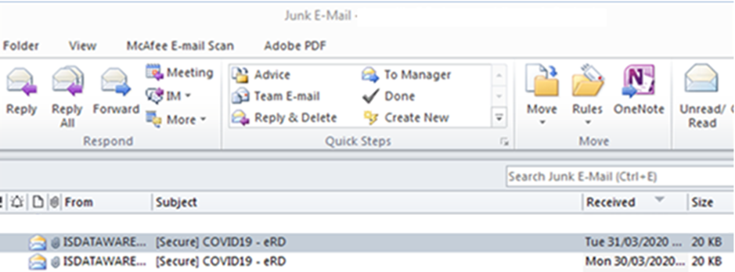

- Both Emails should appear within 30 minutes of each other
- In some cases, the emails will go to the Junk/Spam Email folder
  - The email must be moved to the Inbox to allow the zip file attachment to be opened
  - You can do this by
    - Right Click on the email, select Move and select Inbox or
    - Dragging the email into your Inbox
- If you do not receive either of the emails, please get in touch with epssupport@nhsbsa.nhs.uk and they will look to resolve this
- Double click on the attachment to open
- When opening the attachment it should present with the following:

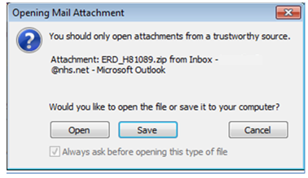

- By using the ‘Open’ option the zip file should open automatically, however if this does not work you will have to ‘Save’ the attachment to a local drive and then open the file

- Once opened the file explorer will be presented as follows:
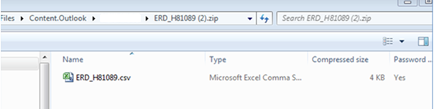
- Double clicking the eRD file results in the Excel file opening.
(Please Note: If the icon isn’t for Excel the csv file extension may be associated with a different application. To open in Excel it may be necessary to copy the file to an alternative local drive, open Excel and go to the File, Open dialog in Excel to open it.)
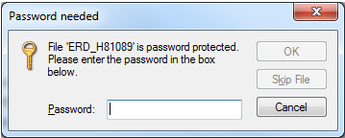
- The ‘Password needed’ dialogue box will then be presented

- Copy and paste the password from the email into the dialogue box
(Please note: Ensure only the password is copied and pasted, any spaces included will cause the password to fail. To ensure there are no mistakes in copying and pasting your password you may wish to copy the password from the email into a document such as Notepad and then copy and paste from there)
- On the rare occasion where more than one password is received, the password email with the most recent date stamp should be used.
- Once password is entered click OK and the file will open
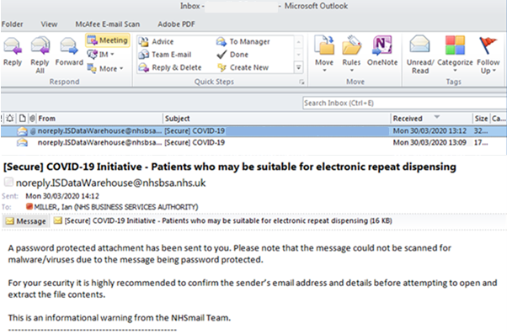
Some users may be presented with the message below when receiving the data file:

- The attached email must be opened in order to see the Email that has the Zip File

