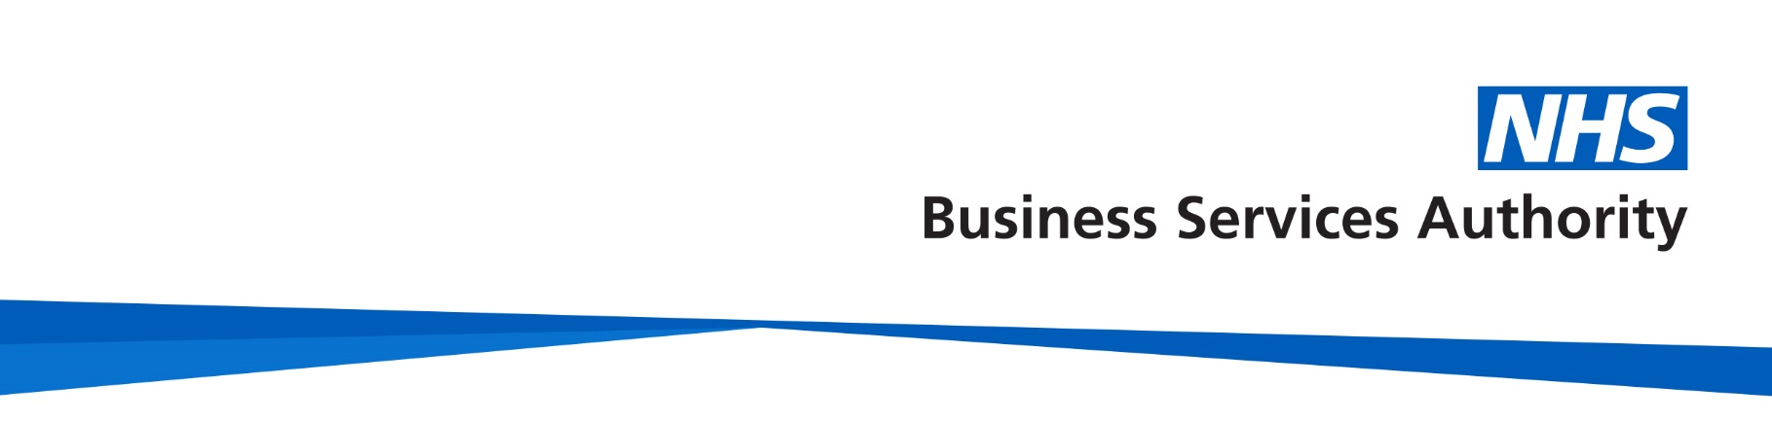
Increasing the use of electronic Repeat Dispensing

Patient email template

The NHS Business Services Authority (NHSBSA) works collaboratively with primary care staff to increase the use of electronic Repeat Dispensing (eRD).

We have created some email content you can use to promote eRD to your patients. We hope you find this useful. If you have any feedback or suggestions, please get in touch with us at: gpsupport@nhsbsa.nhs.uk

Legal basis for sending messages by text or email

The General Data Protection Regulation (GDPR) says you must have a lawful basis to use personal information to send promotional messages by text or email. It is appropriate to contact patients regarding eRD as it relates to providing direct care. However, there must be appropriate ‘fair processing’ to support this. This means you have let patients know why you might contact them, how, and provided them with an opportunity to not participate, or opt out. In many cases you will already have explicitly informed patients that they may be contacted via text message or email regarding their care and the service at the practice. If so, then you can send text messages and emails to patients informing them of eRD using our templates. If you have not previously informed patients that they may be contacted via text message or email, then you should provide this information and an opportunity for the patient to not participate, or opt out. This could be done by sending a text message or email and providing patients with a reasonable amount of time to opt out. Your GP practice is ultimately responsible for ensuring that patients’ personal information is used appropriately. Please contact your local information governance lead if you require further advice or support on this.

View general advice about GDPR

Email content

Subject line: Electronic Repeat Dispensing (eRD) a new way to receive your repeat medication.

Hello [Patient name],

[Name of practice] is moving suitable patients to electronic Repeat Dispensing (eRD).
You are receiving this email because you might be suitable for eRD.

eRD will help you protect yourself and continue to receive your regular medication. It means we can send your regular or repeat prescriptions electronically to a pharmacy of your choice. You can then collect your medication from your pharmacy or ask them to deliver it to your home. It’s easy to set up and you don't need a computer or electronic device.

You don’t need to do anything. Your GP will set up eRD for you.

Benefits of eRD

eRD allows your GP to prescribe your regular medicines for up to a year. It’s reliable, secure and confidential. Your regular prescriptions are stored securely on the NHS database, so they'll be ready at the pharmacy each time you need them.

Using eRD, you can:

- save time by avoiding unnecessary trips or calls to your GP every time you need to order a repeat prescription
- pick up your repeat prescriptions directly from your pharmacy without having to visit your GP
- spend less time waiting for your prescription in the pharmacy or GP practice, which means you can stay at home and avoid face-to-face contact when you need your repeat prescription during the coronavirus pandemic
- save paper – you won’t need a paper prescription to collect your medicine from the pharmacy

You can find more information at: www.nhsbsa.nhs.uk/eRD-patients

Thank you,

[Insert practice manager name]
Practice Manager's [GP Practice]
[GP Practice Phone no]

