C-104697

How to use early re-test codes 4.1 and 4.2 on a GOS form in England

In this guide, we will provide guidance on using early re-test codes 4.1 and 4.2 on a GOS (General Ophthalmic Service) form.

This is worth half a non-interactive Continuous Professional Development (CPD) point and is suitable for all General Optical Council (GOC) registrants.

**Learning Objectives**

* To understand the process required to correctly use early re-test codes 4.1 and 4.2.
* To understand best practice for submitting a GOS1 and GOS6 form.

**How to gain the CPD point**

This CPD will take approximately 30 minutes to complete.

To obtain 0.5 CPD points, you must:

* read the information in this article
* read the cited references
* pass the Multiple-Choice Questionnaire (MCQ) assessment with a score greater than 60%

The link to the MCQ assessment is available at the end of this article.

**What happens next?**

Upon completion of the MCQ assessment, you will receive an email outlining whether you have passed or failed.

This will be sent to the email address you entered on registering for the MCQ assessment. The email you receive stating that you have been successful in your MCQ attempt should be saved. You will need to upload the email as evidence when you are logging your CPD on the MyGOC website.

Feedback of the correct responses will be shared with both successful and unsuccessful responders.

**This guide covers:**

* An overview of GOS claiming and NHSBSA (NHS Business Services Authority) Post Payment Verification (PPV) activity
* Early re-test codes 4.1 and 4.2: what these codes are and how to use them correctly
* Best practice for submitting a GOS1 or GOS6 form

As specified in the Memorandum of Understanding (MoU), part of which is summarised in ‘Vouchers at a Glance’ (Figure 1), the Department of Health and Social Care (DHSC) made recommendations for the minimum interval between sight tests for specific patient categories in England.

If a contractor undertakes a GOS sight test at a shorter interval, you must annotate the GOS1 or GOS6 form with the appropriate early re-test code.

Furthermore, as per paragraph 2.1 of the Memorandum of Understanding, Contractors and Performers should not apply a blanket retest period for patients within a particular category.

“2.1 The GOS regulations require practitioners to satisfy themselves that a sight test is clinically necessary. Therefore, the intervals given below are not to be read as applying automatically to all patients in a category.”

Figure 1

**The NHSBSA encourage that any GOS sight test undertaken at an interval of less than two years has a reason noted on the clinical record card, along with an early retest code. This will also help the next optometrist to understand the reason for the early test.**

The MoU guidelines do not always reflect the impact of current practice or new professional guidance. For example, most diabetic patients are now seen in the national Diabetic Retinal Screening programme and would not be expected to present for a sight test at an interval of less than two years. The College of Optometrists’ guidance supports this:

“A216:If patients are in an NHS diabetic eye screening programme, recall should be the same as for patients who do not have diabetes.”

The College of Optometrists also recommends:

“A64: In the absence of clinical indications, you should not examine patients who are being monitored by the hospital eye service (HES) more frequently than every two years.”

As required by the regulations, you should only undertake a GOS sight test if it is clinically necessary (Figure 2, an extract from the GOS Model Contract July 2018). You should also exercise clinical judgement when recalling patients for their next sight test or issuing a change in prescription.

**General Ophthalmic Mandatory Services Model Contract (July 2018)  
Standard (Additional Services) General Ophthalmic Services Contract (October 2010)**

37.4.1. Subject to clause 38 the Contractor shall satisfy itself that the testing of sight is necessary.

**Testing of Sight**

30. The Contractor shall, having accepted an application from or on behalf of an eligible person for the testing of sight—

30.1. secure the testing of the patient’s sight to determine whether he needs to wear or use an optical appliance; and

30.2. in so doing, secure the fulfilment of any duty imposed on a tester of sight by, or in regulations made under, section 26 of the Opticians Act (duties to be performed on sight testing).

Figure 2: an extract from the GOS Model Contract – July 2018

GOS eligibility is based on clinical need and not refractive outcome. Therefore, you should not tell the patient they may need to pay privately for the sight test if no change in prescription is found.

Good record keeping is not only good practice but also ensures continuity of care and effective ongoing management for patients. It also supports GOS claims in the event of queries by the NHS. If a practice is subject to a PPV review, not documenting an early re-test code and the reasons for its use, on both the patient record and GOS 1/6 form, may lead to payment recovery.

Selection for PPV review is not an indication of wrongdoing. It is a process for both the NHS and contractors/performers to ensure claims are accurate and in accordance with the GOS contract. GOS Contract section 52 says you must:

“Keep full, accurate and contemporaneous records.”

If the sight test is at an interval of less than 2 years then it is essential that these records include the clinical reason for the early re-test, the relevant early re-test code, and the next sight test recall. Under PPV, the NHSBSA can make a written request to review NHS patient records. The records must be produced within 21 days. The NHSBSA will assess both the clinical record and the GOS 1/6 form (eGOS or paper format).

**Suggested evidence**

The Contractor will be asked to submit relevant records for the patient. [The GOC Standards of Practice for Optometrists and Dispensing Opticians](https://optical.org/media/201flx0e/standards_of_practice_for_optoms_dos.pdf), section 8, states that a registrant must “maintain clear, legible and contemporaneous patient records which are accessible for all those involved in the patient’s care”. As a minimum, these records must show:

* the consultation date
* the patient’s personal details
* the consultation reason and any presenting condition
* the details and any assessment findings
* any treatments, referrals, or advice that you provided, including any drugs or optical devices prescribed or a copy of a referral letter
* the consent obtained for any examination or treatment
* the details of those involved in the consultation including their names and signatures

To validate a GOS claim, the NHS also requires:

* the date of the last sight test (or approximate date)
* the previous prescription, including presenting vision or visual acuities (VA) at distance and near- *in the event the patient’s previous spectacle are not available at the sight test but the previous prescription is known, (from previous records, previous prescription copy or by contacting the previous optometrist), the visual acuity from this previous prescription should be attained by inserting it in a trial frame/phoropter.*
* the condition and age of the current spectacles

A GOC registered clinical advisor will assess individual GOS claims marked for payment recovery.

When considering performing an early sight test, you must investigate whether there is an alternative pathway or commissioned service that may benefit the patient more than a GOS sight test. For more information, contact your Local Optometric Committee (LOC) <https://www.loc-online.co.uk/> .

A GOS sight test must not be used more frequently for patients:

* with specific learning difficulties, including dyslexia, dyspraxia, dyscalculia, and attention deficit hyperactivity disorder.
* Under myopia management interventions. [Information from the College of Optometrists](https://www.college-optometrists.org/category-landing-pages/clinical-topics/myopia/myopia-management-guidance-faqs) currently says: “Myopia management is not currently funded by the NHS in the UK. This means you must pay for myopia management, and it is more expensive than traditional glasses or contact lenses.”

* Under locally commissioned services e.g., MECS/CUES. Existing urgent eye care services (MECS, CUES, PEARS or local equivalent) are not funded under GOS. Many ocular conditions we see in routine practice are not an emergency. This should be managed by the contractor/performer.

**What is early re-test code 4.1?**

Patient is needing complex lenses.

* A complex lens: a lens with a power in any one meridian of plus or minus 10 dioptres or more or a prism-controlled bifocal lens. If the distance prescription is below 10 dioptres but the reading addition takes it to 10 dioptres or more, the complex lens voucher applies to the reading spectacles only and not to the distance spectacles or to bifocal spectacles. If, subsequently, a patient is found to no longer require a complex lens, then you can claim a GOS sight test this time only and should advise the patient appropriately. It is also important to consider transposition of the patient’s prescription to determine if it satisfies the ‘complex lens’ definition.

**Examples of the appropriate use of early re-test code 4.1**

* **Clinical Record 1-** an example of a clinical record that correctly supports the use of re-test code 4.1.

* A prism-controlled bifocal (or multifocal) is a lens whose method of construction permits some independent control of prismatic effect or optical centration of the various portions of the lens.  This can include a “slab-off” or bi-prism lens where, for example, the near portion of one lens of a pair contains a prism to reduce the vertical prism imbalance that would otherwise occur in anisometropia.

Lenses with increased inset of the near segment to produce a limited amount of addition-dependent base-in prism and a pair of lenses with two different sized round segments to produce a limited amount of addition-dependent relative vertical prism, are not for the purpose of the GOS H voucher, prism-controlled bifocal, or multifocal lenses.

* **Clinical Record 2 –** an example of a clinical record that correctly supports the use of re-test code 4.1.

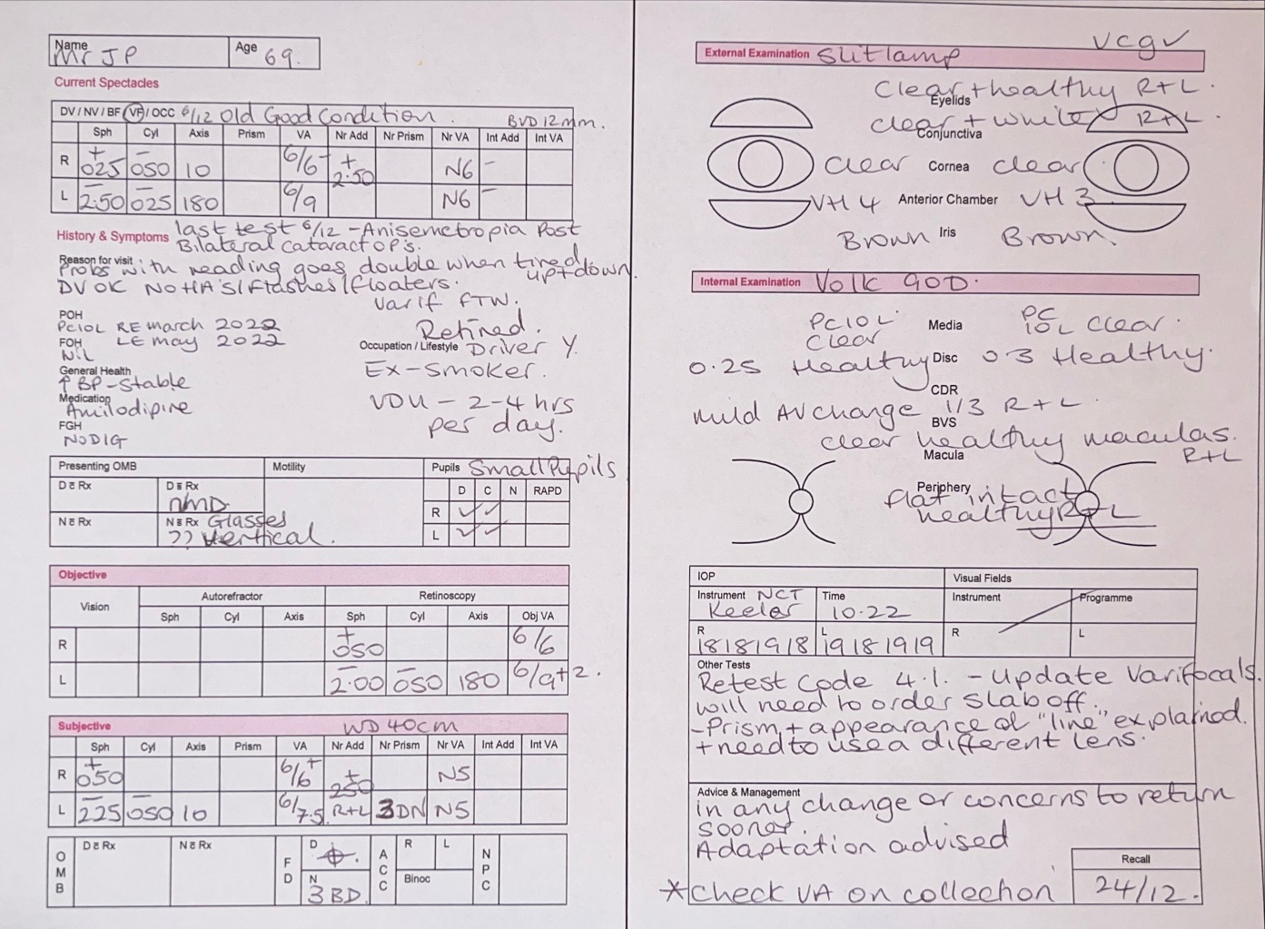

**Example 1:**

A patient who is new to the practice presents for a sight test after only twelve months since their previous sight test. The patient says they were told they would need a more frequent sight test due to their ‘high prescription.’

* focimeter the spectacles to determine the most current prescription.
* record the visual acuity in the presenting spectacles.
* record the visual acuity in the final prescription.
* confirm that the presenting prescription or final prescription satisfies the definition of ‘complex.’
* inform the patient of when their next sight test should take place, providing justification for your recall period in the clinical record.

The College of Optometrists recommends:

“A62: In the absence of clinical indications, you should not recall patients more frequently than the following intervals… 16 years old and over… Two years.”

You must note that in isolation, a complex lens prescription is not considered justification for a sight test at an interval of less than two years.

Where you consider it necessary to monitor a patient at an interval of less than two years due to reasons related to the complex lens prescription, you should clearly explain your justification in the clinical record and note re-test code 4.1 on the clinical record and GOS 1 form.

**What is early re-test code 4.2?**

A patient has corrected vision of less than 6/60 in one eye.

**Examples of the appropriate use of early re-test code 4.2**

**Example 1:**

A patient has presented for a sight test after only twelve months, but at the request of the last optometrist. The last sight test notes say the patient has poor vision one eye; the cause is pathology which is stable. The patient had been noticing some change to their binocular/stereoscopic vision, possibly due to the poor vision in one eye, and so was put on a 12 month recall for review.

You are advised to:

* record the monocular vision or VA in the presenting spectacles
* carry out the necessary binocular vision tests, record the tests and the results
* record the VA in the final prescription
* confirm that the patient has/had corrected vision of less than 6/60 in at least one eye at the sight test
* inform the patient of when their next sight test should take place and provide justification for the recall period in the clinical record

**Example 2:**

A patient has 3/60 vision in the right eye and 6/60 vision in the left eye. The previous optometrist noted they wanted to monitor the patient’s field of vision for possible referral for certification for sight impairment.

You are advised to:

* record the monocular vision and VA in the presenting spectacles
* record the VA in the final prescription
* confirm that the patient has/had corrected vision of less than 6/60 in at least one eye at the sight test
* carry out additional tests such as fields and intraocular pressures and record the test results
* inform the patient of when their next sight test should take place, providing justification for your recall period in the clinical record
* for your recall period in the clinical record.

**Please note that the list of examples is non-exhaustive and professional clinical judgement should always be used. The clinical record must support the clinical judgement and reason for the sight test.**

Considering the College of Optometrist’s guidance, as referenced above, it is important to note that in isolation, corrected vision of less than 6/60 in one eye, is not considered justification for a sight test at an interval of less than 2 years. Where you consider it necessary to monitor a patient at an interval of less than 2 years due to reasons related to poor corrected vision, you should clearly explain your justification in the clinical record and note re-test code 4.2 on the clinical record and GOS 1/6 form.

The College of Optometrists also provides guidance that:

‘A64 *In the absence of clinical indications, you should not examine patients who are being monitored by the hospital eye service more frequently than every two years.’*

It is therefore recommended that you check whether the patient for whom you are performing an earlier sight test for, is under the HES for reasons related to the complex prescription or corrected vision being less than 6/60.

To support using early re-rest code 4.2on examination your record should as a minimum include:

* the date of the last sight test (or approximate date)
* the consultation date and reason for visit
* the reason for the consultation and any presenting condition.
* the symptoms that the patient is experiencing
* the age and condition of the current spectacles
* the details of the previous prescription, including the presenting VA’s distance and near or unaided vision, and any refraction with VA’s
* details of external and internal examination
* a note of all tests carried out to investigate symptoms
* the details of any recommendations or advice provided, including drugs or optical devices prescribed or a copy of a letter to the GP
* the consent obtained for any examination or treatment
* the details of those involved in the consultation, including names and signatures
* the recommendation for the date of the next sight test with the justification on the clinical record. If the recall is shorter than two years, then it is encouraged to note a suggested re-test code to help the next performer understand the rationale behind this
* the re-test code which should be recorded on both the clinical record and the GOS 1/6 form

**Best practice for submitting your GOS 1/6 form**

* Record the dates of the latest and last sight tests on both the patient’s record and the GOS 1/6 form. Make sure you provide the date within the last sight test field in a valid format. Only the year is required if the last sight test was more than two years ago. The following formats are accepted:
  + YYYY (for example 2019)
  + MMMYYYY (for example MAR2019)
  + DDMMYYYY (for example 01032019)
* Clearly specify the clinical justification for the early re-test on the patient’s record.
* Record the tests you have performed and the corresponding results on the patient’s record.
* Include an early re-test code if the sight test is performed at a shorter interval than two years.
* Record the early re-test code on both the patient’s record and the GOS 1/6 form. Select the most accurate, appropriate, and consistent code across these records.
* Write all other information on the GOS 1/6 form in the correct place, correlated with the information on the patient record.
* Select a recall period for the next sight test on the patient’s record. If the interval is less than two years, it is good practice to suggest a retest code to help the next performer.

**Complete the MCQ assessment:**

You can now complete the MCQ assessment. Use the link or QR code to access the assessment.

Access the [online MCQ assessment.](https://forms.office.com/e/C0Y8hcDs7n)

**For more information:**

* Visit [our website](https://www.nhsbsa.nhs.uk/provider-assurance-ophthalmic-services)
* Read [Making accurate claims England 2022](https://www.fodo.com/members/guidance/category-3/making-accurate-claims/)
* Read [Vouchers at a glance – England 2022](https://www.abdo.org.uk/wp-content/uploads/2023/03/13347B-2023-Voucher-England-FINAL.pdf)
* Read guidance from [The College of Optometrists](https://www.college-optometrists.org/clinical-guidance/guidance)