

eDEN – Finance Users

Accessing Finance reports

Interactive Contents

Use this interactive content list to jump straight to the content you want to see. Just click the titles below to go directly to that section:

Activating your account

Signing in to eDEN

Accessing the ICB Finance reports

Accessing the Regional Finance Reports

Navigating the system

Getting more help

Activating your account

Once you are registered for the system your account must be activated and password and security question details set to allow you to access the system.

An email will be sent containing account details and a link to the system.

1. Click the link to activate your account.

hand indicating to click on the activate your account link 

1. Create a password.

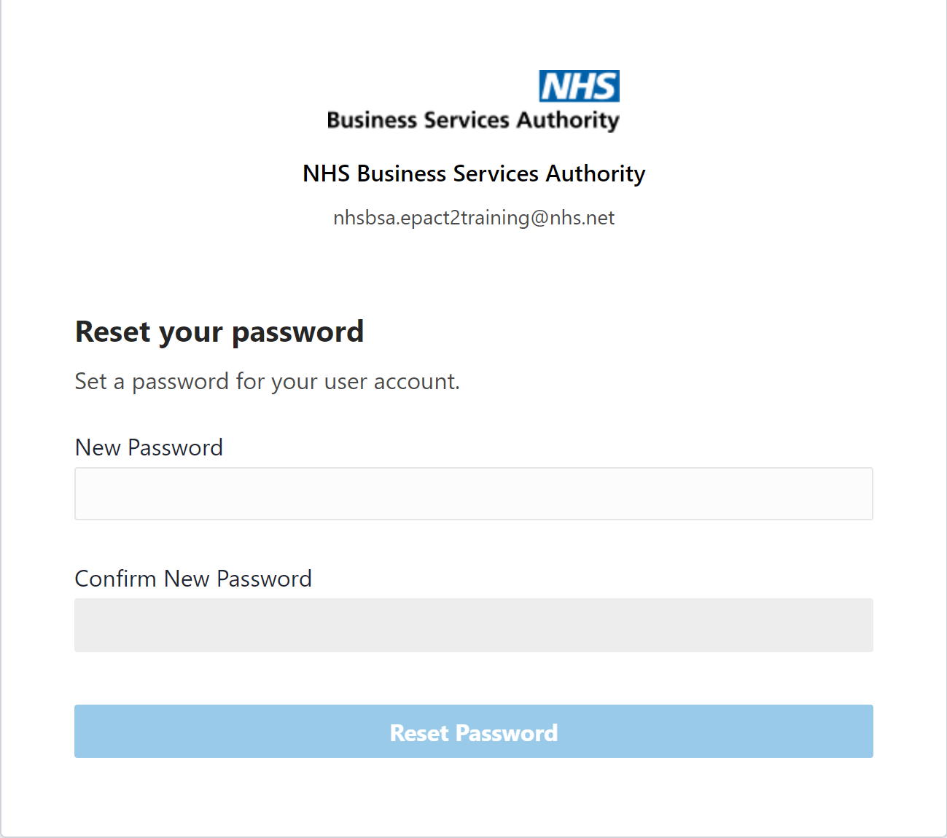

1. Click ‘Reset’ password.

images showing new password boxes complete and hand hovering over 'Reset' Password' indicating to click on button once you have completed your password

1. You will be notified of the password change success.

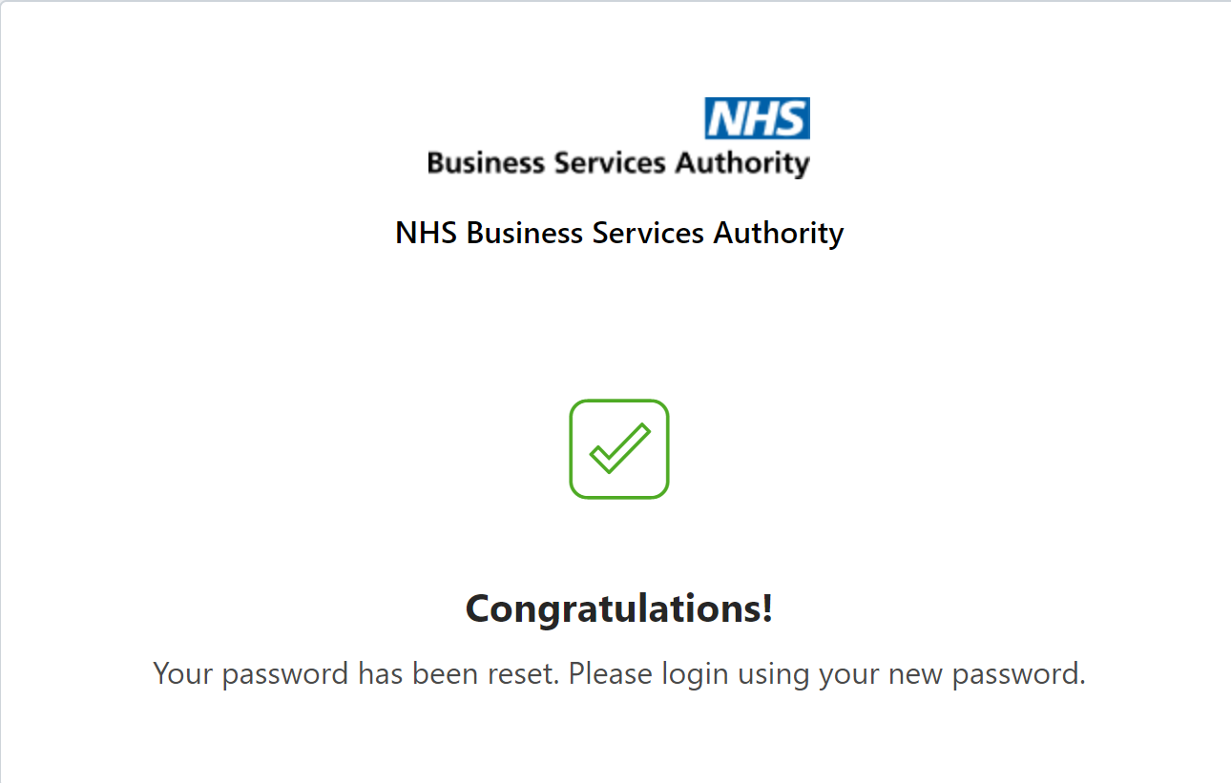

You can now go to the sign in page and log into your new eDEN account.

# Signing in to eDEN

1. Go to: <https://www.nhsbsa.nhs.uk/access-our-data-products/eden>
2. Graphical user interface

   Description automatically generated with medium confidenceClick on ‘Log in to eDEN’.

You will be taken to the sign in page for your eDEN account.

1. Enter your email address in the 'Username' box and your password in the 'Password' box.

1. Click ‘Sign in’.

Accessing the ICB Finance reports

1. Access eDEN England Commissioner landing page

1. ICB Finance reports can be accessed via the NHS England Dentistry Dashboard v1 located in the ‘Dashboards’ section of the landing page.

1. Once selected the finance reports are located under either the ‘Finance’ (for 2022/23 financial year reports) or ‘ICB Finance’ (for 2023/24 financial year reports onwards) tabs



1. The prompt can be used to select the time period and organisation(s) required.

# Accessing the Regional Finance Reports

1. Access eDEN NHS England Central Team landing page

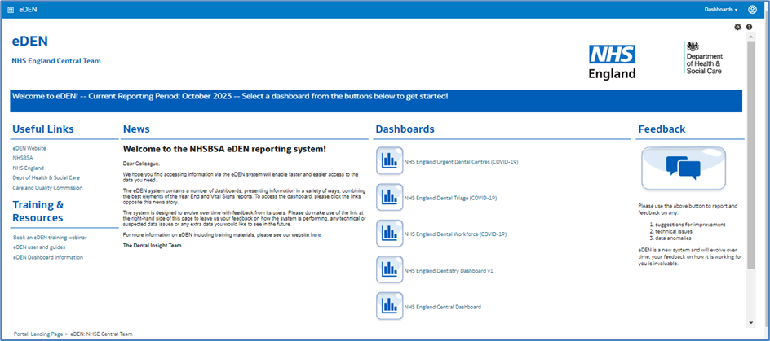

1. Regional Finance reports can be accessed via the NHS England Central Dashboard located in the ‘Dashboards’ section of the landing page.

1. Once selected the finance reports are located under the ‘Finance’ tab



1. The prompt can be used to select the time period and organisation(s) required.

Navigating the system

Once selected, the dashboard will open in a separate browser window.

If you wish to navigate back to the landing page after you have viewed other eDEN content, select the original browser window.

Alternatively, use the breadcrumb trail at the bottom of any page by selecting ‘eDEN: England’

# Getting more help

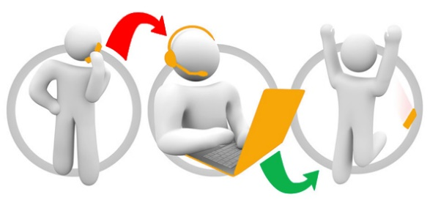

**Additional training material and user guides**

The eDEN training team has developed several how to guides to help you get the best out of eDEN. These can be found on our [eDEN Training Hub webpage](https://www.nhsbsa.nhs.uk/access-our-data-products/eden/eden-training-hub)

**Webinar sessions**

We offer a free webinar training service to all our users, and you can book as many sessions as you need.

Our webinar sessions are 45 minutes long and are tailored to different user types.

Our experienced trainers deliver these sessions using MS Teams and you can take part wherever you are as long as you can get online.

You can find our more and book your webinar by going to our [eDEN Training Hub webpage](https://www.nhsbsa.nhs.uk/access-our-data-products/eden/eden-training-hub)