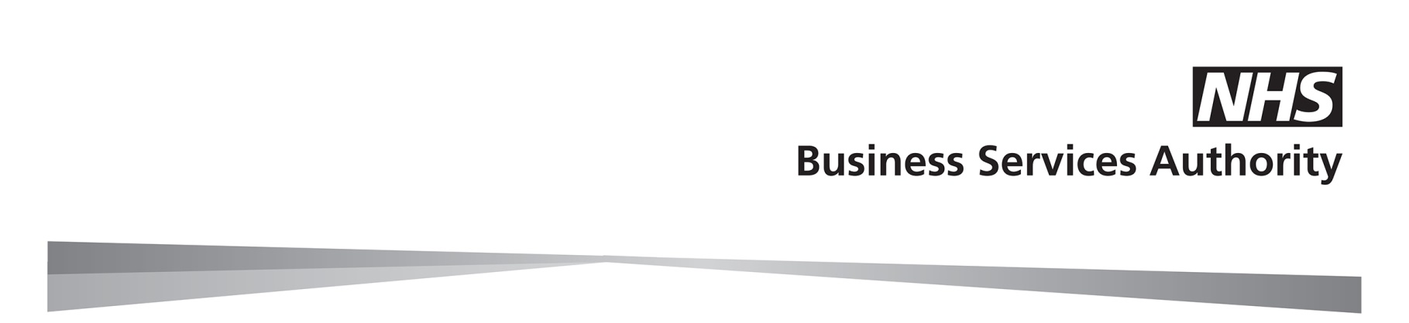
NHS Pensions - Early Retirement Reduction Buy Out (ERRBO) Application for agreement (2015 Scheme members only)

Part 1 - To be completed by the member in all cases

Surname
First names
Address
National Insurance number
Membership number SD |  |  | /
Date of birth |  |  | / |  |  | /
Your normal pension date (same as your State Pension date)
Buy out to purchase in whole years: 1, 2 or 3 |  |  |  |  |  |  |  |  |  |  |  | years |  |  |  |  |  |  |  |  |  |  |  | days
(a part year may be applicable in certain cases)
Additional percentage contribution rate |  |  |  |  |  | %
ERRBO agreement start date |  |  | / |  |  | /
Provide details of all current employers

Complete this section using the details we provided in the quotation. Please consider the options carefully. Once the application has been accepted we cannot allow you to reduce the ERRBO.

 | I have read the ERRBO factsheet and confirm that I would like to make a purchase. If I have more than one NHS job, I understand that I must pay the additional contributions in all those jobs.
Your signature
Date |  |  |  | / |  |  | /

Please send a copy of the quotation along with this form to your employer.

How we use your information

The NHS Business Services Authority – NHS Pensions will use the information provided for administering your NHS Pension Scheme membership and processing payment of your NHS pension benefits. We may share your information to administer and pay your NHS pension, enable us to prevent and detect fraud and mistakes, for debt collection purposes, or as required by law. For more information about who we share your information with and how long we keep your personal data and your rights, please visit our website at www.nhsbsa.nhs.uk/yourinformation

Part 2 - To be completed by the employer only after the member has completed Part 1.

The date of birth provided by the member in Part 1 must be verified. Tick this box to confirm verification.

Employer declaration

I confirm the member is in pensionable employment. I agree to collect the additional contributions and pay them to NHS Pensions in accordance with the Scheme regulations.

Pensions Officer’s signature
Print name
Date |  |  | / |  |  | /
EA name
Telephone number
EA code
EA/GP name stamp

Please send the completed form to NHS Pensions at:

NHS Pensions
PO Box 683
Unit 5
Newcastle Upon Tyne
NE5 9EE

We will write to you and the member to confirm whether the application has been accepted.

