

**NHS Pensions Online Guide (POL)**

27. AW8

Contents

Important - Notes to remember before submitting form AW8 3

Completion of the electronic AW8 7

Part 1 – Payable date and reason for retirement 8

Part 2 – Employment details 11

Part 3 - Pay details 12

Part 4 - TPP details for part time workers 14

Part 5 - Redundancy cases 15

Part 6 - Miscellaneous inputs 16

Part 7 – Marital details and census information 19

Part 8 - The HM Revenue and Customs information screen 20

Part 9 – Member’s address and bank details 21

Overseas bank account 21

Voluntary deductions 23

Confirmation of input details 24

Frequently Asked Questions 25

Appendix A – Additional bank account information 27

# Important - Notes to remember before submitting form AW8

If for any reason, the retirement benefits claim form (AW8) cannot be submitted via POL, the paper AW8 should be sent to The National Health Service Business Services Authority (NHSBSA) for processing. When sending the paper AW8 you must supply a valid reason for why you have been unable to submit the form via POL. If a reason is not provided, the application will be returned to you for submission via POL.

The information listed below must be sent to The NHSBSA immediately after the submission of the AW8 on POL. The NHSBSA will not be able to process the application if the information is outstanding.

**Important -** Emails (including attachments) sent via the internet may not be secure. It is the Employers responsibility to ensure that their email service is satisfactorily configured to ensure protection of the content in transit, and they may prefer to use a postal service. Employers who are using NHSMail can refer to the [NHS Digital website](https://digital.nhs.uk/nhsmail) to gain assurance that the content of emails is adequately protected within the service.

In either case, The NHSBSA cannot be held responsible if the information is sent to an incorrect email address.

If the member is employed as a Practitioner, the email address you should contact is [practitioners@nhsbsa.nhs.uk](mailto:practitioners@nhsbsa.nhs.uk)

For all other members, please contact [polia3@nhsbsa.nhs.uk](mailto:polia3@nhsbsa.nhs.uk)

Partial Retirement Supplementary Form

To be submitted once the AW8 has been completed for Partial Retirement.

**Overseas mandate for foreign bank account details**

See part 9, overseas bank details section, for details on how to submit the AW8 via POL for a member with an overseas bank account. The [overseas mandate forms](https://www.nhsbsa.nhs.uk/member-hub/applying-your-pension) can be found on our website.

**Her Majesty’s Revenue and Customs (HMRC) protection certificates**

See part 8 for details on how to submit the AW8 via POL for a member with a protection certificate.

**Maximum tax free amount**

When entering the member’s lump sum decision (part 6, section 5), you are unable to specify whether the member wishes to receive the maximum lump sum which may incur a tax charge, or whether they wish to receive the maximum tax free amount. Select whether the member wishes to receive no additional lump sum, the maximum or a specific amount. The NHSBSA will contact you if they require any additional information.

**Redundancy supplementary information checklist or concurrent pensionable employment form (AW343)**

If the member is claiming benefits on redundancy, please complete the redundancy supplementary checklist and send this to [polia3@nhsbsa.nhs.uk](mailto:polia3@nhsbsa.nhs.uk) The [redundancy supplementary information checklist](https://www.nhsbsa.nhs.uk/employer-hub/employer-forms) can be found on our website.

Concurrent pensionable employment form (AW343) should be sent if the member is claiming redundancy benefits from one post only. This should be sent to [polia3@nhsbsa.nhs.uk](mailto:polia3@nhsbsa.nhs.uk) The [concurrent pensionable employment form (AW343)](https://www.nhsbsa.nhs.uk/employer-hub/employer-forms) can be found on our website.

**Interests of Efficiency (IOE) checklist**

The Interests of the Efficiency (IOE) checklist will require completing for all IOE retirements. The [Interests of the Efficiency (IOE) checklist](https://www.nhsbsa.nhs.uk/employer-hub/employer-forms) can be found on our website. Once the AW8 has been submitted on POL, please send the checklist to [polia3@nhsbsa.nhs.uk](mailto:polia3@nhsbsa.nhs.uk)

**Serious ill health over normal pension age**

The application should be submitted with the reason for retirement as Age. You must then notify The NHSBSA immediately those benefits are to be commuted and send the [application to commute age retirement benefits on grounds of serious ill health form (AW341a)](https://www.nhsbsa.nhs.uk/member-hub/applying-your-pension).

**Serious ill health under normal pension age**

The application should be submitted with the reason for retirement as Commuted Incapacity. You must then notify The NHSBSA immediately that benefits are to be commuted and send the [application to commute ill health retirement benefits form (AW341)](https://www.nhsbsa.nhs.uk/member-hub/applying-your-pension).

**Maximum service/maximum pensionable age details**

If the member has reached maximum pensionable age or maximum service the employment should be terminated, where possible, with an exit code of 11 (ceased to be pensionable, upper age limit).

**Important –** You must ensure that the correct payable date is entered onto POL. The payable datefor benefits will be the day after the member’s non-pensionable last day of employment. For members of the 1995 Section of the 1995/2008 Scheme, the Total Pensionable Pay (TPP) periods that are produced on POL will be the last three years to the date the member reached maximum pensionable age/service and the pension record was terminated.

If you are unsure if the member has achieved maximum age/membership, please email [pensionsawards@nhsbsa.nhs.uk](mailto:pensionsawards@nhsbsa.nhs.uk) with the subject title ‘Award pending – Maximum age/membership’. They will then advise accordingly.

**Same sex marriage where male member is married to a male**

See part 6, section 7 for details on how to submit the AW8 via POL. You will then need to email The NHSBSA to advise that the member is a male member married to a male.

**Pay protection within 12 months of retirement**

If the member has pay protection within 12 months of retirement, please complete [form AW8 Annex](https://www.nhsbsa.nhs.uk/employer-hub/employer-forms) and send to [polia3@nhsbsa.nhs.uk](mailto:polia3@nhsbsa.nhs.uk)

**Claiming pension benefits from a later date**

Where the member is claiming pension benefits from a date later than their last day of Scheme membership, you must send the [AW8 supplementary form](https://www.nhsbsa.nhs.uk/employer-hub/employer-forms) to advise The NHSBSA of the payable date of benefits.

Where a member is under normal pension age when they opted out of the Scheme, the application should **not** be processed on POL and the paper form must be sent to The NHSBSA.

Where a member is over normal pension age when they opted out of the Scheme, the application should be submitted on POL with the correct prospective payable date entered. The payable date will be the day after the members last day of non-pensionable employment.

**Disallowed days**

If a member has disallowed days within the pay periods, (last three years for 1995 Section, 10 years for 2008 Section) you must advise The NHSBSA of the following information:

* The exact dates of the disallowed days.
* Confirmation of whether the disallowed days were followed by annual leave, paid notice or return to work. Please also supply the relevant dates.

**Important –** the employment should be terminated with the members last day of employment with you, not the day that they went onto no pay.

**Re-employed Pensioners / members with benefits already in payment**

**When submitting an AW8 for a re-employed pensioner, or a member who already has benefits from a previous scheme in payment, POL will not produce the bank details section of the form. Benefits will be paid into the bank account details that their current benefits are being paid into.**

**Partial Retirement – 1995, 2008 and 2015 Scheme**

Applications for Partial Retirement must now be submitted via POL, and the supplementary form submitted via email to [polia3@nhsbsa.nhs.uk](mailto:polia3@nhsbsa.nhs.uk)

* The date the member wishes to take Partial Retirement.
* That the current rate of pensionable pay has been in place for at least 12 months before taking Partial Retirement.
* Confirmation that the pensionable pay will reduce by at least 10%.
* That the reduced pensionable pay will remain in place for at least 12 months.
* The percentage level of drawdown required, minimum 20%, maximum 80%.
* Employer pay and hours (if part time) from 1 April to the date before benefits are to be drawn down.

**Data issues preventing submission of the AW8**

If the record has a data issue that you are unable to rectify, please email [datamanagement@nhsbsa.nhs.uk](mailto:datamanagement@nhsbsa.nhs.uk) who will correct the issue to enable you to continue processing the AW8 electronically. In subject header please input ‘Award Pending’

**Action to be completed before submitting the AW8**

Before you submit the AW8, the following action will need to be taken:

* The member’s employment will require terminating by submitting form SD55T via POL, unless the member is claiming Partial Retirement.
* The member’s date of birth must be verified
* All relevant sectionsof the paper AW8 form must be complete.
* Check if any additional information needs to be sent to The NHSBSA.

**Retention of the completed paper copy of the AW8**

NHS Pension Scheme application forms must be retained by NHS employers for a minimum of seven years. After seven years, the forms must be destroyed under confidential conditions that meet Department of Health and Social Care guidelines.

# Completion of the electronic AW8

Once you have selected the AW8 link in E-Forms, the following screen will appear.

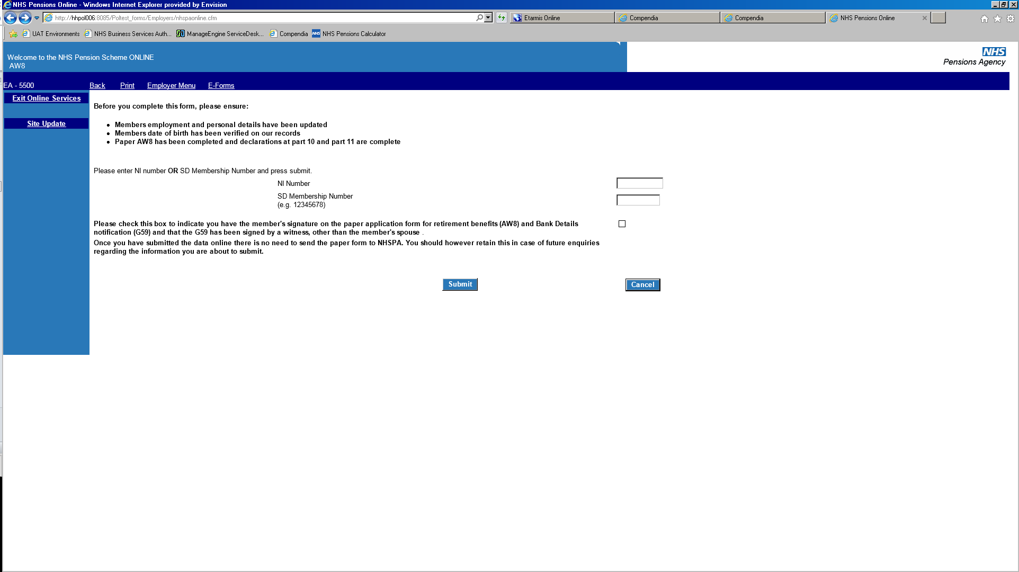

Enter the member’s NHS Pension Scheme membership number (SD) or National Insurance number (NiNo) into the relevant box. You must tick the small box to identify that checks have been made to the relevant section of the AW8. If you do not tick the box a message will be produced and you will notbe able to continue.

# Part 1 – Payable date and reason for retirement

The member details are prepopulated from the information held on NHSBSA records. If any information is incorrect, please make the amendments before submitting the AW8.

The last day of membership displayed is the date that the employment has been terminated via form SD55T. If this is incorrect, please amend by form SD55E on POL, before continuing with the AW8.

If the member is claiming Partial Retirement the last day of service will be displayed as the date last cyclic updated to, please ensure this is up to date.

The member’s Scheme membership will determine what option boxes are produced.

**Important –** It is the employer’s responsibility to ensure that the member is eligible to claim specific Scheme benefits and that the payable date and reasons for retirement are correct. POL has limited validations.

You must ensure that the correct payable date and reason for retirement are input. If these are incorrect it may lead to a delay in the member’s application and incorrect benefits.

**One Section/Scheme only**

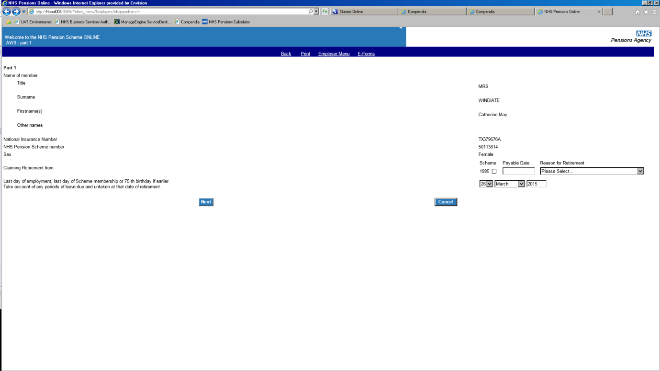

Tick the box to select 1995 (or 2008, 2015 dependent upon the member’s Section/Scheme membership). Insert the relevant payable date and select the reason for retirement.

If Reason for Retirement is Partial Retirement an additional box for Reason for Partial Retirement will be produced and the reason of Age or ARER must be selected.

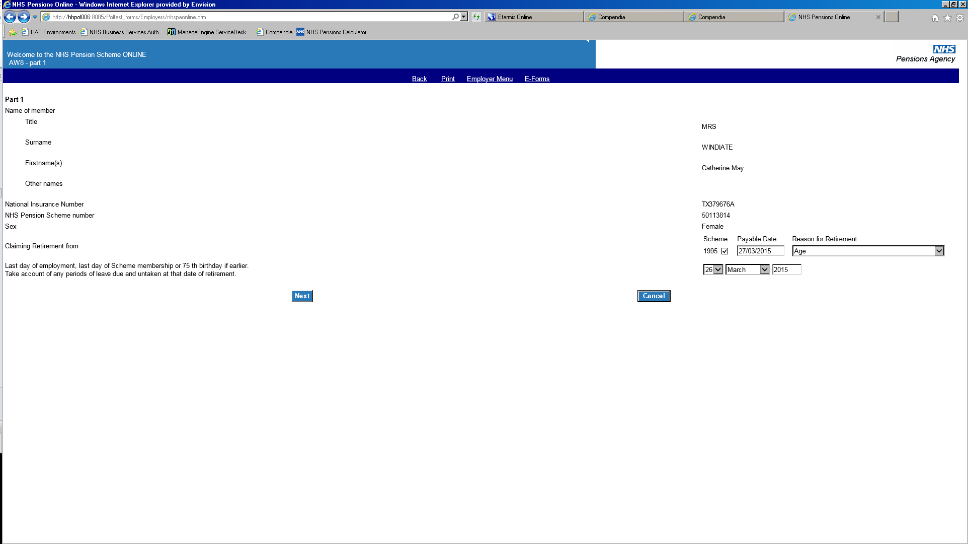

Select **next** to continue.

**Either Section/Scheme**

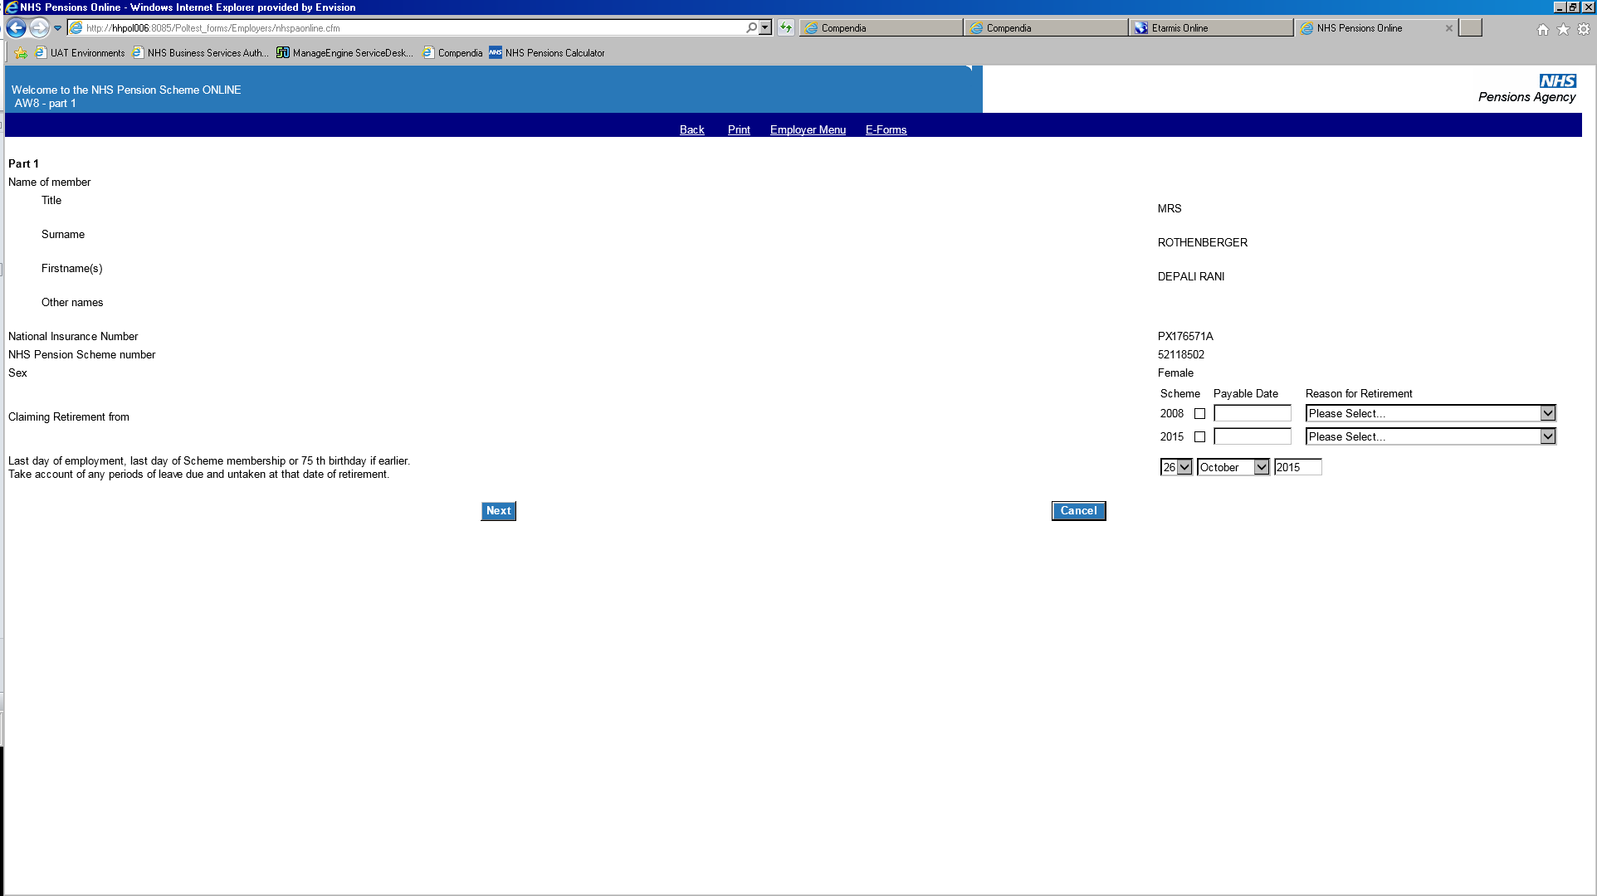

If the member wishes to claim benefits from both Schemes, you will need to tick the box next to each Section/Scheme, inserting a payable date and selecting a reason for retirement for each Section/Scheme.

If Reason for Retirement is Partial Retirement an additional box for Reason for Partial Retirement will be produced and the reason of Age or ARER must be selected.

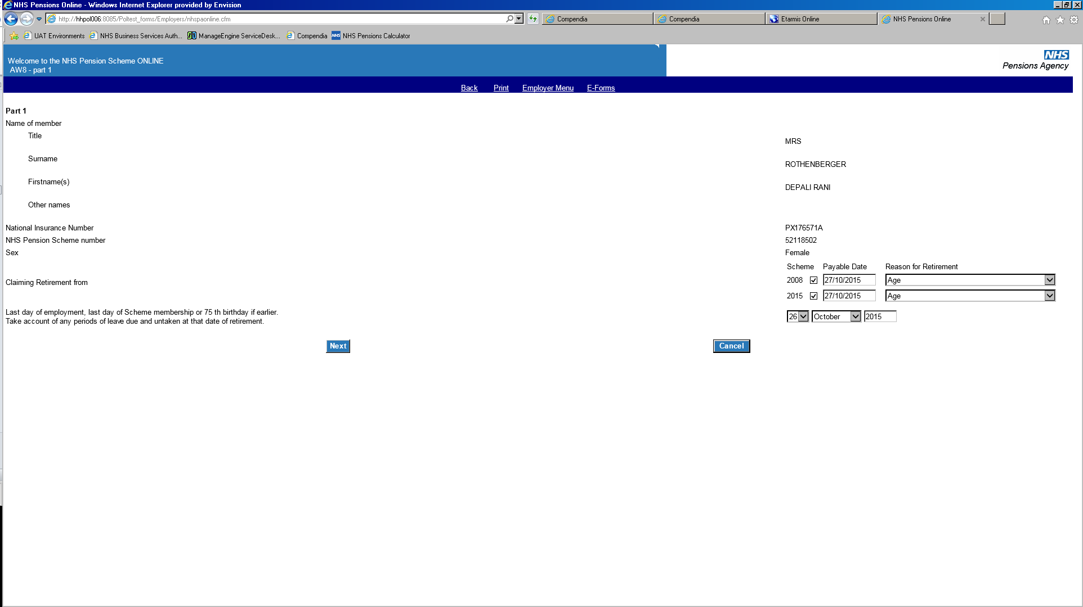

If the member only wishes to claim benefits from one Section/Scheme, tick the relevant Section/Scheme entering a payable date and reason for retirement for that Section/Scheme only.

If Reason for Retirement is Partial Retirement an additional box for Reason for Partial Retirement will be produced and the reason of Age or ARER must be selected.

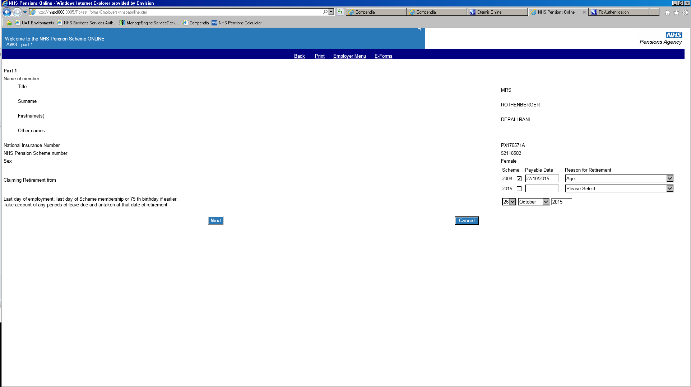

**Both Sections/Schemes**

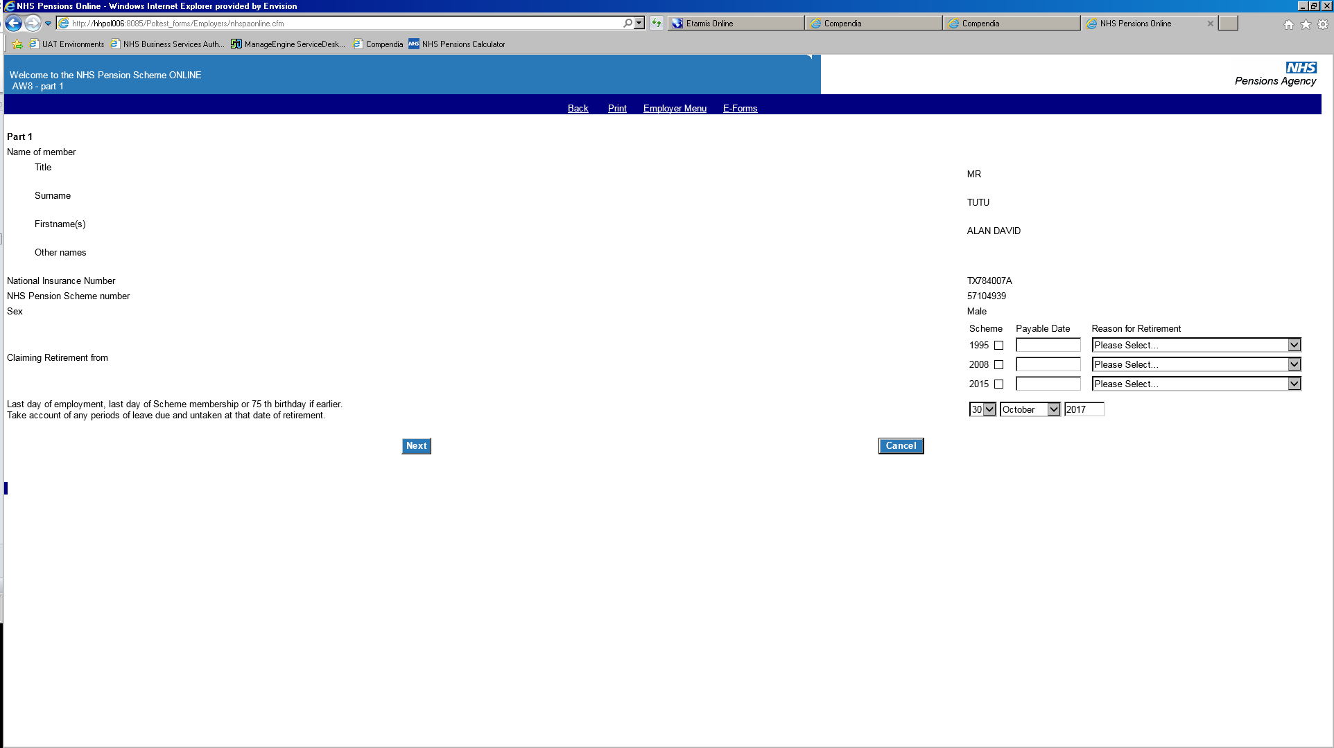

If the member wishes to claim benefits from all Sections/Schemes, you will need to tick the box next to each one, inserting a payable date and selecting a reason for retirement for each Section/Scheme.

If the member only wishes to claim benefits from one or two Sections/Schemes, tick the relevant box entering a payable date(s) and reason for retirement for that Section/Scheme

If Reason for Retirement is Partial Retirement an additional box for Reason for Partial Retirement will be produced and the reason of Age or ARER must be selected.

Select **next** to continue.

**Ill health**

**Important –** If a member has deferred benefits in a separate Section/Scheme they must also submit an application to be accepted for ill health retirement for benefits from that Section/Scheme before the AW8 can be submitted.

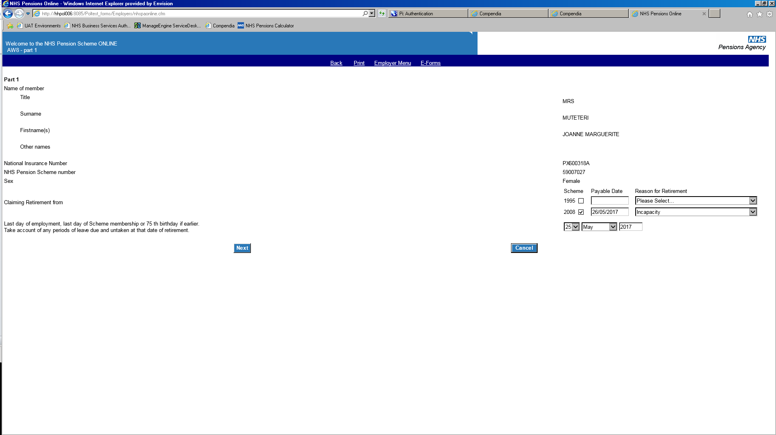

Select **next** to continue

**Commuted ill health**

**Important –** If a member has deferred benefits in a separate Section/Scheme they must also submit an application to be accepted for ill health retirement for benefits from that Section/Scheme.

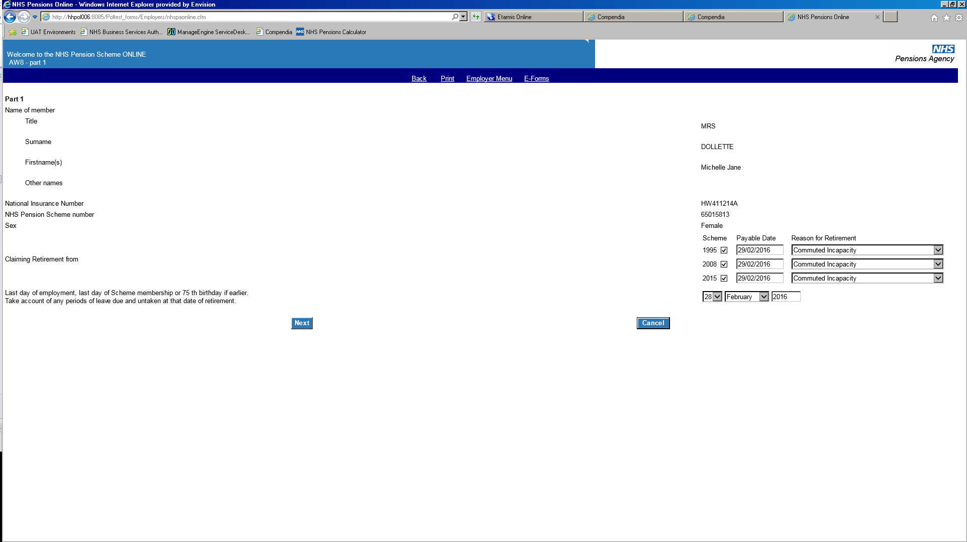

Upon selecting **next** the following question will appear.

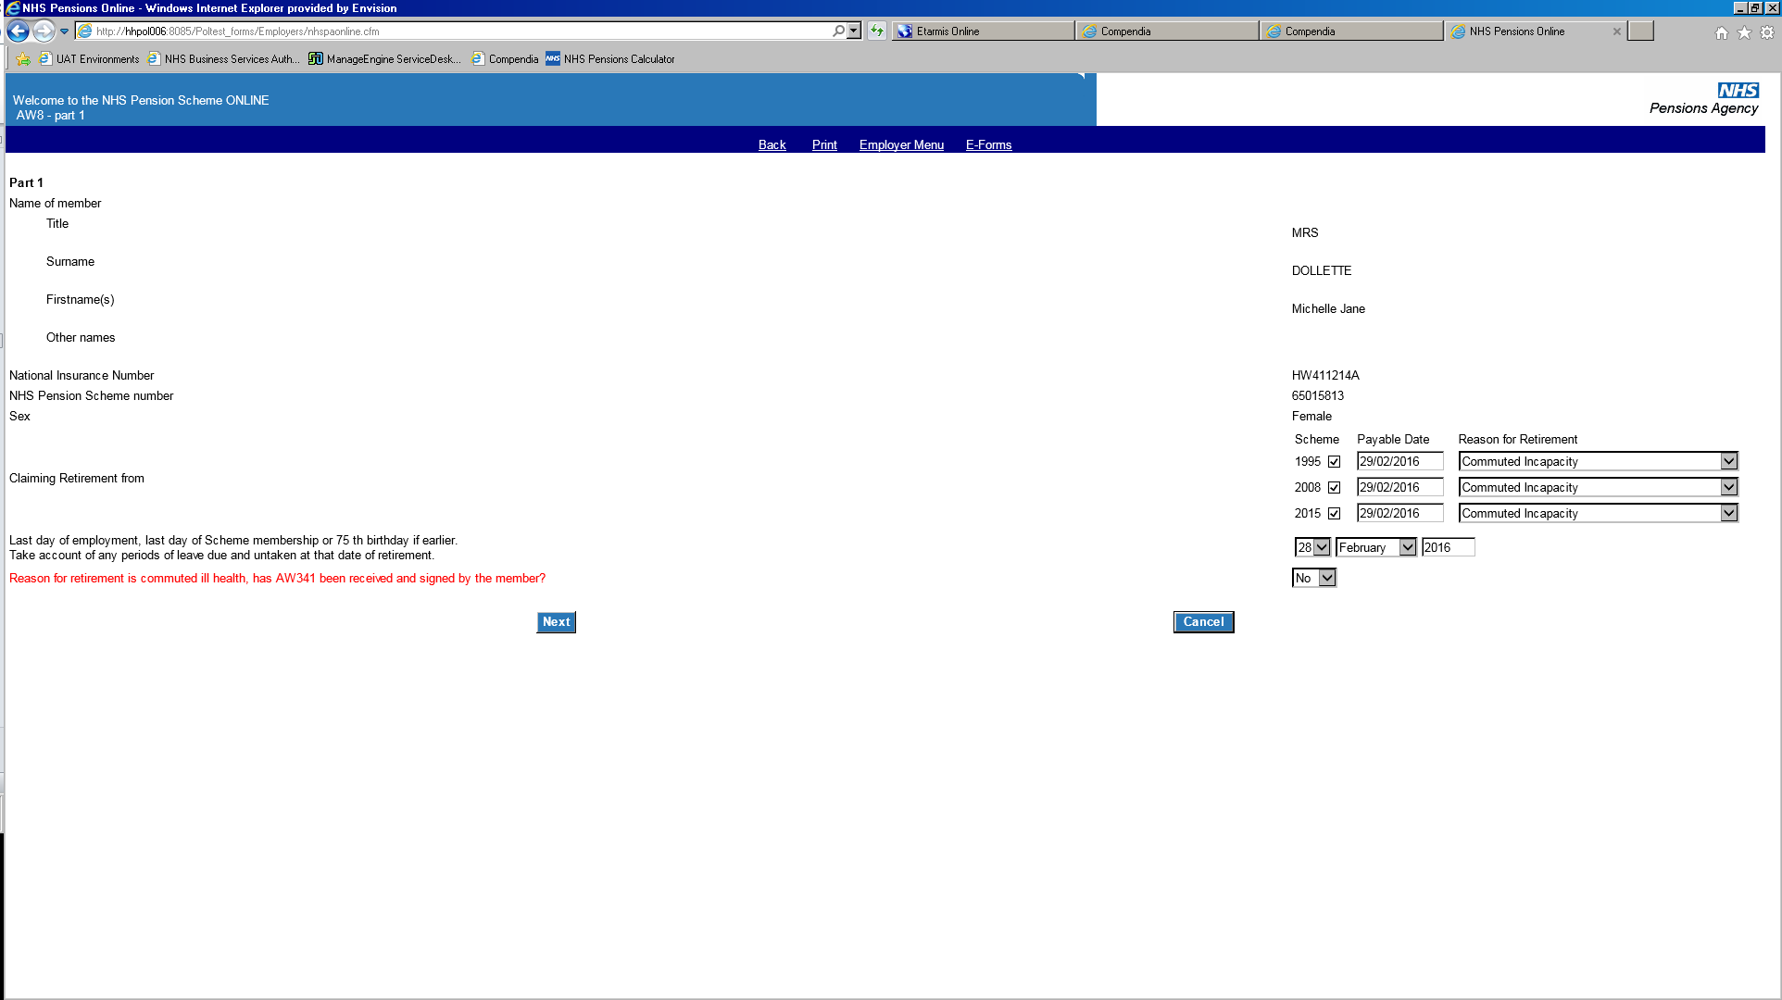

If you select No, you will not able to proceed with the application. When selecting Yes, the below message will appear.

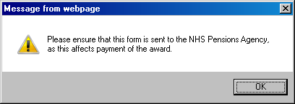

Select ok and then **next** to continue

**Interests of Efficiency (IOE)**

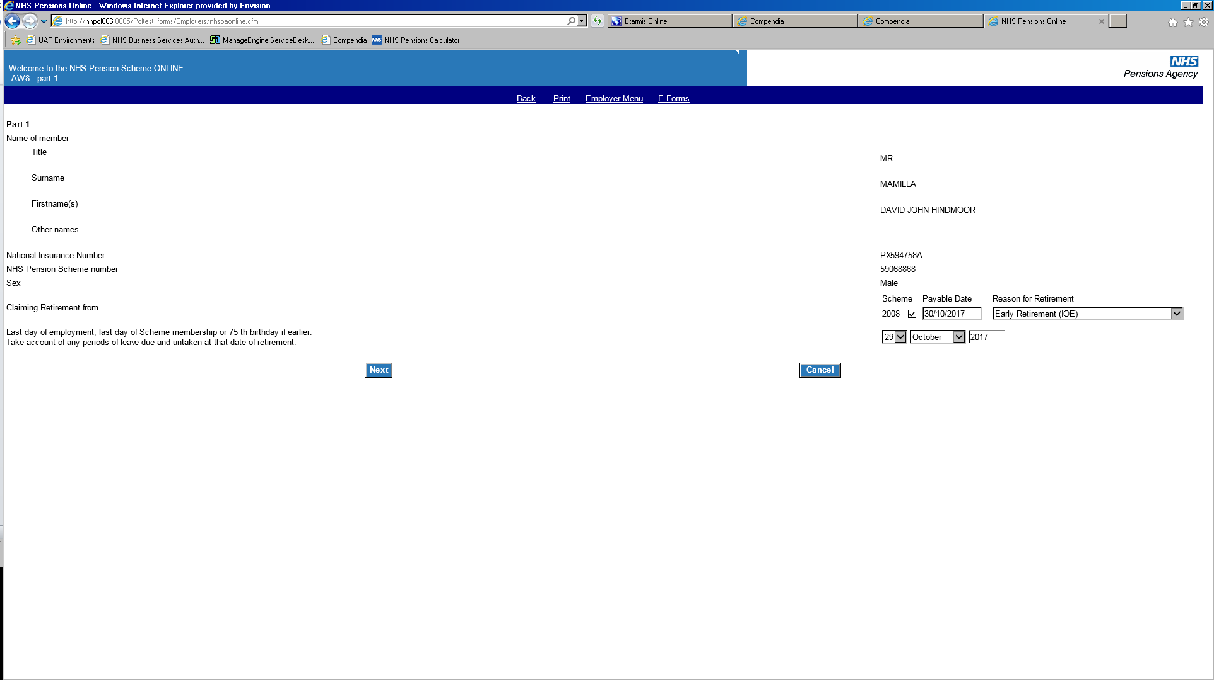

When selecting **next,** additional information will be requested.

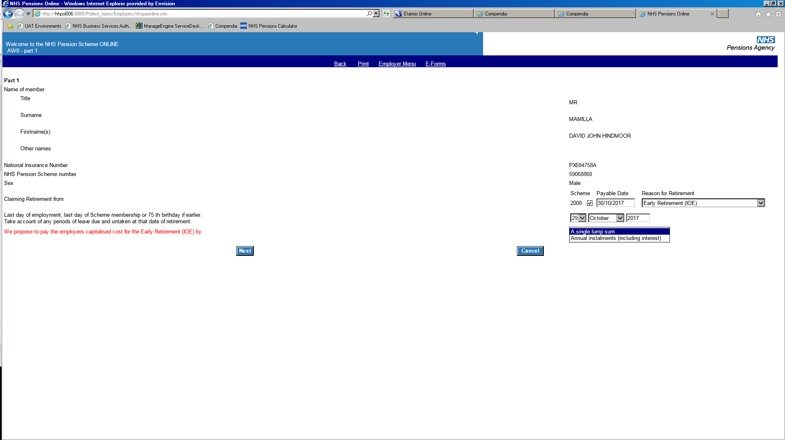

You must select the option **a single lump sum** and select **next** to proceed.

**Redundancy/Compensation**

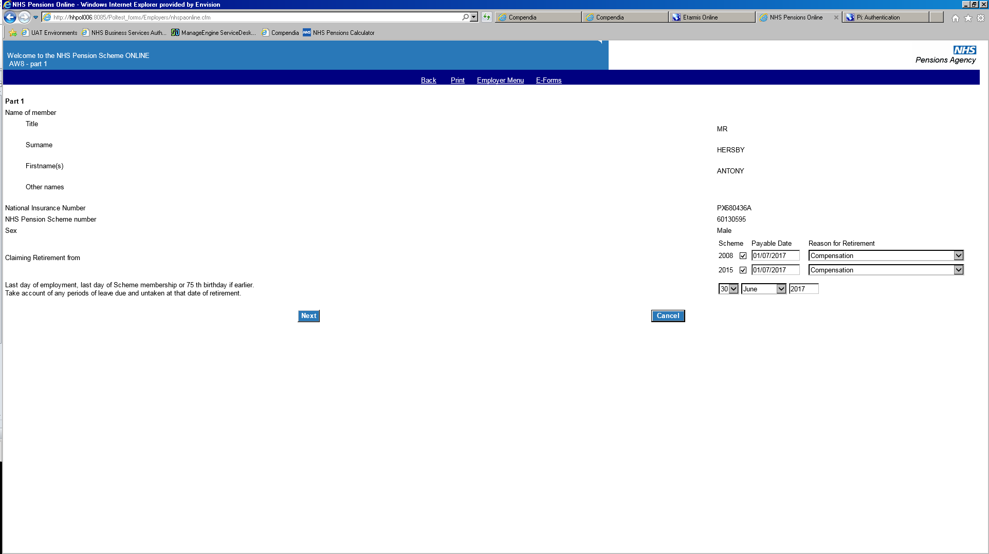

When selecting **next,** additional information will be requested.

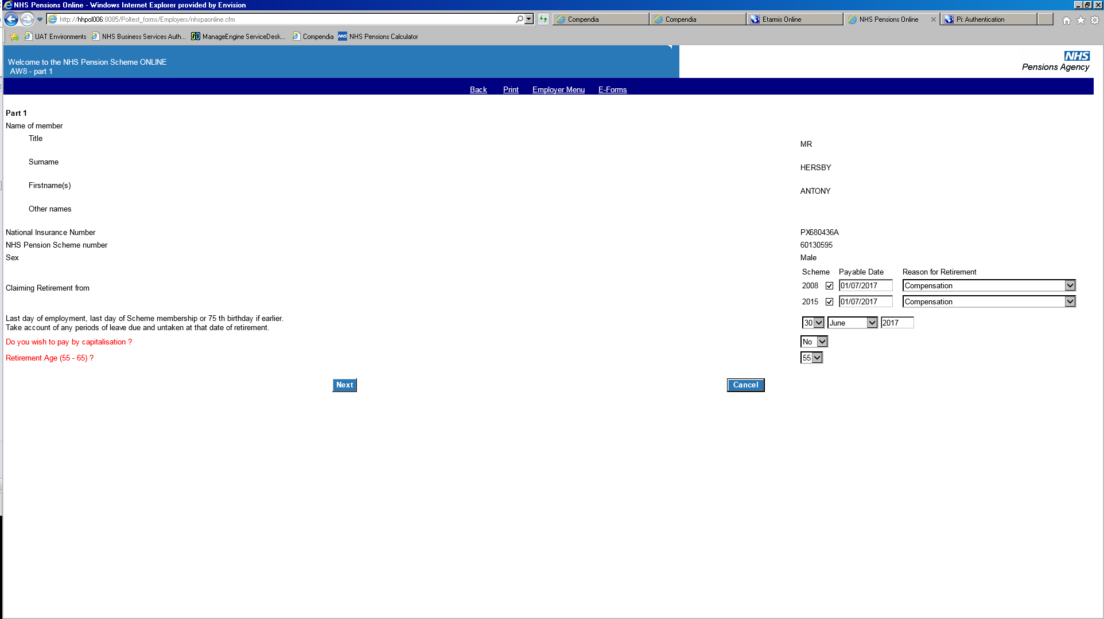

Capitalisation must be set to **Yes** and retirement age must be **65** in all cases.

# Part 2 – Employment details

If not already prefilled, input the member’s job title and place of employment.

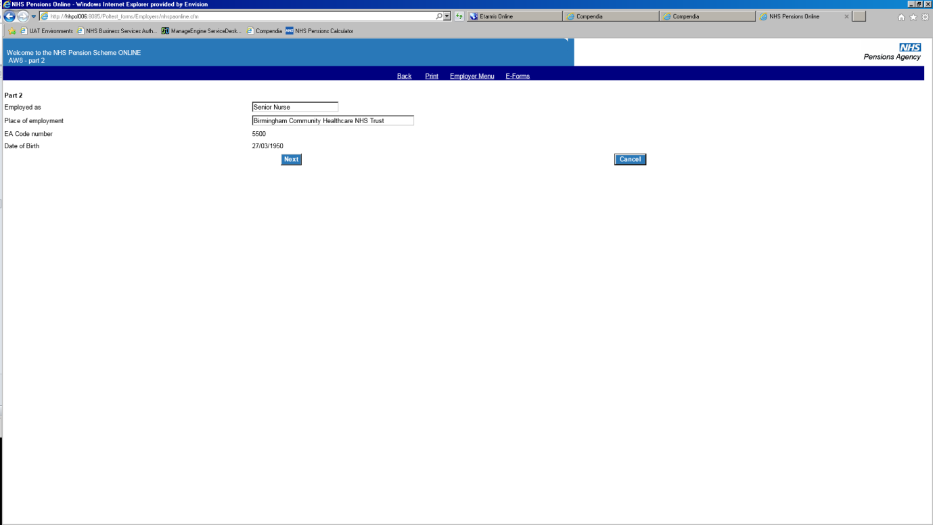

Select **next** to continue.

If the reason for retirement has been selected as compensation, the additional input screen will be produced.

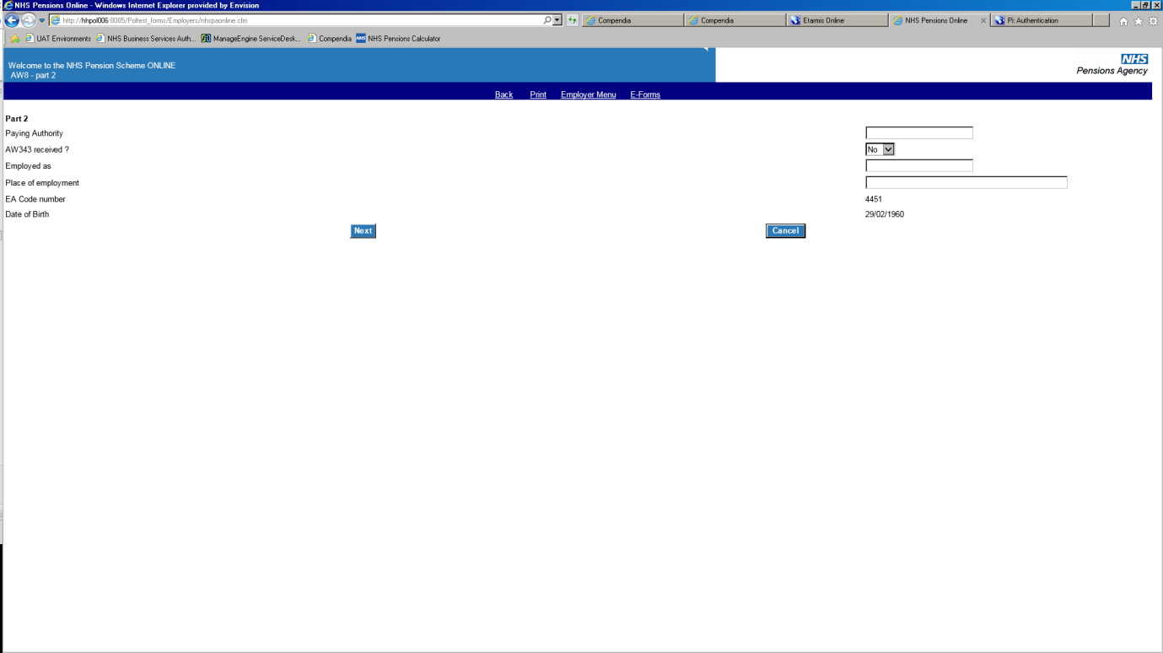

Complete the requested information in order to proceed.

Select **next** to continue.

# Part 3 - Pay details

**Note:** If the member is in the 2008 Section of the 1995/2008 Scheme, 2015 Scheme or is employed as a Locum GP, General Medical, Dental or Ophthalmic Practitioner then the screens for pay will not be produced and POL will take you to Part 5.

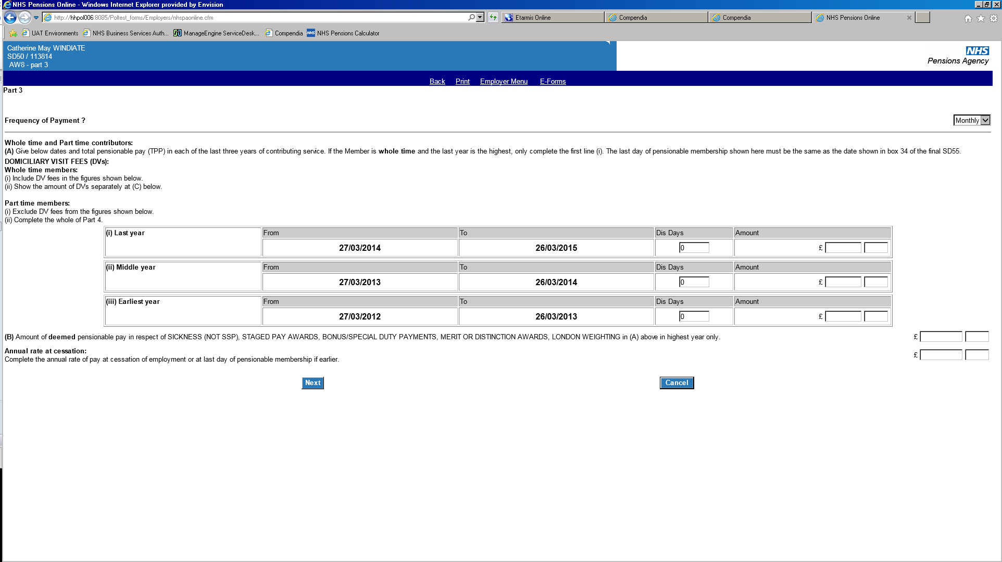

It is important to note the correct **frequency of payment**. If **weekly** is chosen then the following message will be produced.

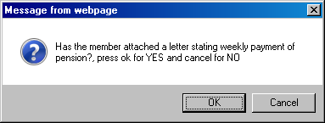

If **weekly** is correct, please email the members letter to The NHSBSA.

**Total Pensionable Pay (TPP)**

The latest **to** date produced should always match the members last day of Scheme membership.

If the member is employed full time and the last year’s TPP is the highest, it is only necessary to complete the final year and input figures of 0.00 in previous years.

If the member is employed in a part time capacity all three years must be completed.

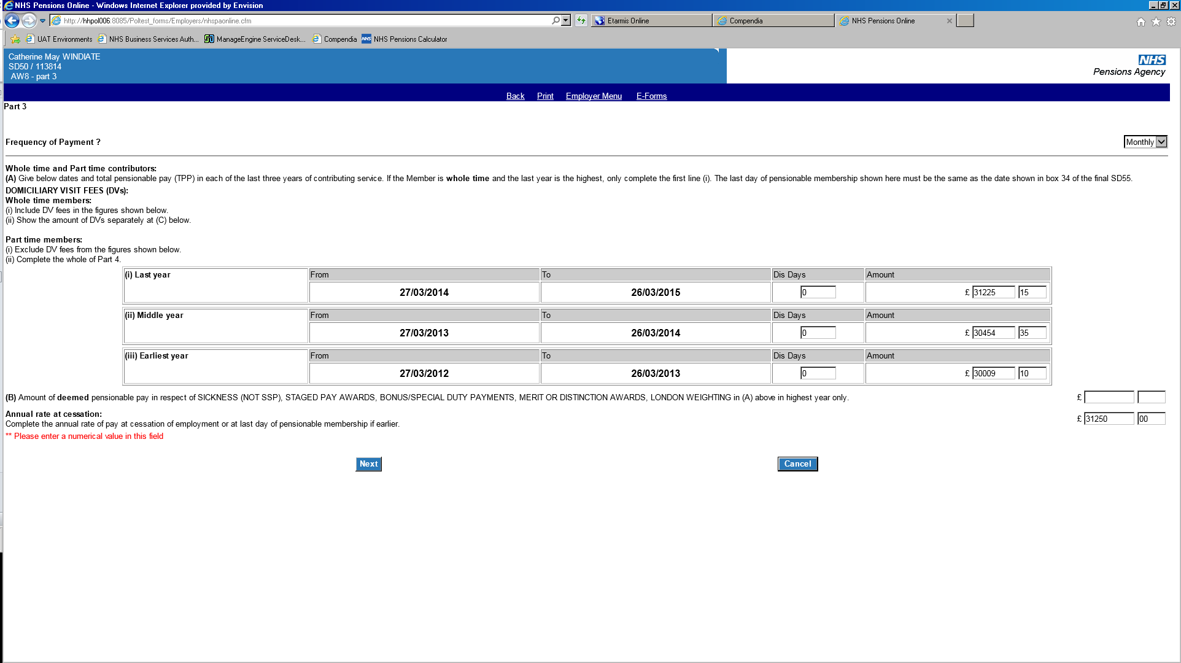

If the member has been employed with you for less than three years, POL will only ask you to input the part of the three years that relate to your employment. If you have details for the whole of the TPP period, please email [polia3@nhsbsa.nhs.uk](mailto:polia3@nhsbsa.nhs.uk) with the relevant details.

If the member has disallowed days within the TPP periods you will need to enter the amount of disallowed days into the input box. When you select next, POL will automatically step back the periods to take account of the disallowed days.

If the member has deemed pay within their highest year’s pay, this should be input into box (B) above.

POL will check that the figures you have input reconcile with those previously supplied on the SD55 updates and termination. If the figures do not reconcile, POL will produce either a tick box or text box for you to confirm you are happy with these figures, and provide a reason why these figures do not reconcile.

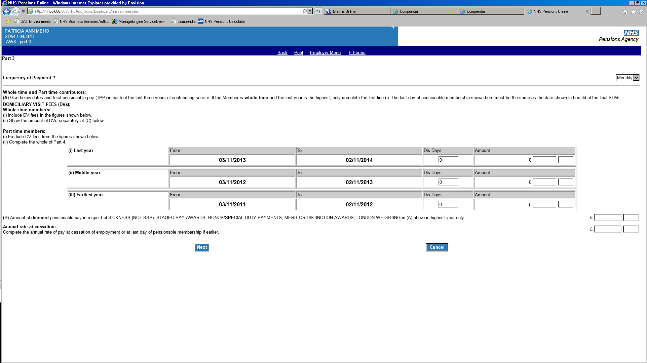

Insert the member’s annual rate of pay into the annual rate of cessation box.

Select **next** to continue

**Pensionable pay and deemed dates**

Where the middle or first year pensionable pay is higher than the final year’s pay, The NHSBSA will use the highest pensionable pay, but will use the final year’s deemed date. This is to avoid any overpayment of Pensions Increase.

If no substitute award is received within six months, The NHSBSA will change the deemed date to the middle or earliest year and the member will then receive any Pensions Increase that is due.

# Part 4 - TPP details for part time workers

The following screen will only be produced for members who work part time.

This should be completed using the member’s notional whole time equivalent pay figure.

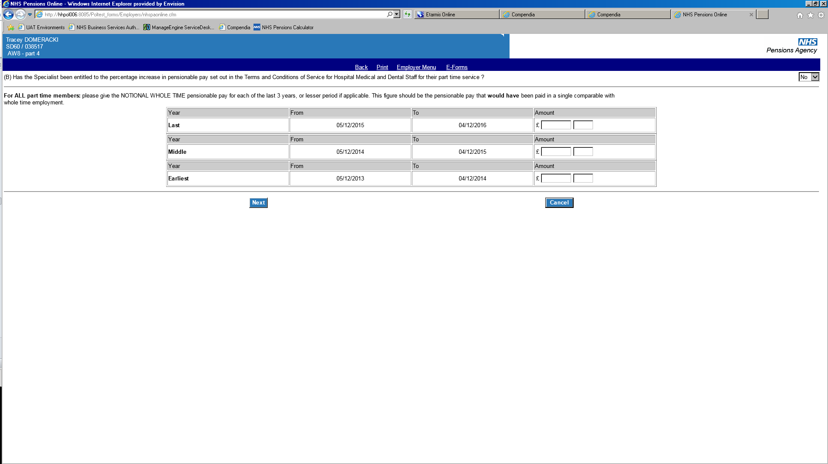

If the member has had a change to part time within the last three years, you will be required to input a figure for all three years. Where the member was employed whole time, insert the TPP figure that you have input on the previous page.

Select **next** to continue.

# Part 5 - Redundancy cases

This screen will only be produced when the reason for retirement has been selected as compensation.

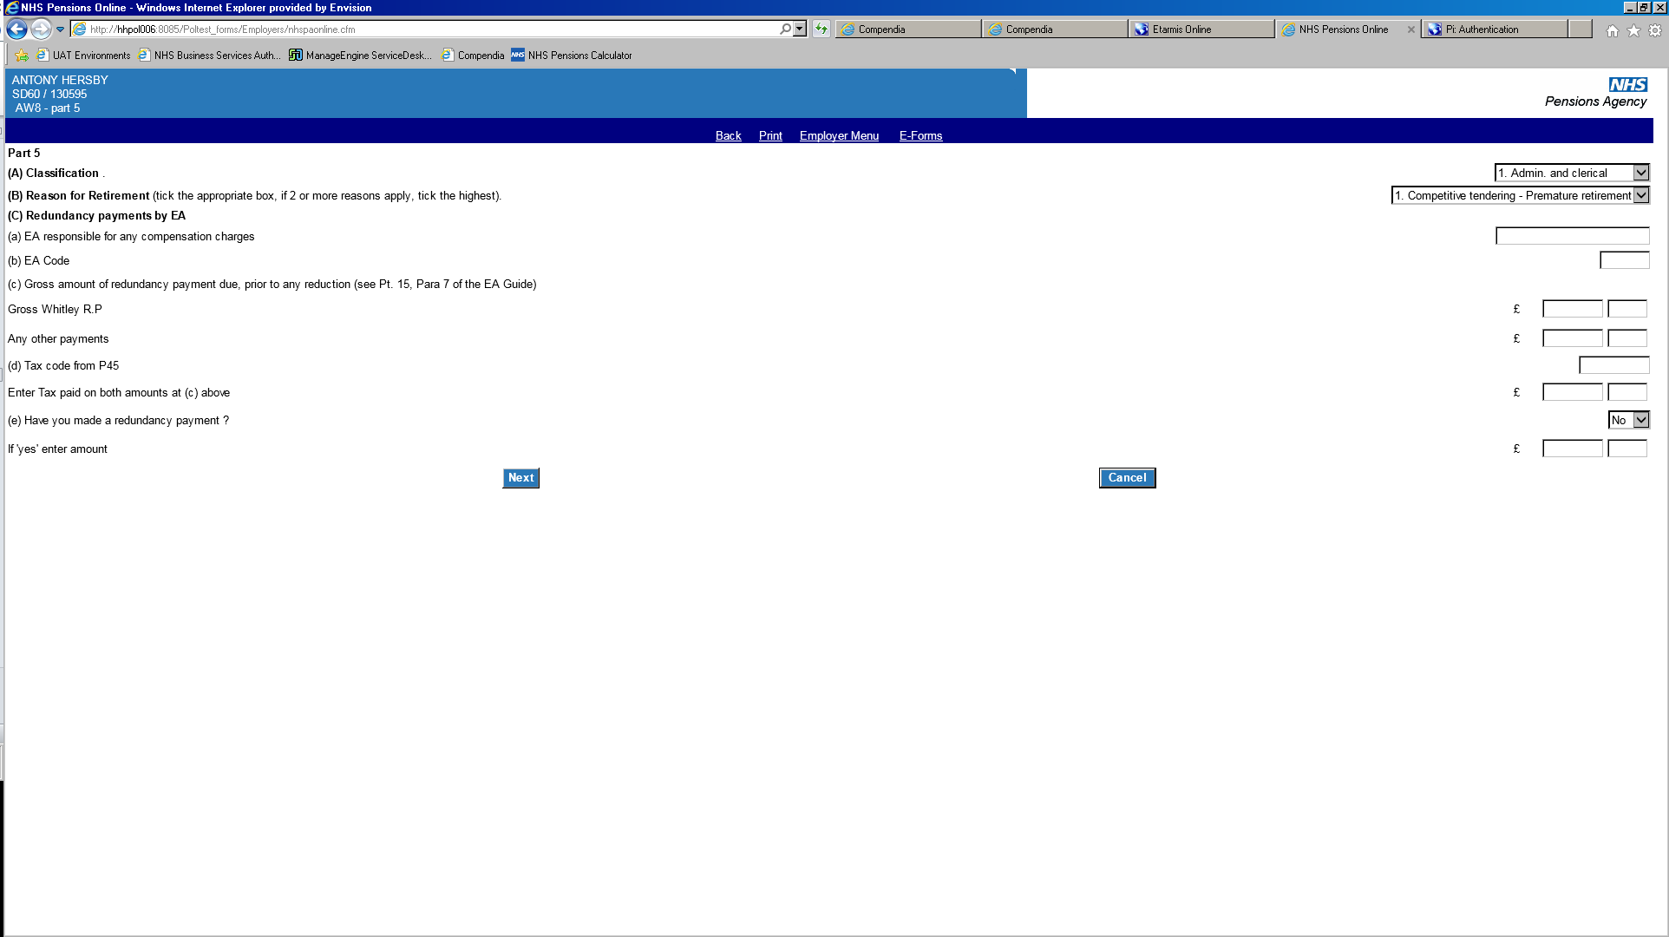

Make a selection from the drop down list and input the relevant details. If details are in an incorrect format or are missing, warning messages will be produced and you will be unable to proceed.

Select **next** to continue.

# Part 6 - Miscellaneous inputs

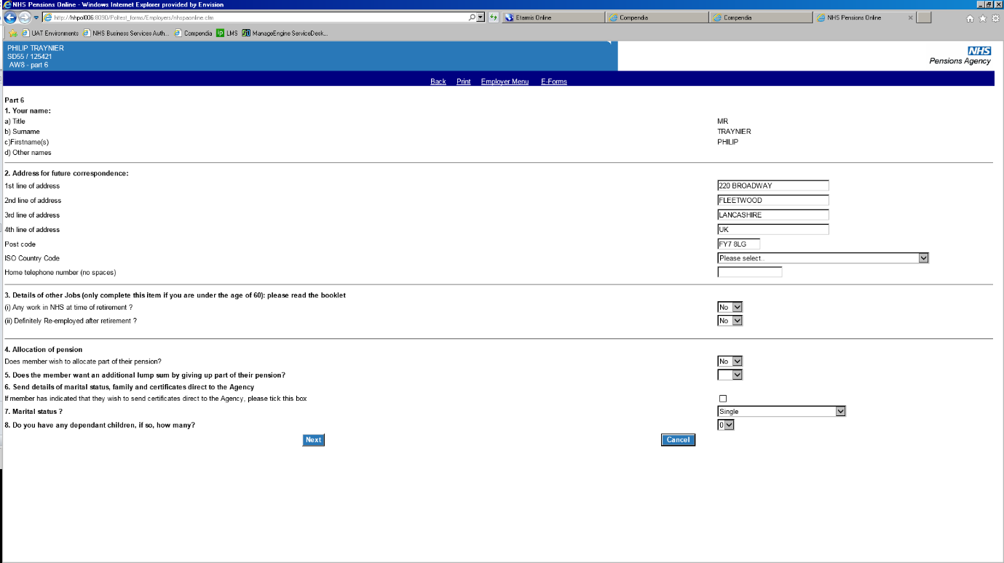

**Section 1** displays the member’s name that we hold on our system.

**Section 2** contains the member’s address, which has been taken from NHSBSA records.

If incorrect, this should be amended before submitting the AW8.

The ISO country code must be selected from the dropdown list available.

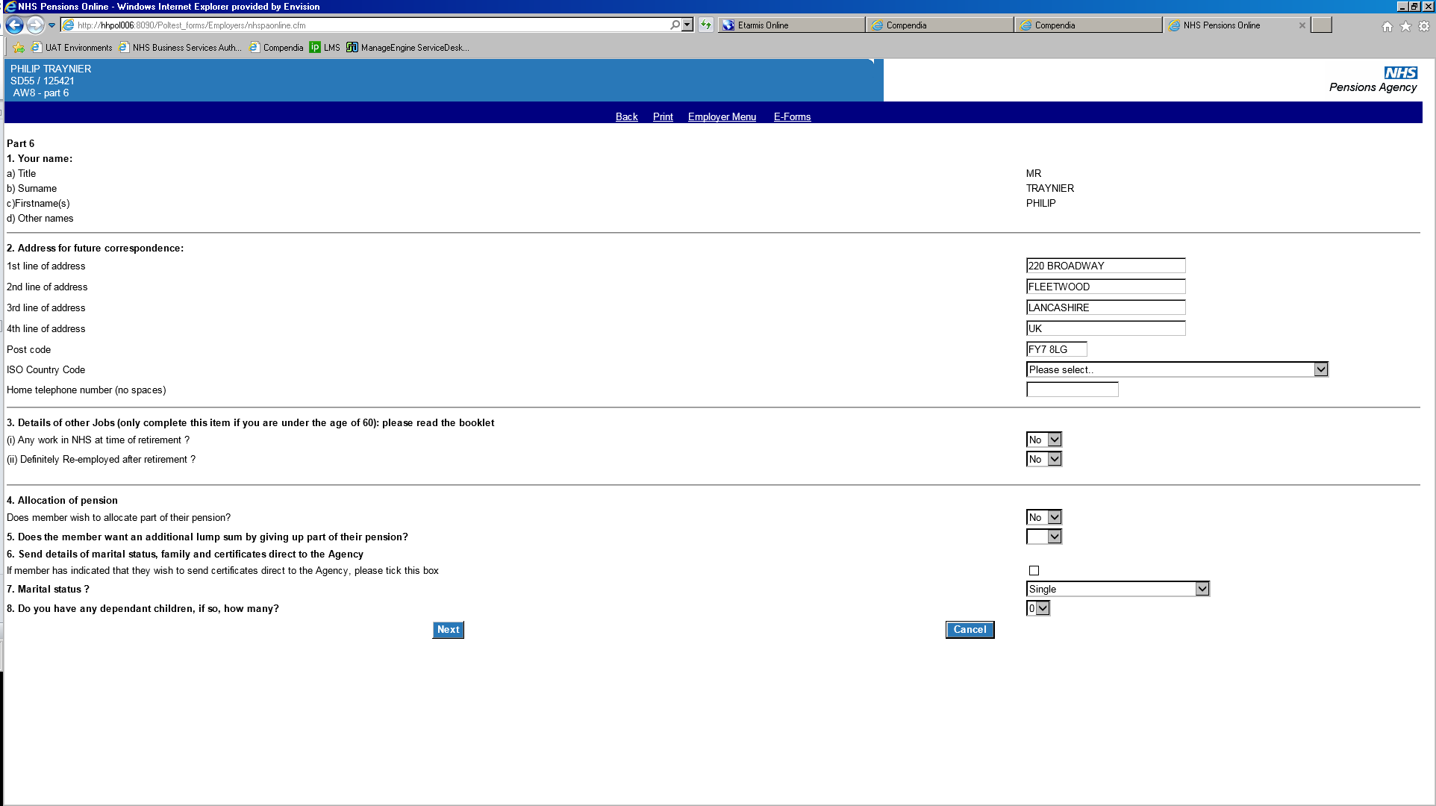

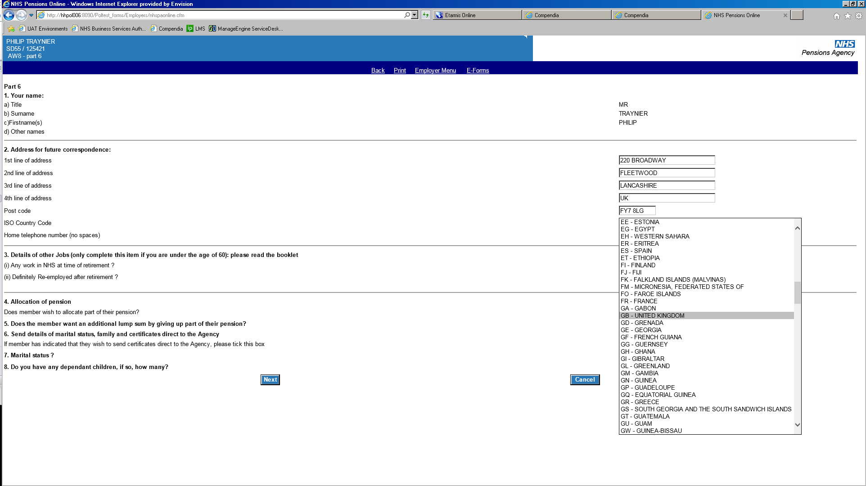

**Section 3** requests details of any other employments at the time of, or after retirement.

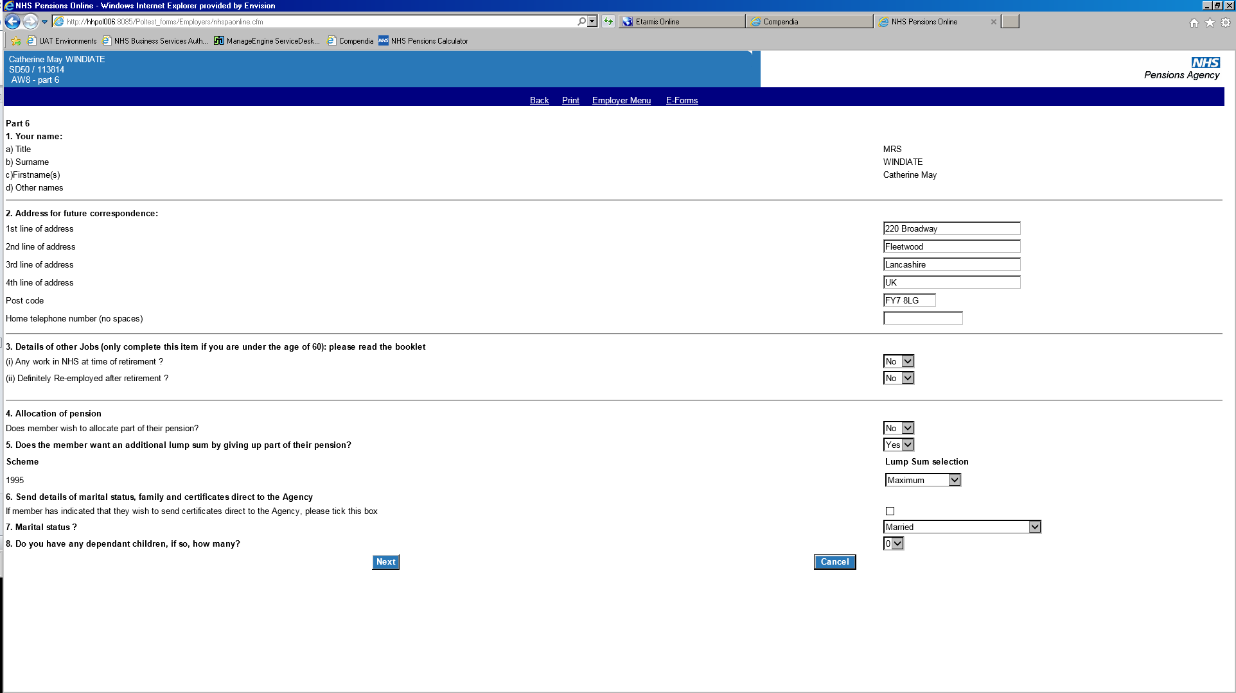

If **yes** is selected the additional input screen below will be produced. Insert the name and address of the re-employment position and member’s job title.

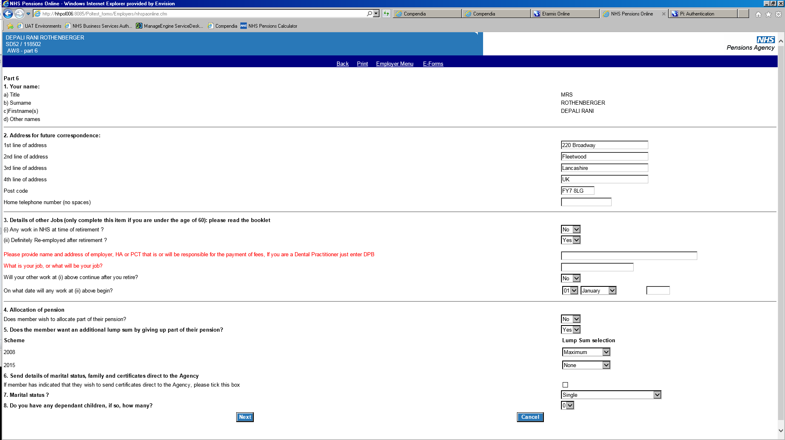

**Section 4** asks for confirmation of whether the member wishes to allocate part of their pension. If yes is selected, the allocation of pension form (AW811A) must be sent to The NHSBSA.

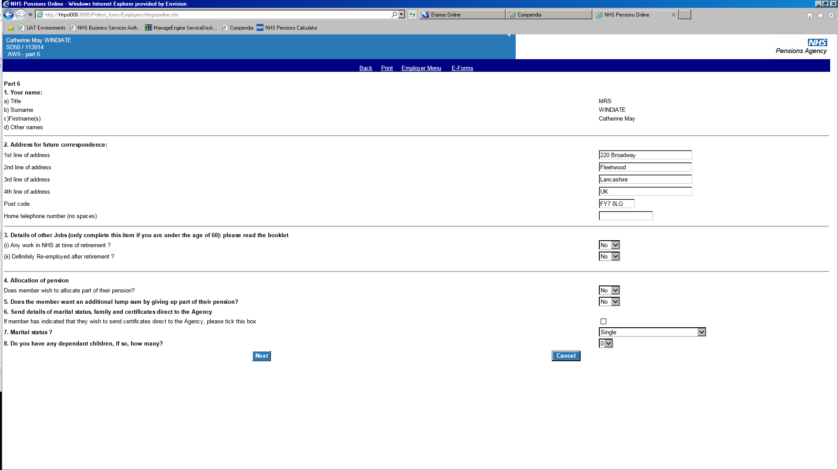

**Section 5** asks for confirmation of whether the member wishes to commute some of their pension into a lump sum retiring allowance.

**Important -** Section 5 will not be displayed if the reason for retirement has been selected as **Commuted Incapacity**. Commuting pension for a larger lump sum occurs automatically in these circumstances.



**Important** – you will be unable to input whether the member wishes to claim the maximum lump sum which incurs a tax charge, or the maximum tax free amount. The NHSBSA will contact you for this information if it is required.

If the member is only claiming benefits from one Section or Scheme, the lump sum option will only be produced for that relevant Section/Scheme.

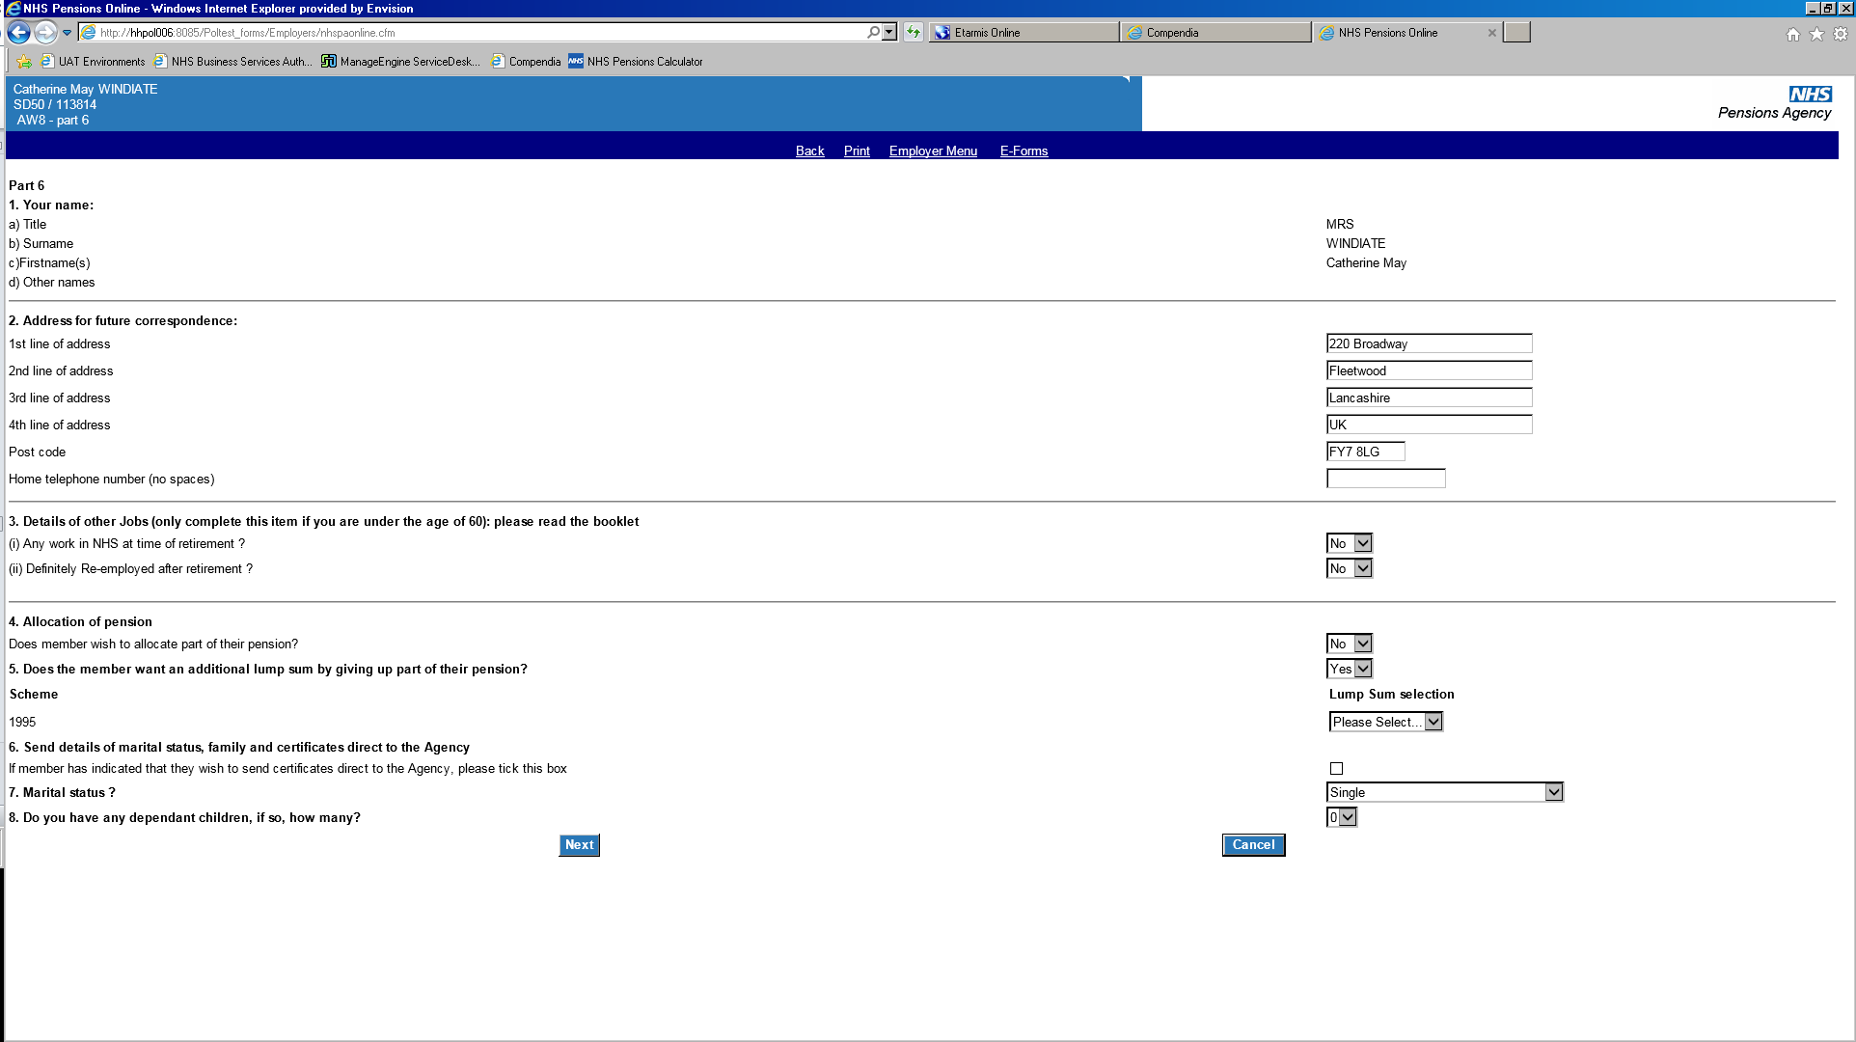

Select the member’s lump sum decision from the drop down list.

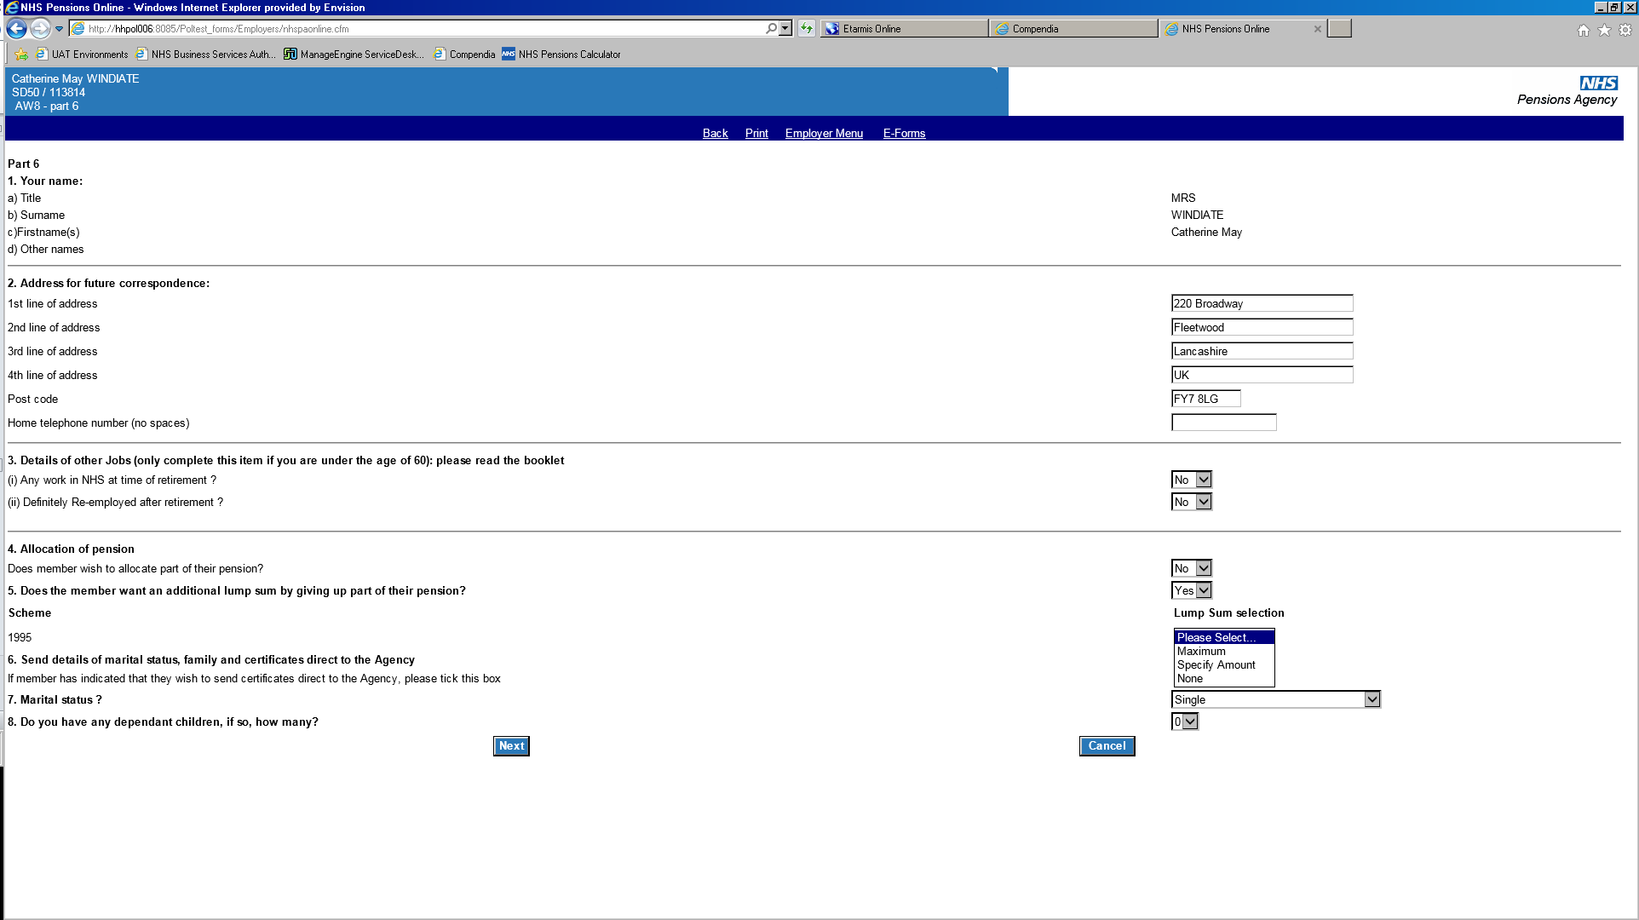

If **specify amount** is selected, you will be required to input the amount that the member has specified on their application form. This is in addition to any basic/mandatory lump sum and must be wholly divisible by 12.

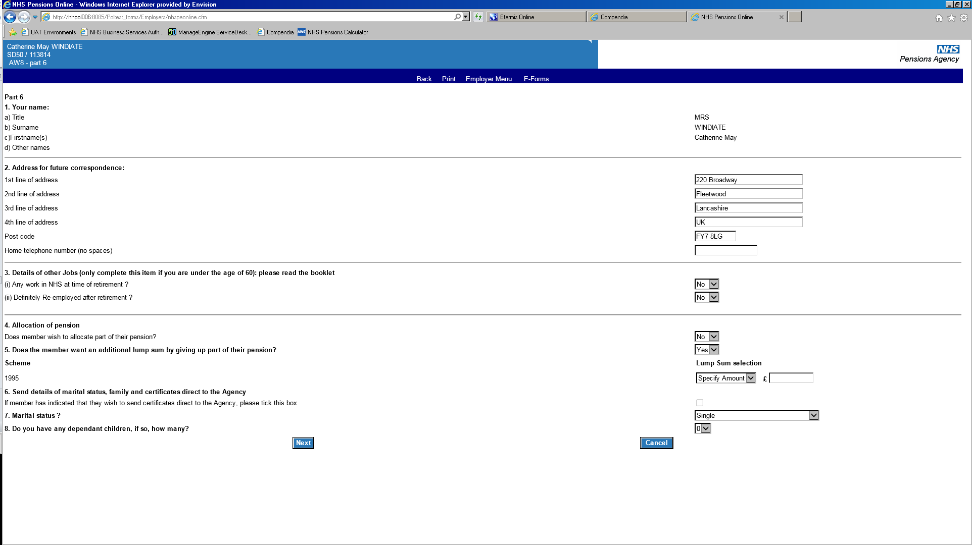

If the member is claiming benefits from more than one Section/Scheme, the lump sum option will be produced for each Section/Scheme that the member is claiming benefits from.

**Important –** If a member has benefits in multiple Sections/Schemes, a lump sum choice will be produced where the 1995 Section membership ends before 31 March 2008. Before inputting the 1995 Section lump sum you must check that the member has service in the 1995 Section after 31 March 2008. If the member doesn’t have 1995 Section membership after 31 March 2008, the 1995 Section lump sum must be selected as **none**.

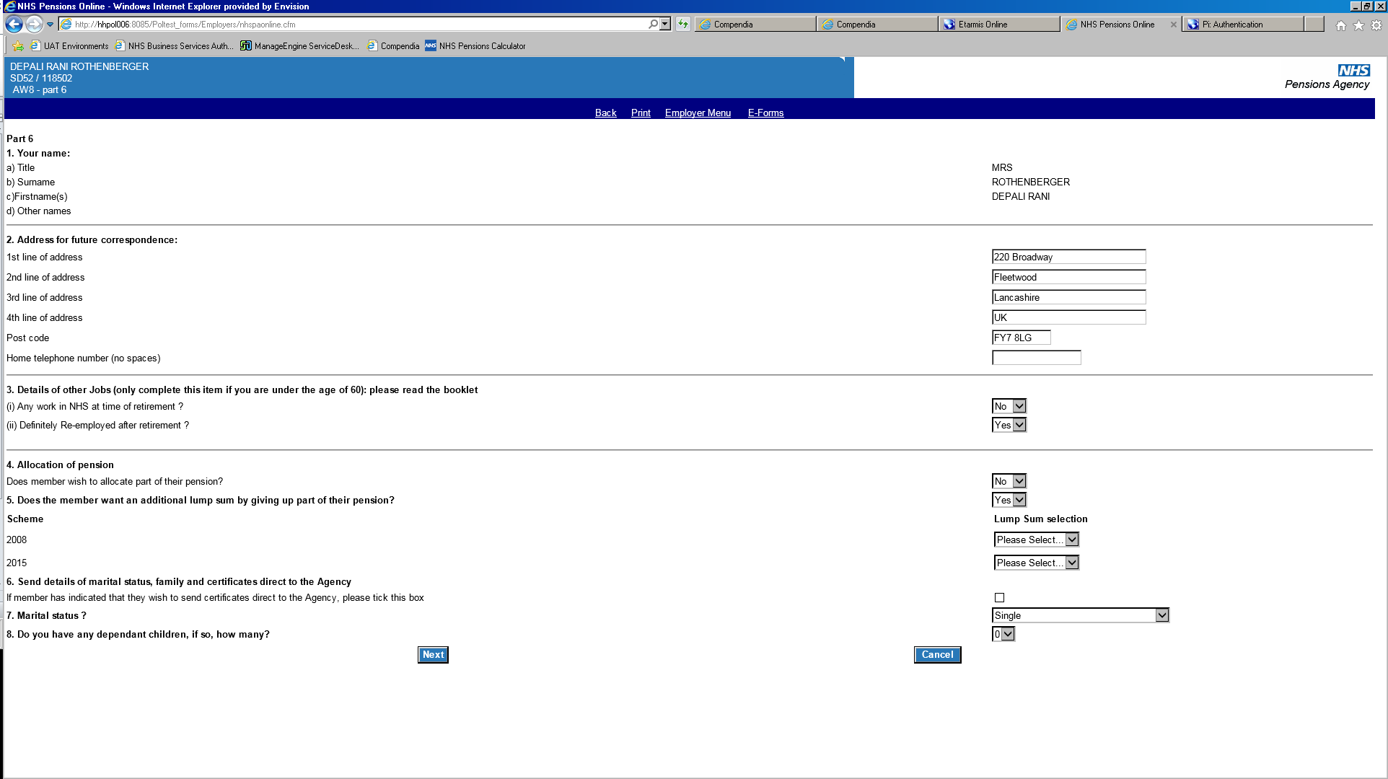

Select the lump sum option that the member has selected for each Section/Scheme.

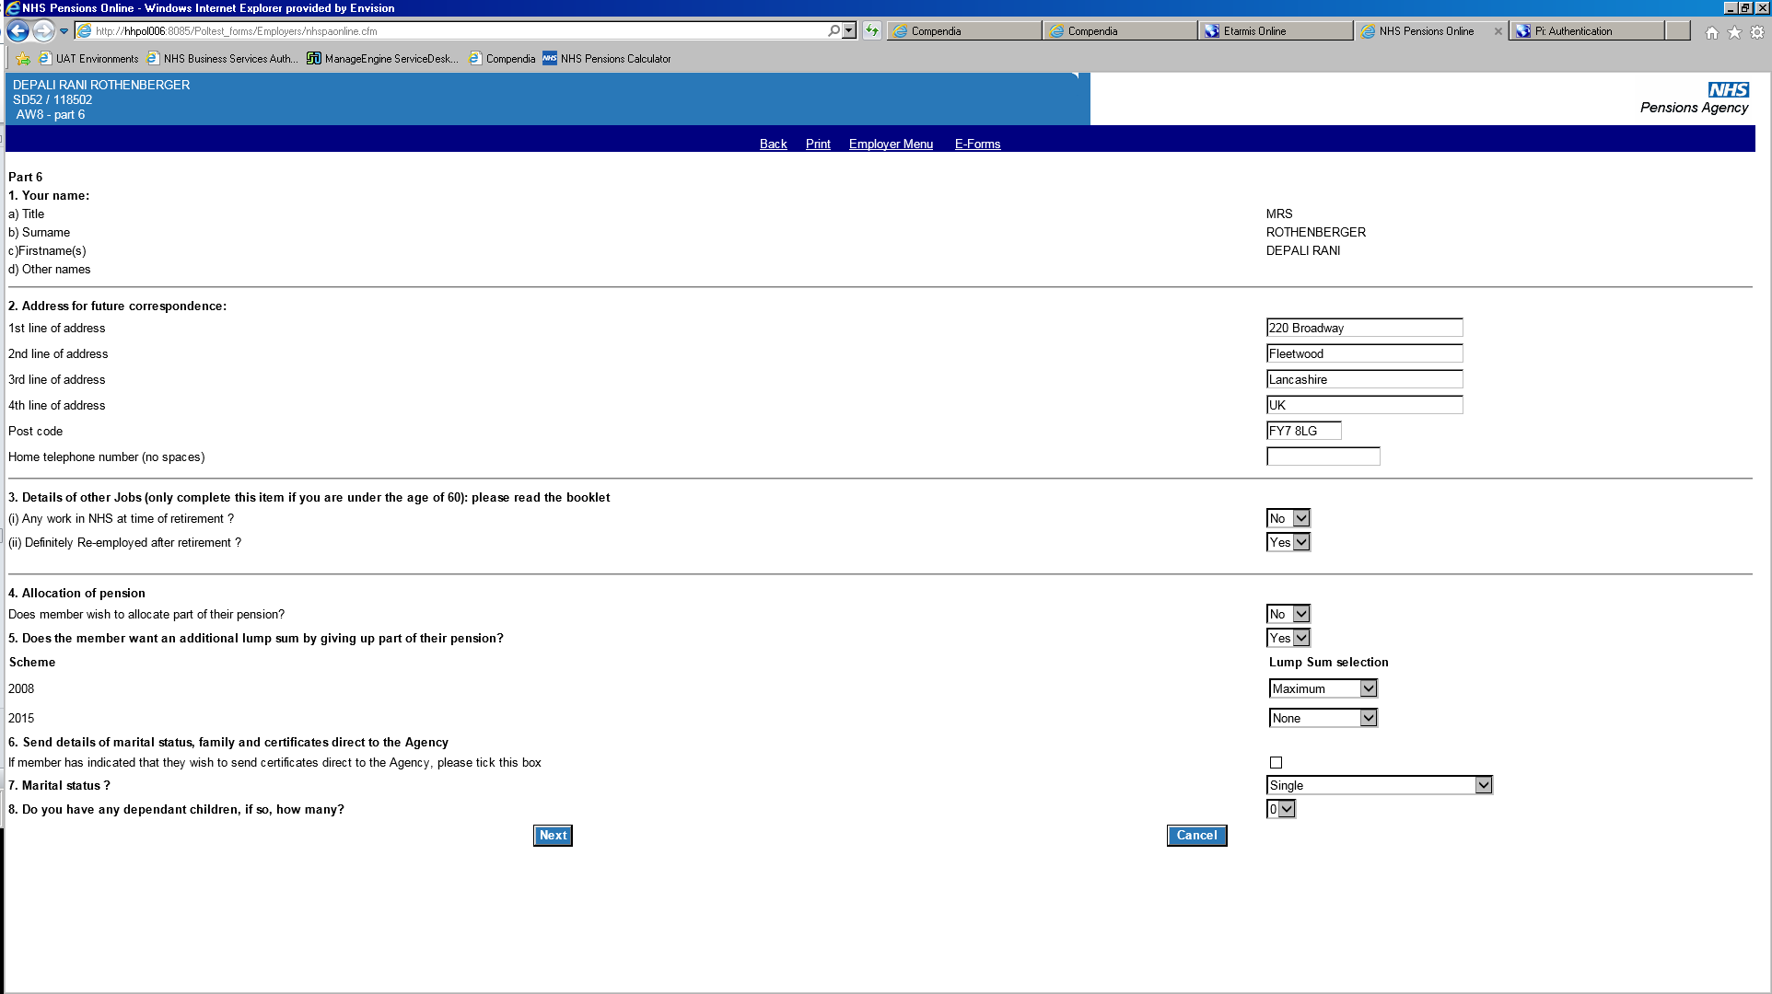

When reviewing the form before submission the details will be displayed for you to check.

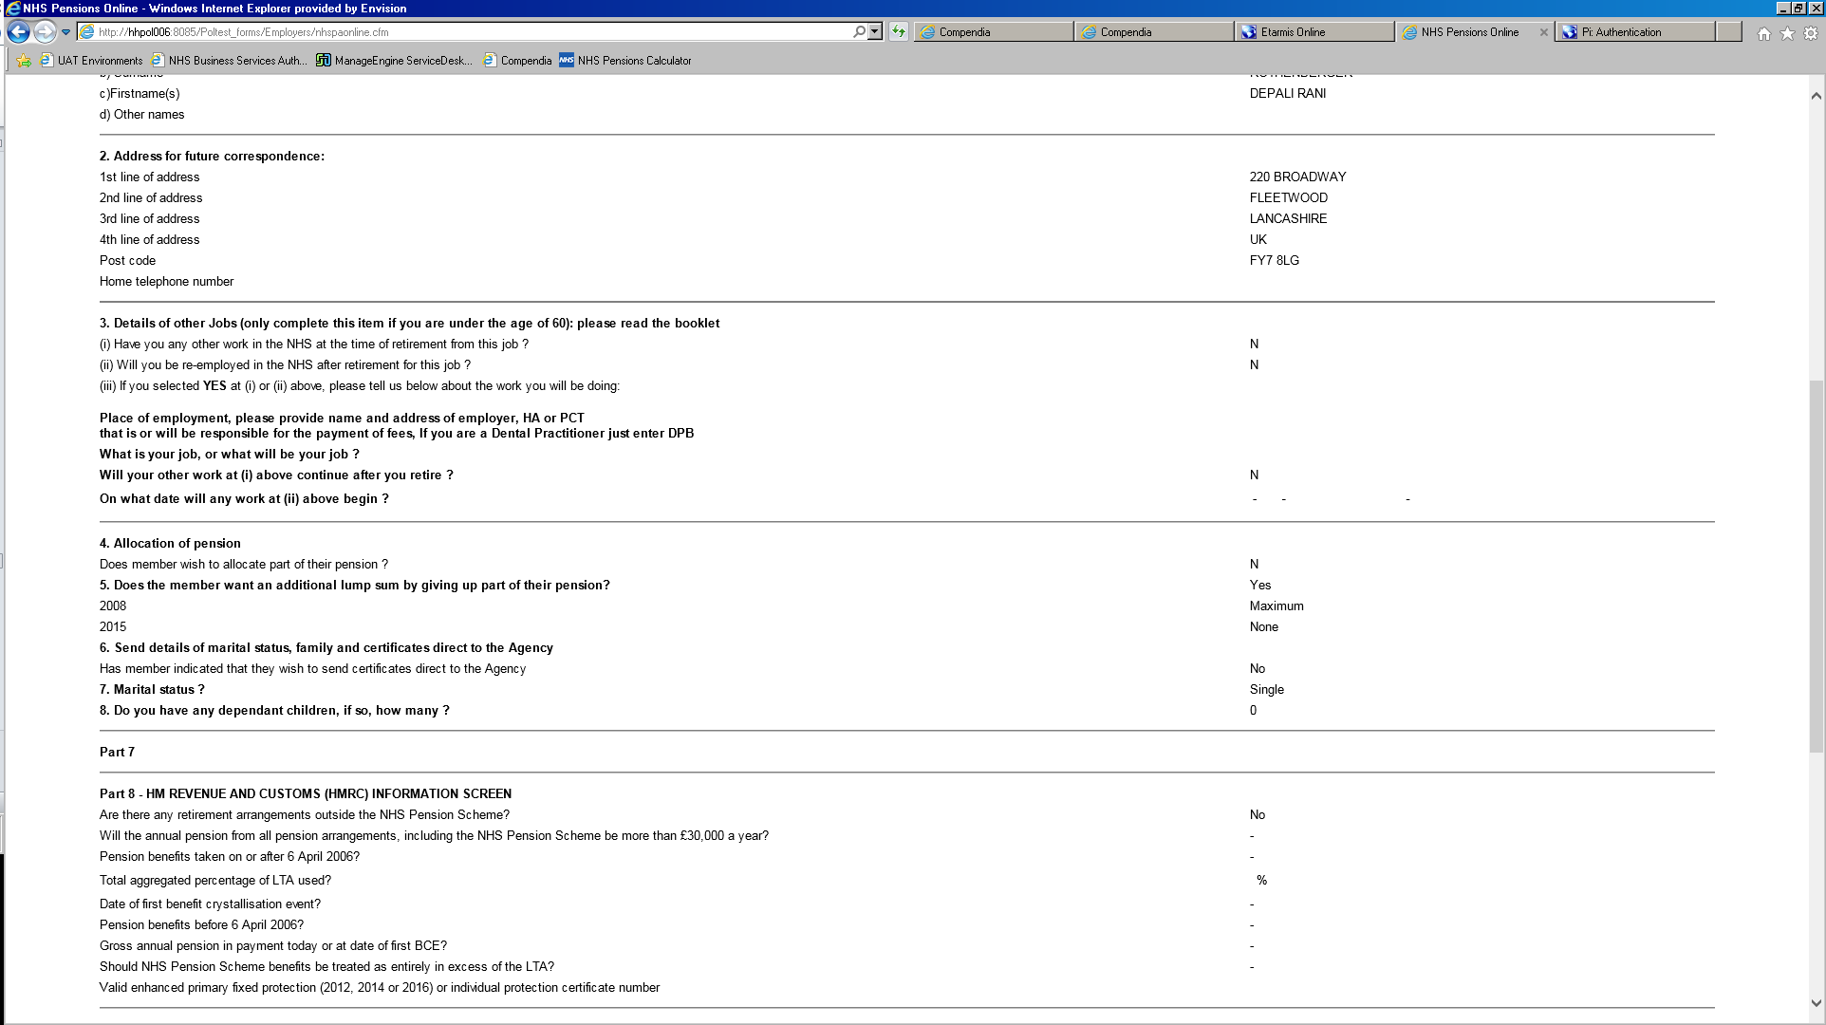

**Section 6** should only be tickedif the member wishes to send certificates direct to The NHSBSA.



If the member wishes to send their certificates direct to The NHSBSA, please ask them to make sure they enclose a covering letter with their full name, membership number (SD) and address and postcode. This is to ensure that they are linked to the correct AW8 and are returned promptly.

**Section 7** asks for the member’s marital status. You will input the relevant details at Part 7.

**Important** - If the member is a male who is married to a male, the AW8 must be submitted with the marital status as **civil partnership**. If married is selected, this will lead to incorrect survivor benefits.

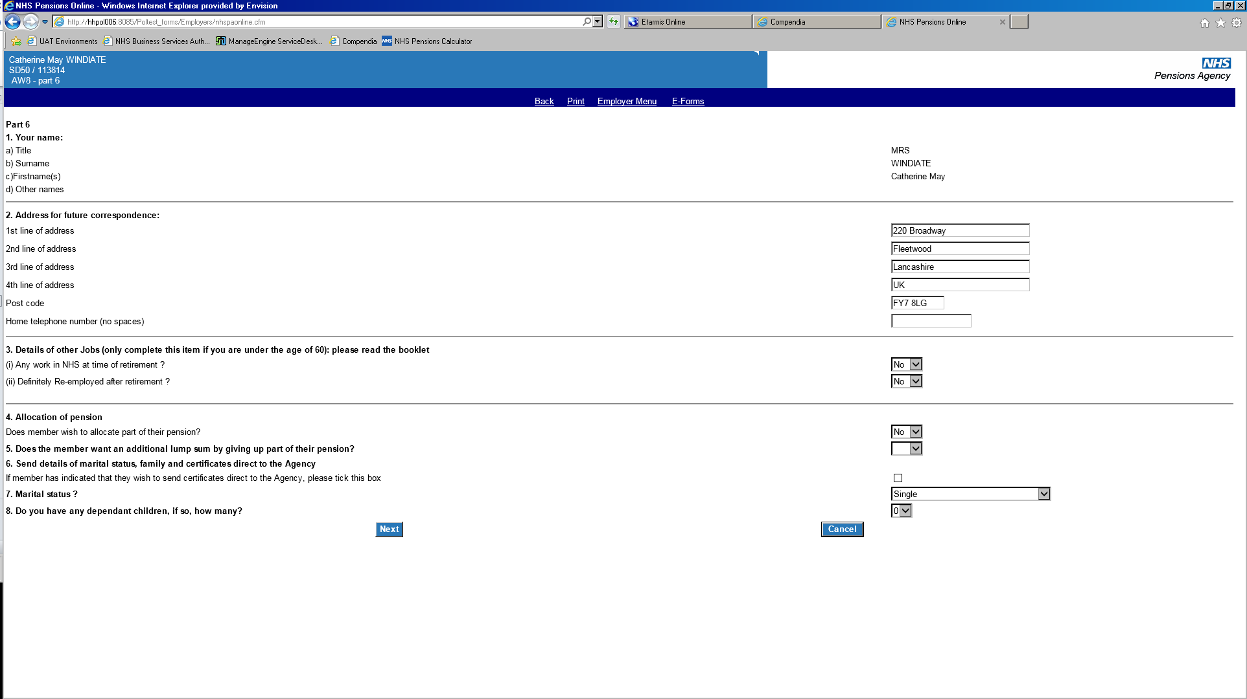

**Section 8** requests the number of any dependent children. If there are dependent children, the details will be input at Part 7.



Select **next** to continue.

# Part 7 – Marital details and census information

The member’s marital status will determine what information is required. If the member is single you will only receive an input screen for the Census data unless there are dependent children.

The spouse’s surname will prepopulate the same as the member’s. This can be overtyped if the surnames differ.

If you have not seen the original certificates or original certified copies the drop down selection must be set to **no**.

If the member is unable to provide the relevant date, you should proceed by inputting 01/01/1900 with the drop down selection as **no**. The member’s first name should be input as unknown.

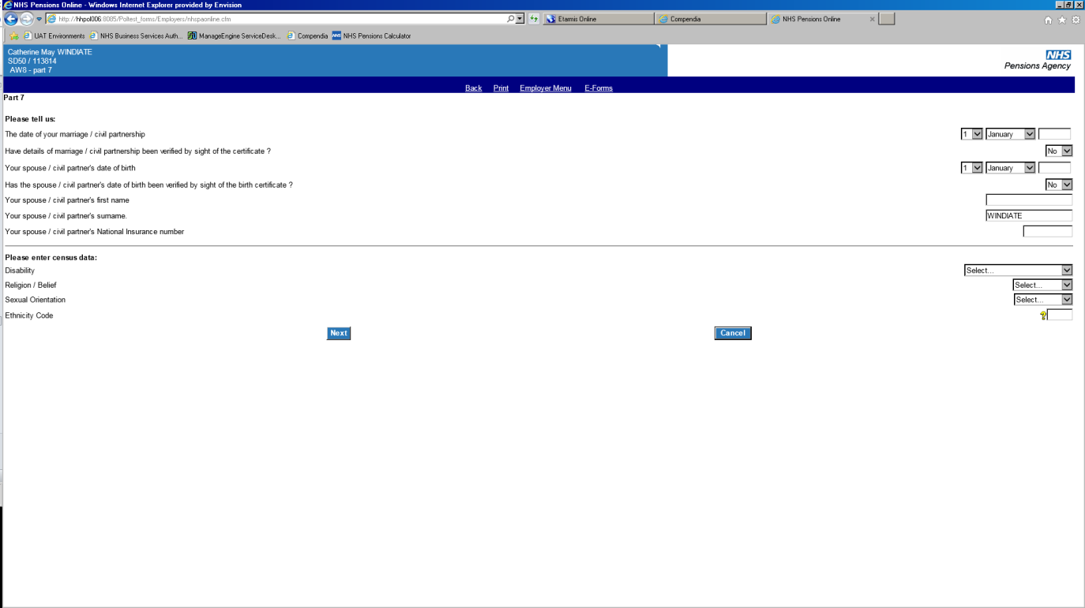

In all cases, the census data should be selected as **unknown** with the ethnicity code **ZZ**.

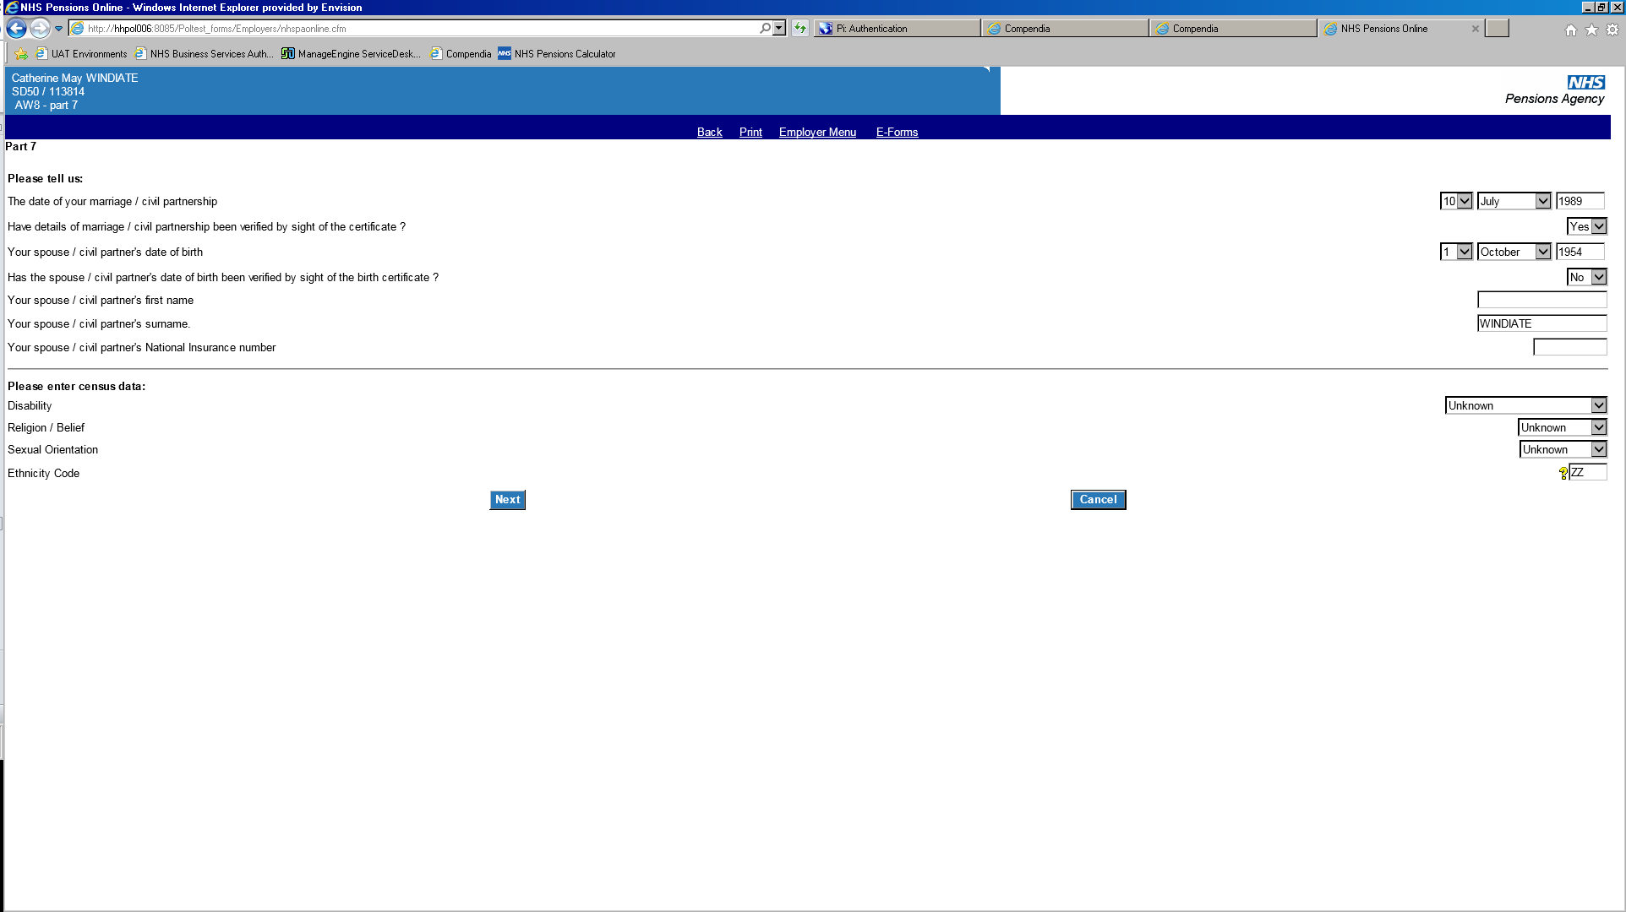

If there are dependent children the additional input boxes will be produced for each dependent’s details.

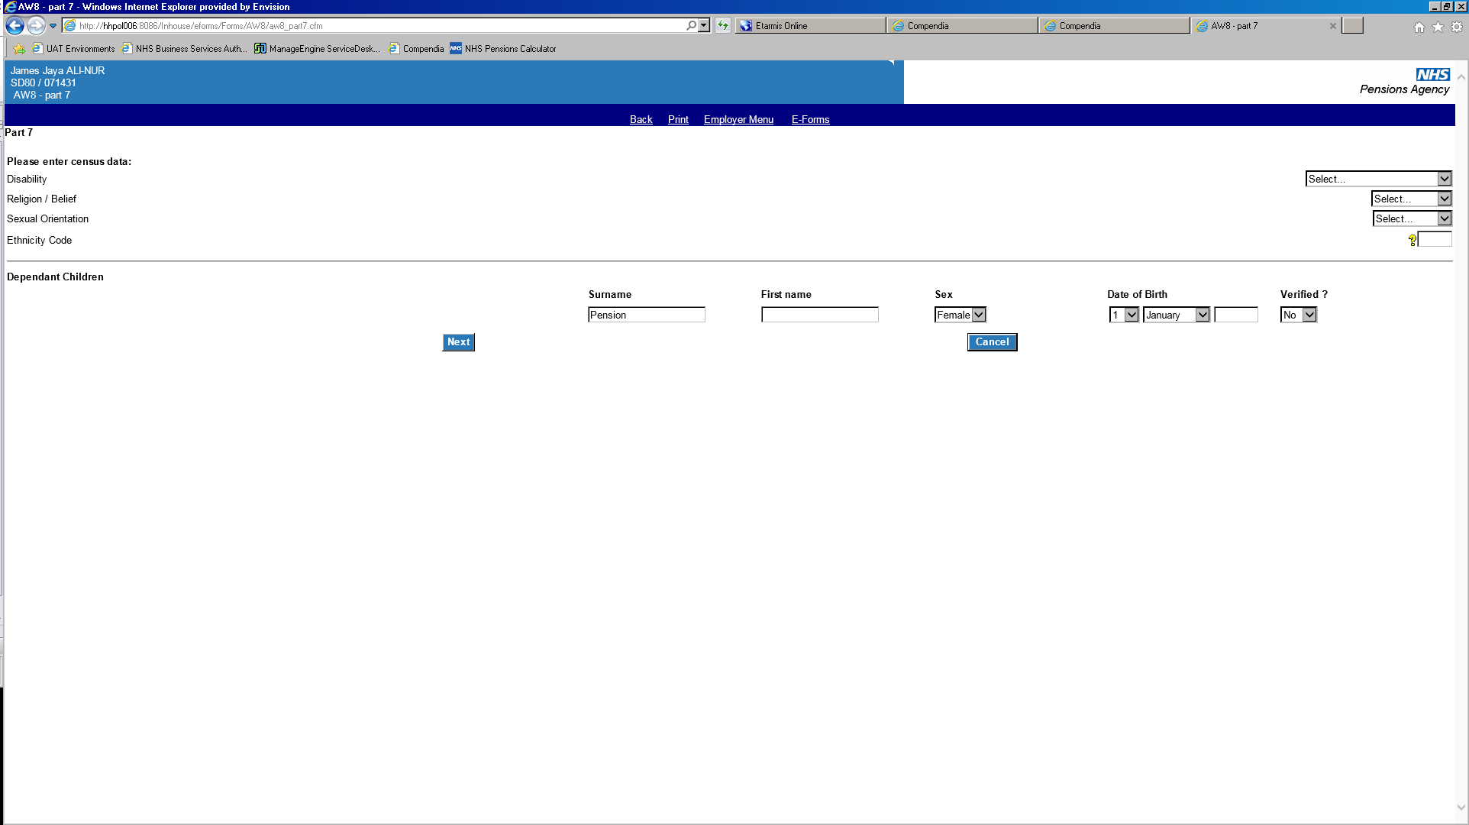

Select **next** to continue.

# Part 8 - The HM Revenue and Customs (HMRC) information screen

This contains information required by The NHSBSA to enable the member’s Lifetime Allowance to be correctly notified to the member under the HMRC rules.

Please use the drop down boxes as appropriate and complete the required information as detailed on the AW8.

If any mandatory information is missing or in an incorrect format an on screen warning message will be produced.

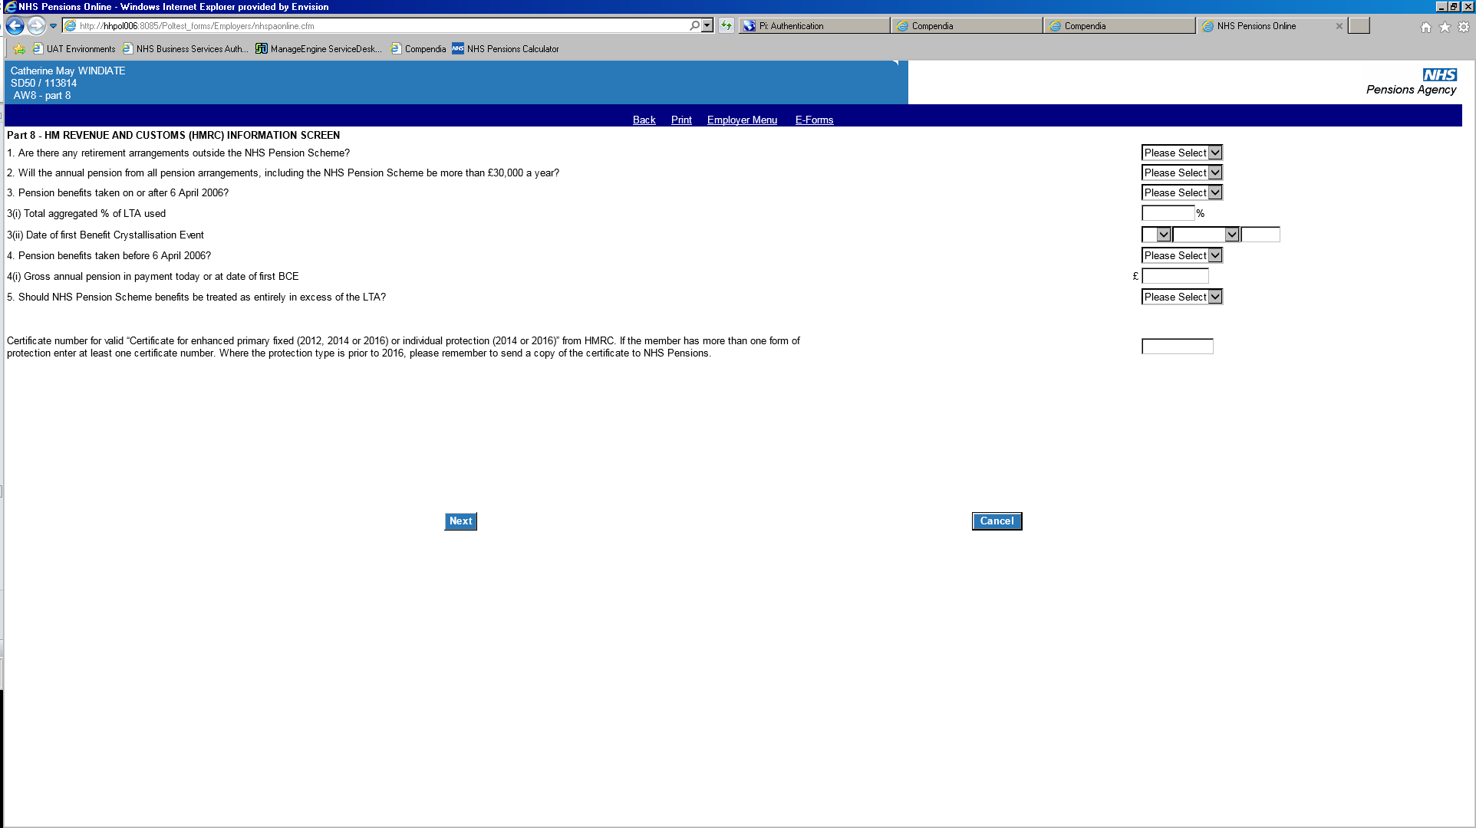

Where a member has a protection certificate, the last eight digits of the certificate must be input in order to proceed.

# Part 9 – Member’s address and bank details

This part of the form requests the member’s current address and the bank details that the member has provided for payment of their pension/lump sum amounts.

There is a provision to change the member’s address if they intendto change their address or move abroad. If the address is to change please notify The NHSBSA to avoid queries.

If any mandatory information is missing or is in an incorrect format on screen validations will be produced.

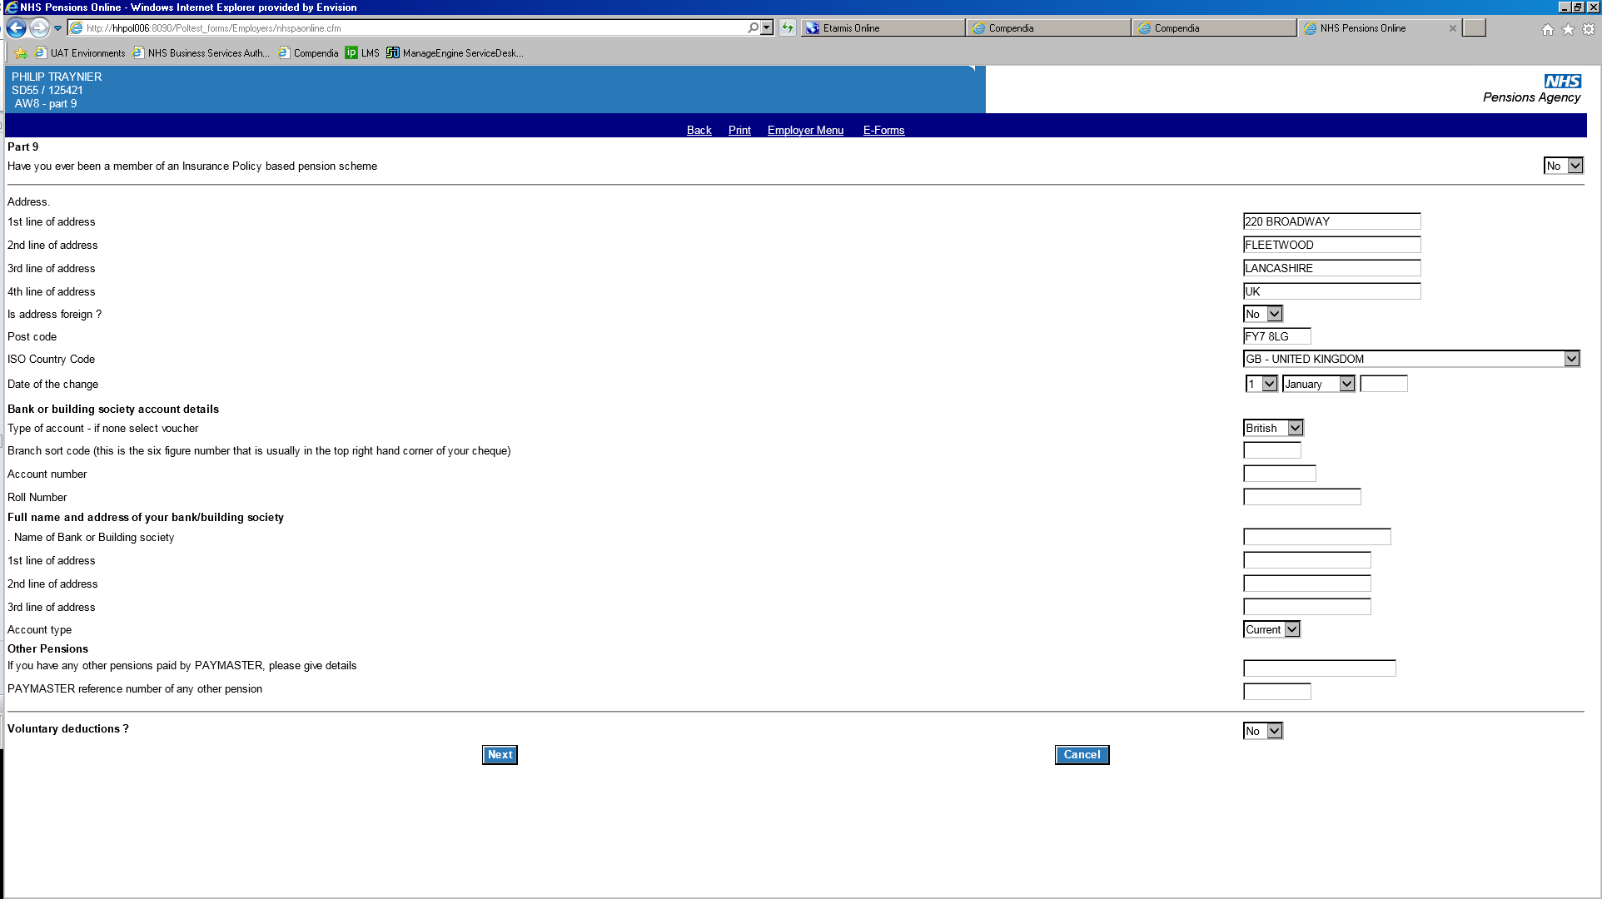

The bank account details will usually consist of a six digit sort code and an eight digit account number. However there are several variables where more information can be found at the end of this document.

**Important -**

For Re-employed Pensioners, or members who are already in receipt of pension benefits, the screen will appear as below –

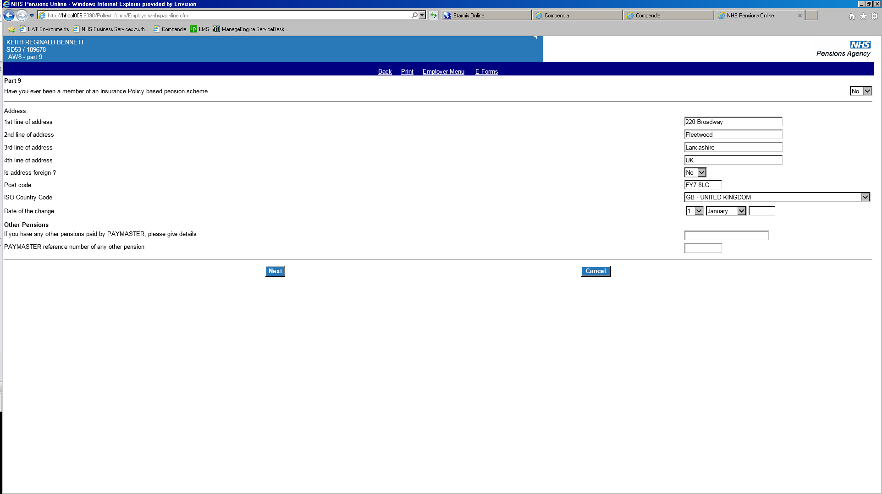

# Overseas bank account

Where the member has an overseas bank account they must complete the relevant overseas bank mandate specific to the country that they are requesting benefits to be paid.

No overseas bank account details should be input into POL. You should process the form by selecting the type of account as **foreign** and account type as **N/A**.

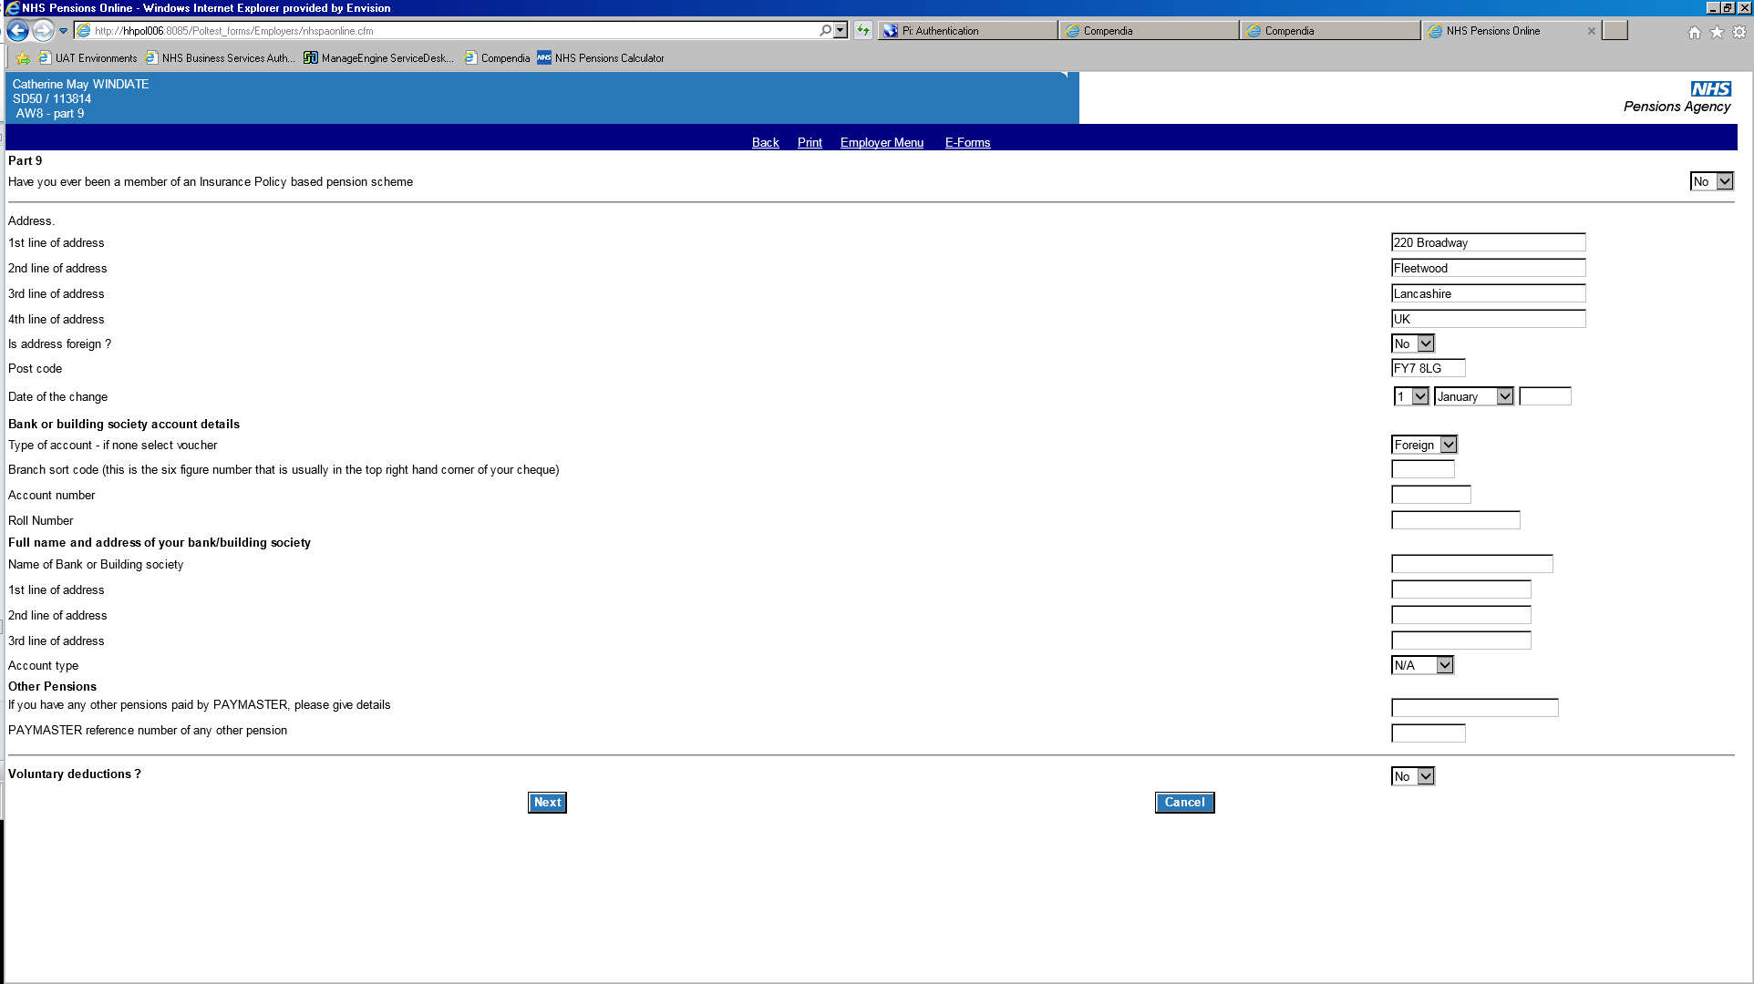

When reviewing the AW8, the bank details will be shown as follows:

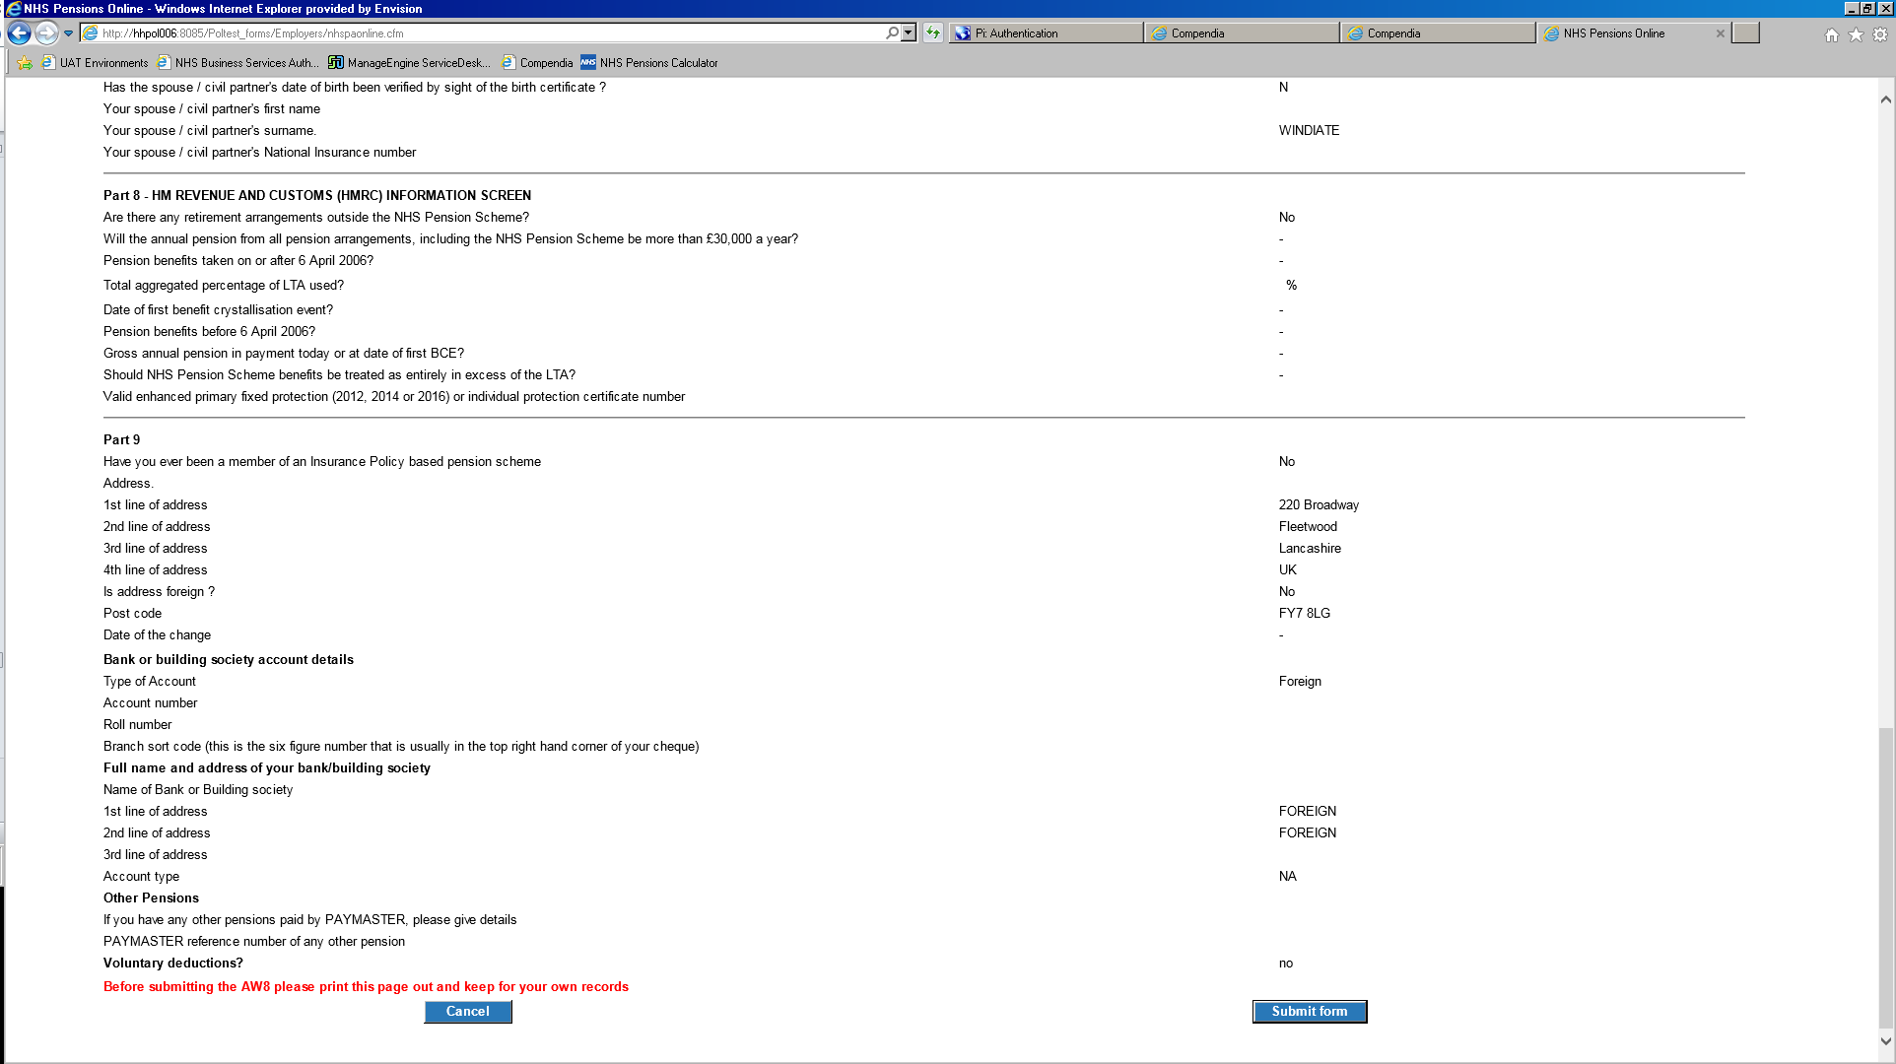

The overseas mandate form must be sent to The NHSBSA immediately after the POL submission.

# Voluntary deductions

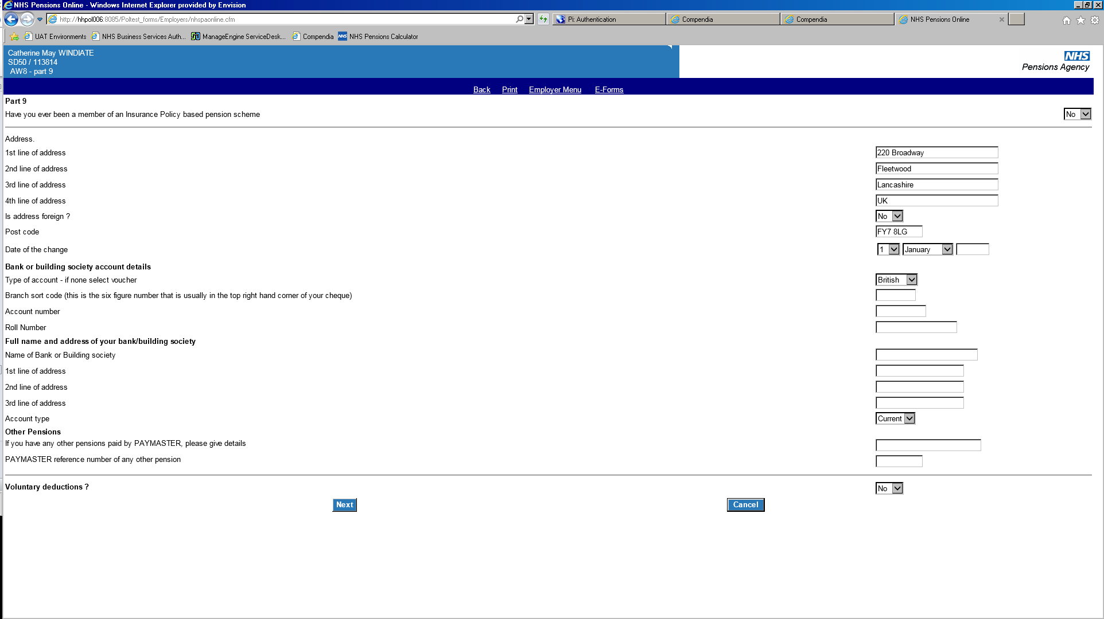

If a member has provided details of voluntary deductions, select **yes** and an additional input screen will be produced for you to input the details.

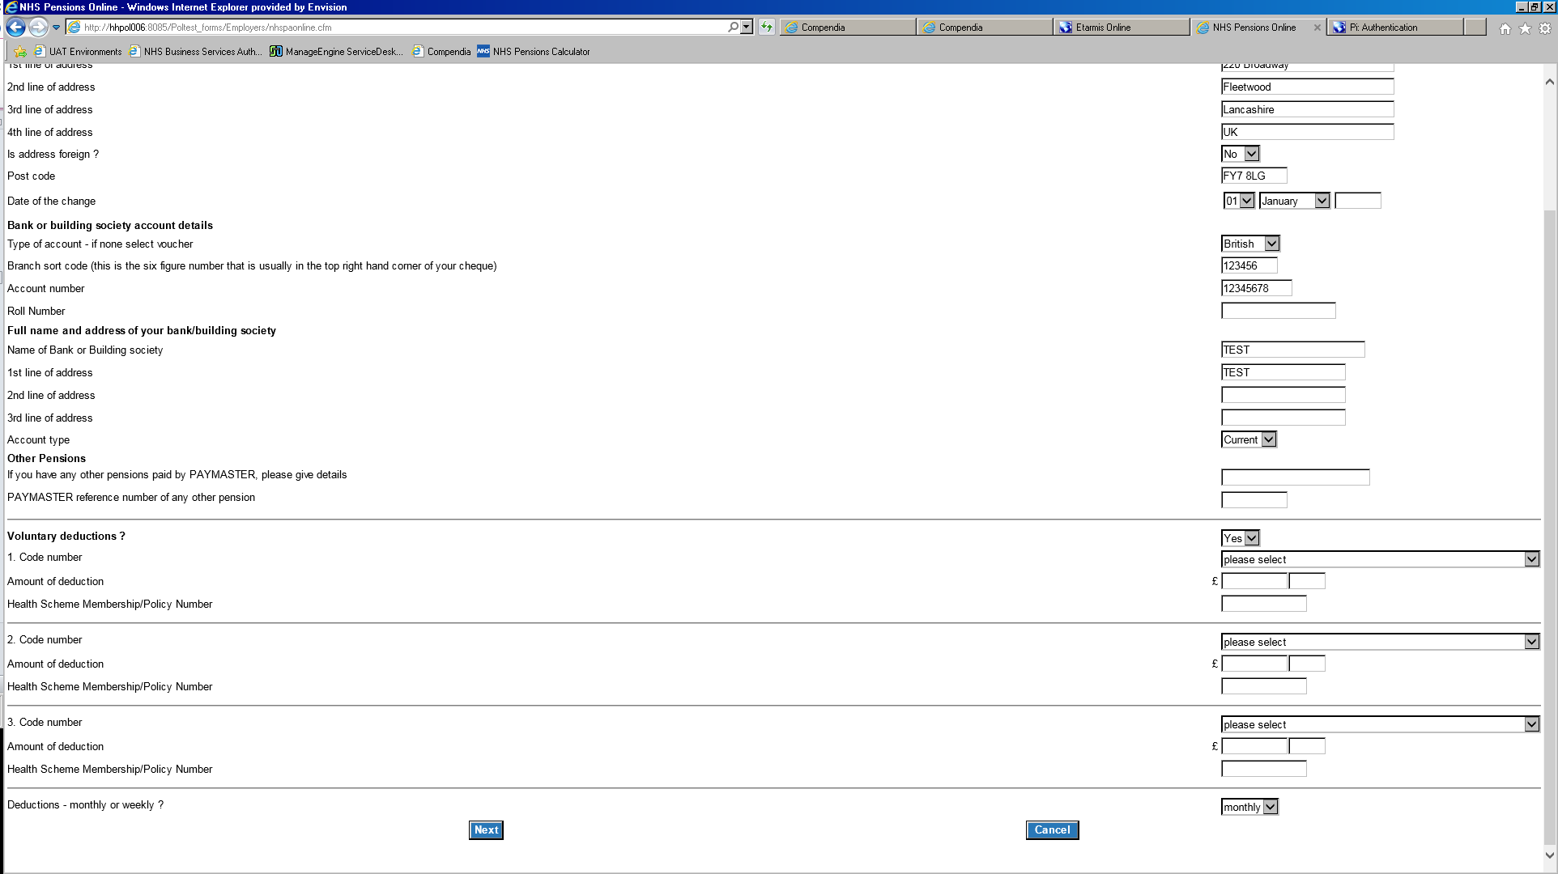

Use **drop down** boxes and enter amount of deduction accordingly.

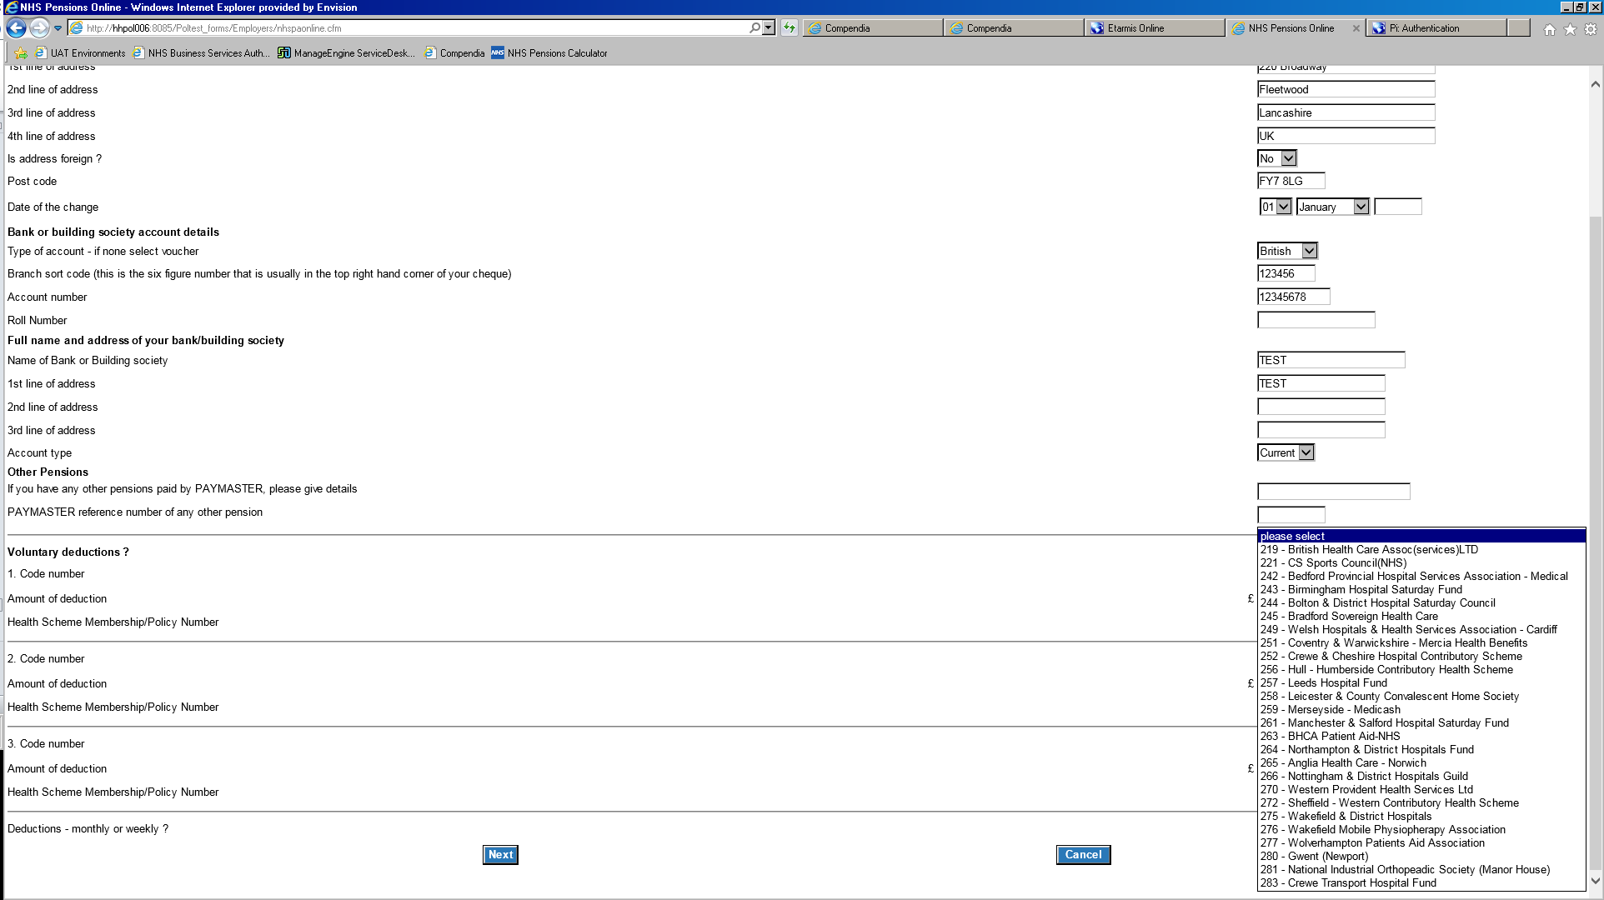

Use **drop down** boxes and enter amount of deduction accordingly.

Select **next** to continue.

# Confirmation of input details

Once you have input all sections of the AW8, you will then be shown the details that you have input on the form. You should review these details to ensure that they are correct before selecting **submit**.

If details are incorrect select **cancel**. You will then need to re input the form.

If the information is correct, select **submit form** and the following confirmation message will be produced.



Select **ok** and you will be taken back to E-Forms.

If after submitting the AW8 you realise that information has changed or is incorrect please notify The NHSBSA of the relevant information. Please **do not** submit another AW8 on POL as this will result in duplication and a delay in benefits.

# Frequently Asked Questions

**Q. What do I do if the following message is produced?**

‘There are update forms in suspense at NHSBSA. Please contact your Pension Administrator to arrange clearance of these forms before you proceed to submit the retirement application’

**A.** Send an email with the subject titled ‘Award Pending – SD ******** to [datamanagement@nhsbsa.nhs.uk](mailto:datamanagement@nhsbsa.nhs.uk) The team will arrange for the relevant action to be taken and advise when you can proceed with the AW8.

**Q. What if I have definitely closed the record down, but the message is still being produced saying that I need to close the employment?**

**A.** Check to see if the member has another open employment at your Trust (e.g. bank post). If so, this employment will also need to be terminated via SD55T before submitting the AW8.

If still unable to submit please email [datamanagement@nhsbsa.nhs.uk](mailto:datamanagement@nhsbsa.nhs.uk) who will investigate and advise.

**Q.** **Which form should the member complete? Retirement benefits claim form (AW8)/ Deferred benefits claim form (AW8P)**

**A.**

* If the member is claiming previous deferred Scheme benefits only, they should complete deferred benefits claim form (AW8P) which has to be sent to The NHSBSA for processing.
* If the member is in NHS employment at thetime of their retirement, the retirement benefits claim form (AW8) should be completed. **Important** – If the member is in non-pensionable employment you must read the ‘Claiming pension benefits from a later date’ section under ‘Notes to remember before submitting form AW8’ before submitting the AW8.
* If the member has left NHS employment they should complete deferred benefits claim form (AW8P) which has to be sent to The NHSBSA for processing.

**Q. How do I input whether the member wishes to receive the maximum tax free amount or the maximum additional lump sum which may incur a tax charge?**

**A.** When entering the member’s retirement lump sum (Part 10 of the paper AW8) onto POL, you are unable to specify whether the member wishes to receive the maximum lump sum which may incur a tax charge, or whether they wish to receive the maximum tax free amount.

Please submit the AW8 with the member’s decision as either no commutation, specific amount or maximum commutation (whichever they have chosen) and The NHSBSA will contact you if they require any further information in relation to the tax charge.

**Q. The member has a HMRC protection certificate. Which digits do I input onto the form?**

**A.** Insert the last eight digits of the certificate number into the input box. The protection certificate must then be sent to The NHSBSA.

**Q. The member has not worked for you for the last full three years. What pay figures do we require?**

**A.** POL will only produce an input box with the dates where the member has worked for your employing authority. Input the relevant pay details and The NHSBSA will calculate the remainder of the three years.

# Appendix A – Additional bank account information

|  |  |  |  |  |
| --- | --- | --- | --- | --- |
| **Name of society** | **Type of account** | **Sort code** | **Field 2 account number** | **Field 10 account**  **number** |
| Abbey National Plc | Bank account Instant Plus | 09 01 26 | Pensioner's a/c no | Not required |
|  | All savings accounts Instant Saver, Five Star, Sterling Seven Day | 09 00 00 | 00050005 | Pensioner's a/c no. |
| Alliance and Leicester Plc | Cash Plus | 72 58 26 | Cashplus reference (appears on Cashplus card) | Not required |
|  | Standing Order Collection Accounts | 72 58 10 | 00000000 | Pensioner's a/c no |
|  |  | 16 55 10 | 00000000 | Pensioner's a/c no |
|  | Alliance and Leicester Giro | 72 60 00 to 72 60 06 (Scotland) 89 20 00 to 89 20 06 | Nine-digit account numbers. 1st digit of a/c no becomes last digit of sort code | Not required |
|  | Alliance Account | 72 50 00 to 72 60 06 (Scotland) 89 10 00 to 89 10 06 | Same rules apply as for Girobank accounts (first digit of a/c no becomes last digit of sort code) | Not required |
|  | Alliance and Leicester - Isle of Man | 16 60 17 | 12000043 | Pensioner's a/c no |
| Anglo Irish Bank Corp (IOM) PLC |  | 40-05-15 | 35341139 | Pensioner's a/c no |
| Barnsley | All accounts | 62 17 19 | 00000000 | Pensioner's a/c no |
| Bath Investment | All accounts | 40 09 19 | 40133094 | Pensioner's a/c no |
| Beverley | All accounts | 60 02 23 | 97451436 | Pensioner's a/c no |
|  |  | 62 28 90 | 00000000 | Pensioner's a/c no |
| Birmingham Midshires | All accounts | 20 97 78 | 00968773 | Pensioner's a/c no |
| Bradford and Bingley | 13 40 00 accounts | 13 40 00 | 00000000 | Pensioner's a/c no |
| Bradford and Bingley | 40 19 38 accounts | 40 19 38 | 10312000 | Pensioner's a/c no |
| Britannia former Bristol and West Savings a/c | All accounts | 62 30 23 | 53731530 | Pensioner's a/c no |
|  | Direct Savings | 62 24 53 | 53731530 | Pensioner's a/c no |
|  |  | 30 93 73 | 00124371 | Pensioner's a/c no |
| Britannia | All eight fig accounts | 57 13 27 | Pensioner's a/c no | Not required |
|  | All nine fig accounts | 57 13 27 | 00000000 | Pensioner's a/c no |
|  | Isle of Man - All | 60 07 03 | 71040625 | Pensioner's a/c no |
| Buckinghamshire | All accounts | 20 02 06 | 20224448 | Pensioner's a/c no |
| Cambridge | All accounts | 20 17 22 | 40338346 | Pensioner's a/c no |
| Caixa Galicia | All accounts | 72 60 00 | 05197279 | Not required |
| Caixa Galicia | All accounts | 30 00 02 | 00493231 | Not required |
| Chelsea | All accounts | 08 60 72 | 00000001 | Pensioner's a/c no (first eight digits) |
| Cheltenham and Gloucester Plc | All accounts |  |  |  |
| Chesham | All accounts | 40 17 12 | 90232009 | Pensioner's a/c no |
| Cheshire | All accounts | 20 53 77 | 50244961 | Pensioner's a/c no |
| Chorley and District | All accounts | 16 16 22 | 11758805 | Pensioner's a/c no |
| City and Metropolitan | All accounts | 40 15 05 | 71469134 | Pensioner's a/c no |
| Clay Cross | All accounts | 60 01 10 | 04803183 | Pensioner's a/c no |
| Coventry | All accounts | 40 63 01 | Pensioner's nine digit a/c, omitting the last digit and the / | N/A |
| Cumberland | All accounts (old type) | 16 52 21 | 99999999 | Pensioner's a/c no |
|  | All accounts (new type) | 16 52 21 | Pensioner's a/c no | Not required |
| Darlington | All accounts | 40 19 03 | 40277061 | Pensioner's a/c no |
| Derbyshire | All accounts | 57 00 55 | 00000000 | Pensioner's a/c no |
| Dudley | All accounts | 08 90 48 | 70715024 | Pensioner's a/c no |
| Dunfermline | Account types 11 - 19 (inc Dunfermline Gold) | 83 92 06 | Pensioner's a/c no | Not required |
|  | All others | 83 92 07 | 00000000 | Pensioner's a/c no |
| Earl Shilton | All accounts | 60 07 12 | 13761536 | Pensioner's a/c no |
|  | New sort code (replacement) | 60 11 06 | 13761536 |  |
|  | New Accounts | 62 28 71 | Pensioner's a/c no |  |
| Ecology | 6 digit accounts starting 00 or 000 | 05 03 88 | 40417739 | Pensioner's a/c no |
|  | All others | 05 03 88 | 40417716 | Pensioner's a/c no |
| First Active PLC | All accounts | 30 15 25 | 63227798 | Pensioner's a/c no |
| First National | All accs except Guaranteed Windfall | 90 21 27 | 11327930 | Pensioner's a/c no |
| Furness | All accounts | 16 12 27 | 40393606 | Pensioner's a/c no |
| Frizzell Bank Ltd | All accounts | 51 81 18 | 02618281 | Pensioner's a/c no |
| Gainsborough | All accounts | 30 93 41 | 00041688 | Pensioner's a/c no |
| Greenwich | All accounts | 60 09 16 | 25225138 | Pensioner's a/c no |
| Halifax Plc | Cashcard, Maxim or accounts with banking details | Halifax range of sort codes (11 series) | Pensioner's a/c no (as quoted on statement) | Not required |
|  | All others | Halifax range of sort codes (11 series) | 00000000 or 99999999 | Pensioner's a/c no |
| Halifax Plc | Isle of Man - All | 30 12 80 | 00135710 | Pensioner's a/c no |
| Hanley Economic | All accounts | 30 01 20 | 09995102 | Pensioner's a/c no |
| Harpenden | All accounts | 40 23 11 | 01246356 | Pensioner's a/c no |
| Hinckley and Rugby | All accounts | 40 24 19 | 81228218 | Pensioner's a/c no |
| Holmesdale | All accounts | 60 17 27 | 27584798 | Pensioner's a/c no |
| Ilkeston | All accounts | 40 25 29 | 21052683 | Pensioner's a/c no |
| Ipswich | All accounts | 23 44 48 | 00004000 | Pensioner's nine-digit  a/c no  commencing 25 |
| Jamaica National Overseas (UK) Ltd | All accounts | 30 12 95 | 00189875 | Pensioner's a/c no |
| Kent Reliance | All accounts | 62 24 97 | 00000000 | Pensioner's a/c no |
| Lambeth | All accounts | 57 11 94 | 34266844 | Pensioner's a/c no |
| Leeds (previously Leeds and Holbeck) | All accounts | 30 00 00 | 00240303 | Pensioner's a/c no |
|  | Investment accounts | 30-00-05 | 00038664 | Pensioner's a/c no |
|  | includes former Mercantile a/c's | 40 27 15 | 12440040 | Pensioner's a/c no |
|  | Premier cheque account | 08 61 19 | Pensioner's a/c no | N/A |
| Leek United | All accounts | 40-28-01 | 11012258 | Pensioner's a/c no |
| Loughborough | All accounts (use for new notifications) | 30 00 80 | 01781004 | Pensioner's a/c no |
|  | Old sortcode-collection acc still in use | 30 95 21 | 00556885 | Pensioner's a/c no |
| Manchester Building Society | All accounts | 08 90 00 | 70127065 | Pensioner's a/c no |
| Mansfield | All accounts | 20 55 62 | 10613185 | Pensioner's a/c no |
| Market Harborough | All accounts | 20 49 08 | 70608386 | Pensioner's a/c no |
| Marsden | All accounts | 01 05 93 | 01525182 | Pensioner's a/c no |
| Melton Mowbray | All accounts | 40 32 14 | 10572780 | Pensioner's a/c no |
| Monmouthshire | All accounts | 40 34 27 | 10600717 | Pensioner's a/c no |
| Nat West | Cash Plus | 6 digit sort code supplied | 8 digit a/c supplied | 16 digit Card Reference not necessary |
| National Commercial Bank Jamaica Ltd(London) 1st Floor 83 Victoria St LONDON SW1H OHW |  | 20 00 00 | 90663689 | Pensioner's a/c no |
| National Counties | Pre-1993 accounts | 40 20 24 | 90614629 | Pensioner's a/c no (10 digits followed by first three letters of name) |
| National Counties | Post-1993 accounts | 40 20 24 | 90614629 | Pensioner's a/c no (10 digits - No letters of surname) |
| Nationwide | Flexaccount | 07 01 16 | Pensioner's a/c no | Not required. If an account number is quoted as ****/6******** then use a sortcode of 07 01 16 and the account number less the ****/6 in field 2 |
|  | Cashbuilder (Card account) | 07 00 30 | Pensioner's a/c no | Not required |
|  | Cashbuilder (Passbook a/c) and other investment a/cs | 07 00 93 | 33333334 | Pensioner's a/c no |
| Newbury | All accounts | 20 59 14 | 50660000 | Pensioner's a/c no |
|  |  | 62 28 74 | 00000000 | Pensioner's a/c no |
| Newcastle | All accounts | 23 59 54 | 00000008 | Pensioner's full a/c no (inc alpha characters) |
|  | All accounts | 23 59 54 | Pensioner's a/c no (numeric digits only) | Not required |
| Northern Rock | Cheque accounts | 08 60 64 | Pensioner's a/c no | Not required |
|  | Investment accounts | 08 61 15 | 88888888 or 00000515 is preferred | Pensioner's a/c no |
|  | Guernsey - All accounts | 30 93 73 | 01207246 | Pensioner's a/c no |
| North Lanarks Municipal | All accounts | 82 20 00 | 90005528 | Pensioner's a/c no |
| National Westminster | Gibraltar - all accounts | 60 60 60 | 02100002 | Pensioner's a/c no |
| North of England | All accounts | 20 83 69 | 40672432 | Pensioner's a/c no |
| Norwich and Peterborough | All accounts | 08 60 81 | Pensioner's a/c no | Not required |
| Nottingham | All accounts | 60 80 09 | 96875364 | Pensioner's a/c no |
| Nottingham Imperial | All accounts | 40 35 18 | 41137085 | Pensioner's a/c no |
| Penrith | All accounts | 60 16 21 | 77173163 | Pensioner's a/c no |
| Portman | Cheque a/cs, Portman Wessex Current a/c | 23 71 70 | Pensioner's a/c no | Not required |
|  | All investment a/cs | 20 11 39 | 90050210 | Pensioner's a/c no |
| Post Office |  | 90-78-68 | Pensioner's eight digit a/c | Not required |
| Principality | All accounts | 20 18 15 | 90653535 | Pensioner's a/c no |
| Progressive Building Society | All accounts | 90 21 27 | 43486565 | Pensioner's a/c no |
| Providian National Bank | All accounts | 20 32 53 | 00159255 | Pensioner's a/c no |
| Prudential | Egg Account | 40 61 99 | 0 before the pensioner's seven digit a/c no | Not required |
| Saffron Walden Herts and Essex | All accounts | 20 74 05 | 00775991 | Pensioner's a/c no |
| Saga A/c Postal Service | All accounts | 57 11 84 | 53731530 | Pensioner's a/c no |
| Scarborough | All accounts | 40 40 22 | 40724971 | Pensioner's a/c no |
| Scottish | All accounts | 83 06 08 | 00255419 | Pensioner's a/c no |
| Shepshed | All accounts | 60 14 10 | 89883209 | Pensioner's a/c no |
| Skipton | Investment accounts | 20 78 42 | 70798924 | Pensioner's a/c no |
| Stafford Railway | All accounts | 20 81 00 | 70848336 | Pensioner's a/c no |
| Staffordshire | All accounts | 20 97 78 | 10789011 | Pensioner's a/c no (eight digit) |
|  | Mortgage accounts | 20 97 78 | 50789038 | Pensioner's a/c no |
| Standard | All accounts | 30 96 15 | 00152528 | Pensioner's a/c no (11 digit) |
| Stroud and Swindon | All accounts | 40 43 21 | 91199501 | Pensioner's a/c no |
| Swansea | All accounts | 30 95 46 | 01464485 | Pensioner's a/c no |
| Teachers | All accounts | 60 24 43 | 60230282 | Pensioner's a/c no |
| Tipton and Coseley | All accounts | 20 27 17 | 70885096 | Pensioner's a/c no |
| Universal | All accounts | 30 00 47 | 00013906 | Pensioner's a/c no |
| Vernon | All accounts | 08 90 24 | 70236215 | Pensioner's a/c no |
| Victoria Mutual | All accounts | 20 00 00 | 80571512 | Pensioner's a/c no |
| West Bromwich | All accounts | 40 46 13 | 91066277 | Pensioner's a/c no |
| West Cumbria | All accounts | 82 68 29 | 90000990 | Pensioner's a/c no |
| Woolwich Plc | Current account | 10 80 02 see * | Pensioner's Cheque A/c No | N/A * Woolwich transferred to Barclays Bank in 2007. Obtain individual account details from members |
| Woolwich transferred to Barclays Bank in 2007. Obtain individual account details from members | Prime Gold card | 10 80 02 see * | Pensioner's a/c no (last eight digits) | N/A * Woolwich transferred to Barclays Bank in 2007. Obtain individual account details from members |
|  | Open Plan | 10 80 12 see * | Pensioner's A/C no | N/A * Woolwich transferred to Barclays Bank in 2007. Obtain individual account details from members |
|  | All others | 10 80 00 to 10 80 09 see * | First eight digits of roll number | N/A * Woolwich transferred to Barclays Bank in 2007. Obtain individual account details from members |
|  | Guernsey - All accounts | 60 09 20 | 49652494 | Pensioner's a/c no |
| Yorkshire / Gainsborough Building Society | All accounts except mortgage, secured loan and Sharesave | 57 00 45 | First eight digits of roll number | Full 10-digit roll number |
|  | Mortgage, secured loan, Sharesave | 62-23-37 | First eight digits of roll number | Full 10-digit roll number |
| Yorkshire Building Society |  | 60 92 04 | First eight digits | Not required |