# 

# NHS Pensions

# Online (POL) Guide

**22. SD55E – Amending contributions and pay**

# Contents

SD55E form 3

Open employments 4

Closed employments 6

Early Retirement Reduction Buy Out (ERRBO) 8

Linked employments 8

# SD55E form

The SD55E form allows you to change contributions and pay details for both open and closed employments.

After you have selected the link to the form, you will be asked to input the member’s National Insurance (NI) number or SD membership number.

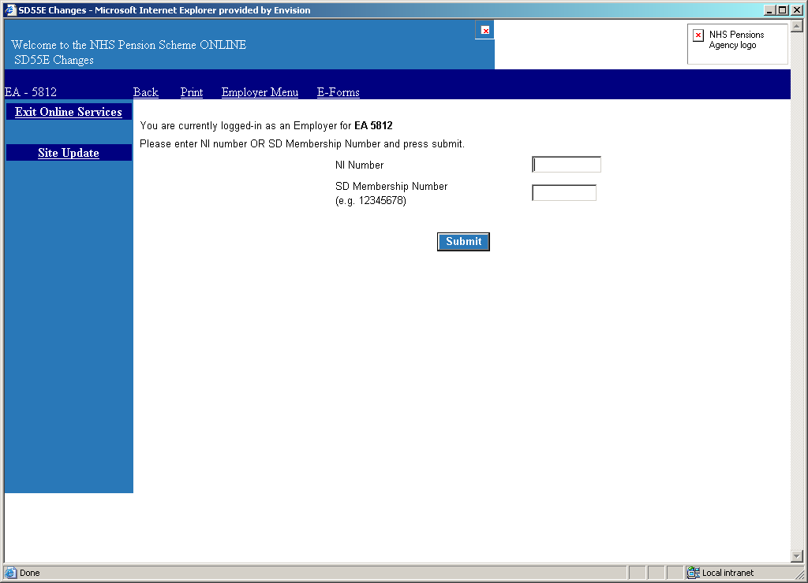

Once you have entered the member’s National Insurance or SD number, you will be shown a list of all employments the member had/has with your Authority/GP Practice. Select the employment you wish to amend by clicking on the blue link in the column titled ‘Employer’.



# Open employments

For an open employment, you will then be asked to input the year that you wish to amend.



If you make an error and select a year that is not available for amendment, you will receive an on screen error message.

If the year that has been entered is correct but you are still receiving an error message, the reasons for this could be that either the previous year end update is in Error Handling, is yet to be submitted or the correct dates of service are not held by NHS Pensions.

If you havesubmitted the annual update form, it may have been sent to Error Handling for further action. The link to this can be found on the main employer menu page. Details about how to action forms in Error Handling are provided later in this guide.

If the update is in Error Handling then, as well as resolving the reason for the error, you would also be able to amend the contributions and/or pay details before resubmitting the form for processing. You will then no longer need to submit a form SD55E.

Where you select a valid year for amendment you will then be taken to the SD55E that will show the details that NHS Pensions hold on their records for that year.

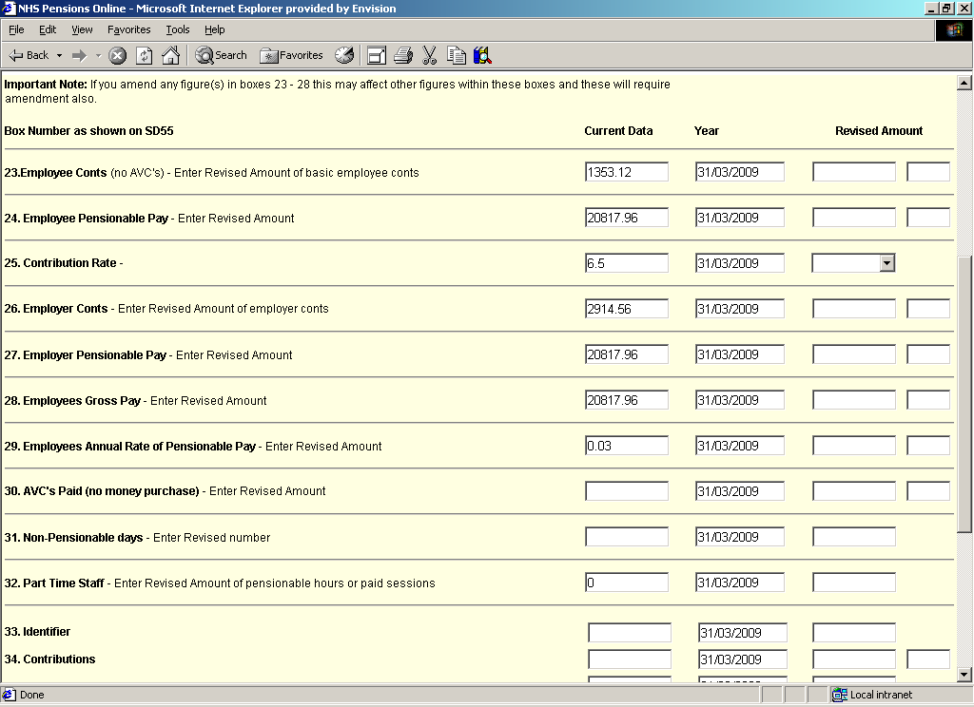

The validation for all these fields mirrors the validation on the original annual update and any revised data is validated against any unchanged data.

Please be aware that if an amendment to the contribution rate or contract is required (for example, part time hours change or amendment to capacity code) this cannot be done via form SD55E. You will instead need to use the Rewind Employment form for open employments, or ‘Open and Rewind for closed employments’.

Once backdated, the employment can be updated/terminated using the respective SD55 form again with the correct changes included.

### Example

The employer’s pensionable pay is shown as £20,817.96 with employee contributions of £1,353.12. If the contributions were amended to £2,353.12, an on screen error message would be produced, as this revised figure does not equate to 6.5% of the employee’s pensionable pay figure of £20,817.96.

In some cases, if you amend one pay or contributions figure you will be prompted to check and amend other figures.

Additionally, if hours or sessions worked were entered and the employment is not part time during this year, then an onscreen error message will be produced.

Examples of some of the error messages are as follows:

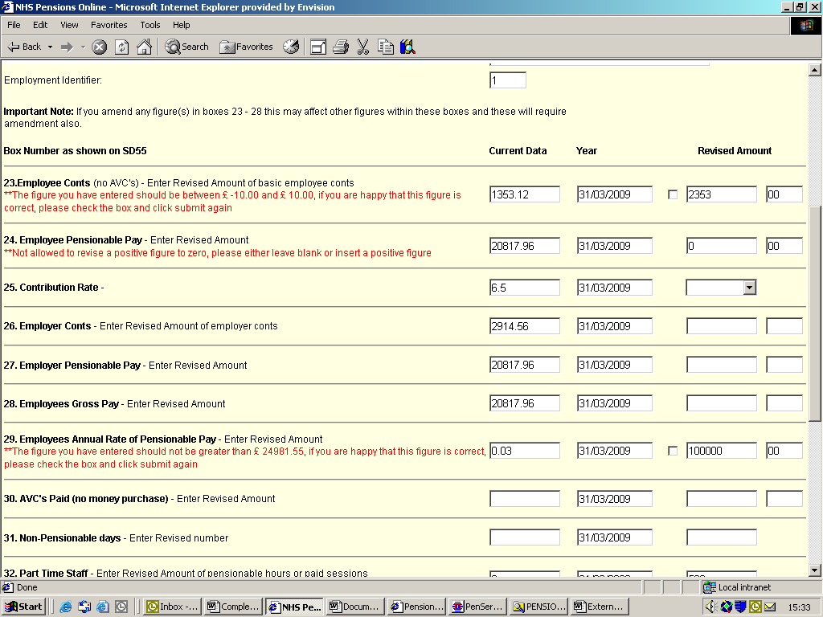

# Closed employments

For a closed employment you can select either a year for amendment (from the available years displayed) or, if you wish to amend the leaving date that was provided on the original termination, you would enter the revised Date of Termination (DOT).

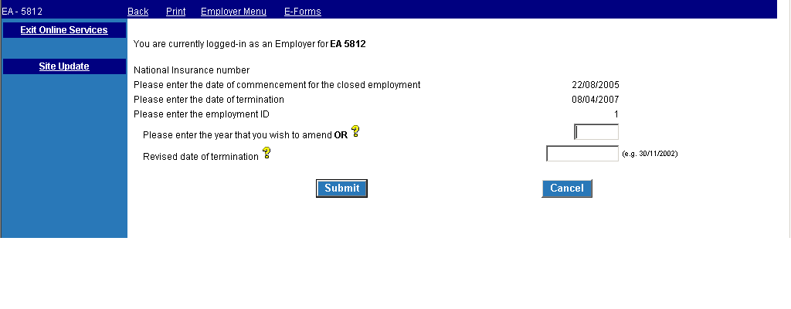

You should only access the SD55E form using the revised DOT option if you are amending the actual DOT.

You will also receive a message reminding you to consider whether any amendments to the year in which the original DOT fell are required.

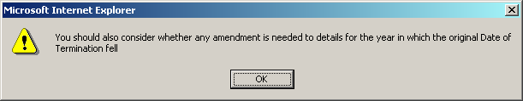

After selecting OK you will be taken to the SD55E.

If you wish to amend the DOT to a date in a previous financial or tax year, you will not be allowed to continue. If the amendment is required on a ‘new’ post with minimum year end updates attached, the adjustment can be done locally by deleting the employment and adding the service using the correct dates on the respective Joiner form. Should the amendment be needed to an older post, or you receive error 0470 (invalid employment status for deletion error) you will need to contact the NHS Pensions Data Management Team at [datamanagement@nhsbsa.nhs.uk](mailto:datamanagement@nhsbsa.nhs.uk) to make the necessary changes.

An SD55E cannot be used where the last day of employment changes across a financial or tax year. You will need to submit an ‘Open a Closed Employment request’ via e-forms and replace any update necessary before submitting the correct SD55 termination.

Where this change is required for a pensioner, refunded or transferred out employment, opening the employment will not be possible and you will receive an error 0480 (invalid employment status, allocated to NHS Pensions). You will need to contact the NHS Pensions Data Management Team at [datamanagement@nhsbsa.nhs.uk](mailto:datamanagement@nhsbsa.nhs.uk), including all of the information you listed on the SD55E, employee and employer contributions, employee and employer pay, hours where part time, employee contribution rate and revised date of termination. Please include both penultimate and final years if crossing financial and/or tax years.

# Early Retirement Reduction Buy Out (ERRBO)

The SD55E form and employer Error Handling form have been amended to:

* remove annual basic pay
* include new ERRBO contribution field (ERRBO contributions may only be entered where the employment is in the 2015 Scheme)

The new ERRBO contributions field will be added immediately after the existing Additional Voluntary Contributions (AVC) field and before none pensionable days.

# Linked employments



2015 Scheme transition members must have a split shown in their employment where it has crossed the Scheme transition date. This results in two employments being recorded - one for the earlier 1995/2008 Section membership and the other for their 2015 Scheme membership.

The SD55E form will not split employments. Linked employments will be handled as follows:

you may select either the earlier 1995/2008 Sections or the 2015 Scheme separately

you will be prohibited from changing the end date of a linked employment for the earlier 1995/2008 Section employment ID. This is because it would create a break in the linked employment. If the end date needs to be changed to a date earlier than the transition date, then the rewind employment form should be used