# NHS Business Services Authority logoNHS Pensions

# Annual Allowance – Remediable Pension Savings Statement Guide

## Contents

NHS Pensions 1

Annual Allowance – Remediable Pension Savings Statement Guide 1

About this guide 3

Why have you been sent a remediable pension savings statement? 4

How HMRC’s 'Calculate your public service pension adjustment' tool can help you 6

What is in your remediable pension savings statement? 7

What to do once you have your remediable pension savings statement 16

What to do if your accountant or IFA is supporting your use of the tool 20

What about my 2023/24 tax year Pensions Savings Statement? 21

If I have an annual allowance charge to pay, can I apply to the NHS England and NHS Improvement (NHSEI) 2019/20 Pensions Annual Allowance Charge Compensation Policy? 22

## About this guide

We have started sending out remediable pension savings statements from October 2024 to members who need them. We are sending these in phases, so if you do not have yours yet, you do not need to do anything – we will send it as soon as possible.

The next section explains who needs a remediable pensions statement, and:

* if you have one, why do you have one?
* if you don’t have one, do you need one?
* if you don’t need one, why you do not need one.

The majority of members who need a remediable pension savings statement have previously been sent a pension savings statement for one or more of the remedy tax years 2015/16 to 2021/22. A small number of members may need a remediable pension savings statement for the first time for tax year 2022/23 because their pension growth is more than the standard annual allowance of £40,000.

The remediable pension savings statement is a one-off letter, very much in the style of our standard pension savings statement.

Whether you have received a previous pension savings statement before or the remediable pension savings statement is your first, the topic of pensions tax can be complex, and this guide has been created to:

* explain why you have been sent a remediable pension savings statement
* take you through the figures on each page of your remediable pension savings statement
* highlight how the figures fit in with the HMRC 'Calculate your public service pension adjustment' tool, specifically designed to support members affected by the Public Service Pensions Remedy (also known as McCloud)
* highlight the next steps that you may need to take

The [Pensions Saving Statement Guide (V2)](https://www.nhsbsa.nhs.uk/member-hub/annual-allowance) has important information about:

* how to calculate your pension input amount – pages 10 to 12
* the tapered annual allowance – pages 17 to 18
* the alternative annual allowance – pages 19 to 20
* carry forward – pages 21 to 23
* scheme pays – pages 26 to 31
* glossary – pages 33 to 36

These topics are not repeated in this guide, so you may find it useful to read both documents.

## Why have you been sent a remediable pension savings statement?

### If you have received a remediable pension savings statement

We have sent you a remediable pension savings statement because you:

* are affected by the Public Service Pensions Remedy
* had your pensionable service between 1 April 2015 and 31 March 2022 moved from the 2015 Scheme to the 1995/2008 Scheme
* may need to check and update your pension tax information with HMRC

Moving your service to the 1995/2008 Scheme may have changed your pension tax position for the tax years 2015/16 through to 2021/22 and could mean you have overpaid an annual allowance charge and need to claim a tax refund, or you are amongst a small number of members who may have extra tax to pay.

You should follow the steps explained in this guide to check your pension tax position with HMRC. The majority of members should find that there is little or no change to their pension tax position.

### If you haven’t yet received a remediable pension savings statement

We’ll send you a remediable pension savings statement as soon as possible if your service has moved back to the 1995/2008 Scheme and you either:

* went over your annual allowance limit in any tax year from 2015/16 to 2021/22
* are over the standard annual allowance limit of £40,000 in the tax year 2022/23
* did not go over your annual allowance limit in any tax year from 2015/2016 to 2021/2022 but were provided with a pension savings statement on request
* and haven’t claimed any of your pension benefits yet, or you retired after 30 September 2023

### Members who don’t need a remediable pension savings statement

You don’t need a remediable pension savings statement if:

* you are not affected by the Public Service Pensions Remedy
* or your pensionable service between 1 April 2015 and 31 March 2022 has always been in the 1995/2008 Scheme, there is no change to your pension input amounts

You do not need to check your tax position with HMRC because it hasn’t changed.

If you have not already received one, and think you may need one, you can request a pension savings statement for the tax year 2022/23 by contacting NHS Pensions in writing, by email, at [nhsbsa.pensionsmember@nhsbsa.nhs.uk](mailto:nhsbsa.pensionsmember@nhsbsa.nhs.uk), or on the phone, at 0300 330 1346.

### If you started receiving pension benefits before 1 October 2023

If you retired before 1 October 2023, you will not be sent a remediable pension savings statement until after you have been contacted to choose which benefits you want for the remedy period, between 1 April 2015 and 31 March 2022.

The government has designed the remedy so that you only receive a remediable pension savings statement if you actually need one. Whether you need one or not will depend on the benefits you choose when we contact you to make your Public Service Pensions Remedy choice.

Timings for when you can expect to receive your choice are currently under review, and we will update our Public Service Pensions Remedy page when these timings are confirmed. If your decision means you need to check and update HMRC about your pension tax position, we will send you a remediable pension savings statement at that time.

## How HMRC’s 'Calculate your public service pension adjustment' tool can help you

We have sent you a remediable pension savings statements so that you can use HMRC’s ‘Calculate your public service pension adjustment’ tool.

HMRC has developed this tool to help you:

* decide whether you need to use the full HMRC tool service – more information on page 16
* enter information to check if your pension tax position has changed because of the remedy – more information on page 16
* work out any reduced annual allowance charge you have previously overpaid
* work out any new or extra annual allowance charges that you may have to pay
* apply to claim compensation from the NHS Pension Scheme for any overpaid annual allowance charges that you have paid directly to HMRC for tax years 2015/16 to 2018/19
* apply to claim a refund from HMRC of any overpaid annual allowance charges that you have paid directly to HMRC for tax years 2019/20 to 2021/22
* apply to update your scheme pays arrangement for any overpaid annual allowance charges that you asked the NHS Pension Scheme to pay to HMRC for tax years 2015/16 to 2021/22
* pay a new or extra annual allowance charge, either directly to HMRC or by scheme pays, for tax years 2019/20 to 2021/22
* pay an annual allowance charge, either directly to HMRC or by scheme pays, for tax year 2022/23
* automatically update your self-assessment tax return information with any pension tax changes during the remedy tax years 2015/16 to 2021/22

### HMRC’s tool has three sections

The HMRC tool has three sections, although these are not signposted as sections in the tool.

Section 1 – **triage** – more information on page 16

Section 2 – **calculator** – more information on page 16

Section 3 – **submission** – more information on page 17

## What is in your remediable pension savings statement?

Before going into more detail about the HMRC tool, let’s explain what’s in your remediable pension savings statement.

Your remediable pension saving statement shows you:

* your new pension input amounts in both the 1995/2008 Scheme and 2015 Scheme for tax years 2015/16 through to 2021/22
* your old pension input amounts in both the 1995/2008 Scheme and 2015 Scheme for tax years 2015/16 through to 2021/22
* your old pension input amounts in the 1995/2008 Scheme for the carry forward tax years 2010/11 through to 2014/15
* any annual allowance charges you asked the scheme to pay on your behalf to HMRC using ‘scheme pays’ for tax years 2014/15 through to 2021/22

Where we have the information to calculate your pension input amount for the tax year 2022/23, we’ll include this information in your remediable pension savings statement, and you won’t get a separate pension savings statement.

You’ll need the information included in your remediable pension savings statement to use and work your way through the first two sections of the HMRC tool.

There is a lot of information in your remediable pension savings statement, so we’ll take you through each section, as numbered on the tables throughout.

### Your NHS Pension Scheme Remedial Pension Savings Statement – Relevant tax years

**3**

**5**

**4**

**8**

**2**

**1**

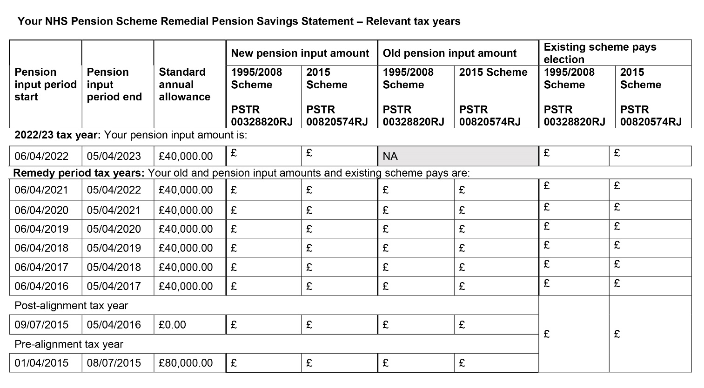

**6**

**9**

**7**

### 1. and 2. Pension input period start and end

The ‘pension input period start and end’ columns cover the period over which your pension savings growth is measured – the pension input amount. The statement shows the pension input period start and end for each tax year from 2010/11 through to 2022/23.

## **3. Standard annual allowance**

The annual allowance is the maximum amount of pension savings you can make each tax year with the benefit of tax relief. Your statement shows the standard annual allowance limit in each of the tax years. You don’t have a separate standard annual allowance for each pension scheme you were a member of during these tax years, the limit is for your pension growth across all your pension schemes.

Your annual allowance could be lower than the standard annual allowance if you are a higher earning member or are over age 55 and flexibly accessed your money purchase scheme pension. If you think this might be you, then you need to read pages 17 to 20 of the [Pensions Saving Statement Guide (V2)](https://www.nhsbsa.nhs.uk/member-hub/annual-allowance) to understand if your annual allowance limit could be lower.

### 4. New pension input amounts in the 1995/2008 Scheme and the 2015 Scheme

Because your pensionable service between 1 April 2015 and 31 March 2022 was moved from the 2015 Scheme to the 1995/2008 Scheme, your pension input amounts in both NHS Schemes have changed.

#### 1995/2008 Scheme

This column shows your updated pension input amounts in the 1995/2008 Scheme for these tax years. You will also have a pension input amount in the 1995/2008 Scheme for tax year 2022/23.

#### 2015 Scheme

Where you joined the 2015 Scheme on 1 April 2022 you will have a very small pension input amount in your 2015 Scheme for tax year 2021/22. This covers the 5-day period 1 April 2022 to 5 April 2022. Unless you purchased additional pension there should be no pension input amounts in tax year 2015/16 to 2020/21.

If you purchased, or were purchasing, additional pension in the 2015 Scheme between 1 April 2015 and 31 March 2022, then under the rules of the remedy your additional pension was automatically moved to the 1995/2008 Scheme and for the tax years in your remediable pension savings statement remained in the 2015 Scheme. This means you will have a new pension input amount in the 2015 Scheme for the tax year the original purchase was made in, and for each subsequent tax year through to 2022/23.

#### 1995/2008 Scheme and 2015 Scheme

You will need to enter your new pension input amount figures into the calculator section of the HMRC tool, if you need to use it.

You can find out how we calculated your new pension input amounts on pages 10 and 11 of the [Pensions Saving Statement Guide (V2)](https://www.nhsbsa.nhs.uk/member-hub/annual-allowance).

### 5. Old pension input amounts in the 1995/2008 Scheme and the 2015 Scheme

#### 1995/2008 Scheme

The table shows your 1995/2008 Scheme pension input amounts calculated in the relevant remedy tax year. These are based on your service between 1 April 2015 and 31 March 2022, **before** this service was moved from the 2015 Scheme to the 1995/2008 Scheme.

#### 2015 Scheme

The table shows your original 2015 Scheme pension input amounts calculated in the relevant remedy tax year. They are based on your service between 1 April 2015 and 31 March 2022 in the 2015 Scheme, **before** this was moved to the 1995/2008 Scheme.

#### 1995/2008 Scheme and 2015 Scheme

You do not need the old pension input amounts to use the calculator section of the HMRC tool but you may need them to use the triage section of the tool.

### 6. Understanding why your old pension input amount may have changed

Your remediable pension savings statement may show a different figure for your old pension input amount for one or more tax years compared to a previous pension savings statement you received. This is not a mistake.

Before sending your statement, we took the opportunity to recalculate these figures to make sure you have the most up to date information possible. Your updated old pension input amounts now take into account one or both of the following:

* any changes to your pensionable pay and/or membership details shared with NHS Pensions by your employer or host board since we sent your pension savings statement
* your pensionable pay in a previous year was higher than the final year’s pay used in our original calculation of your old pension input amount. This only affects a small number of 1995 Section members where the pay earned in either of the two immediately preceding years was higher. If this applies to you, we have used the earlier year's pay to work out your final salary benefits.

### 7. £0.00 pension input amount in your statement

Your statement will show a nil (£0.00) pension input amount in the 1995/2008 Scheme if you have a negative 1995/2008 Scheme pension input amount, because:

* the growth in the Consumer Price Index (CPI), used to adjust the opening value, outweighs the growth in your pensionable earnings
* your pensionable pay was a lower amount at the closing value compared to that used in the opening value

Where there is a negative 1995/2008 Scheme pension input amount before 2023/24 HMRC confirm that the pension input amount is nil for that pension input period.

### 8. Existing scheme pays election

If you had an annual allowance charge for any of the remedy tax years and you asked the NHS Pension Scheme to pay your charge to HMRC, these are all the annual allowance charges paid by scheme pays.

You will need the new pension input amounts if you need to use the calculator section of the tool.

### 9. Pension scheme tax reference

Each NHS scheme has its own pension scheme tax reference and the statement shows both of these. If you reach the calculation section of the tool, you will be asked to enter your public service pension scheme and one pension scheme tax reference.

If you need to use the calculator section of the tool, we recommend you enter the ‘**NHS Pension Scheme**’ along with the reference for the 1995/2008 Scheme – **00328820J**.

### 10. Tax year 2015/16

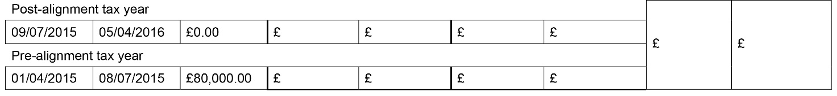

**10**

Two mini tax years were created for tax year 2015/16 – these were called pre-alignment and post-alignment. This was done to align the pension input period for all pension schemes to tax year from 2016/17.

In the pre-alignment tax year, from 1 April 2015 to 8 July 2015 the standard annual allowance was £80,000.

In the post-alignment tax year, from 9 July 2015 to 5 April 2016 the standard annual allowance was £0.00. But up to £40,000 of any unused annual allowance from the pre-alignment pension input period could be carried forward to the post-alignment pension input period.

If you were in active pensionable employment during tax year 2015/16, then you have both pre-alignment and post-alignment pension input periods.

If you had an annual allowance charge for 2015/16 this is not split between the two mini tax years.

### 11. Carry forward pension input amounts

**11**

#### Carry forward tax years

Your pension input amounts in the previous five tax years in the 1995/2008 Scheme are:

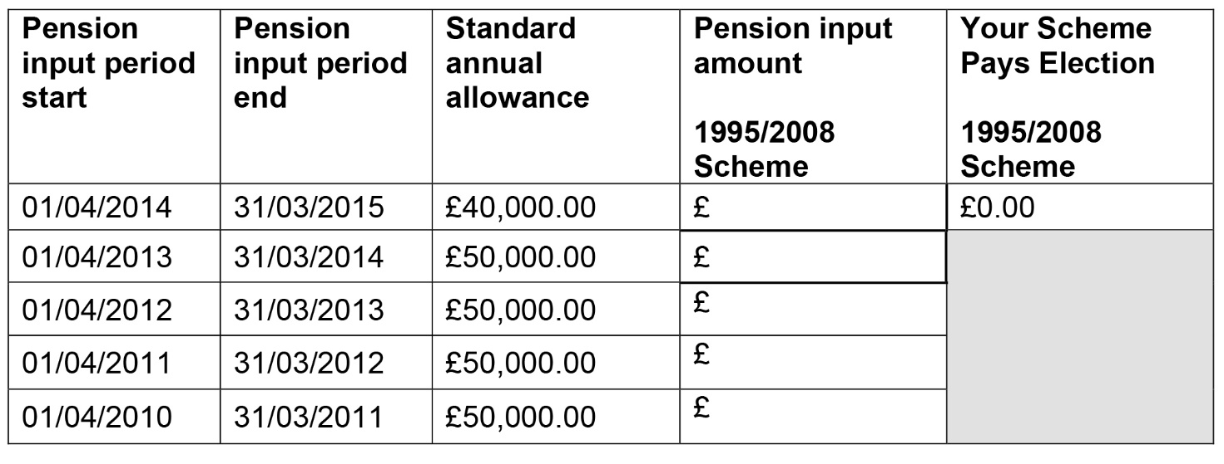

**12**

**7**

To increase the annual allowance available to you in each relevant tax year you can carry forward your unused annual allowance from the previous three tax years. As the first remedy tax year is 2015/2016, your statement shows the pension input amounts in the 1995/2008 Scheme for the three previous tax years, 2012/2013, 2013/14 and 2014/2015.

You may, or more likely not, be amongst a very small number of members where the amount of your unused annual allowance for these three carry forward tax years is impacted by the previous two tax years. If you are, your statement also shows the pension input amounts in the 1995/2008 Scheme for tax years 2010/11 and 2012/13.

You may need all these pension input amounts if you need to use the calculator section of the tool.

### Carry forward tax year missing in your statement

If you have one or more pension input periods missing in your statement, this may be because you either left the NHS Pension Scheme or were a deferred member for the whole pension input period.

For any missing periods, your unused annual allowance would be your annual allowance limit for that tax year, unless you have a pension input amount in another pension scheme.

## **13.** **Opening and closing values for your new pension input amounts in the 1995/2008 Scheme**

#### Opening and closing values for your new pension input amounts in the 1995/2008 Scheme

Your pension input amounts are the difference between the value of your 1995/2008 NHS Pension Scheme benefits at the start (the opening value) and the end (the closing value) of the pension input period.

**13**

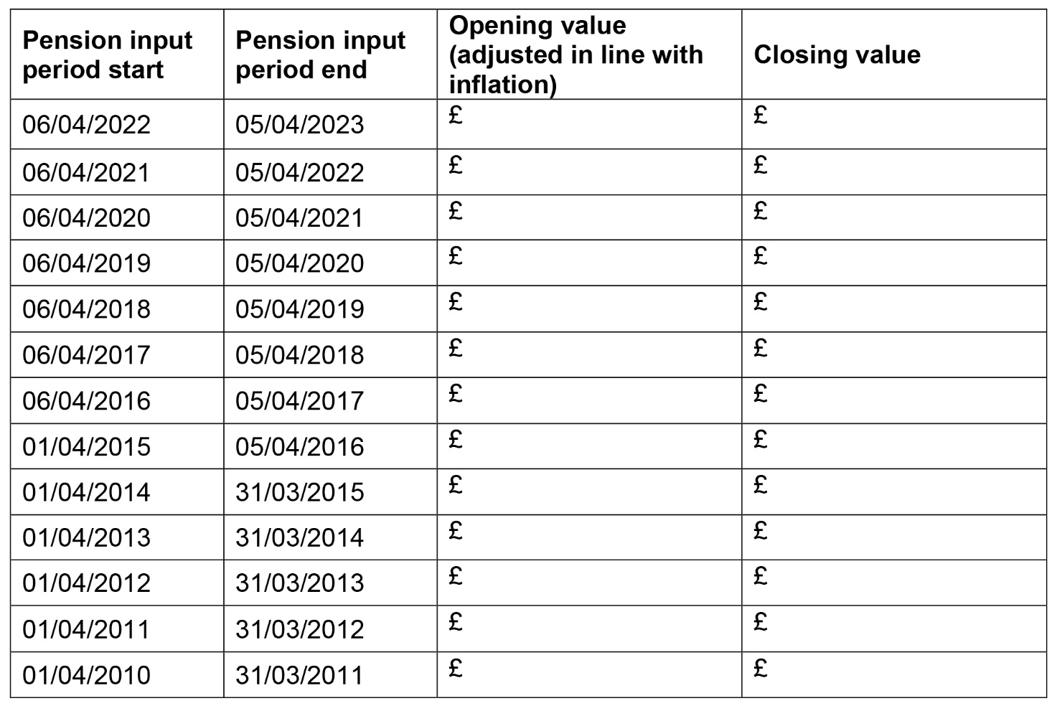

Your new 1995/2008 Scheme pension input amounts are calculated using pensionable pay and service details provided by your employer or host board. Your statement shows your opening and closing values for each pension input period, including the five carry forward pension input periods.

Your opening value has been adjusted in line with inflation. You can find more information about this is on page 11 of the [Pensions Saving Statement Guide (V2)](https://www.nhsbsa.nhs.uk/member-hub/annual-allowance).

### 14. Opening and closing values for your new pension input amounts in the 2015 Scheme

**14**

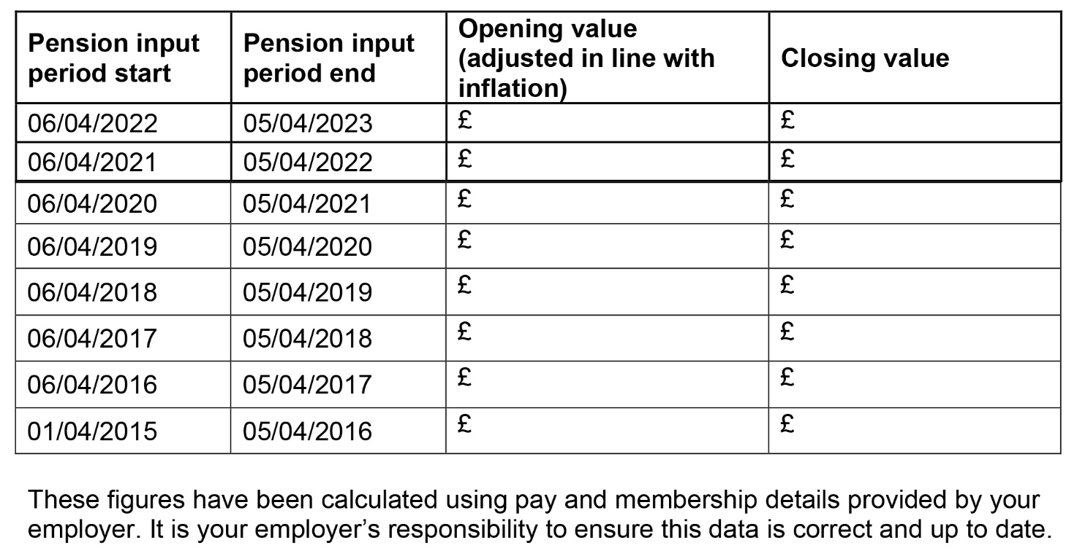

Your new 2015 Scheme pension input amounts are calculated using pensionable pay details provided by your employer or host board. Your statement shows your opening and closing values for each pension input period, for tax years 2015/16 through to 2022/23.

Your opening value has been adjusted in line with inflation. You can find more information about this on page 11 of the [Pensions Saving Statement Guide (V2)](https://www.nhsbsa.nhs.uk/member-hub/annual-allowance).

### 15. Summary page

We’ve added your 1995/2008 Scheme and 2015 Scheme pension input amounts and scheme pays together to make it easier for you to input these into the calculator section of HMRC’s Digital Service.

**14**

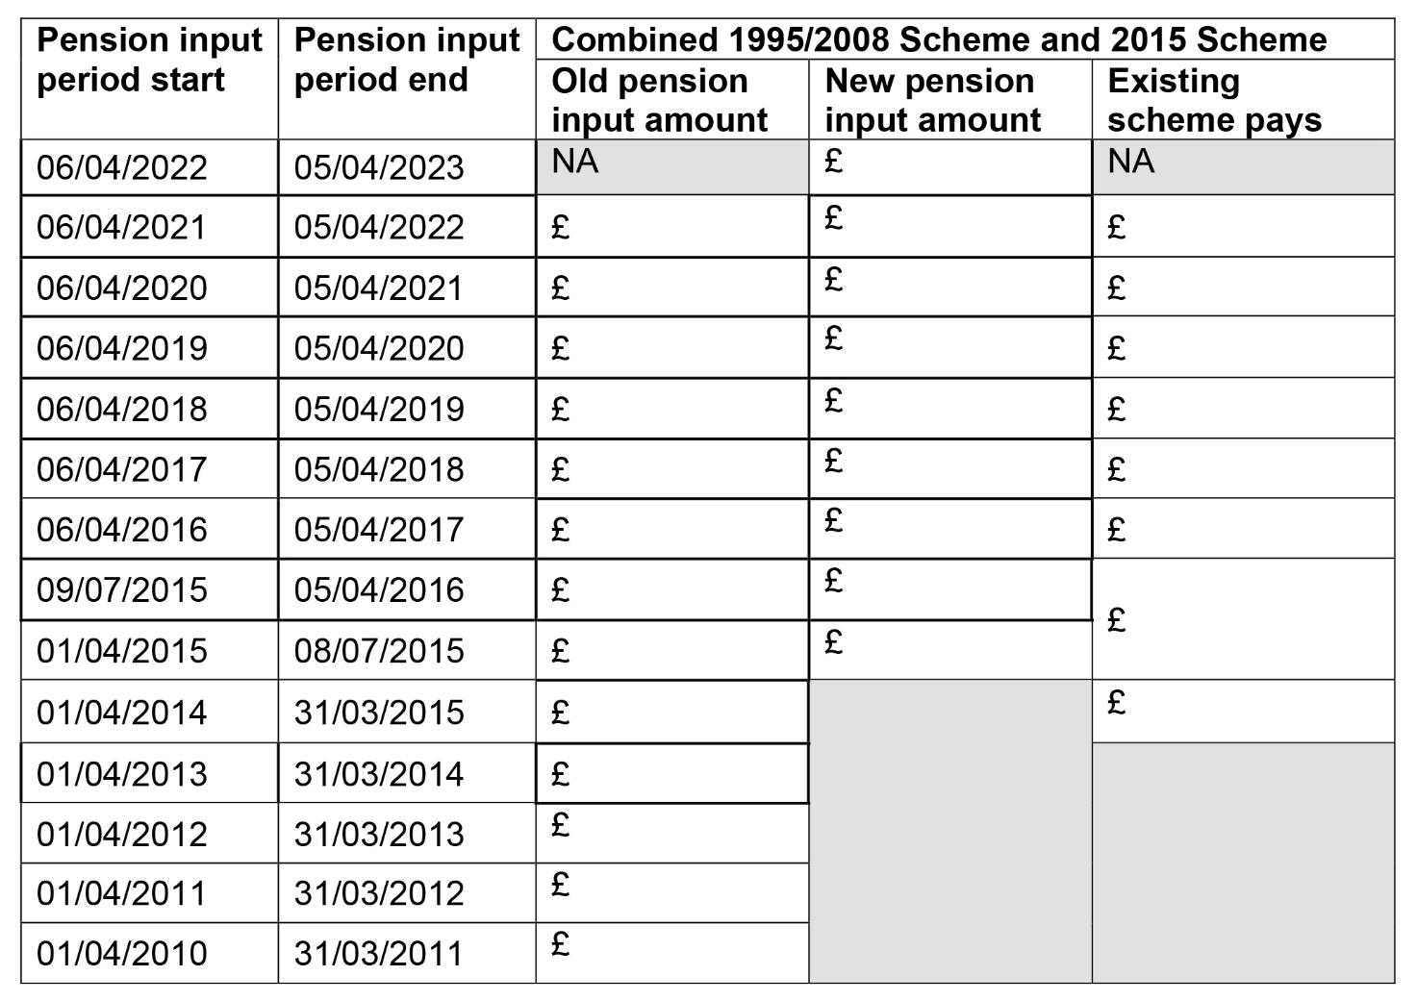

For each tax year the summary adds together:

* your old pension input amounts in the 1995/2008 Scheme and your old pension input amounts in the 2015 Scheme
* your new pension input amounts in the 1995/2008 Scheme and your new pension input amounts in the 2015 Scheme

and shows you any annual allowance charges paid by scheme pays.

#### The triage section of the HMRC tool

If you did not have an annual allowance charge for any of the remedy tax years, the summary page will help you with the question:

‘**Have any of your pension input amounts for any tax years from 5 April 2015 to 5 April 2021 increased as a result of the Public Service Pensions remedy?**’

For each tax year your statement will show you your total NHS Pension Scheme, old pension input amount, and the new pension input amount. So, you can easily see if any of your pension input amounts in these tax years are increased.

#### The calculation section of the HMRC tool

If you do need to use the calculator section of the tool, you will need to enter the total NHS Pension Scheme new pension input amounts. The summary shows you all of these for all the remedy tax years.

You will also need to enter your annual allowance charges for the remedy tax years.

## What to do once you have your remediable pension savings statement

### 1. Visit the HMRC 'Calculate your public service pension adjustment' tool

#### Your sign in options

You can use your **government gateway user ID and password** to sign in before you use the tool. If your pension tax position has been affected and you need to use the tool in full, you will be asked for a lot of information and it will take time to complete. Signing in means you can save your information and return to it later, and you will only have to enter your information **once**.

If you do not have one, you can create a government gateway user ID by visiting HMRC’s website.

If you do not sign in, you can still use the tool, but you will not be able to save your information or use the submission section of the tool. If you need to use the calculator section of the tool, beyond the first triage section, and if you need to make a claim to HMRC, you will have to sign into the tool later and re-enter all your information again.

### 2. Complete the first section of the tool – the triage section

Complete the first section, this is the triage section of the tool. HMRC have introduced the triage section to help you decide whether you need to use the calculator and submission sections of the tool. In this section there is a maximum of 10 questions asking for ‘**yes**’, ‘**no**’, or ‘**don’t know**’ answers.

Most members will be able to answer these questions themselves, without needing professional support from an accountant or Independent Financial Adviser (IFA). If your tax position is not affected, the tool will tell you that you do not need to use the tool and there is nothing more you need to do.

### 3. Complete the second section – the calculator section

Once you have reached the 'Check your answers' page, press 'Continue' – the next screen will confirm whether you must go on to use the tool in full to submit your updated information. The tool will then tell you that you need to use the calculator section:

‘**You are eligible to use the Public Service Pensions adjustment service’**

If you see this message, you need to enter your new total NHS Pension Scheme pension input amounts, any annual allowance charges you have had and other requested information into the tool. You can either:

* continue in the tool if you are signed in – if you need to you can then go through to the submission section
* sign in and continue – you will need to re-enter your answers to the triage section
* continue without signing in – you will not be able to go forward to the submission section if you need to unless you sign in
* ask an accountant or IFA to help you – more information about this on page 20

#### What other information will you need?

Make sure you have all the documents you need to hand. As well as your remediable pension savings statement, you will need:

* a copy of your SA302 tax calculation for each tax year – to request these, visit HMRC’s SA302 support page or email: [publicservicepensionsremedy@hmrc.gov.uk](mailto:publicservicepensionsremedy@hmrc.gov.uk) – make sure you put ‘SA302 request’ in the subject line of your email
* a pensions savings statement for each remedy and carry forward tax year from any other pensions you have outside of your NHS pension – you will need to contact your other pension scheme for a copy of these if you do not have them

Before you start, you can find information from HMRC on what you will need and [guidance on the questions you will be asked](https://view.officeapps.live.com/op/view.aspx?src=https%3A%2F%2Fassets.publishing.service.gov.uk%2Fmedia%2F66f6af6f080bdf716392ea8c%2FCYPSPA-Guidance-Notes.odt&wdOrigin=BROWSELINK).

#### The calculation results page

At the end of the calculator section of the tool, the **calculation results** page will tell you if you have:

* an annual charge to pay – tax years 2019/20 to 2022/23
* overpaid an annual allowance charge and are entitled to:
  + compensation equal to a refund of annual allowance charge because you paid the charge directly to HMRC – tax years 2015/16 to 2018/19
  + a refund of annual allowance charge - tax years 2019/20 to 2021/22
  + an adjustment to your scheme pays arrangement - tax years 2015/16 to 2021/22

### 4. Complete the third section – the submission section

#### An overpaid annual allowance charge for remedy tax years 2019/20 to 2021/22

If you are signed in and the **calculation results** page says you have overpaid an annual allowance charge in a remedy tax year 2019/20 to 2021/22, you can use the submission section to make an application to claim back the overpaid amount of the charge.

If you:

* paid the original charge yourself to HMRC, you’ll be asked for your bank details and HMRC will refund you the amount of overpaid charge.
* asked the NHS Pension Scheme to pay the charge to HMRC, there is nothing else you need to do. HMRC will automatically update NHS Pensions and we will write to you to confirm that your scheme pays arrangement has been amended.

#### An overpaid annual allowance charge for remedy tax years 2015/16 to 2018/19

If you are signed in and the **calculation results** page says you have overpaid an annual allowance charge in a remedy tax year 2015/16 to 2018/19, you can use the submission section to make an application to claim back the overpaid amount of the charge.

If you:

• paid the original charge yourself to HMRC, HMRC will automatically update NHS Pensions, and we will contact you to arrange the payment from the NHS Pension Scheme

• asked the NHS Pension Scheme to pay the charge to HMRC, there is nothing else you need to do. HMRC will automatically update NHS Pensions and we will write to you to confirm that your scheme pays arrangement has been amended.

#### An overpaid annual allowance charge for remedy tax years 2015/16 to 2021/23 and your pension benefits are in payment

If the **calculation results** page says you have overpaid an annual allowance charge in a remedy tax year 2015/16 to 2021/22, you asked the NHS Pension Scheme to pay the charge and your pension benefits are in payment we will write to you to confirm that your:

* scheme pays arrangement has been amended, and
* pension (and lump sum in the 1995 Section) reduction has been recalculated, and
* we will pay any pension (and lump sum) arrears with interest.

#### A new or extra annual allowance charge to pay for remedy tax years 2019/20 to 2022/23

If you are signed in and the **calculation results** page says you have an annual allowance charge to pay, this can only be for a tax year from 2019/20 to 2022/23. You can use the submission section to pay the charge. HMRC will ask you how you want to pay the charge. If you want to pay the charge yourself, HMRC will explain how to do this.

If you want to use scheme pays, you do not need to do anything else – HMRC will automatically update NHS Pensions of your decision. We will pay the charge to HMRC and then write to you to confirm your scheme pays arrangement has been updated.

If you are signed in and use the submission section of the tool, you don’t need to complete a scheme pays election (form SPE2) because your submission to HMRC is treated as your scheme pays election.

If you are not signed in and need to pay an annual allowance charge, you can sign in to the tool using your government gateway user ID and password.

#### A new or extra annual allowance charge for remedy tax years 2015/16 to 2018/19

If you think that you may, or should, have an annual allowance charge for one or more of the remedy period tax years 2015/16 to 2018/19 but the **calculation results** says that you don’t, this is not a mistake. HMRC are not pursuing any annual allowance charges before tax year 2019/20.

#### If you need any help using the HMRC tool

NHS Pensions cannot answer any questions about your tax position or give any updates after you have submitted your information using the tool. HMRC has set up a dedicated support team to help with queries about updating your pension tax for the Public Service Pensions Remedy.

You can reach them at publicservicepensionsremedy@hmrc.gov.uk or by phoning 0300 123 1079 and choosing option 1.

## What to do if your accountant or IFA is supporting your use of the tool

Steps if your accountant or IFA is supporting your use of the HMRC tool.

### 1. To use the HMRC 'Calculate your public service pension adjustment' tool on your behalf.

Your accountant or IFA will need access to information in your remediable pension savings statement, your SA302 for each affected tax year, and any pension input amounts you have for those tax years in a pension scheme outside the NHS Pension Scheme.

### 2. If you have an annual allowance charge to pay for remedy tax years 2019/20 to 2022/23

If you have used an accountant or IFA to use the HMRC tool and have an annual allowance charge that you want the scheme to pay, you **must** complete a [scheme pays election form (SPE2)](https://www.nhsbsa.nhs.uk/member-hub/annual-allowance) and post this to NHS Pensions or send the form by email to nhsbsa.pensionsmember@nhsbsa.nhs.uk. NHS Pensions will then contact you about this.

The mandatory scheme pays deadline for an annual allowance charge in remedy tax years 2019/20 - 2022/23 is 6 July 2025. It is extended to 6 July 2027 for members who retired before 1 October 2023.

We will accept a scheme pays election after these deadlines either via HMRC’s tool if you are signed in, or a scheme pays election form (SPE2) if you are using an accountant or IFA, and your election will be processed as voluntary scheme pays.

### 3. NHS Cost Claim Back Scheme

If you are affected and you need professional support to use HMRC’s tool, you can apply to the NHS Cost Claim Back Scheme to have your costs reimbursed up to the eligible limit.

Our [Cost Claim Back Scheme](https://www.nhsbsa.nhs.uk/public-service-pensions-remedy-mccloud/nhs-cost-claim-back-scheme) webpage explains what evidence you will need to supply with your application. For example, it’s a good idea to save a screenshot or image of any pages in the HMRC tool that tell you action is required, such as your calculation results page.

Most members who use the triage section of the tool and are told that their tax position is not affected are not likely to need professional support. This means applications to cover costs for support with this first section of the tool may not be accepted, but all claims will be individually considered.

## What about my 2023/24 tax year Pensions Savings Statement?

If you need one, we will send your standard pension savings statement for the tax year 2023/24 separately, after we send out your remediable pension savings statement. You can check if you have an annual allowance charge on your pension savings using HMRC’s standard [Annual Allowance Calculator](https://www.gov.uk/guidance/check-if-you-have-unused-annual-allowances-on-your-pension-savings).

You will need to use the information in both your pension savings statement and your remediable pension savings statement to use HMRC’s annual allowance calculator and enter your new pension input amounts in the 1995/200 Scheme and 2015 Scheme for the tax years between 2015/16 and 2022/23.

### I have received my 2023/24 PSS

There have been two changes from tax year 2023/24:

1. The standard annual allowance increased to £60,000,
2. If your pension input amount in the 1995/2008 Scheme is calculated to be a negative amount, you are allowed to offset this against a positive pension input amount in the 2015 Scheme in the same tax year. More information about this can be found in the ‘[Negative Pension Input Amount Fact sheet](https://www.nhsbsa.nhs.uk/member-hub/annual-allowance)’.

If you have an annual allowance charge you need to report this charge to HMRC in your self-assessment tax return by HMRC’s deadline of 31 January 2025.

### I have not received my 2023/24 PSS

If you have not received your 2023/24 you should consider whether you may have one and provide a **provisional figure** in your self-assessment tax return and submit as normal before the 31 January 2025 deadline.

When you receive your 2023/24 PSS, you must update your self-assessment tax return – this needs to be done within 12 months of the 31 January 2025 deadline.

For members who are not familiar with the process of using provisional figures HMRC has provided guidance at: https://www.gov.uk/hmrc-internal-manuals/self-assessment-manual/sam121190

Further information on updating a return can be found at: https://www.gov.uk/self-assessment-tax-returns/corrections

If you submit your self-assessment tax return with a provisional figure by the 31 January deadline then you will not receive a penalty from HMRC. You’ll pay a late filing penalty of £100 if your self-assessment tax return is up to 3 months late.

## If I have an annual allowance charge to pay, can I apply to the NHS England and NHS Improvement (NHSEI) 2019/20 Pensions Annual Allowance Charge Compensation Policy?

You could be compensated in retirement for any reduction to your NHS Pension Scheme benefits if the calculation results page of HMRC’s tool says you have a new or extra annual allowance charge for tax year 2019/20, and

* you are a clinician in England
* you have elected for the scheme to pay this charge to HMRC by scheme pays

You can find more information about the 2019/20 Pension Annual Allowance Charge Compensation Policy, whether you are eligible and how to apply on the [NHSEI website.](https://www.england.nhs.uk/pensions/)

**How we use your information**

For more information about how the NHSBSA processes your personal data, please see our Privacy Notice - [www.nhsbsa.nhs.uk/our-policies/privacy/nhs-pensions-privacy-notice](http://www.nhsbsa.nhs.uk/our-policies/privacy/nhs-pensions-privacy-notice)

**NHS Pensions**

**Annual Allowance – Remediable Pension Savings Statement Guide**

[www.nhsbsa.nhs.uk/nhs-pensions](http://www.nhsbsa.nhs.uk/nhs-pensions)

NHS Pensions, PO Box 683, Unit 5, Newcastle Upon Tyne, NE5 9EE