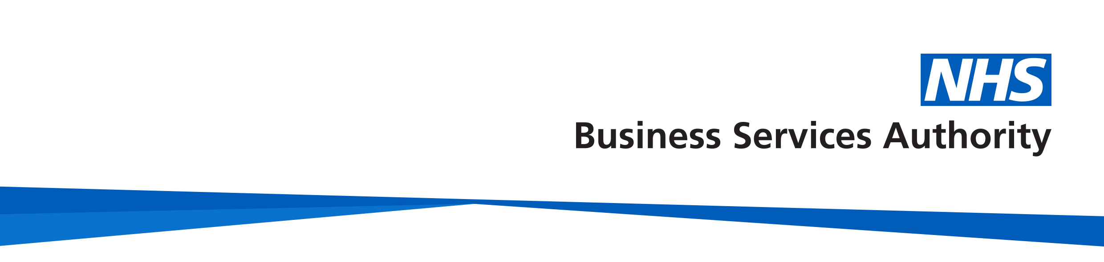

# NHS Pensions

# 

# Member factsheet

# NHS Pensions – Employees on a work visa factsheet

**Membership**

The NHS Pension Scheme is open to any NHS worker aged between 16 and 75, and is:

* directly employed by the NHS
* a medical, dental or ophthalmic practitioner or trainee
* general medical practice staff
* working for certain approved employers
* a practitioner, Locum or non-GP partner

This includes NHS employees who require a visa to work in the UK. Employees on a work visa are afforded the same access to NHS Pension Scheme benefits as those who do not require a visa.

When you commence NHS employment, your employer must enrol you in the NHS Pension Scheme under what are known as contractual and auto-enrolment rules.

**Transferring into the Scheme**

If you have pension benefits with another pension scheme or provider registered with (HMRC), you may be able to transfer these into the NHS Pension Scheme. An application to transfer pension benefits into the NHS Pension Scheme must be made before your normal pension age, and within the time limits set out on our [www.nhsbsa.nhs.uk/member-hub/transferring-scheme](http://www.nhsbsa.nhs.uk/member-hub/transferring-scheme) The Transfer in guide can also be found on our website and contains an application pack that requires completing in order to transfer other benefits you have into the Scheme.

**Leaving or taking a break from the Scheme**

The NHS Pension Scheme offers a number of benefits, and any decision to leave the Scheme should be carefully considered. To opt out of the NHS Pension Scheme, you must complete the application to leave the NHS Pension Scheme (SD502). This should then be passed to your employer to complete their part, who will then send this to us, NHS Pensions.

You will still be subject to auto enrolment rules, and your employer will assess your eligibility to be auto enrolled back into the Scheme every 3 years, dependant on your age and earnings. You would need to opt out each time if you do not want to pay into the NHS Pension Scheme.

If you chose to opt out of the NHS Pension Scheme, but want to rejoin at a later date, you can do this at any time, as long as you satisfy the Scheme’s normal eligibility criteria.

**Less than 2 years qualifying membership**

If you choose to leave the Scheme and have less than 2 years qualifying membership in total, you may be able to request a refund of contributions, less any tax and National Insurance that may be deductible. This is subject to qualifying criteria.

**More than 2 years qualifying membership**

If you choose to leave the Scheme and have 2 years or more in qualifying membership, you will not be eligible to claim a refund of any contributions paid. Your benefits will remain in the Scheme to take at retirement, or you may be able to transfer the value of your benefits to another registered pension scheme.

**Transferring out of the Scheme**

If you are leaving NHS employment, or just the Scheme, you have the option to transfer your pension rights to a new pension provider. You can only transfer to a pension scheme or arrangement that is registered with HMRC and is able to accept a transfer payment from the NHS Pension Scheme.

There are also some restrictions on the type of scheme you can transfer to, and time limits may apply for members with less than 2 years qualifying membership. More information on transferring out of the NHS Pension Scheme can be found on our website [www.nhsbsa.nhs.uk/member-hub/leaving-or-taking-break-scheme](http://www.nhsbsa.nhs.uk/member-hub/leaving-or-taking-break-scheme)

**How we use your information**

For more information about how the NHSBSA processes your personal data, see our privacy notice - [www.nhsbsa.nhs.uk/our-policies/privacy/nhs-pensions-privacy-notice](http://www.nhsbsa.nhs.uk/our-policies/privacy/nhs-pensions-privacy-notice)

**NHS Pensions**

**Factsheet name**

[www.nhsbsa.nhs.uk/nhs-pensions](http://www.nhsbsa.nhs.uk/nhs-pensions)