**NHS Pensions Online (POL) guide**

43. Open and rewind employment

**Open a closed employment**

A new menu option ‘open employment’ will be added to the existing e-form menu, as follows:

**Member selection**

You may select a member by entering either the National Insurnace number or SD reference number, as follows:

**Employment selection grid**

On passing the member validations, a grid will be produced showing all closed employments for that member.

Note: For linked employments the grid will provide a single row combining both the 1995 / 2008 Section and 2015 Scheme elements of the employment.

**Summary screen**

On selecting the relevant closed employment to open, the summary screen will be produced.

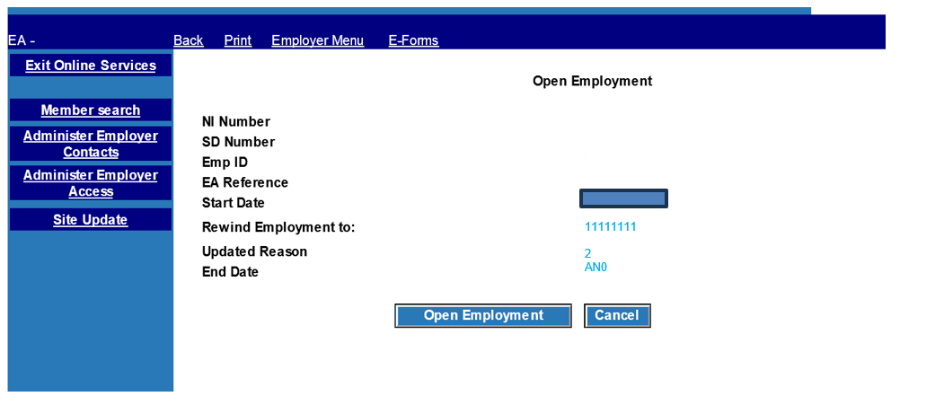

The ‘rewind employment to’ field is pre populated as follows:

* to the 31 March immediately before the employment end date as long as this date is no earlier that the service start date; or
* otherwise set to the service start date.

You may amend this date to:

* an earlier 31 March as long as it is not before the service start date; or
* the service start date (to indicate removing all cyclic data for the employment).

When you click ‘submit’ they will be prompted with a confirmation message.

The following confirmation message is produced: “Your request to re-open this employment has now been submitted, thank you.”

**Rewind Open Employment**

Rewind open employment is a new Pensions Online (POL) form present in the e-forms menu.

**Member selection**

When you select the ‘rewind open employment’ form the member input screen is produced, existing validation rules will apply to the member input screen.

**Employment selection grid**

On passing the member validations, a grid will be produced showing all open employments for that member.

Note: For linked employments the grid will provide a single row combining both the 1995 / 2008 Section and 2015 Scheme elements of the employment.

**Summary screen**

On selecting the relevant open employment to rewind, the summary screen will be produced.

The ‘rewind employment to’ field is pre-populated using the same rules as for open a closed employment, thats is, as follows:

* to the 31 March immediately before the employment end date as long as this date is no earlier than the service start date; or
* otherwise set to the service start date.

You may amend this date to:

* an earlier 31 March as long as it is not before the service start date; or
* the service start date (to indicate removing all cyclic data for the employment).

When you click ‘submit’ they will be prompted with a confirmation message.

The following confirmation message is produced: ‘Your request to rewind this employment has now been submitted, thank you.’

**Employer error handling**

The existing Employer Error Handling (EEH) menus will be extended to support the new employment open a closed employment and rewind open employment forms.

Error handling breakdown will now include the new forms, as shown below:

Select ‘Error Handling’ from the main POL menu and you are presented with the sub menu:

If you then click on any of the three numbers in the Error Handling Statistics section then a breakdown of the number of errors by form type is displayed.

These statistics are to be extended to include the new forms, as follows:

Open employment: Open a closed employment

Rewind employment: Rewind an open employment

**Employer allocated errors**

If you select the option “Employer Allocated errors” from the sub menu the following menu is displayed allowing you to select a form type.

This menu has been extended to include:

* Open Closed Employment
* Rewind Open Employment

**Employer errors selection grid**

Errors for each form will be produced in the standard employer error handling grid.

Errors for the new forms option will be included; the grid is unchanged apart from the inclusion of the new form options”.

**Error handling sub menu**

On accessing an employer error you will have the standard options for dealing with the error. All options will work the same as all other current employer error handling forms.

**Amend and/or submit**

###### Open a closed employment

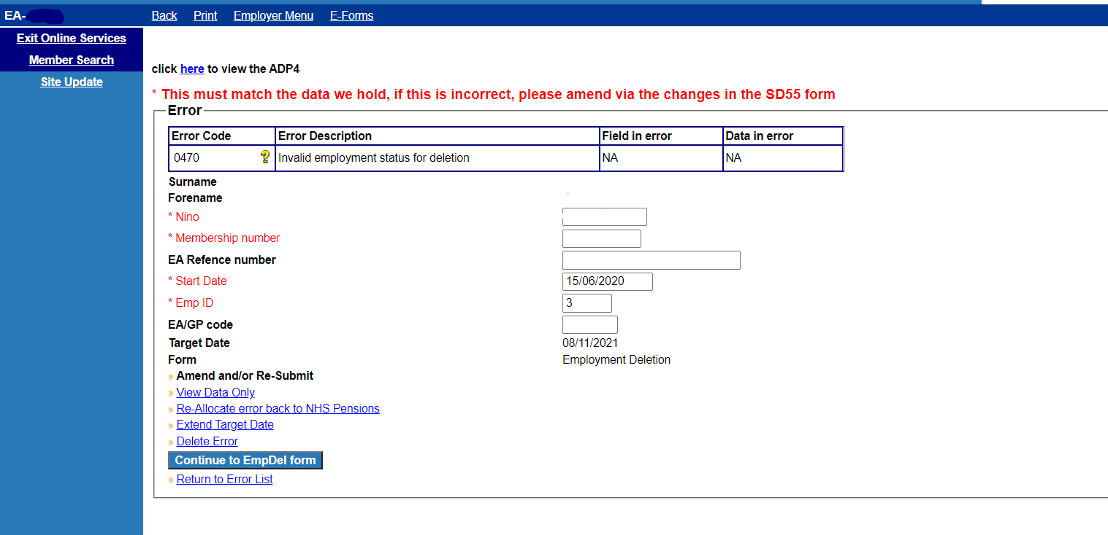

###### On selecting the ‘continue to OpenEmp form’ the following confirmation page is presented subject to all mandatory fields populated and matching the member record. Please note, on the Error Handling form you can only amend EA reference number, start date, emp ID, and EA/GP code.

###### **Rewind an open employment**

**View data only**

Both ‘open a closed employment’ and ‘rewind an open employment’ forms are identical except for the form title.

The example screen shot below is for ‘Open a Closed Employment’.

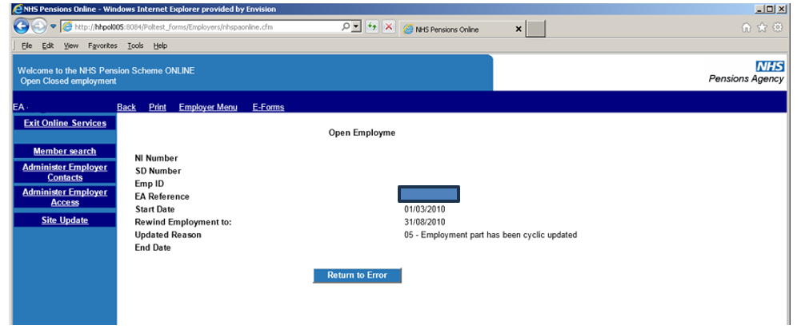

The page title for rewind employment is ‘Rewind Employment’

This is provided in an identical manner to existing forms, as follows:

Again, the only difference between the two form types is the title. The above screen shot is for ‘Rewind an Open employment’.

**Extend target**

This is provided in an identical manner to existing forms, (example below is ‘Rewind Employment’) as follows:

**Delete error**

The example above is for open a closed employment. Again, the screen is identical except for the form name description.