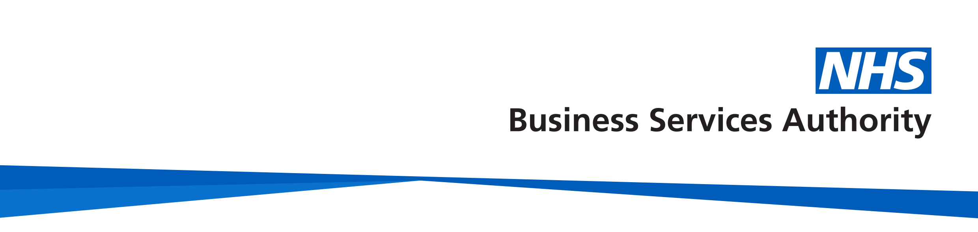
Opting Out
NHS Pensions
Member factsheet

Background
From 6 April 1988 all eligible members were automatically enrolled on to the NHS Pension Scheme on commencing pensionable NHS employment but membership is voluntary.
Eligible members do not include freelance locum medical practitioners who must opt into the NHS Pension Scheme.
Before considering opting out of the NHS Pension Scheme you should first read the Leaving Early and Transferring Out Guide and also the relevant Member Guide both of which can be found on our website because there are many worthwhile reasons to remain in the NHS Pension Scheme.

The opting out process
To opt out of the NHS Pension Scheme you must complete Part 1 of the Application to leave the NHS Pension Scheme (SD502). The completed Part 1 should be given to your Payroll Department along with Part 2 for completion by your employer. The employer will then complete Part 2 and forward both Parts 1 and 2 to NHS Pensions.
A request to opt out that is made by any other means e.g. letter, email or made verbally cannot be accepted.
NHS Pensions insists eligible members sign and date the application to leave the NHS Pension Scheme (SD502) form because this form includes important declarations and information that must be read to confirm that you are aware of what benefits you are giving up if you do decide to opt out.
The application to leave the NHS Pension Scheme (SD502) can be downloaded and printed off from our website.
If you are unable to download and print a copy of the form yourself, you can request one by calling the Member Helpline on 0300 3301 346.

The application to leave the NHS Pension Scheme (SD502) contains additional notes and information for your consideration before deciding to opt out of the NHS Pension Scheme.
When does the decision to opt out take effect?
Form SD502 received before the end of the first pay period
If the application to leave the NHS Pension Scheme (SD502) is signed by the member on commencing work and is received by the employer before the end of the first pay period, the member will be treated as never having been included in the Scheme. Any pension contributions taken during this period must be returned locally by the employer. The employer must also make any adjustments that may be required for national insurance and income tax.
Form SD502 received after the end of the first pay period
If the application to leave the NHS Pension Scheme (SD502) is signed and received by the employer after the end of the first pay period the decision to opt out will take effect from the first day of the next pay period following receipt. If you hold under two years qualifying membership at the date of opting out and wish to claim a refund of the contributions paid, an application to request a refund of pension contributions (RF12) form must be completed.
Where you have provided a later date to opt out on the application to leave the NHS Pension Scheme (SD502) form, the decision to opt out will be effective from the first day of the next pay period following the date given.
Can my employer provide me with an Application to leave the NHS Pension Scheme form (SD502)?
No. Under the auto enrolment rules, employers are prevented from issuing pension scheme opt out forms directly to their employees, and they must be sourced by the employee on our website..
I don’t have personal access to the internet or a printer. Can I use the computer facilities at my place of work to download the Application to leave the NHS Pension Scheme (SD502)?
Yes, if your employer agrees. To comply with the auto enrolment rules, any facility made available by your employer must be on the understanding that you are obtaining the form yourself, rather than the employer providing you with the form.
Where do I send my completed Application to leave the NHS Pension Scheme (SD502) form?
Once you have signed the application to leave the NHS Pension Scheme (SD502) form, it must then be passed to your employer for them to complete and process - please do not send the form to NHS Pensions.

Once the SD502 opting out form has been completed, where are they stored?
Your employer will keep a copy of the completed application to leave the NHS Pension Scheme (SD502) form and send the original to NHS Pensions.
I have already opted out of the NHS Scheme – why do I have to join the scheme and opt out again?
Your employer is required by law to assess their employees for auto enrolment.
Employees that are not members of a qualifying pension scheme and who qualify for auto-enrolment must be enrolled in a scheme on your staging date. If you are Auto Enrolled back into the NHS Pension Scheme on your staging date and do not wish to remain in the NHS Pension Scheme then you will need to opt out again by completing a further SD502 form.
The rules apply even where the employee has already opted out of the Scheme before the enrolment date.
I have more than one NHS job – do I have to opt out the scheme in respect of all my jobs?
For each job that you wish to opt out of you must complete an application to leave the NHS Pension Scheme (SD502) form. However, if you are a Practitioner who opts out you must opt out of all your practitioner related posts but you can continue to contribute in respect of any concurrent hospital posts if you wish to do so.
If I opt out will my employer automatically re-enrol me in the future?
Employers will continue to monitor the pension status of their employees and are they are obliged to re-enrol all eligible employees by conducting an auto enrolment exercise every three years.
If I opt out can I join the NHS Pension Scheme at a later date?
Yes. You can join or rejoin the NHS Pension Scheme at any time as long as you satisfy the Scheme’s normal eligibility criteria. However you cannot re-join the NHS Pension Scheme if you are absent from work for any reason.
How do I apply to re-join the NHS Pension Scheme?
You must apply in writing to your employer. You will be entered into the NHS Pension Scheme from the first day of the pay period following receipt of the application by the employer.
If you state that you wish to join or re-join from a specific date you should be entered into the NHS Pension Scheme from the first day of the next pay period following this date.
The date of joining / re-joining cannot be back dated.
I am opting out of the NHS Pension Scheme – will I get my contributions back?
If you leave the NHS Pension Scheme and have less than two years qualifying membership in total then a refund of contributions, less tax and National Insurance is possible.
Who will pay my NHS Pension Scheme refund?
Either your employer or NHS Pensions may pay a refund of contributions, this depends on how soon you opt out of the Scheme after your enrolment.
How do I claim a refund from NHS Pensions if my contributions cannot be refunded by my Employer?
If you have less than two years qualifying NHS Pension membership you can download and print off the refund application form (RF12) from our website.
How we use your information
For more information about how the NHSBSA processes your personal data, please see our Privacy Notice - www.nhsbsa.nhs.uk/our-policies/privacy/nhs-pensions-privacy-notice
NHS Pensions
Opting Out
www.nhsbsa.nhs.uk/nhs-pensions

