

# NHS Pensions

# NHS Pensions Online (POL) Guide

# 35. Electronic Staff Record (ESR) status

## ESR status

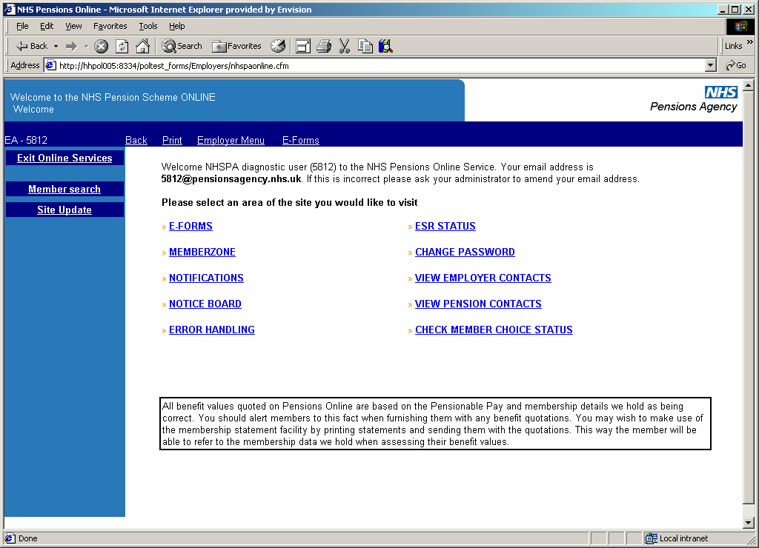

The ESR status page displays information as illustrated below:

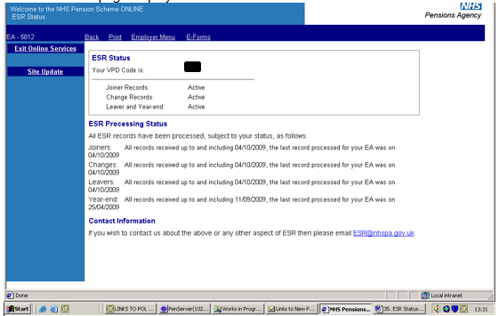

The Virtual Private Database (VPD) code is your unique ESR identification code.

Also displayed are the active ESR interfaces. On this example ESR submits joiner, change, leaver and year end interfaces, for this employer.

ESR Processing Status shows to what date each of these interfaces have been processed and the date the last record was processed.

If you are not able to submit information via ESR the page will display the following information:

