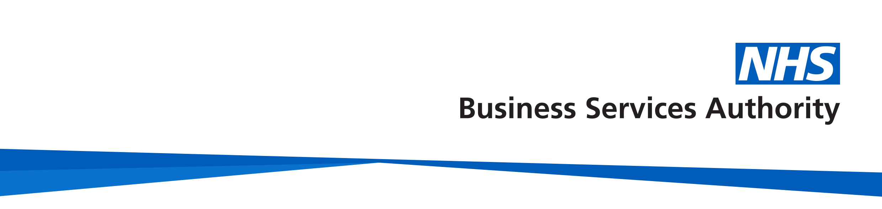
NHS Pensions – Maternity leave, paternity leave, parental leave and adoption leave
NHS Pensions
Member factsheet
A member can continue to be pensionable throughout any period of absence for maternity, paternity, parental or adoption. This is referred to in this factsheet as ‘special leave’.

Your employer must provide you with the necessary information about pension arrangements before you start any special leave for maternity, paternity, parental or adoption.

Any type of parental leave does not apply to locum practitioners.

If you are taking another type of leave then read our ‘Authorised leave/career break factsheet’ on our membership page.

Contributions
Pension contributions will be taken regardless of whether the special leave is paid or unpaid, unless you opt out. If you continue to pay contributions, your employers’ contributions will also continue based on your full rate of pay.

Full pay
Your pension contributions, at the tier you were paying before the leave, will be deducted on the amount of pensionable earnings you actually receive during the leave.

When you go on special leave your full pay is calculated using the average weekly earnings rules, and also accounts for any pay awards or annual increments before or during paid your leave. Therefore, the pay received during a period of full pay leave may not be the same as the pay immediately before the leave commenced.

Half pay
Your pension contributions will be deducted on the amount of pensionable earnings actually received.

Statutory Pay ( Statutory Maternity Pay, Maternity Allowance, Statutory
Adoption Pay)
Your pension contributions will be deducted on the amount of statutory pay or maternity allowance you receive.

Unpaid leave
Your pension contributions will be payable on the rate of pensionable earnings immediately before any period of unpaid special leave begins.

Bank staff
You will need to check your contract of employment or discuss with your NHS employer if you’re eligible to receive pay during parental leave. If you’re a bank employee and receive maternity pay, you can pay pension contributions.

Added years/additional pension/early retirement reduction buy out (ERRBO)
Additional contributions continue to be paid on the pensionable earnings you were receiving prior to any reduction.

Part time members
If you work part time, the hours you would have worked will be included in your membership for pension purposes for the period you were paying pension contributions.

Pensionable earnings for benefit purposes will be based on your normal level of pay.

If you decide not to return to work
If you intend to return to work and have already paid some contributions during your leave and then decide that you are not returning to work, your last day of membership will be the last day that you paid pension contributions.

If you do not intend to return to work, you are still entitled to pay pension contributions during the period of leave and your last day of membership will be the last day you paid pension contributions.
All members, whether they opt out of the Scheme or leave, should be aware that pensionable membership will not be extended unless contributions are paid. Entitlement to benefits will be affected by the length of Scheme membership. If you opt out, you will not be entitled to life assurance benefits.

Annual leave
If you have untaken annual leave and do not return to work, your last day of Scheme membership will be the last day you pay pension contributions extended by any days of remaining annual leave entitlement.

Where an employer pays a separate additional earnings lump sum (also known as annual leave in lieu) instead of annual leave as actual days after an authorised break, the last day of membership will not be extended but the pensionable pay will be higher. Pension contributions may increase for this period.

Keep in Touch (KIT) and Shared Parental Leave in Touch (SPLiT) days
Keep in Touch (KIT) days are where a member carries out up to 10 days work during the maternity, paternity or adoption leave period.

Shared parental leave in touch (SPLiT) days are where a member carries out up to 20 days during the shared parental leave period.

For pension purposes, KIT or SPLiT days do not break the period of leave. The member will pay contributions for the these days; however, these will be based on the reduced earnings for the special leave. Any additional pay received during the KIT or SPliT days should be excluded.

Paid special leave: amount of pay flexibilities
By prior agreement with your employer, occupational special leave pay may be paid as a combination of full pay and half pay or a fixed amount spread equally over the special leave period

If you have 6 months paid and 6 months unpaid leave, but your pensionable earnings are averaged out over the 12 month period, your monthly contributions will be deducted based on the underlying entitlement.

This provision does not apply to locum practitioners.

If you cannot afford to pay pension contributions whilst on leave
Arrears of pension contributions built up during a period of unpaid leave can be collected when you return to work provided, they are collected within a reasonable amount of time. This should be agreed between you and your employer.

Your contract upon returning to work after special leave
You will need to discuss the terms of your employment with your employer.

Refund entitlements
If contributions have been paid on any part of your leave, whether the leave is paid or unpaid, they cannot be refunded unless you have less than 2 years qualifying membership.

Joining the NHS Pension Scheme during your leave
An employee cannot join the NHS Pension Scheme during a period of absence for any reason .

How we use your information
For more information about how the NHSBSA processes your personal data, please see our Privacy Notice -
www.nhsbsa.nhs.uk/our-policies/privacy/nhs-pensions-privacy-notice
NHS Pensions
Maternity, paternity, parental and adoption leave member factsheet
www.nhsbsa.nhs.uk/nhs-pensions

