# **NHS Jobs Self-Serve Job Adverts API**

This document describes the usage process and different options that are available to a consumer to help retrieve job adverts from the NHS Jobs Service.

The NHS Jobs Self-Serve Job Adverts API allows a consumer to make a request to the NHS Jobs service and receive back live job adverts. Requests can also be tailored to only bring back adverts matching specific criteria.

You can retrieve your job adverts in 3 ways. These can be embedded within your own website or intranet or link candidates to our service with a pre-filtered URL.

1. You can create a custom filtered link directly to our search service that can be displayed in various ways for example, website, intranet, or emails etc.
2. You can return a list of vacancies in XML format, which can be used to display these on your own website or intranet
3. You can return a list of vacancies as an RSS feed

These options can be filtered for only external job adverts, only internal job adverts or a combined list of both external and internal job adverts.

|  |
| --- |
| **Important:** ‘Internal Only’ adverts should only be available through your own intranet to avoid receiving applications from job seekers outside of your organisation. If the API is used to share these adverts on public websites, you may receive applications from unsuitable applicants. |

# **Usage of NHS Jobs Search Service**

The NHS Jobs Search Service provides the ability to link directly into the Search results with a custom URL depending on your intended usage. This URL can be customised with filter criteria to refine the results set.

https://www.jobs.nhs.uk/candidate/search/results?

The link will direct a user to the NHS Jobs website on the search results page, opposed to them being displayed within your own website. You could display this information in a new browser window/tab so that your website remains open in your browser.

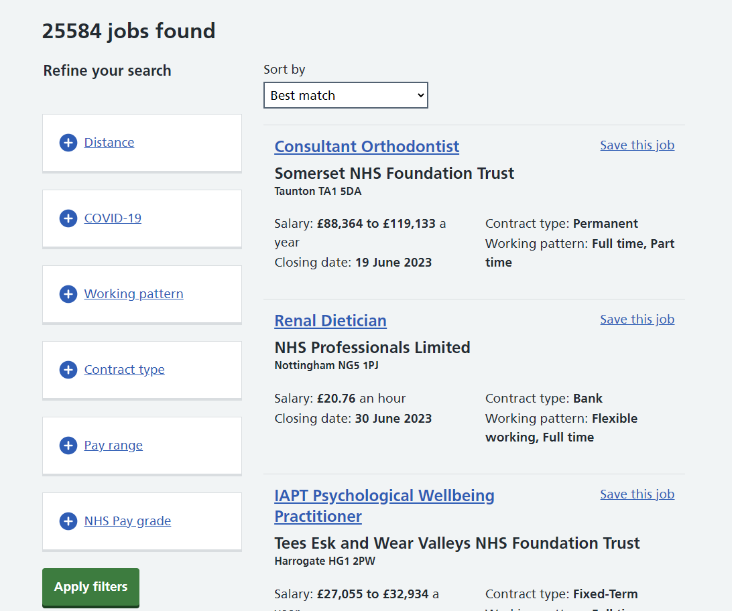

# **Usage of the NHS Search XML End Point**

The NHS Search Service provides an end point that returns the results of searches in XML format. It is intended that this end point can be used by website developers wishing to embed results within their own pages or make use of the data in some other way.

https://www.jobs.nhs.uk/api/v1/search_xml?

The sections below expand on what is contained within each field, and the query parameters that can be used as part of the request URL to search, filter, and sort the vacancy information that is included in the response document.

## Xml Response Wrapper (Named “nhsJobs”)

|  |  |
| --- | --- |
| **Field** | **Description** |
| **totalPages** | The number of pages in the search |
| **totalResults** | The total number of results returned by the search |
| **vacancyDetails** | The list of vacancy details not wrapped. The XML Response Wrapper will thus contain multiple (up to 10 per page) instances of this tag |

## Vacancy Details

|  |  |
| --- | --- |
| **Field** | **Description** |
| **Id** | The unique identifier for this vacancy |
| **title** | The Job Title for this vacancy |
| **employer** | The name of the Employer that created this vacancy |
| **description** | Contains a truncated segment of the job overview for the vacancy, an introduction to the job rather than a long form job description |
| **closeDate** | The closing date for this vacancy |
| **postdate** | The date that this vacancy was posted. Note this can change if a vacancy is updated and re-published |
| **locations** | A list of towns and postcodes where the vacancy is located. Nested XML array where each entry is a <location> composed of a town name, a comma, and a post code |
| **reference** | The job reference for this vacancy |
| **salary** | The salary range for this vacancy, in the format of the following example: "£20,000 to £30,000" |
| **type** | The contract type for this vacancy |
| **url** | A URL that links to this specific vacancy |

## XML Example Structure

**<?xml version="1.0" encoding="UTF-8"?>**

**<nhsJobs>**

**<totalPages>0</totalPages>**

**<totalResults>0</totalResults>**

**<vacancyDetails>**

**<closeDate>2022-01-01</closeDate>**

**<description>This role for a nurse involves the following duties ...</description>**

**<employer>Your Local Health Board</employer>**

**<id>12345</id>**

**<locations>**

**<locations>Cardiff, CF14 4XW</locations>**

**<locations>Newport, NP20 2UB</locations>**

**</locations>**

**<postDate>2023-01-01T05:25:50.696544</postDate>**

**<reference>ABC-123-DFE</reference>**

**<salary>£20,000 to £30,000</salary>**

**<title>Nurse</title>**

**<type>Permanent</type>**

**<url>https://www.jobs.nhs.uk/candidate/jobadvert/A0000-00-0000</url>**

**</vacancyDetails>**

**</nhsJobs>**

# **Usage of the NHS Jobs Search RSS Feed**

The NHS Jobs Search Service provides an end point that returns the results of searches in RSS 2.0 format. It is intended that this end point can be used by website developers wishing to embed results within their own pages or subscribe to the feed to make use of the data in some other way.

https://www.jobs.nhs.uk/api/v1/search_rss?

As per the RSS 2.0 standard (version 2.0.11) the end point returns a channel containing Items in XML format. The sections below expand on what is contained within each field, the two non-standard fields that are present in version 1 of this end point, and the query parameters that can be used as part of the request URL to search, filter, and sort the vacancy information that is included in the response feed.

## Channel

|  |  |  |
| --- | --- | --- |
| **Field** | **Standard (Yes/No)** | **Description** |
| **title** | Yes | Field will be present in response, but contain no information |
| **description** | Yes | Contains details of the search terms used to request this feed |
| **link** | Yes | Contains the full URL used to request this feed |
| **language** | Yes | Contains the language code for the data contained in this feed. With version 1, this will always be “en-uk” |
| **pubDate** | Yes | Contains an RFC 882 formatted Date, representing the date and time that the request for this feed was made |
| **lastBuildDate** | Yes | Contains an RFC 882 formatted Date, representing the date and time that the request for this feed was made |
| **Image** | Yes | Contains the fields “link” and “url” to use as the image for this feed, consisting of a link containing the full URL used to request this feed, matching the Channel link, and a URL for the NHS logo. An empty title field will also be present |
| **ttl** | Yes | Contains the time to live, indicating how long this feed can be cached |
| **count** | No | Contains the total number of results returned by the query used to request this feed. Use this in combination with the page query parameter to paginate through the results |

## Item

|  |  |  |
| --- | --- | --- |
| **Field** | **Standard (Yes/No)** | **Description** |
| **title** | Yes | Contains the Job Title for this vacancy |
| **author** | Yes | Contains the name of the Employer that created this vacancy |
| **link** | Yes | Contains a URL that links to this specific vacancy |
| **guid** | Yes | Contains a URL that links to this specific vacancy in RSS Guid format |
| **pubDate** | Yes | Contains an RFC 882 formatted Date, representing the date and time that the Job Advert was published. Note this can change if a vacancy is updated and re-published |
| **description** | Yes | Contains a truncated segment of the job overview for the vacancy, an introduction to the job rather than a long form job description |
| **closingDate** | No | Contains an RFC 882 formatted Date, representing the closing date for this vacancy |

## RSS example Structure

**<?xml version="1.0" encoding="UTF-8"?>**

**<rss version="2.0">**

**<channel>**

**<title/>**

**<description>keyword=nurse</description>**

**<link>https://www.jobs.nhs.uk/api/search_xml?keyword=nurse</link>**

**<language>en-uk</language>**

**<pubDate>Wed, 26 Aug 2015 13:00:00 GMT</pubDate>**

**<lastBuildDate>Wed, 26 Aug 2015 13:00:00 GMT</lastBuildDate>**

**<image>**

**<title/>**

**<link>https://www.jobs.nhs.uk/api/search_xml?keyword=nurse</link>**

**<url>http://www.jobs.nhs.uk/images/nhs_logos.png</url>**

**</image>**

**<ttl>0</ttl>**

**<count>100</count>**

**<item>**

**<title>Nurse</title>**

**<description>This role for a nurse involves the following duties ...</description>**

**<author>Your Local Health Board</author>**

**<link>https://www.jobs.nhs.uk/candidate/jobadvert/A0000-00-0000</link>**

**<guid>https://www.jobs.nhs.uk/candidate/jobadvert/A0000-00-0000</guid>**

**<pubDate>Wed, 26 Aug 2015 13:00:00 GMT</pubDate>**

**<closingDate>Wed, 26 Aug 2015 13:00:00 GMT</closingDate>**

**</item>**

**</channel>**

**</rss>**

# **Making requests – setting up your own search**

You can setup up your own search URL by using any of the parameters below to customise your query. These can be used in various combinations to filter and sort your results to your exact need.

Additionally, you could add a search form, or search box, on your website where the visitor can enter the term(s) they are searching for. When the visitor activates the search, the values entered would produce the necessary search on the NHS Jobs database and list the results on your website.

Here are a few guidelines concerning constructing your URLs:

* All characters should be URL encoded, e.g.
  + spaces should be replaced with %20, e.g. day%20care
  + &s should be replaced with %26
  + Double quotes should be replaced with %22

*To check for appropriate URL encoding, use an appropriate online tool*

* To use parameters in combination, use &s between them (see sample URLs in this document).
* employerCode is unique to each employer and needs to be replaced with your organisations specific code.
* If you wish to include multiple employers, each employerCode should be separated by a comma.

Examples of valid URLs:

**For “Internal Only” Jobs for a specific employer:**

https://www.jobs.nhs.uk/api/v1/search_xml?employerCode=A1234&internalOnly=true

https://www.jobs.nhs.uk/api/v1/search_rssl?employerCode=A1234&internalOnly=true

https://www.jobs.nhs.uk/candidate/search/results?employerCode=A1234&internalOnly=true

**For all “Nurse” jobs for multiple employers:**

https://www.jobs.nhs.uk/api/v1/search_xml?employerCode=A1234,B1234&keyword=Nurse

https://www.jobs.nhs.uk/api/v1/search_rss?employerCode=A1234,B1234&keyword=Nurse

https://www.jobs.nhs.uk/candidate/search/results?employerCode=A1234,B1234&keyword=Nurse

**For all “Paediatric Nurse” jobs for a specific employer:**

https://www.jobs.nhs.uk/api/v1/search_xml?employerCode=A1234&keyword=Paediatric%20Nurse

https://www.jobs.nhs.uk/api/v1/search_rss?employerCode=A1234&keyword=Paediatric%20Nurse

https://www.jobs.nhs.uk/candidate/search/results?employerCode=A1234&keyword=Paediatric%20Nurse

**For all jobs from a specific employer, sorted by publication date:**

https://www.jobs.nhs.uk/api/v1/search_xml?employerCode=A1234&sort=publicationDateAsc

https://www.jobs.nhs.uk/api/v1/search_rss?employerCode=A1234&sort=publicationDateAsc

https://www.jobs.nhs.uk/candidate/search/results?employerCode=A1234&sort=publicationDateAsc

**For all jobs within specific “Staff Groups”:**

https://www.jobs.nhs.uk/api/v1/search_xml?staffGroup=CLINICAL_SERVICES%2CPROF_SCIENTIFIC_AND_TECHNICAL%2CADMINISTRATIVE_AND_CLERICAL

https://www.jobs.nhs.uk/api/v1/search_rss?staffGroup=CLINICAL_SERVICES%2CPROF_SCIENTIFIC_AND_TECHNICAL%2CADMINISTRATIVE_AND_CLERICAL

<https://www.jobs.nhs.uk/candidate/search/results?staffGroup=CLINICAL_SERVICES%2CPROF_SCIENTIFIC_AND_TECHNICAL%2CADMINISTRATIVE_AND_CLERICAL>

**To limit the number of adverts returned:**

https://www.jobs.nhs.uk/api/v1/search_xml?limit=20

https://www.jobs.nhs.uk/api/v1/search_rss?limit =20

https://www.jobs.nhs.uk/candidate/search/results?limit =20

Requests made to the NHS Search end points can be customised using the following path parameters. These are parameters that can be included as part of the request URL, and will control the search, filter, and sorting of the response.

## Query Attributes

|  |  |  |
| --- | --- | --- |
| **Parameter** | **Description** | **Notes / Values** |
| **contractType** | Provide this parameter to limit responses to only those job adverts matching specific contract types. | You may filter by one or more of the following contract type options:   * Permanent * Training * Apprenticeship * Fixed-Term * Locum * Secondment * Voluntary * Honorary * Bank * NHS Reservist   If you wish to include multiple contract types, contractType values should be separated by a comma  *e.g., contractType=Permanent,NHS%20Reservist* |
| **covidJobsOnly** | Provide this parameter to limit responses to only those job adverts which are related to Covid-19 | Value must be: true   *e.g.,* *covidJobsOnly=true* |
| **location** | Provide this parameter to limit responses to only those job adverts in a specific location.  **N.B.** This must be either a post code or the name of a location. | Requires the distance parameter to also be provided. |
| **distance** | Provide this parameter to limit responses to only those job adverts within a specific distance in miles from the location specified in the ‘location’ parameter. | Requires the location parameter to also be provided |
| **employer** | Provide this parameter to limit responses to only those job adverts with a matching Employer name. |  |
| **employerCode** | Provide this parameter to limit responses to only those job adverts with a matching Employer identifier code | If you wish to include multiple employers, employerCode should be separated by a comma  *e.g., employerCode=A1234,B1234* |
| **externalOnly** | Provide this parameter to limit responses to only those job adverts which should be advertised externally.  **N.B.** If employerCode is supplied and this parameter is absent or false, the response will include all job adverts for the employer that should be advertised internally and externally. If this parameter is present and true, the response will only include job adverts that should be advertised externally | Requires the employerCode parameter to also be provided  Value must be: true  *e.g., employerCode=A1234&externalOnly=true* |
| **internalOnly** | Provide this parameter to limit responses to only those job adverts which should be advertised internally.  **N.B.** If employerCode is supplied and this parameter is absent or false, the response will include all job adverts that should be advertised internally and externally. If this parameter is present and true, the response will only include job adverts that should be advertised internally | Requires the employerCode parameter to also be provided  Value must be: true  *e.g., employerCode=A1234&internalOnly=true* |
| **jobReference** | Provide this parameter to limit responses to only those job adverts with a matching Job reference number. If provided, then no other filter parameters will be used. This is used for exact matching to a job advert. |  |
| **keyword** | Provide this parameter to limit responses to only those job adverts which include a specific keyword in the job title and job advert text (excluding the ‘About us’ section). | Free form keyword based search of vacancy description and other fields |
| **limit** | Provide this parameter to limit the total number of job adverts per page to a specific value. Maximum value 100. | If the value is more than 100, it shall be considered 100. |
| **page** | Provide this parameter to return the specified page of the search results. Each page contains a maximum of 10 vacancies, unless specified otherwise by the “limit” parameter. |  |
| **payBandFilter** | Provide this parameter to limit responses to only those job adverts which match one of the provided pay bands. Multiple pay bands should be provided in a comma separated format | You may filter by one or more of the following pay band options:   * BAND_2 * BAND_3 * BAND_4 * BAND_5 * BAND_6 * BAND_7 * BAND_8A * BAND_8B * BAND_8C * BAND_8D * BAND_9 * SPECIALTY_DOCTOR * FOUNDATION_DOCTOR * CONSULTANT * SPECIALTY_REGISTRAR * DOCTOR_OTHER * SPECIALIST * VERY_SENIOR_MANAGER   If you wish to include multiple pay bands, payBand values should be separated by a comma  *e.g., payBand=BAND_9,SPECIALTY_DOCTOR* |
| **payRange** | Provide this parameter to limit responses to only those job adverts which match a selected pay range.  This parameter is an extension of both salaryFrom and salaryTo, allowing you to provide multiple pay ranges. Pay ranges should be provided in the form of the upper and lower bounds of the range in thousands of pounds (the “from” and “to”) separated by a “-“ dash character, for example, “40-50” is a pay range filter of between £40,000 and £50,000 | Upper and lower ranges need to be separated with a “-“  *e.g., payRange=40-50* |
| **publishedFrom** | Provide this parameter to limit responses to only those job adverts published after a specific date and time | Supported formats for date include yyyy-MM-dd, yyyy-MM-dd'T'HH:mm:ss.SSS where seconds and milliseconds are optional, and the 4 digit year RFC 822 date times returned by the RSS endpoint, like “Wed, 26 Aug 2015 13:00:00 GMT” where the name of the day is optional  *e.g.,* *publishedFrom=2025-09-01* |
| **salaryFrom** | Provide this parameter to filter out any job adverts with a salary lower than a provided number |  |
| **salaryTo** | Provide this parameter to filter out any job adverts with a salary higher than a provided number |  |
| **sort** | Provide this parameter to sort the job adverts found by the search. | You may only sort by one of the following options:   * distance – sort by distance from provided location * closingDate – sort by soonest closing date first * salaryAsc – sort by salary in ascending order * salaryDesc – sort by salary in descending order * publicationDate - sort by publication date in descending order * publicationDateDesc - sort by publication date in descending order * publicationDateAsc - sort by publication date in ascending order |
| **staffGroup** | Provide this parameter to limit responses to only those job adverts matching the provided staff group(s). | You may filter by one or more of the following staff group options:   * CLINICAL_SERVICES * PROF_SCIENTIFIC_AND_TECHNICAL * ADMINISTRATIVE_AND_CLERICAL * ALLIED_HEALTH_PROF * ESTATES_AND_ANCILLARY * HEALTHCARE_SCIENTISTS * MEDICAL_AND_DENTAL * NURSING_AND_MIDWIFERY_REGD * STUDENTS |
| **workingPattern** | Provide this parameter to limit responses to only those job adverts matching the provided working pattern(s). | You may filter by one or more of the following working pattern options:   * full-time * part-time * job-share * flexible-working * remote-working * compressed-hours * term-time-hours * annualised-hours |

## Support

For any support using this NHS Jobs feature, please contact:

[nhsbsa.nhsjobs@nhsbsa.nhs.uk](mailto:nhsbsa.nhsjobs@nhsbsa.nhs.uk)

## API Spec



## Document Revision

|  |  |  |  |
| --- | --- | --- | --- |
| **Version** | **Date** | **Author** | **Issue** |
| 0.01 | 19/4/2023 | Daniel Dowling | First draft |
| 0.06 | 16/06/2023 | Kyle Anderson | Various draft amendments |
| 1.0 | 16/06/2023 | Kyle Anderson | Baseline version 1.0 |
| 1.01 | 20/06/2023 | Kyle Anderson | Fixed an error in URL path |
| 1.02 | 17/07/2023 | Daniel Dowling | Added new contract type “NHS Reservist”  Fixed issue in swagger related to workingPattern |
| 1.04 | 25/07/2024 | Meraj Ahmad  Harshal Gadhia | Added new filter “Staff group”  Add limit to response of Vacancy |
| 1.05 | 25/11/2024 | Madhura Joshi | Added new filter ‘external only’ |
| 1.06 | 25/09/2025 | Meraj Ahmad  Ashley Brodie | Added multiple employer guidance related to ‘employerCode’  Various readability improvements |